Handed out Sunday 29th March
Name:
Class:
To be emailed back to your Bible Study servant by 4th April
Completed Bible Study = 15 points,

Emailed by the due date = 5 points

The GOSPEL according to St. John
Year 6 – Bible Study 6

- Monday 30th March Read John Chapter 9 verses 1 -12

A Man Born Blind Receives Sight
¹ Now as Jesus passed by, He saw a man who was blind from birth. ² And His disciples asked Him, saying, “Rabbi, who sinned, this man or his parents, that he was born blind?”
³ Jesus answered, “Neither this man nor his parents sinned, but that the works of God should be revealed in him. ⁴ I^{[a]} must work the works of Him who sent Me while it is day; the night is coming when no one can work. ⁵ As long as I am in the world, I am the light of the world.”
⁶ When He had said these things, He spat on the ground and made clay with the saliva; and He anointed the eyes of the blind man with the clay. ⁷ And He said to him, “Go, wash in the pool of Siloam” (which is translated, Sent). So he went and washed, and came back seeing.
⁸ Therefore the neighbors and those who previously had seen that he was blind^{[b]} said, “Is not this he who sat and begged?”
⁹ Some said, “This is he.” Others said, “He is like him.”^{[c]}
He said, “I am he.”
¹⁰ Therefore they said to him, “How were your eyes opened?”
¹¹ He answered and said, “A Man called Jesus made clay and anointed my eyes and said to me, ‘Go to the pool of^{[d]} Siloam and wash.’ So I went and washed, and I received sight.”
¹² Then they said to him, “Where is He?”
He said, “I do not know.”
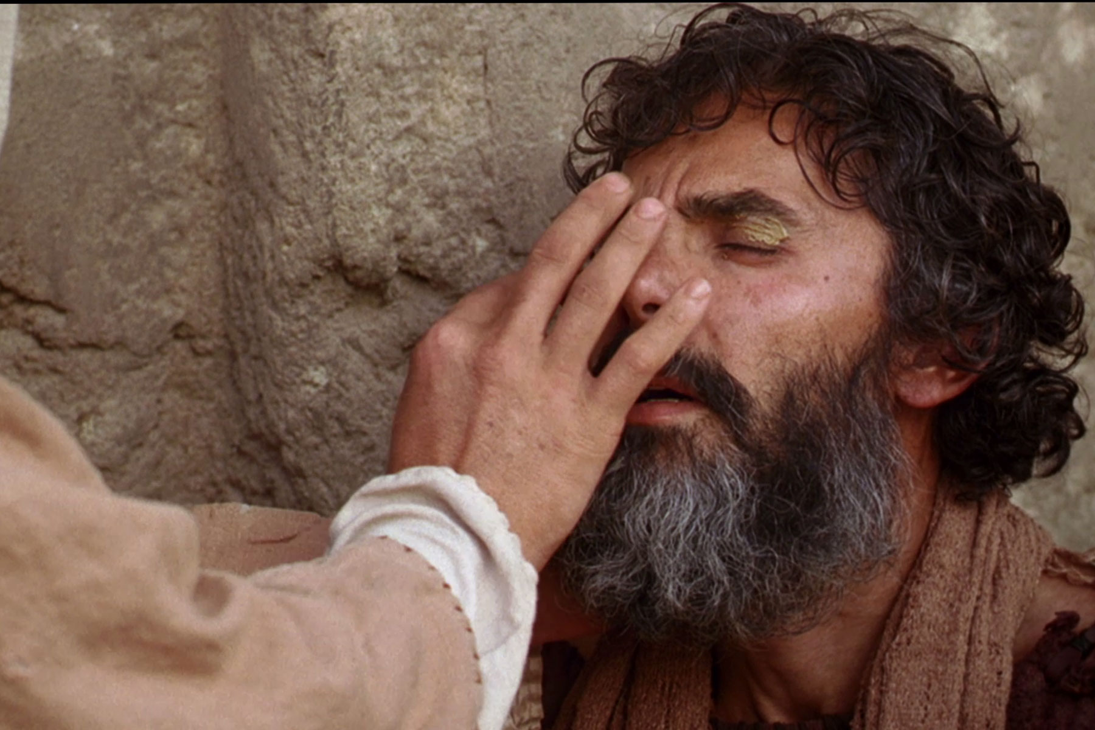
Watch the video link below to tell you this beautiful story showing the love and mercy of our Lord story
https://www.youtube.com/watch?v=Uo9ILFTVdhQ

- Fill in the blanks

“Neither this man nor his parents , but that the works of

should be in him.”
- Tuesday 31st March Read Chapter 9 verses 21-23

The Pharisees Excommunicate the Healed Man
¹³ They brought him who formerly was blind to the Pharisees. ¹⁴ Now it was a Sabbath when Jesus made the clay and opened his eyes. ¹⁵ Then the Pharisees also asked him again how he had received his sight. He said to them, “He put clay on my eyes, and I washed, and I see.”
¹⁶ Therefore some of the Pharisees said, “This Man is not from God, because He does not keep the Sabbath.”
Others said, “How can a man who is a sinner do such signs?” And there was a division among them.
¹⁷ They said to the blind man again, “What do you say about Him because He opened your eyes?”
He said, “He is a prophet.”
¹⁸ But the Jews did not believe concerning him, that he had been blind and received his sight, until they called the parents of him who had received his sight. ¹⁹ And they asked them, saying, “Is this your son, who you say was born blind? How then does he now see?”
²⁰ His parents answered them and said, “We know that this is our son, and that he was born blind; ²¹ but by what means he now sees we do not know, or who opened his eyes we do not know. He is of age; ask him. He will speak for himself.” ²² His parents said these things because they feared the Jews, for the Jews had agreed already that if anyone confessed that He was Christ, he would be put out of the synagogue. ²³ Therefore his parents said, “He is of age; ask him.”
2. On what day did Jesus heal the blind man? According to the Jews it was unlawful to heal on this day.

3. Why did the blind man’s parents tell the Pharisees that their son can speak for himself?

- Wednesday 1st April Read John Chapter 9 verses 24-34

²⁴ So they again called the man who was blind, and said to him, “Give God the glory! We know that this Man is a sinner.”
²⁵ He answered and said, “Whether He is a sinner or not I do not know. One thing I know: that though I was blind, now I see.”
²⁶ Then they said to him again, “What did He do to you? How did He open your eyes?”
²⁷ He answered them, “I told you already, and you did not listen. Why do you want to hear it again? Do you also want to become His disciples?”
²⁸ Then they reviled him and said, “You are His disciple, but we are Moses’ disciples. ²⁹ We know that God spoke to Moses; as for this fellow, we do not know where He is from.”
³⁰ The man answered and said to them, “Why, this is a marvelous thing, that you do not know where He is from; yet He has opened my eyes! ³¹ Now we know that God does not hear sinners; but if anyone is a worshiper of God and does His will, He hears him. ³² Since the world began it has been unheard of that anyone opened the eyes of one who was born blind. ³³ If this Man were not from God, He could do nothing.”
³⁴ They answered and said to him, “You were completely born in sins, and are you teaching us?” And they cast him out.

4. Jesus said the blind man was not born blind because of sin, but was born blind so that the works of God should be revealed. How did this man reveal the beautiful work of God?

- Thursday 2nd April Read John Chapter 8 verses 35-38

True Vision and True Blindness
³⁵ Jesus heard that they had cast him out; and when He had found him, He said to him, “Do you believe in the Son of God?”^{[e]}
³⁶ He answered and said, “Who is He, Lord, that I may believe in Him?”
³⁷ And Jesus said to him, “You have both seen Him and it is He who is talking with you.”
³⁸ Then he said, “Lord, I believe!” And he worshiped Him.

5. In verse 35 “Jesus heard they cast him out” Who is “they” and “him” ?
“they” is
“him” is

6. Cast out means
a. To go tell everyone outside about Jesus
b. To make him stand at the back of the synagogue
c. To throw him out of the synagogue
d. To make him a priest.

6. Jesus felt sorry for the blind man so He went looking for him. When Jesus found him He told the man that He is the Son of God. Jesus told the blind man now he can SEE Him. Did the blind man believe what Jesus said to him? What was the blind man’s response?

- Friday 3rd April Read John Chapter 9 verses 39-41

³⁹ And Jesus said, “For judgment I have come into this world, that those who do not see may see, and that those who see may be made blind.”
⁴⁰ Then some of the Pharisees who were with Him heard these words, and said to Him, “Are we blind also?”
⁴¹ Jesus said to them, “If you were blind, you would have no sin; but now you say, ‘We see.’ Therefore your sin remains.

7. Jesus talks about Physical blindness and spiritual blindness.
a. Can you explain the difference? Who was physically blind? Who were spiritually blind?

8. Highlight or underline the correct word.
The Jewish leaders could/couldn't “see” who Jesus was. They saw him heal and teach. They should have been able to understand/not understand who Jesus was. But the truth was they did/didn't want to see who He was––because if they admitted that Jesus was from God, people would listen to Him instead of listening to them.
The blind man was physically blind until Jesus gave him his sight. Jesus does not rob the Pharisees of their sight, but they are blinded/not blinded by their refusal to see Jesus as the Son of God

Jesus does not force belief or unbelief on either the blind man or Jewish leaders. He acts in a way that reveals God's glory, and allows/not allows people to choose. The blind man responds by believing/not believing, and the Jewish leaders respond by believing /not believing.
.
The Jewish leaders saw the blind man as a sinner because his blindness. Now Jesus portrays them as sinners, the evidence being their refusal/acceptance to spiritually see Jesus, the light of the world.

□ Saturday 11th April:
MEMORY VERSE: Copy and Learn by heart: (John 9:3). You will find it in last Monday’s Bible Study

PARENTS SECTION:
We kindly ask you as a parent to read (a little each day) in the Holy Bible with your family.
Now email your answers to your teacher, choose ONE of the email addresses below.
stthomas6b1@gmail.com Uncle George
stpeter6b2@gmail.com Uncle Mina or

stphilip6g@gmail.com Aunty Jacky

Click on the following link to see how many points you have.
Year 6B1 (St Thomas)
https://docs.google.com/spreadsheets/d/1B3hbaPWXLPr-bqV8YIabw159aKTkQlJ3I1pKK7mRhEI/edit?usp=sharing
Year 6B2 (St Peter)
https://docs.google.com/spreadsheets/d/1-3aY66NbtvgQdVxKQsLKIN32-mekY1UfV-fU-a6A3aE/edit?usp=sharing
Year 6G (StPhilip)
https://docs.google.com/spreadsheets/d/1KKS7TLUdMux972uO8yehkyA-gpRY7so_qA22MaRSM-I/edit?usp=sharing

