Handed out Sunday 15th March
Name:
Class:
To be emailed back to your Bible Study servant by 21st March
Completed Bible Study = 15 points,

Emailed by the due date = 5 points

The GOSPEL according to St. John
Year 6 – Bible Study 4

- Monday 16th March Read Chapter 7 verses 1 – 9
After these things Jesus walked in Galilee; for He did not want to walk in Judea, because the Jews^{[a]} sought to kill Him. ² Now the Jews’ Feast of Tabernacles was at hand. ³ His brothers therefore said to Him, “Depart from here and go into Judea, that Your disciples also may see the works that You are doing. ⁴ For no one does anything in secret while he himself seeks to be known openly. If You do these things, show Yourself to the world.” ⁵ For even His brothers did not believe in Him.
- Then Jesus said to them, “My time has not yet come, but your time is always ready. ⁷ The world cannot hate you, but it hates Me because I testify of it that its works are evil. ⁸ You go up to this feast. I am not yet^{[b]} going up to this feast, for My time has not yet fully come.” ⁹ When He had said these things to them, He remained in Galilee.
1. John mentions that the Jews’ Feast was at hand, what was this feast?
a) Passover
b) Unleavened bread
c) First fruits
d) Tabernacles
It is very important to note that Mary did not have any other children besides Jesus. It is implied in this passage that “His brothers” were Jesus’ bothers. During Jesus’ time first cousins were called “brothers”.
So “His brothers” are in fact His first cousins.

- Tuesday 17th March Read Chapter 7 verses 10-19

The Heavenly Scholar
¹⁰ But when His brothers had gone up, then He also went up to the feast, not openly, but as it were in secret. ¹¹ Then the Jews sought Him at the feast, and said, “Where is He?” ¹² And there was much complaining among the people concerning Him. Some said, “He is good”; others said, “No, on the contrary, He deceives the people.” ¹³ However, no one spoke openly of Him for fear of the Jews.
¹⁴ Now about the middle of the feast Jesus went up into the temple and taught. ¹⁵ And the Jews marveled, saying, “How does this Man know letters, having never studied?”
¹⁶ Jesus^{[c]} answered them and said, “My doctrine is not Mine, but His who sent Me. ¹⁷ If anyone wills to do His will, he shall know concerning the doctrine, whether it is from God or whether I speak on My own authority. ¹⁸ He who speaks from himself seeks his own glory; but He who seeks the glory of the One who sent Him is true, and no unrighteousness is in Him. ¹⁹ Did not Moses give you the law, yet none of you keeps the law? Why do you seek to kill Me?”
2. Some Jews said Jesus was good, other Jews said Jesus deceives people. However, when Jesus went to teach in the temple they all marvelled (they were all amazed). Why were they all amazed?

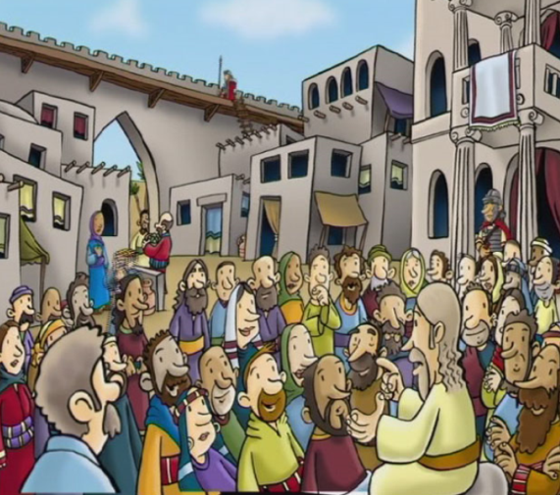

- Wednesday 18th March Read Matthew Chapter 7 verses 13-31

Could This Be the Christ?
²⁵ Now some of them from Jerusalem said, “Is this not He whom they seek to kill? ²⁶ But look! He speaks boldly, and they say nothing to Him. Do the rulers know indeed that this is truly^{[d]} the Christ? ²⁷ However, we know where this Man is from; but when the Christ comes, no one knows where He is from.”
²⁸ Then Jesus cried out, as He taught in the temple, saying, “You both know Me, and you know where I am from; and I have not come of Myself, but He who sent Me is true, whom you do not know. ²⁹ But^{[e]} I know Him, for I am from Him, and He sent Me.”
³⁰ Therefore they sought to take Him; but no one laid a hand on Him, because His hour had not yet come. ³¹ And many of the people believed in Him, and said, “When the Christ comes, will He do more signs than these which this Man has done?”
3. Many of the people believed in Jesus because He showed them many signs that He is the Christ. True/false
The other Gospels referred to these signs as miracles

4. “…because His hour has not come…” Verse 31 means.. Underline the correct answer
a) 60 minutes have not past
b) Jesus time has not come to depart from the world.
c) It was too early for Jesus to leave the temple

- Thursday 19th March Read Matthew Chapter 7 verses 32-36

Jesus and the Religious Leaders
³² The Pharisees heard the crowd murmuring these things concerning Him, and the Pharisees and the chief priests sent officers to take Him. ³³ Then Jesus said to them,^{[f]} “I shall be with you a little while longer, and then I go to Him who sent Me. ³⁴ You will seek Me and not find Me, and where I am you cannot come.”
³⁵ Then the Jews said among themselves, “Where does He intend to go that we shall not find Him? Does He intend to go to the Dispersion among the Greeks and teach the Greeks? ³⁶ What is this thing that He said, ‘You will seek Me and not find Me, and where I am you cannot come’?”
5. When Jesus said “I shall be with you a little while longer, and then I go to Him who sent me”

a) Who is Him?
B) Did the Pharisees and chief priests understand what Jesus meant? Where did they think Jesus was going? Were they correct?

- Friday 20th March Read Matthew Chapter 7 verses 37-43

The Promise of the Holy Spirit
³⁷ On the last day, that great day of the feast, Jesus stood and cried out, saying, “If anyone thirsts, let him come to Me and drink. ³⁸ He who believes in Me, as the Scripture has said, out of his heart will flow rivers of living water.” ³⁹ But this He spoke concerning the Spirit, whom those believing^{[g]} in Him would receive; for the Holy^{[h]} Spirit was not yet given, because Jesus was not yet glorified.
6. The Living Water is the Holy Spirit given to people who believe in Jesus. True/False?

7. Jesus said the Holy Spirit was not yet given. When did Jesus give the Holy spirit to believers? Underline the correct answer.
a) The last supper
b) Good Friday
c) Pentecost Sunday
d) Easter Sunday
Who Is He?
⁴⁰ Therefore many^{[i]} from the crowd, when they heard this saying, said, “Truly this is the Prophet.” ⁴¹ Others said, “This is the Christ.”
But some said, “Will the Christ come out of Galilee? ⁴² Has not the Scripture said that the Christ comes from the seed of David and from the town of Bethlehem, where David was?” ⁴³ So there was a division among the people because of Him. ⁴⁴ Now some of them wanted to take Him, but no one laid hands on Him.

8. Where was Jesus born?
Verse
9. Which verse stated this?

- Saturday 21st March Read Matthew Chapter 7 verses 21-23

Rejected by the Authorities
⁴⁵ Then the officers came to the chief priests and Pharisees, who said to them, “Why have you not brought Him?”
⁴⁶ The officers answered, “No man ever spoke like this Man!”
⁴⁷ Then the Pharisees answered them, “Are you also deceived? ⁴⁸ Have any of the rulers or the Pharisees believed in Him? ⁴⁹ But this crowd that does not know the law is accursed.”
⁵⁰ Nicodemus (he who came to Jesus by night,^{[j]} being one of them) said to them, ⁵¹ “Does our law judge a man before it hears him and knows what he is doing?”
⁵² They answered and said to him, “Are you also from Galilee? Search and look, for no prophet has arisen^{[k]} out of Galilee.”
10. Jesus was rejected by the authorities (chief priests and Pharisees)
Who in the above Verses believed Jesus was the Messiah?

Note:
The chief priests were members of the high priestly families or those acting with the authority of the high priest –
The Jews were divided into 2 types
- Pharisees- The Pharisees believed in the resurrection
- Sadducees did not believe in the resurrection
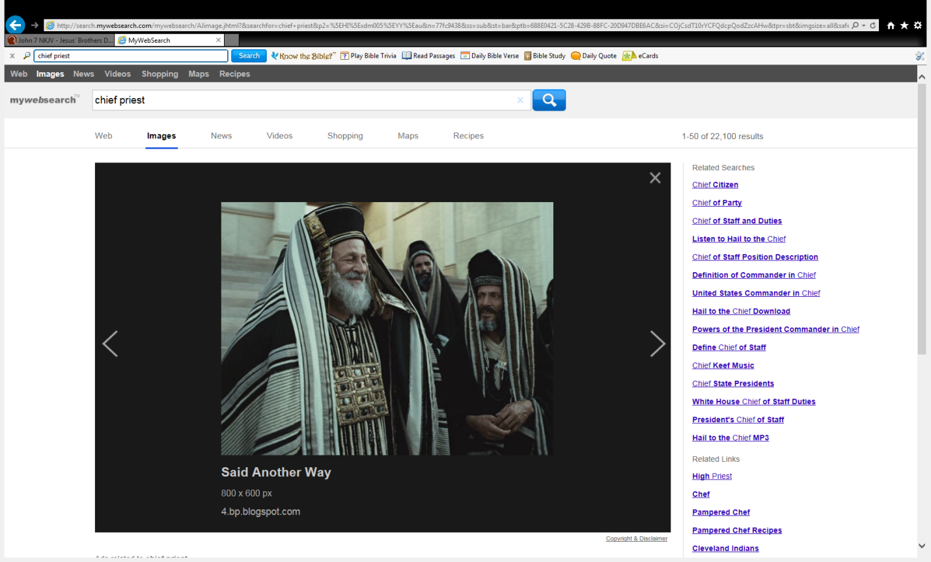
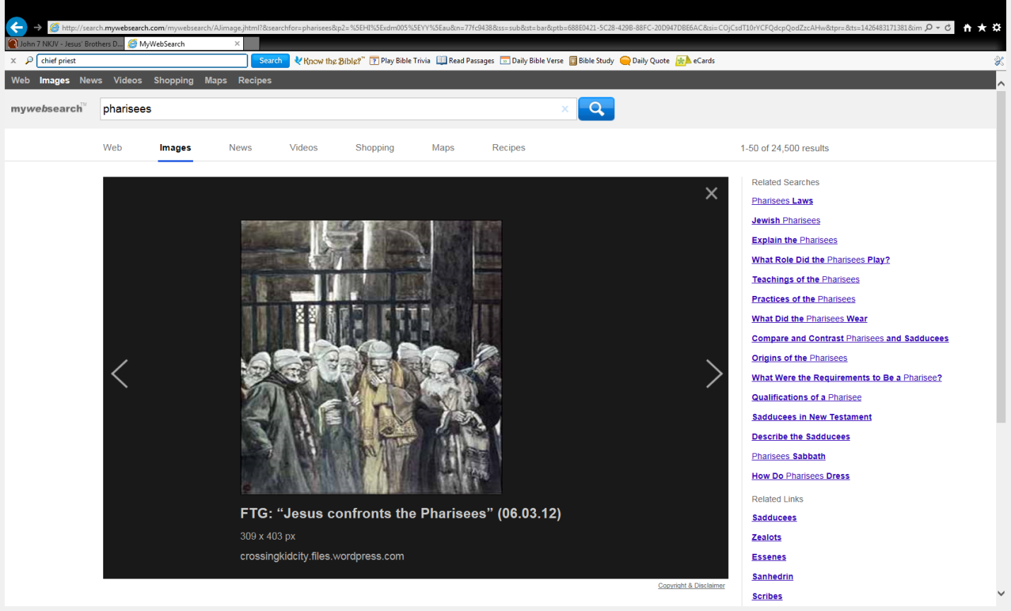
Chief Priests
Pharisees

PARENTS SECTION:
We kindly ask you as a parent to read (a little each day) in the Holy Bible with your family.
Now email your answers to your teacher, choose ONE of the email addresses below.
stthomas6b1@gmail.com Uncle George
stpeter6b2@gmail.com Uncle Mina or

stphilip6g@gmail.com Aunty Jacky

Click on the following link to see how many points you have.
Year 6B1 (St Thomas)
https://docs.google.com/spreadsheets/d/1B3hbaPWXLPr-bqV8YIabw159aKTkQlJ3I1pKK7mRhEI/edit?usp=sharing
Year 6B2 (St Peter)
https://docs.google.com/spreadsheets/d/1-3aY66NbtvgQdVxKQsLKIN32-mekY1UfV-fU-a6A3aE/edit?usp=sharing
Year 6G (StPhilip)
https://docs.google.com/spreadsheets/d/1KKS7TLUdMux972uO8yehkyA-gpRY7so_qA22MaRSM-I/edit?usp=sharing

