Handed out Sunday 26th April
Name:
Class:
To be emailed back to your Bible Study servant by 2nd May
Completed Bible Study = 15 points,

Emailed by the due date = 5 points

The GOSPEL according to St. John
Year 6 – Bible Study- John Chapter 11

- Monday 27th April Read John Chapter 11 verses 1 -16

The Death of Lazarus
¹ Now a certain man was sick, Lazarus of Bethany, the town of Mary and her sister Martha. ² It was that Mary who anointed the Lord with fragrant oil and wiped His feet with her hair, whose brother Lazarus was sick. ³ Therefore the sisters sent to Him, saying, “Lord, behold, he whom You love is sick.”
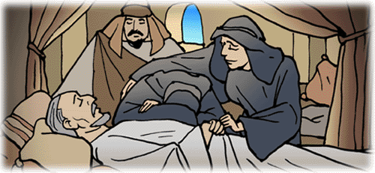
⁴ When Jesus heard that, He said, “This sickness is not unto death, but for the glory of God, that the Son of God may be glorified through it.”
⁵ Now Jesus loved Martha and her sister and Lazarus. ⁶ So, when He heard that he was sick, He stayed two more days in the place where He was. ⁷ Then after this He said to the disciples, “Let us go to Judea again.”
⁸ The disciples said to Him, “Rabbi, lately the Jews sought to stone You, and are You going there again?”
⁹ Jesus answered, “Are there not twelve hours in the day? If anyone walks in the day, he does not stumble, because he sees the light of this world. ¹⁰ But if one walks in the night, he stumbles, because the light is not in him.” ¹¹ These things He said, and after that He said to them, “Our friend Lazarus sleeps, but I go that I may wake him up.”
¹² Then His disciples said, “Lord, if he sleeps he will get well.” ¹³ However, Jesus spoke of his death, but they thought that He was speaking about taking rest in sleep.
¹⁴ Then Jesus said to them plainly, “Lazarus is dead. ¹⁵ And I am glad for your sakes that I was not there, that you may believe. Nevertheless let us go to him.”
¹⁶ Then Thomas, who is called the Twin, said to his fellow disciples, “Let us also go, that we may die with Him.”

Question 1
When Lazarus was ill, his sister Mary sent someone to tell Jesus so He could come and heal him. When Jesus heard the news why do you think He waited 2 more days before He travelled to their home?

- Tuesday 28th April Read John Chapter 11 verses 17-27

I am the Resurrection and the Life
¹⁷ So when Jesus came, He found that he had already been in the tomb four days. ¹⁸ Now Bethany was near Jerusalem, about two miles away. ¹⁹ And many of the Jews had joined the women around Martha and Mary, to comfort them concerning their brother.
²⁰ Now Martha, as soon as she heard that Jesus was coming, went and met Him, but Mary was sitting in the house. ²¹ Now Martha said to Jesus, “Lord, if You had been here, my brother would not have died. ²² But even now I know that whatever You ask of God, God will give You.”
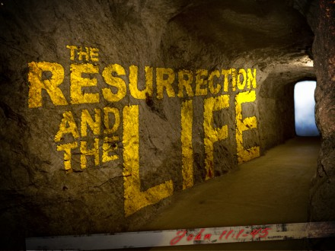
²³ Jesus said to her, “Your brother will rise again.”
²⁴ Martha said to Him, “I know that he will rise again in the resurrection at the last day.”
²⁵ Jesus said to her, “I am the resurrection and the life. He who believes in Me, though he may die, he shall live. ²⁶ And whoever lives and believes in Me shall never die. Do you believe this?”
²⁷ She said to Him, “Yes, Lord, I believe that You are the Christ, the Son of God, who is to come into the world.”
Question 2
What does Martha tell Jesus would have happened had He stayed in Bethany?

Question 3
What event did Martha think Jesus was talking about when Jesus told her that Lazarus would rise again?

Question 4
Explain in your own words what you think Verses 25 and 26 mean. Do you believe that this is true? Why or why not?

- Wednesday 29th April Read John Chapter 11 verses 28-37

Jesus and Death, the Last Enemy
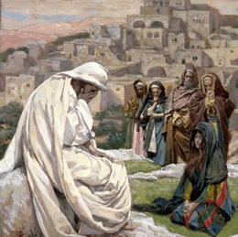
²⁸ And when she had said these things, she went her way and secretly called Mary her sister, saying, “The Teacher has come and is calling for you.” ²⁹ As soon as she heard that, she arose quickly and came to Him. ³⁰ Now Jesus had not yet come into the town, but was in the place where Martha met Him. ³¹ Then the Jews who were with her in the house, and comforting her, when they saw that Mary rose up quickly and went out, followed her, saying, “She is going to the tomb to weep there.”
³² Then, when Mary came where Jesus was, and saw Him, she fell down at His feet, saying to Him, “Lord, if You had been here, my brother would not have died.”
³³ Therefore, when Jesus saw her weeping, and the Jews who came with her weeping, He groaned in the spirit and was troubled. ³⁴ And He said, “Where have you laid him?”
They said to Him, “Lord, come and see.”
³⁵ Jesus wept. ³⁶ Then the Jews said, “See how He loved him!”
³⁷ And some of them said, “Could not this Man, who opened the eyes of the blind, also have kept this man from dying?”
Question 5
Mary repeated something that Martha told Jesus. What was this?

Question 6
The fact that Jesus was crying tells us that He experienced all of our emotions. What fact about the nature of Jesus does this prove?
That he was fully God and fully H___________

- Thursday 30th April Read John Chapter 11 verses 38-44

Lazarus Raised from the Dead
³⁸ Then Jesus, again groaning in Himself, came to the tomb. It was a cave, and a stone lay against it. ³⁹ Jesus said, “Take away the stone.”
Martha, the sister of him who was dead, said to Him, “Lord, by this time there is a stench, for he has been dead four days.”
⁴⁰ Jesus said to her, “Did I not say to you that if you would believe you would see the glory of God?” ⁴¹ Then they took away the stone from the place where the dead man was lying. And Jesus lifted up His eyes and said, “Father, I thank You that You have heard Me. ⁴² And I know that You always hear Me, but because of the people who are standing by I said this, that they may believe that You sent Me.” ⁴³ Now when He had said these things, He cried with a loud voice, “Lazarus, come forth!”
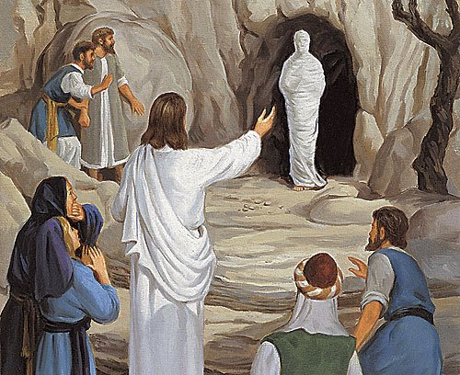
⁴⁴ And he who had died came out bound hand and foot with graveclothes, and his face was wrapped with a cloth. Jesus said to them, “Loose him, and let him go.”
Question 7

How long was Lazarus dead before Jesus raised him?
Question 8
According to Verse 42, why did Jesus do this miracle?
- He wanted people to like Him
- Because He was asking God the Father for it
- So that people may believe that He was the Son of God
- Since Martha and Mary were upset

Question 9
True or False
Lazarus had a bad smell around him when he came forth? True / False

- Friday 1st May Read John Chapter 11 verses 45-57

The Plot to Kill Jesus
⁴⁵ Then many of the Jews who had come to Mary, and had seen the things Jesus did, believed in Him. ⁴⁶ But some of them went away to the Pharisees and told them the things Jesus did. ⁴⁷ Then the chief priests and the Pharisees gathered a council and said, “What shall we do? For this Man works many signs. ⁴⁸ If we let Him alone like this, everyone will believe in Him, and the Romans will come and take away both our place and nation.”
⁴⁹ And one of them, Caiaphas, being high priest that year, said to them, “You know nothing at all, ⁵⁰ nor do you consider that it is expedient for us that one man should die for the people, and not that the whole nation should perish.” ⁵¹ Now this he did not say on his own authority; but being high priest that year he prophesied that Jesus would die for the nation, ⁵² and not for that nation only, but also that He would gather together in one the children of God who were scattered abroad.
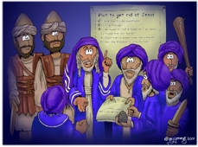
⁵³ Then, from that day on, they plotted to put Him to death. ⁵⁴ Therefore Jesus no longer walked openly among the Jews, but went from there into the country near the wilderness, to a city called Ephraim, and there remained with His disciples.
⁵⁵ And the Passover of the Jews was near, and many went from the country up to Jerusalem before the Passover, to purify themselves. ⁵⁶ Then they sought Jesus, and spoke among themselves as they stood in the temple, “What do you think—that He will not come to the feast?” ⁵⁷ Now both the chief priests and the Pharisees had given a command, that if anyone knew where He was, he should report it, that they might seize Him.

Question 10
Why do you think that Jews were afraid of people believing in Jesus?

Question 11
Which city did Jesus dwell in to escape from the Chief Priests?
- Judea
- Bethany
- Ephraim
- Jerusalem

- Saturday 2nd May

Question 11
What is the main message that you have gotten from this chapter? How will this help you in your day to day life?

PARENTS SECTION:
We kindly ask you as a parent to read (a little each day) in the Holy Bible with your family.
Now email your answers to your teacher, choose ONE of the email addresses below.
stthomas6b1@gmail.com Uncle George
stpeter6b2@gmail.com Uncle Mina or

stphilip6g@gmail.com Aunty Jacky

Click on the following link to see how many points you have.
Year 6B1 (St Thomas)
https://docs.google.com/spreadsheets/d/1B3hbaPWXLPr-bqV8YIabw159aKTkQlJ3I1pKK7mRhEI/edit?usp=sharing
Year 6B2 (St Peter)
https://docs.google.com/spreadsheets/d/1-3aY66NbtvgQdVxKQsLKIN32-mekY1UfV-fU-a6A3aE/edit?usp=sharing
Year 6G (StPhilip)
https://docs.google.com/spreadsheets/d/1KKS7TLUdMux972uO8yehkyA-gpRY7so_qA22MaRSM-I/edit?usp=sharing

