Handed out Sunday 19th April
Name:
Class:
To be emailed back to your Bible Study servant by 25th April
Completed Bible Study = 15 points,

Emailed by the due date = 5 points

The GOSPEL according to St. John
Year 6 – Bible Study- John Chapter 10

- Monday 20th April Read John Chapter 10 verses 1 -6

Jesus the True Shepherd
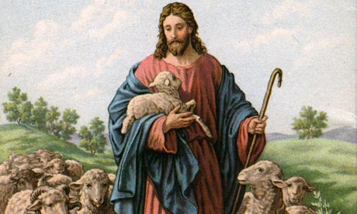
¹ “Most assuredly, I say to you, he who does not enter the sheepfold by the door, but climbs up some other way, the same is a thief and a robber. ² But he who enters by the door is the shepherd of the sheep. ³ To him the doorkeeper opens, and the sheep hear his voice; and he calls his own sheep by name and leads them out. ⁴ And when he brings out his own sheep, he goes before them; and the sheep follow him, for they know his voice. ⁵ Yet they will by no means follow a stranger, but will flee from him, for they do not know the voice of strangers.” ⁶ Jesus used this illustration, but they did not understand the things which He spoke to them.
Question 1
If we know the voice of the Shepherd (Jesus) what should we do when we hear the voice of a stranger (the devil) telling us to follow him?

Question 2
What do we call these short stories that Jesus used to illustrate things that people did not understand?

- Tuesday 21st April Read John Chapter 10 verses 7-21

Jesus the Good Shepherd
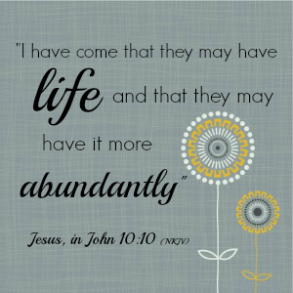
⁷ Then Jesus said to them again, “Most assuredly, I say to you, I am the door of the sheep. ⁸ All who ever came before Me are thieves and robbers, but the sheep did not hear them. ⁹ I am the door. If anyone enters by Me, he will be saved, and will go in and out and find pasture. ¹⁰ The thief does not come except to steal, and to kill, and to destroy. I have come that they may have life, and that they may have it more abundantly.
¹¹ “I am the good shepherd. The good shepherd gives His life for the sheep. ¹² But a hireling, he who is not the shepherd, one who does not own the sheep, sees the wolf coming and leaves the sheep and flees; and the wolf catches the sheep and scatters them. ¹³ The hireling flees because he is a hireling and does not care about the sheep. ¹⁴ I am the good shepherd; and I know My sheep, and am known by My own. ¹⁵ As the Father knows Me, even so I know the Father; and I lay down My life for the sheep. ¹⁶ And other sheep I have which are not of this fold; them also I must bring, and they will hear My voice; and there will be one flock and one shepherd.
¹⁷ “Therefore My Father loves Me, because I lay down My life that I may take it again. ¹⁸ No one takes it from Me, but I lay it down of Myself. I have power to lay it down, and I have power to take it again. This command I have received from My Father.”
¹⁹ Therefore there was a division again among the Jews because of these sayings. ²⁰ And many of them said, “He has a demon and is mad. Why do you listen to Him?”
²¹ Others said, “These are not the words of one who has a demon. Can a demon open the eyes of the blind?”
Do you know what a “hireling” is?
A hireling – that is one who is not a shepherd and who does not own the sheep – he leaves the sheep and flees when he sees the wolf coming, and the wolf pounces down on the sheep and scatters them. The reason why the hireling flees is that he is a hireling, and does not care for the sheep.”
Question 3
Explain what it means when Jesus tells us that He has come to give us life “more abundantly” (Verse 10)

Question 4

Question 4
If the sheep were attacked by wolves, what does Jesus say would happen if there was a person who is not a shepherd looking after the sheep? Who is OUR shepherd?

Question 5
When people claimed that Jesus had a demon, what was the response that was given by others to say that He was not?

- Wednesday 22nd April Read John Chapter 10 verses 22-30

The Shepherd knows His Sheep
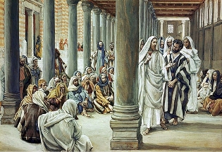
²² Now it was the Feast of Dedication in Jerusalem, and it was winter. ²³ And Jesus walked in the temple, in Solomon’s porch. ²⁴ Then the Jews surrounded Him and said to Him, “How long do You keep us in doubt? If You are the Christ, tell us plainly.”
²⁵ Jesus answered them, “I told you, and you do not believe. The works that I do in My Father’s name, they bear witness of Me. ²⁶ But you do not believe, because you are not of My sheep, as I said to you. ²⁷ My sheep hear My voice, and I know them, and they follow Me. ²⁸ And I give them eternal life, and they shall never perish; neither shall anyone snatch them out of My hand. ²⁹ My Father, who has given them to Me, is greater than all; and no one is able to snatch them out of My Father’s hand. ³⁰ I and My Father are one.”
What is the Feast of Dedication?
The Feast of Dedication is today known as Hanukkah, it is a festival that is celebrated in December. It celebrates the Temple of Jerusalem being used for burnt offerings, and as a general temple for the Jewish people. This was the SAME temple that Jesus started preaching in throughout this passage
Question 6
Fill in the blanks

And I give them life, and they shall perish;

neither shall anyone them out of my (Verse 29)

- Thursday 23rd April Read John Chapter 10 verses 31-39

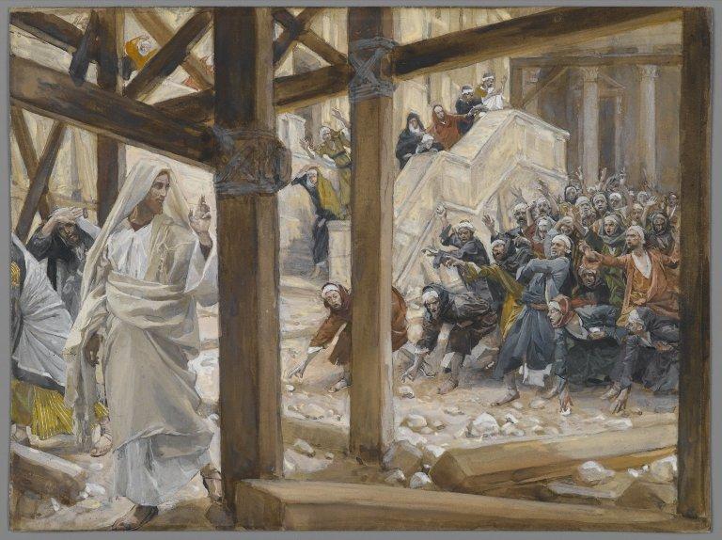
Renewed Efforts to Stone Jesus
³¹ Then the Jews took up stones again to stone Him. ³² Jesus answered them, “Many good works I have shown you from My Father. For which of those works do you stone Me?”
³³ The Jews answered Him, saying, “For a good work we do not stone You, but for blasphemy, and because You, being a Man, make Yourself God.”
³⁴ Jesus answered them, “Is it not written in your law, ‘I said, “You are gods”’? ³⁵ If He called them gods, to whom the word of God came (and the Scripture cannot be broken), ³⁶ do you say of Him whom the Father sanctified and sent into the world, ‘You are blaspheming,’ because I said, ‘I am the Son of God’? ³⁷ If I do not do the works of My Father, do not believe Me; ³⁸ but if I do, though you do not believe Me, believe the works, that you may know and believe that the Father is in Me, and I in Him.” ³⁹ Therefore they sought again to seize Him, but He escaped out of their hand
What is Blasphemy?
Blasphemy is talking in an offensive way about God- it is like cursing God.
Question 7
Why did the Jews want to stone Jesus?
- Because He healed many people
- Because He was teaching in the temple
- Because He made Himself equal to God the Father
- Because people did not believe that He was the Son of God

Question 8
True or False
In the Old Testament, people that heard the word of God were called gods? True / False

- Friday 24th April Read John Chapter 10 verses 40-42

The Believers beyond the Jordan
⁴⁰ And He went away again beyond the Jordan to the place where John was baptizing at first, and there He stayed. ⁴¹ Then many came to Him and said, “John performed no sign, but all the things that John spoke about this Man were true.” ⁴² And many believed in Him there.

Question 9
Why do you think that Jesus went to the river Jordan? How did the people there react to Him?

- Saturday 25th April

Question 10
What is YOUR favourite verse in this Chapter? Write OUT the VERSE and explain why it is.

PARENTS SECTION:
We kindly ask you as a parent to read (a little each day) in the Holy Bible with your family.
Now email your answers to your teacher, choose ONE of the email addresses below.
stthomas6b1@gmail.com Uncle George
stpeter6b2@gmail.com Uncle Mina or

stphilip6g@gmail.com Aunty Jacky

Click on the following link to see how many points you have.
Year 6B1 (St Thomas)
https://docs.google.com/spreadsheets/d/1JYhrjeuxvNyBxw7to2JY6vNKjGWB0RwBs0cwis84HWM/edit?usp=sharing
Year 6B2 (St Peter)
https://docs.google.com/spreadsheets/d/1UHPsNofZqXaE5DQg6F0iqlUoVLiqk3eS_oPyZ0SUhgQ/edit?usp=sharing
Year 6G (StPhilip)
https://docs.google.com/spreadsheets/d/1KKS7TLUdMux972uO8yehkyA-gpRY7so_qA22MaRSM-I/edit?usp=sharing

