Handed out Sunday 15th March
Name:
Class:
To be emailed back to your Bible Study servant by 21st March
Completed Bible Study = 15 points,

Emailed by the due date = 5 points

The GOSPEL according to St. Matthew
Year 5 – Bible Study 4

- Monday 16th March Read Chapter 7 verses 1 – 6

Do Not Judge
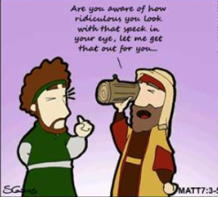
“Judge not, that you be not judged. ² For with what judgment you judge, you will be judged; and with the measure you use, it will be measured back to you. ³ And why do you look at the speck in your brother’s eye, but do not consider the plank in your own eye? ⁴ Or how can you say to your brother, ‘Let me remove the speck from your eye’; and look, a plank is in your own eye? ⁵ Hypocrite! First remove the plank from your own eye, and then you will see clearly to remove the speck from your brother’s eye.
⁶ “Do not give what is holy to the dogs; nor cast your pearls before swine, lest they trample them under their feet, and turn and tear you in pieces.

- Why should we not judge other people?

- Jesus says that by judging others we can often be like a Hypocrite.
What does this mean?

An example of a hypocrite is a person who says they care about the environment, but is constantly throwing rubbish on the ground.

- Tuesday 17th March Read Chapter 7 verses 7 – 20

Keep Asking, Seeking, Knocking

⁷ “Ask, and it will be given to you; seek, and you will find; knock, and it will be opened to you. ⁸ For everyone who asks receives, and he who seeks finds, and to him who knocks it will be opened. ⁹ Or what man is there among you who, if his son asks for bread, will give him a stone? ¹⁰ Or if he asks for a fish, will he give him a serpent? ¹¹ If you then, being evil, know how to give good gifts to your children, how much more will your Father who is in heaven give good things to those who ask Him! ¹² Therefore, whatever you want men to do to you, do also to them, for this is the Law and the Prophets.

- Complete the following

“Ask ”

“Seek ”

“Knock ”

- Wednesday 18th March Read Matthew Chapter 7 verses 13-14
The Narrow Way
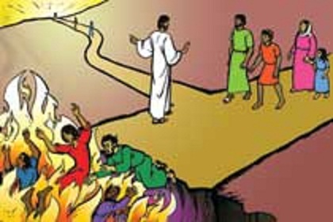
Look at the Picture below. Matthew 7:13-14
Jesus Christ said there are two ways in life. He said, "Go in through the narrow gate. The gate to destruction is wide, and the road that leads there is easy to follow. A lot of people go through that gate. But the gate to life is very narrow. The road that leads there is so hard to follow that only a few people find it."
How can they find that way to everlasting life? Look at the picture. Jesus is pointing to the narrow path. He is trying to stop the people from following the wide path because it leads to the fire of hell. People who go that way will be lost forever but if they follow Jesus they will find everlasting life.
4. Which gate can we enter the kingdom of heaven by? (Underline the correct answer) narrow / wide

- Thursday 19th March Read Matthew Chapter 7 verses 15-20

You Will Know Them by Their Fruits
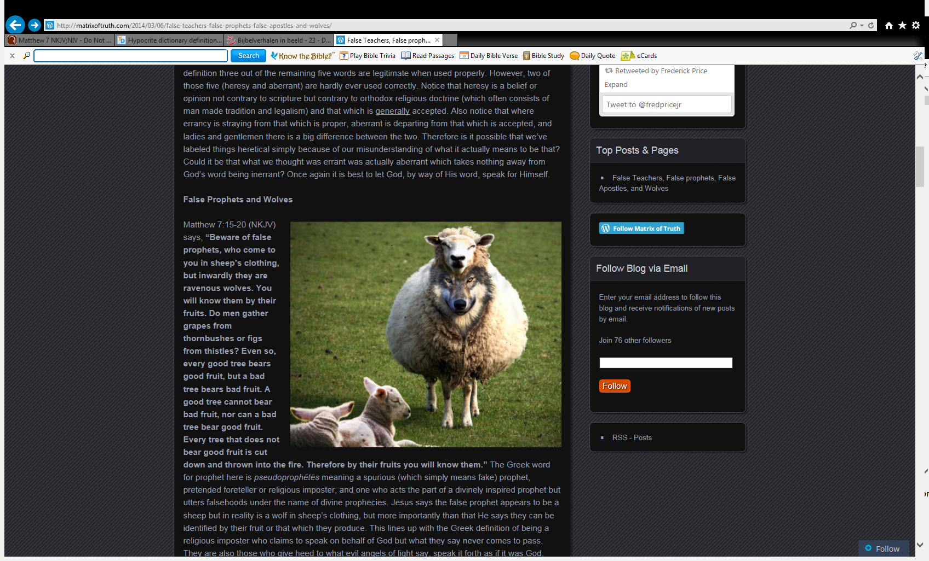
¹⁵ “Beware of false prophets, who come to you in sheep’s clothing, but inwardly they are ravenous wolves. ¹⁶ You will know them by their fruits. Do men gather grapes from thornbushes or figs from thistles? ¹⁷ Even so, every good tree bears good fruit, but a bad tree bears bad fruit. ¹⁸ A good tree cannot bear bad fruit, nor can a bad tree bear good fruit. ¹⁹ Every tree that does not bear good fruit is cut down and thrown into the fire. ²⁰ Therefore by their fruits you will know them.
A

- Jesus said to be careful of false prophets.
Can false prophets appear to teach good things,
behave in a way that appears pleasing to God,
yet lead people away from Christ. True/false

- What does animal “A” represent?

- Friday 20th March Read Matthew Chapter 7 verses 21-23

I Never Knew You
²¹ “Not everyone who says to Me, ‘Lord, Lord,’ shall enter the kingdom of heaven, but he who does the will of My Father in heaven. ²² Many will say to Me in that day, ‘Lord, Lord, have we not prophesied in Your name, cast out demons in Your name, and done many wonders in Your name?’ ²³ And then I will declare to them, ‘I never knew you; depart from Me, you who practice lawlessness!’
- Who did Jesus say would enter the Kingdom of Heaven?

- Saturday 21st March Read Matthew Chapter 7 verses 21-23

Build on the Rock
²⁴ “Therefore whoever hears these sayings of Mine, and does them, I will liken him to a wise man who built his house on the rock: ²⁵ and the rain descended, the floods came, and the winds blew and beat on that house; and it did not fall, for it was founded on the rock.
²⁶ “But everyone who hears these sayings of Mine, and does not do them, will be like a foolish man who built his house on the sand: ²⁷ and the rain descended, the floods came, and the winds blew and beat on that house; and it fell. And great was its fall.”
²⁸ And so it was, when Jesus had ended these sayings, that the people were astonished at His teaching, ²⁹ for He taught them as one having authority, and not as the scribes.

- Label which type of person built these houses

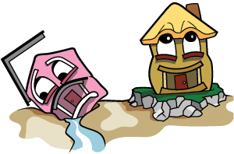

- This parable teaches us that we should build our lives on whom?

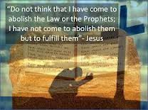
Memory verse

To try to remember the verse, write it out below:

PARENTS SECTION:
We kindly ask you as a parent to read (a little each day) in the Holy Bible with your family.
Now email your answers to your teacher, choose ONE of the email addresses below.

stmatthew5b1@gmail.com Uncle Andrew
or
stmark5b2@gmail.com Uncle Bassem
or
saintluke5g1@gmail.com Aunty Merna
or
stjohn5g2@gmail.com Aunty Angela

Click on the following link to see how many points you have.
Year 5B1 (St Matthew)
https://docs.google.com/spreadsheets/d/1YPfk0C0NBJv0XfLlXzhWewt5SbZHkTAmmAVEaydaUYo/edit?usp=sharing
Year 5B2 (St Mark)
https://docs.google.com/spreadsheets/d/1IU-qPhJOybm8AH80BISZtK-OVRM-f7DXrPzkonxcraU/edit?usp=sharing
Year 5G1 (St Luke)
https://docs.google.com/spreadsheets/d/1S9gmI4ZC4ctLiJjYsJGXg_p__H28tM8WXGWcHD8OBKc/edit?usp=sharing
Year 5G2 (St John)
https://docs.google.com/spreadsheets/d/1B3hbaPWXLPr-bqV8YIabw159aKTkQlJ3I1pKK7mRhEI/edit?usp=sharing

