MC900383922[1]Sunday 19th July, 2015

Name:

Class:

Finish Date: Saturday 25th July, 2015

Completed Bible Study = 15 points

Homework handed in by the due date = 5 points

**Year 6 Memorisation homework**

* **Monday 20th July**

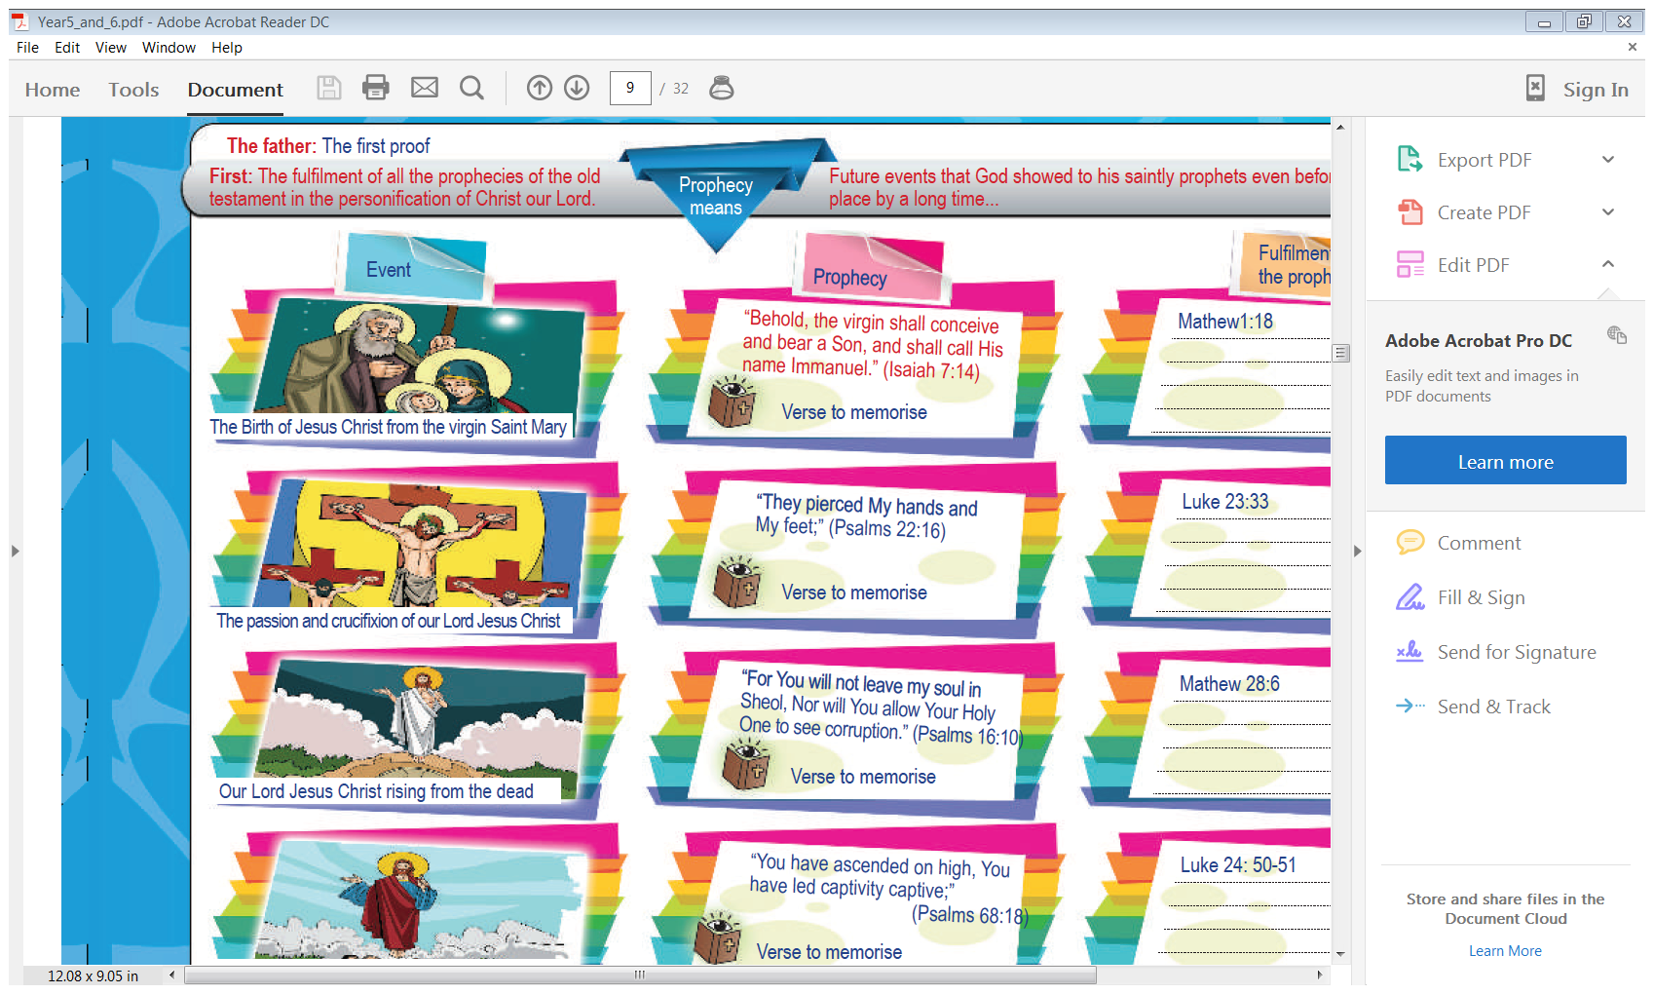

**Memory verse: 2 Peter 1:21**

***“For prophecy never came by the will of man, but holy men of God spoke as they were moved by the Holy spirit”***

**Question 1**

Fill in the missing words

1. but holy men of God spoke as they were

moved by the Holy spirit”

1. “For prophecy never came by the will of man,

**Question2**

Complete each word in the sentence. The first letter has been done for you.

|  |  |  |  |  |  |  |  |  |
| --- | --- | --- | --- | --- | --- | --- | --- | --- |
| F | p | n | c | b | t | w | o | m |
| b | h | m | o | G |  |  |  |  |
| s | a | t | w | m | b | t | H | S |

**Part 3: To be faithful to my God**

**Memory verse: 1Corinthians 14:26**

***“Whenever you come together, each of you has a psalm”***

**Question 3**

Repeat this verse 5 times with your eyes closed.

Can you remember where this verse can be found in the Bible?

* **Tuesday 21st July**

**Part 4: Let us be successful**

**Memory verse: Joshua 1:5**

***“No man shall be able to stand before you all the days of your life:***

***as I was with Moses, so I will be with you.***

**Question 4**

Memorise the verse, without looking, fill in the table by writing the first part of the sentence. The first word in the first column and 2nd part of the sentence has been done for you.

|  |  |
| --- | --- |
| **First word in verse** | **2nd part of the verse** |
| **No** | **before you all the days of your life** |
| **as** | **so I will be with you** |
| **No** | **shall be able to stand before you** |
| **as** | **Moses,** |
| **to** | **of your life** |
| **so** | **with you** |

* **Wednesday 22nd July**

**Part 5: Let’s make our country better**

**Memory verse: Matthew 21:22**

***“And whatever things you ask in prayer, believing, you will receive”***

**Question 5**

Who said this phrase?

**Question 6**

Learn the verse by saying it 5 times, and complete each word in the sentence. The first letter

|  |  |  |  |  |  |  |  |  |  |  |
| --- | --- | --- | --- | --- | --- | --- | --- | --- | --- | --- |
| A | w | t | y | a | i | p | b | y | w | r |

has been done for you.

**Question 7**

Can you remember all the verses you have learnt so far? Test yourself by completing the table.

|  |  |
| --- | --- |
| *“Behold, the virgin shall conceive and bear a Son,* |  |
| *“They pierced* |  |
| *“For You will not leave my soul in Sheol,* |  |
| *“You have ascended on high,* |  |
| *“All Scripture is given by inspiration of God, and is profitable for doctrine,* |  |
| *"Go therefore and make disciples of all the nations, baptizing them to observe all things that I have commanded you;* |  |
| *“For prophecy never came by the will of man,* |  |
| *“Whenever you come together,* |  |
| *“No man shall be able to stand before you all the days of your life:* |  |
| *“And whatever things you ask in prayer,* |  |

* **Thursday 23rd July**

**Question 8**

Can you remember the Chapter and the verse number for the verses you memorised?

Complete the table below to test yourself.

|  |  |
| --- | --- |
| Memory Verse | Name of Book Chapter number Verse number |
| *“Behold, the virgin shall conceive and bear a Son, and shall call His name Immanuel.”* |  |
| *“They pierced My hands and My feet;”* |  |
| *“For You will not leave my soul in Sheol, Nor will You allow your Holy one to see corruption.”* |  |
| *“You have ascended on high, You have led captivity captive;”* |  |
| *“All Scripture is given by inspiration of God, and is profitable for doctrine, for reproof, for correction, for instruction in righteousness.”* |  |
| *"Go therefore and make disciples of all the nations, baptizing them to observe all things that I have commanded you; and lo, I am with you always, even to the end of the age.”* |  |
| *“For prophecy never came by the will of man, but holy men of God spoke as they were moved by the Holy spirit”* |  |
| *“Whenever you come together, each of you has a psalm”* |  |
| *“No man shall be able to stand before you all the days of your life:*  *as I was with Moses, so I will be with you.* |  |
| *“And whatever things you ask in prayer, believing, you will receive”* |  |

* **Friday 24th July**

Read Psalm 142 and answer the questions that follow to help you learn it.

** **Memorisation: Psalm 142**

***1 I cry out to the Lord with my voice;  
With my voice to the Lord I make my supplication.  
2I pour out my complaint before Him;  
I declare before Him my trouble.***

***3When my spirit was overwhelmed within me,  
Then You knew my path.  
In the way in which I walk  
They have secretly set a snare for me.  
4Look on my right hand and see,  
For there is no one who acknowledges me;  
Refuge has failed me;  
No one cares for my soul.***

***5I cried out to You, O Lord:  
I said, “You are my refuge,  
My portion in the land of the living.  
6Attend to my cry,  
For I am brought very low;  
Deliver me from my persecutors,  
For they are stronger than I.  
7Bring my soul out of prison,  
That I may praise Your name;  
The righteous shall surround me,  
For You shall deal bountifully with me.”***

**Learn the verses then answer the questions to help you memorise**

**Verse 1-2**

***1 I cry out to the Lord with my voice;  
With my voice to the Lord I make my supplication.  
2I pour out my complaint before Him;  
I declare before Him my trouble.***

**Question 9**

Fill in the table by completing the sentences

|  |  |
| --- | --- |
| *1 I cry out to the Lord* |  |
| *With my voice to the Lord* |  |
| *2I pour out my complaint* |  |
| *I declare before Him* |  |
|  | *with my voice;* |
|  | *I make my supplication.* |
|  | *before Him;* |
|  | *my trouble* |

**Question 10**

**Fill in the missing words**

*1 I cry out with my voice;*

*With my voice I make my supplication*

*.  
2I pour out before Him;*

*I declare my trouble.*

**Question 11**

Complete each word in the sentence. The first letter has been done for you.

|  |  |  |  |  |  |  |  |  |  |
| --- | --- | --- | --- | --- | --- | --- | --- | --- | --- |
| I | c | o | t | t | L | w | m | v |  |
| W | m | v | t | t | L | I | m | m | s |
|  |  |  |  |  |  |  |  |  |  |
|  | I | p | o | m | c | b | H |  |  |
|  |  | I | d | b | H | m | t |  |  |

* **Saturday 25th July**

**Verse 3-4**

***3When my spirit was overwhelmed within me,  
Then You knew my path.  
In the way in which I walk  
They have secretly set a snare for me.  
4Look on my right hand and see,  
For there is no one who acknowledges me;  
Refuge has failed me;  
No one cares for my soul.***

**Question 12**

Fill in the table by completing the sentences

|  |  |
| --- | --- |
| *When my spirit was overwhelmed within me,* |  |
| *In the way in which I walk* |  |
| *4Look on my right hand and see,* |  |
| *Refuge has failed me;* |  |
|  | *Then You knew my path.* |
|  | *They have secretly set a snare for me.* |
|  | *For there is no one who acknowledges me;* |
|  | *No one cares for my soul.* |

**Question 13**

Fill in the missing word

*3When my was within me,*

*Then You my*

*In the in which I*

*They have set a for me.*

*4Look on my hand and ,*

*For there is no who me;*

*has me;*

*No one for my*

**Question 14**

Complete each word in the sentence. The first letter has been done for you.

|  |  |  |  |  |  |  |  |
| --- | --- | --- | --- | --- | --- | --- | --- |
| W | m | s | w | o | w | m |  |
|  | T | Y | k | m | p |  |  |
| I | t | w | i | w | i | w |  |
| T | h | s | s | a | s | f | m |
|  | L | o | m | r | h | a | s |
| F | t | i | n | o | w | a | m |
|  |  | R | h | f | m |  |  |
|  | N | o | c | f | m | s |  |

***What to do when you finish your memorisation***

***Hand in a hard copy of the study to your Bible Study servants next Sunday.***

***Click on the following link to see how many points you have.***

**Year 6B1 (St Thomas)**  
[https://docs.google.com/spreadsheets/d/1B3hbaPWXLPr-bqV8YIabw159aKTkQlJ3I1pKK7mRhEI/edit?usp=sharing](https://webmail.meriden.nsw.edu.au/owa/redir.aspx?C=b6b7aaaa4ff64c008d6db035dc9d08cb&URL=https%3a%2f%2fdocs.google.com%2fspreadsheets%2fd%2f1B3hbaPWXLPr-bqV8YIabw159aKTkQlJ3I1pKK7mRhEI%2fedit%3fusp%3dsharing)

**Year 6B2 (St Peter)**

[https://docs.google.com/spreadsheets/d/1-3aY66NbtvgQdVxKQsLKIN32-mekY1UfV-fU-a6A3aE/edit?usp=sharing](https://webmail.meriden.nsw.edu.au/owa/redir.aspx?C=b6b7aaaa4ff64c008d6db035dc9d08cb&URL=https%3a%2f%2fdocs.google.com%2fspreadsheets%2fd%2f1-3aY66NbtvgQdVxKQsLKIN32-mekY1UfV-fU-a6A3aE%2fedit%3fusp%3dsharing)

**Year 6G (StPhilip)**

[https://docs.google.com/spreadsheets/d/1KKS7TLUdMux972uO8yehkyA-gpRY7so_qA22MaRSM-I/edit?usp=sharing](https://webmail.meriden.nsw.edu.au/owa/redir.aspx?C=b6b7aaaa4ff64c008d6db035dc9d08cb&URL=https%3a%2f%2fdocs.google.com%2fspreadsheets%2fd%2f1KKS7TLUdMux972uO8yehkyA-gpRY7so_qA22MaRSM-I%2fedit%3fusp%3dsharing)