C:\Documents and Settings\suzy\Local Settings\Temporary Internet Files\Content.IE5\3JXW24R5\MC900383922[1].wmfSunday 5th July, 2015

Name:

Class:

Finish Date: Saturday 11th July, 2015

Completed Bible Study = 15 points

Email Homework by the due date = 5 points

**St Mark’s Festival 2015**

**Year 6 Study 1: My faith is steady and strong**

**For the questions below Highlight, underline or change the font colour to choose the correct answer.**

* Monday 6th July: If you have the St Mark’s Festival book Read pages 2-4. You can still complete the Bible study without the book.

**What does the story of Creation tell us?**

In the beginning God created man and before he created him he prepared everything for his comfort and under his authority. This proves that God loved man before creating him.

Read **the following verses from Genesis 1**  and answer the questions:

### The History of Creation

*1 In the beginning God created the heavens and the earth……….*

*3Then God said, “Let there be light”; and there was light. 4And God saw the light, that it was good……So the evening and the morning were the first day.*

*6Then God said, “Let there be a firmament* (space) *in the midst of the waters, and let it divide the waters from the waters.” 7…………. So the evening and the morning were the second day.*

*9Then God said, “Let the waters under the heavens be gathered together into one place, and let the dry land appear…………….11Then God said, “Let the earth bring forth grass, the herb that yields seed, and the fruit tree that yields fruit …………………. And God saw that it was good. 13So the evening and the morning were the third day.*

*14Then God said, “Let there be lights in the firmament of the heavens to divide the day from the night; …………And God saw that it was good. 19So the evening and the morning were the fourth day.*

*20Then God said, “Let the waters abound with an abundance of living creatures, and let birds fly above the earth ……… 21So God created great sea creatures and every living thing that moves, ………… And God saw that it was good. …….. 23So the evening and the morning were the fifth 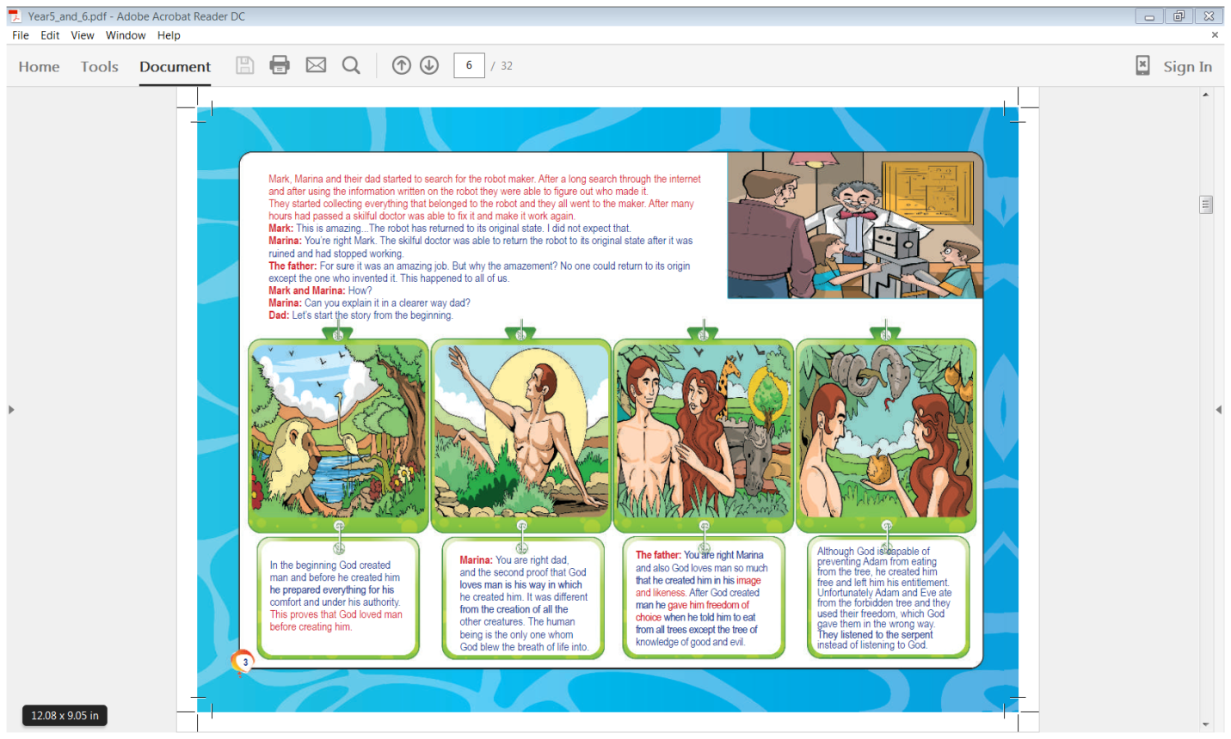day.*

*24Then God said, “Let the earth bring forth the living creature according to its kind: cattle and creeping thing and beast of the earth……… And God saw that it was good.*

*26Then God said, “Let Us make man in Our image, according to Our likeness; let them have dominion over the fish of the sea, over the birds of the air, and over the cattle, over all the earth and over every creeping thing that creeps on the earth.” 27So God created man in His own image; in the image of God He created him; male and female He created them. 28Then God blessed them, and God said to them, “Be fruitful and multiply; fill the earth and subdue it; have dominion over the fish of the sea, over the birds of the air, and over every living thing that moves on the earth.”*

*29And God said, “See, I have given you every herb that yields seed which is on the face of all the earth, and every tree whose fruit yields seed; to you it shall be for food. 30Also, to every beast of the earth, to every bird of the air, and to everything that creeps on the earth, in which there is life, I have given every green herb for food”; and it was so. 31Then God saw everything that He had made, and indeed it was very good. So the evening and the morning were the sixth day.*

**Question 1**

Complete the table by writing what God created on each day

|  |  |
| --- | --- |
| **Day** | **What God created** |
| **1** |  |
| **2** |  |
| **3** |  |
| **4** |  |
| **5** |  |
| **6** |  |

Verse

* Tuesday 7th July: Read **the passages below** and answer the questions:

**From St Mark’s Festival Book:**

….second proof that God loves man is his way in which he created him. It was different from the creation of all the other creatures. The human being is the only one whom God blew the breath of life into…….. God loves man so much that he created him in his image and likeness.

**From the Bible: Genesis 2:**

*7And the Lord God formed man of the dust of the ground, and breathed into his nostrils the breath of life; and man became a living being.………… 16And the Lord God commanded the man, saying, “Of every tree of the garden you may freely eat; 17but of the tree of the knowledge of good and evil you shall not eat, for in the day that you eat of it you shall surely die.”*

**Question 2**

1. God gave life to every creature by breathing into their nostrils. **True/False**
2. God said that Adam and Eve could eat from the tree of knowledge. **True/False**
3. Eating from the tree of Knowledge would let them know everything God knows **True/False**

**From the St Mark’s Festival Book:**

After God created man he gave him freedom of choice when he told him to eat from all trees except the tree of knowledge of good and evil.

**From the Bible: Genesis 2:**

*16And the Lord God commanded the man, saying, “Of every tree of the garden you may freely eat; 17but of the tree of the knowledge of good and evil you shall not eat, for in the day that you eat of it you shall surely die.”*

**Question 3**

1. God warned Adam and Eve if they ate from the tree of knowledge they will die. **True/False**
2. If Adam and Eve never ate from the tree of knowledge they would never die.

**True/False**

**From St Mark’s Festival Book:**

Although God is capable of preventing Adam from eating from the tree, he created him free and left him his entitlement. Unfortunately Adam and Eve ate from the forbidden tree and they used their freedom, which God gave them in the wrong way. They listened to the serpent instead of listening to God.

**From the Bible: Genesis 3:**

*****1Now the serpent was more cunning than any beast of the field which the Lord God had made. And he said to the woman, “Has God indeed said, ‘You shall not eat of every tree of the garden’?”*

*2And the woman said to the serpent, “We may eat the fruit of the trees of the garden; 3but of the fruit of the tree which is in the midst of the garden, God has said, ‘You shall not eat it, nor shall you touch it, lest you die.’”*

*4Then the serpent said to the woman, “You will not surely die. 5For God knows that in the day you eat of it your eyes will be opened, and you will be like God, knowing good and evil.”*

*6So when the woman saw that the tree was good for food, that it was pleasant to the eyes, and a tree desirable to make one wise, she took of its fruit and ate. She also gave to her husband with her, and he ate. 7Then the eyes of both of them were opened, and they knew that they were naked; and they sewed fig leaves together and made themselves coverings.*

**Question 4**

Write the name of the person who said the following statements.

|  |  |
| --- | --- |
| **Statement** | **Name of person** |
| *“We may eat the fruit of the trees of the garden;* |  |
| *“Has God indeed said, ‘You shall not eat of every tree of the garden’?”* |  |
| *‘You shall not eat it, nor shall you touch it, lest you die.’”* |  |
| *“You will not surely die. 5For God knows that in the day you eat of it your eyes will be opened, and you will be like God, knowing good and evil.”* |  |

That is why God did what he did when He judged them

“for in the day that you eat of it you shall surely die.”(Genesis 2:17).

That is how God condemned Adam and Eve and all their children after them to death.

Judgement of death fell on Adam, Eve and all their children. Consequences are:

* Separation from God
* Due to sin their nature was corrupted, they were condemned to death

**Question 5**

What is meant by the word condemned?

1. punishment
2. reward
3. surprise
4. forgiveness

**Question 6**

Which picture shows how Adam and Eve lived after they were condemned?

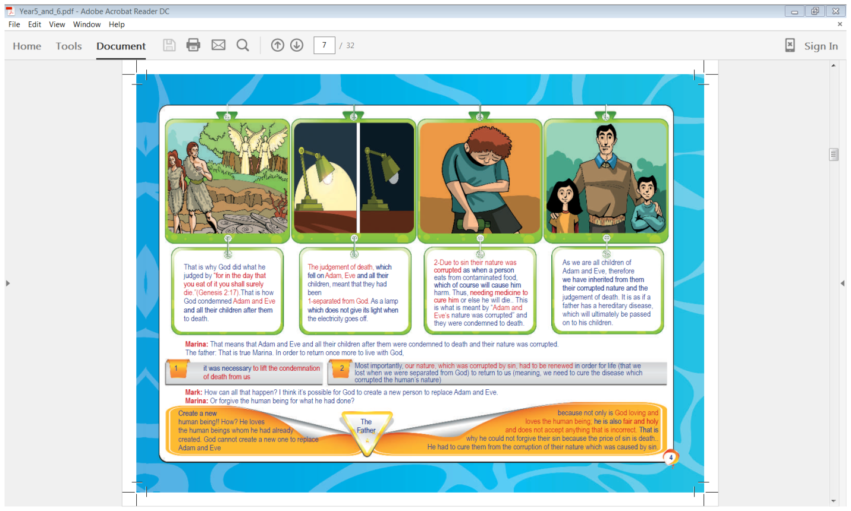**

**B**

**A**

* Wednesday 8th July: (page 5)

**How can we unite again with God?**

1. The condemnation of death, due to sin, must be lifted.
2. Our nature which was corrupted by sin must be renewed.

This would take place if there was a person who could die in our place in order to save us and pay our debt, but this person must have certain qualities which are:

* Must be human
* Must die in place of human kind
* Must be without sin
* Must not be confined (this means must be Eternal –always existed and will always exist)
* Must be a creator
* Must be stronger than death (must conquer death)

**Question 7**

There are reasons for the criteria (qualities) that a person must have to save humanity.

Match by copying/pasting the qualities listed above with the reason stated in the table.

|  |  |
| --- | --- |
| **Quality the person must have to save Humanity** | **Reason** |
|  | Because if he is sinful that means that he needs someone else to save him. |
|  | Because the human being is the one that sinned and the savior cannot be an angel or any other creature. |
|  | In order to be able to save all humanity in all  eras from Adam all the way through to the last person on earth. |
|  | In order to be able to renew the nature which was corrupted and return it to its first image which existed before sin. |
|  | In order to conquer death and destroy it. |
|  | In order to endure the sentence of death. |

**Question 8**

Romans 6:23 says “for the wages of sin is death”, which quality does this refer to?

**Question 9**

We would be saved if there was a person who is perfect, without sin, could die in our place.

Hint

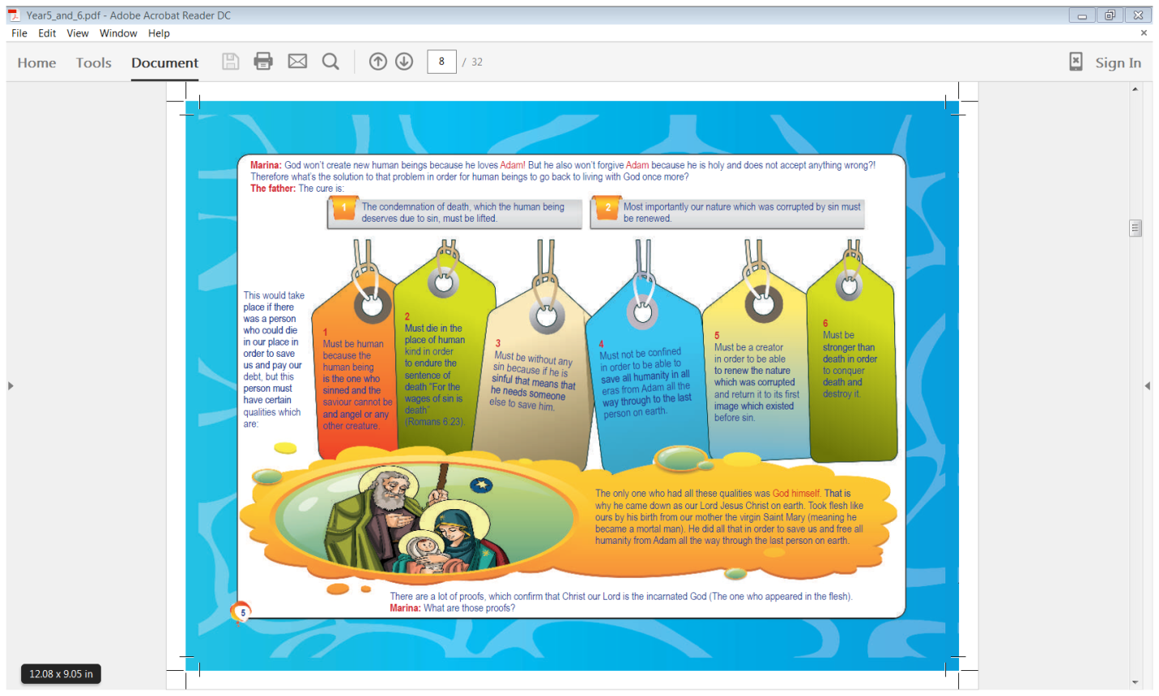

Name the only Person who is able to do this?

**What proof do we have that Christ our Lord is the incarnated God?**

**(God appeared in the flesh as Jesus).**

**The first proof:**

The prophecies of the Old Testament were fulfilled in the person of Christ our Lord.

**Question 10**

God reveals future events to people called

1. Priests
2. Prophets
3. Sinners
4. Poets

**Question 11**

Name one person who prophesised about the birth of Jesus?

**Question 12**

Match the following events with the picture:

Birth of Jesus, Crucifixion of Jesus, Resurrection of Jesus, Ascension of Jesus

|  |  |
| --- | --- |
| Event | Picture |
|  |  |
|  |  |
|  |  |
|  |  |

**Question 13**

Name the days in our church calendar we celebrate the events listed in Question 9:

Christmas, Easter Sunday, Good Friday, Ascension Thursday.

|  |  |
| --- | --- |
| **Event** | **Day in our Church Calendar** |
| Crucifixion of Jesus |  |
| Birth of Jesus |  |
| Ascension of Jesus |  |
| Resurrection of Jesus |  |

**Question 14**

Match the prophecies listed below to the fulfillment of the prophecy

* “Behold, the virgin shall conceive and bear a Son, and shall call His name Immanuel.” (Isaiah 7:14)
* “They pierced My hands and My feet;” (Psalms 22:16)
* “For You will not leave my soul in Sheol, Nor will You allow Your Holy One to see corruption.” (Psalms 16:10)
* “You have ascended on high, You have led captivity captive;”(Psalms 68:18)

|  |  |
| --- | --- |
| **Prophecy (Old Testament)** | **Fulfillment of Prophecy (New Testament)** |
|  | *33And when they had come to the place called Calvary, there they crucified Him, and the criminals, one on the right hand and the other on the left.*  **Luke 23:33** |
|  | *50And He led them out as far as Bethany, and He lifted up His hands and blessed them. 51Now it came to pass, while He blessed them, that He was parted from them and carried up into heaven.*  **Luke 24:50-51** |
|  | *6He is not here; for He is risen, as He said. Come, see the place where the Lord lay.*  **Mathew 28:6** |
|  | *18Now the birth of Jesus Christ was as follows: After His mother Mary was betrothed to Joseph, before they came together, she was found with child of the Holy Spirit.*  **Mathew1:18** |

* Thursday 9th July: Memorise the prophecies stated in the verses from last night’s homework. **(Page 6 from St Mark’s Festival Book)**

**Question 15**

Complete the sentences to help you learn:

1. “Behold, the virgin shall conceive and bear a Son, ” (Isaiah7:14)
2. “They pierced ;” (Psalms 22:16)
3. “For You will not leave my soul in Sheol, Nor will You allow

(Psalms 16:10)

1. “You have ascended on high, (Psalms 68:18)

**Do you know what Sheol means?**

When the Hebrew scriptures were translated into Greek the word "Hades" was substituted for **Sheol**.

* Friday 10th July: Memory verses

**Question 16**

Can you remember the memory verses you learnt last night? Check by completing the sentences.

1. and shall call His name Immanuel.”

(Isaiah 7:14)

1. My hands and My feet;” (Psalms 22:16)
2. Your Holy One to see

corruption.” (Psalms 16:10)

1. You have led captivity captive;”(Psalms 68:18)

* Saturday 27th June: **St Mark’s Festival Book page 7:**

**What is the SECOND proof we have that Christ our Lord is the incarnated God?**

**The second proof: Jesus said so!!!**

**Question 17**

**Practise looking up verses in the Bible**

### For this question I would like you to open a Bible you have at home and find the verses listed and copy into the table below. It is only one sentence. If you have trouble, ask your parents or an older brother or sister to help you. Please do not copy/paste from the Internet.

|  |  |
| --- | --- |
| Verse | Copy the verse from a Bible |
| John 8:56-68 |  |
| Matthew 28:20 |  |
| Matthew 16:27 |  |

**Question 18**

More than once Jesus said that He is everlasting, judge, and eternal.

**Do you know the difference between eternal and everlasting?**

God is Eternal, always was here and always will be here.

God’s promises, love etc are everlasting, He will never stop loving you and He will always keep His promises.

Identify which verse states God is

1. Everlasting?
2. Judge?
3. Eternal?

***What to do when you finish your Bible Study.***

1. ***Either send it by email to your class email address or print and hand it to your servants next Sunday.***
2. ***If you want to send your Bible Study by email, please select your class email address below:***

[stthomas6b1@gmail.com](mailto:stthomas6b1@gmail.com) Uncle George

[stpeter6b2@gmail.com](mailto:stpeter6b2@gmail.com) Uncle Mina

[stphilip6g@gmail.com](mailto:stphilip6g@gmail.com) Aunty Jacky

***Click on the following link to see how many points you have.***

**Year 6B1 (St Thomas)**  
[https://docs.google.com/spreadsheets/d/1B3hbaPWXLPr-bqV8YIabw159aKTkQlJ3I1pKK7mRhEI/edit?usp=sharing](https://webmail.meriden.nsw.edu.au/owa/redir.aspx?C=b6b7aaaa4ff64c008d6db035dc9d08cb&URL=https%3a%2f%2fdocs.google.com%2fspreadsheets%2fd%2f1B3hbaPWXLPr-bqV8YIabw159aKTkQlJ3I1pKK7mRhEI%2fedit%3fusp%3dsharing)

**Year 6B2 (St Peter)**

[https://docs.google.com/spreadsheets/d/1-3aY66NbtvgQdVxKQsLKIN32-mekY1UfV-fU-a6A3aE/edit?usp=sharing](https://webmail.meriden.nsw.edu.au/owa/redir.aspx?C=b6b7aaaa4ff64c008d6db035dc9d08cb&URL=https%3a%2f%2fdocs.google.com%2fspreadsheets%2fd%2f1-3aY66NbtvgQdVxKQsLKIN32-mekY1UfV-fU-a6A3aE%2fedit%3fusp%3dsharing)

**Year 6G (StPhilip)**

[https://docs.google.com/spreadsheets/d/1KKS7TLUdMux972uO8yehkyA-gpRY7so_qA22MaRSM-I/edit?usp=sharing](https://webmail.meriden.nsw.edu.au/owa/redir.aspx?C=b6b7aaaa4ff64c008d6db035dc9d08cb&URL=https%3a%2f%2fdocs.google.com%2fspreadsheets%2fd%2f1KKS7TLUdMux972uO8yehkyA-gpRY7so_qA22MaRSM-I%2fedit%3fusp%3dsharing)