C:\Documents and Settings\suzy\Local Settings\Temporary Internet Files\Content.IE5\3JXW24R5\MC900383922[1].wmfSunday 24th May, 2015

Name:

Class:

Finish Date: Saturday 30th May, 2015

Completed Bible Study = 15 points

Email Homework by the due date = 5 points

**Year 6 Bible Study John Chapter 15**

**For the questions below Highlight, underline or change the font colour to choose the correct answer.**

□ Monday 25th May: Read **John Chapter 15: 1-4** and answer the questions:

### The True Vine

*“I am the true vine, and My Father is the vinedresser. 2Every branch in Me that does not bear fruit He takes away;and every branch that bears fruit He prunes, that it may bear more fruit. 3You are already clean because of the word which I have spoken to you. 4Abide in Me, and I in you. As the branch cannot bear fruit of itself, unless it abides in the vine, neither can you, unless you abide in Me.*

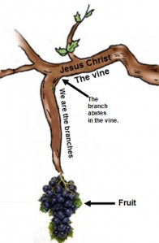**Do you know what a vinedresser is?**

*Put simply, a vinedresser is a farmer, but the only fruit that they look after is grapes. It is their job to care for each vine and nurture it, cutting it the appropriate amount at the appropriate times, fertilizing it, lifting its branches from the ground and supporting them, and taking measures to protect them from insects and disease*

***So how is Jesus the “true vine”***

*This means that Jesus is a vine (the main branch) of grapes that has been pruned well, and now gives life to other branches and bunches of grapes- He is perfect, and therefore, others can grow from Him.*

**Question 1**

What do you think the branches that do not bear fruit (and are taken away) symbolise?

**Question 2**

*‘every branch that bears fruit He prunes, that it may bear more fruit’ (Verse 2)*

Explain what sort of fruit we can bear so that God prunes (looks after) us more.

□ Tuesday 26th May: Read **John Chapter 15: 5-8** and answer the questions:

*5“I am the vine, you are the branches. He who abides in Me, and I in him, bears much fruit; for without Me you can do nothing. 6If anyone does not abide in Me, he is cast out as a branch and is withered; and they gather them and throw them into the fire, and they are burned. 7If you abide in Me, and My words abide in you, you will ask what you desire, and it shall be done for you. 8By this My Father is glorified, that you bear much fruit; so you will be My disciples.*

**Question 3**

Put the correct verse number under each image.

Choose from: beginning verse 6, end of verse 6, verse 8.

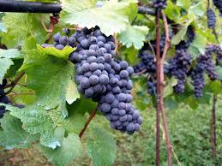 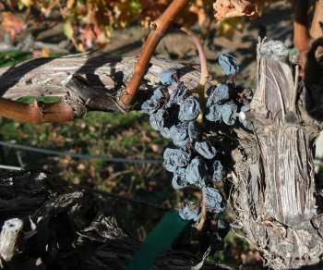 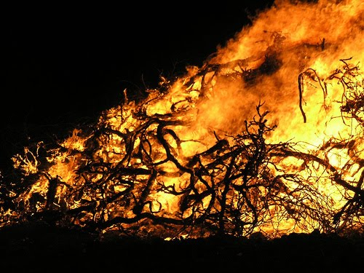

**Question 4**

**Highlight the correct words/ answer**

Without Jesus we *are/aren’t* nothing. I *can/can’t* do anything if Jesus is not with me. This is what Jesus told us in Chapter *14/15* verse *5/6.*

□ Wednesday 27th May: Read **John Chapter 15: 9-17** and answer the questions:

**Love and Joy Perfected**

*9“As the Father loved Me, I also have loved you; abide in My love. 10If you keep My commandments, you will abide in My love, just as I have kept My Father’s commandments and abide in His love.*

*11“These things I have spoken to you, that My joy may remain in you, and that your joy may be full. 12This is My commandment, that you love one another as I have loved you. 13Greater love has no one than this, than to lay down one’s life for his friends.*

*14You are My friends if you do whatever I command you. 15No longer do I call you servants, for a servant does not know what his master is doing; but I have called you friends, for all things that I heard from My Father I have made known to you.*

*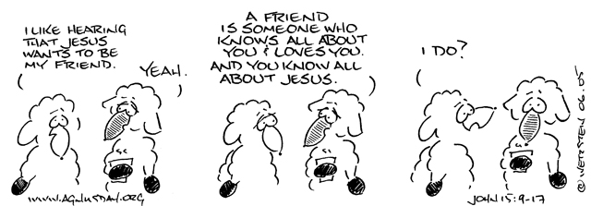16You did not choose Me, but I chose you and appointed you that you should go and bear fruit, and that your fruit should remain, that whatever you ask the Father in My name He may give you. 17These things I command you, that you love one another.*

**Question 5**

**True/ False**

1. Jesus did not keep the commandments of the Father True/ False
2. If we keep the commandments we abide in the love of God True/ False
3. Jesus did not command us to love one another in this passage True/ False
4. The greatest love is to give up our lives for our friends True/ Flase
5. We are the friends of Jesus True/ False

□ Thursday 28th May: Read **John Chapter 15 : 18-25** and answer the questions:

### The World’s Hatred

*18“If the world hates you, you know that it hated Me before it hated you. 19If you were of the world, the world would love its own. Yet because you are not of the world, but I chose you out of the world, therefore the world hates you. 20Remember the word that I said to you, ‘A servant is not greater than his master.’ If they persecuted Me, they will also persecute you. If they kept My word, they will keep yours also. 21But all these things they will do to you for My name’s sake, because they do not know Him who sent Me. 22If I had not come and spoken to them, they would have no sin, but now they have no excuse for their sin. 23He who hates Me hates My Father also. 24If I had not done among them the works which no one else did, they would have no sin; but now they have seen and also hated both Me and My Father. 25But this happened that the word might be fulfilled which is written in their law, ‘They hated Me without a cause.’*

**Question 7**

We are the servants of Jesus, this means that we are no greater than Him. What does the above passage say in reference to this? (HINT: Verse 20)

**Question 8**

Listen to the following hymn, and write down the verse which it relates to.

What is the main message of the hymn and the verse?

<https://www.youtube.com/watch?v=zplX5FDDuH0>

**Question 9**

Fill in the blanks

He who me, hates My also. (Verse 23)

□ Friday 29th May: Read **John Chapter 15: 26-27** and answer the questions:

### The Coming Rejection

*26“But when the Helper comes, whom I shall send to you from the Father, the Spirit of truth who proceeds from the Father, He will testify of Me. 27And you also will bear witness, because you have been with Me from the beginning.*

**Question 10**

Who is the Helper that will be sent?

a) Jesus

b) God the Father

c) The Saints

d) The Holy Spirit

**Question 11**

Who is the Spirit of truth?

a) Jesus

b) God the Father

c) The Saints

d) The Holy Spirit

**Question 12**

Match the words with the meaning: proceeds, testify and witness

|  |  |
| --- | --- |
| **Word** | **Meaning** |
|  | Prove, confirm |
|  | Comes from |
|  | Observer, support what Jesus did/say as true |

□ Saturday 30th May: Memory Verse: John Chapter 15:9

Write it in the Textbox below ( **Hint: Wednesday’s homework)**

***What to do when you finish your Bible Study.***

1. ***Either send it by email to your class email address or print and hand it to your servants next Sunday.***
2. ***If you want to send your Bible Study by email, please select your class email address below:***

[stthomas6b1@gmail.com](mailto:stthomas6b1@gmail.com) Uncle George

[stpeter6b2@gmail.com](mailto:stpeter6b2@gmail.com) Uncle Mina

[stphilip6g@gmail.com](mailto:stphilip6g@gmail.com) Aunty Jacky

***Click on the following link to see how many points you have.***

**Year 6B1 (St Thomas)**  
[https://docs.google.com/spreadsheets/d/1B3hbaPWXLPr-bqV8YIabw159aKTkQlJ3I1pKK7mRhEI/edit?usp=sharing](https://webmail.meriden.nsw.edu.au/owa/redir.aspx?C=b6b7aaaa4ff64c008d6db035dc9d08cb&URL=https%3a%2f%2fdocs.google.com%2fspreadsheets%2fd%2f1B3hbaPWXLPr-bqV8YIabw159aKTkQlJ3I1pKK7mRhEI%2fedit%3fusp%3dsharing" \t "_blank)

**Year 6B2 (St Peter)**

[https://docs.google.com/spreadsheets/d/1-3aY66NbtvgQdVxKQsLKIN32-mekY1UfV-fU-a6A3aE/edit?usp=sharing](https://webmail.meriden.nsw.edu.au/owa/redir.aspx?C=b6b7aaaa4ff64c008d6db035dc9d08cb&URL=https%3a%2f%2fdocs.google.com%2fspreadsheets%2fd%2f1-3aY66NbtvgQdVxKQsLKIN32-mekY1UfV-fU-a6A3aE%2fedit%3fusp%3dsharing" \t "_blank)

**Year 6G (StPhilip)**

[https://docs.google.com/spreadsheets/d/1KKS7TLUdMux972uO8yehkyA-gpRY7so\_qA22MaRSM-I/edit?usp=sharing](https://webmail.meriden.nsw.edu.au/owa/redir.aspx?C=b6b7aaaa4ff64c008d6db035dc9d08cb&URL=https%3a%2f%2fdocs.google.com%2fspreadsheets%2fd%2f1KKS7TLUdMux972uO8yehkyA-gpRY7so_qA22MaRSM-I%2fedit%3fusp%3dsharing" \t "_blank)