Handed out Sunday 3rd May
Name:
Class:
To be emailed back to your Bible Study servant by 9th May

Completed Bible Study = 15 points,
Emailed by the due date = 5 points

The GOSPEL according to St. John
Year 6 – Bible Study- John Chapter 12
- Monday 4th May Read John Chapter 12 verses 1 -10

The Anointing at Bethany
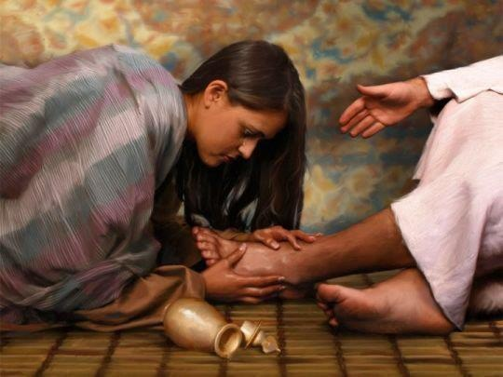
¹ Then, six days before the Passover, Jesus came to Bethany, where Lazarus was who had been dead, whom He had raised from the dead. ² There they made Him a supper; and Martha served, but Lazarus was one of those who sat at the table with Him. ³ Then Mary took a pound of very costly oil of spikenard, anointed the feet of Jesus, and wiped His feet with her hair. And the house was filled with the fragrance of the oil.
⁴ But one of His disciples, Judas Iscariot, Simon’s son, who would betray Him, said, ⁵ “Why was this fragrant oil not sold for three hundred denarii and given to the poor?” ⁶ This he said, not that he cared for the poor, but because he was a thief, and had the moneybox; and he used to take what was put in it.
⁷ But Jesus said, “Let her alone; she has kept this for the day of My burial. ⁸ For the poor you have with you always, but Me you do not have always.”

Question 1
Choose the word that best matches the definition
A liquid produced and sold for its pleasant smell
a) hair b) feet c) Judas d) perfume
The part of the body on which a person stands
a) hair b) Judas c) feet d) poor
The disciple who betrayed Jesus
a) Peter b) Andrew c) John d) Judas
The woman who poured Spikenard on the feet of Jesus
a) Elizabeth b) Mary c) Lydia d) Ruth

The Plot to Kill Lazarus
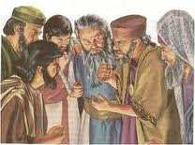
⁹ Now a great many of the Jews knew that He was there; and they came, not for Jesus’ sake only, but that they might also see Lazarus, whom He had raised from the dead. ¹⁰ But the chief priests plotted to put Lazarus to death also, ¹¹ because on account of him many of the Jews went away and believed in Jesus.
Question 2
What did many of the Jews do after they saw the resurrection of Lazarus?

- Tuesday 5th May Read John Chapter 12 verses 12-19

The Triumphal Entry
¹² The next day a great multitude that had come to the feast, when they heard that Jesus was coming to Jerusalem, ¹³ took branches of palm trees and went out to meet Him, and cried out:
“Hosanna!
‘Blessed is He who comes in the name of the Lord!’
The King of Israel!”
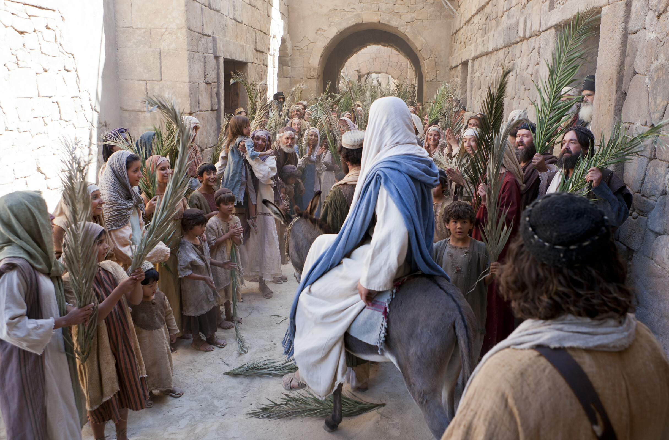
¹⁴ Then Jesus, when He had found a young donkey, sat on it; as it is written:

¹⁵ “Fear not, daughter of Zion;
Behold, your King is coming,
Sitting on a donkey’s colt.”
¹⁶ His disciples did not understand these things at first; but when Jesus was glorified, then they remembered that these things were written about Him and that they had done these things to Him.
¹⁷ Therefore the people, who were with Him when He called Lazarus out of his tomb and raised him from the dead, bore witness. ¹⁸ For this reason the people also met Him, because they heard that He had done this sign. ¹⁹ The Pharisees therefore said among themselves, “You see that you are accomplishing nothing. Look, the world has gone after Him!”
Question 3
Why did the people bring branches of Palm trees to meet Jesus?

Question 4
Verse 16 tells us that the disciples did not understand what had happened until Jesus was glorified. What event are they talking about when they say “when Jesus was glorified?”

Question 5
What do the Pharisees mean when they say “look, the world has gone after Him?” Do we, as people of the world, go after Jesus? Why or why not?

- Wednesday 6th May Read John Chapter 12 verses 20-26

The Fruitful Grain of Wheat
²⁰ Now there were certain Greeks among those who came up to worship at the feast. ²¹ Then they came to Philip, who was from Bethsaida of Galilee, and asked him, saying, “Sir, we wish to see Jesus.”
²² Philip came and told Andrew, and in turn Andrew and Philip told Jesus.
²³ But Jesus answered them, saying, “The hour has come that the Son of Man should be glorified. ²⁴ Most assuredly, I say to you, unless a grain of wheat falls into the ground and dies, it remains alone; but if it dies, it produces much grain. ²⁵ He who loves his life will lose it, and he who hates his life in this world will keep it for eternal life. ²⁶ If anyone serves Me, let him follow Me; and where I am, there My servant
will be also. If anyone serves Me, him My Father will honour.
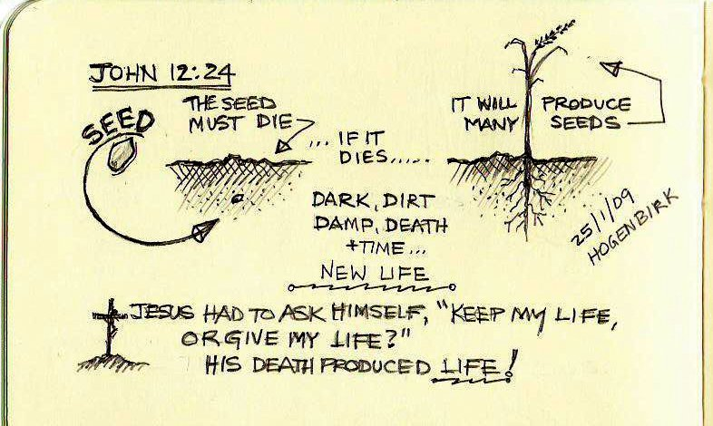
Question 6
Fill in the blanks

He who His life will it, and he who hates his

life in this world will keep it for (Verse 25)

Question 7
In Verse 24, Jesus says that a grain can only grow after it dies and is buried into the ground. Who is He likening the grain to?
a) Judas
b) Himself (Jesus)
c) Phillip
d) Andrew

- Thursday 7th May Read John Chapter 12 verses 27-36

Jesus Predicts His Death on the Cross
²⁷ “Now My soul is troubled, and what shall I say? ‘Father, save Me from this hour’? But for this purpose I came to this hour. ²⁸ Father, glorify Your name.”
Then a voice came from heaven, saying, “I have both glorified it and will glorify it again.”
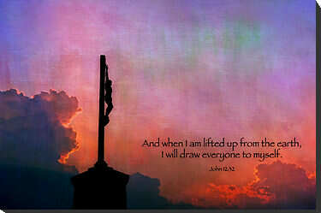
²⁹ Therefore the people who stood by and heard it said that it had thundered. Others said, “An angel has spoken to Him.”
³⁰ Jesus answered and said, “This voice did not come because of Me, but for your sake. ³¹ Now is the judgment of this world; now the ruler of this world will be cast out. ³² And I, if I am lifted up from the earth, will draw all peoples to Myself.” ³³ This He said, signifying by what death He would die.
³⁴ The people answered Him, “We have heard from the law that the Christ remains forever; and how can You say, ‘The Son of Man must be lifted up’? Who is this Son of Man?”
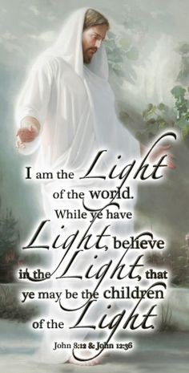
³⁵ Then Jesus said to them, “A little while longer the light is with you. Walk while you have the light, lest darkness overtake you; he who walks in darkness does not know where he is going. ³⁶ While you have the light, believe in the light, that you may become sons of light.” These things Jesus spoke, and departed, and was hidden from them.
Question 8
In verse 29, who was actually speaking to Jesus?
- Thunder
- God the Father
- Holy Spirit
- The disciples

Question 9
True or False
a) Jesus was very comfortable with the persecutions that faced him? True/ False
b) The Son of Man being lifted up refers to Jesus dying on the cross? True / False
c) Jesus is the light that walks with us? True/False

- Friday 8th May Read John Chapter 12 verses 37-41

Who Has Believed Our Report?
³⁷ But although He had done so many signs before them, they did not believe in Him, ³⁸ that the word of Isaiah the prophet might be fulfilled, which he spoke:
“Lord, who has believed our report?
And to whom has the arm of the Lord been revealed?”

³⁹ Therefore they could not believe, because Isaiah said again:
⁴⁰ “He has blinded their eyes and hardened their hearts,
Lest they should see with their eyes,
Lest they should understand with their hearts and turn,
So that I should heal them.”
⁴¹ These things Isaiah said when he saw His glory and spoke of Him.

Question 10
Where does the prophecy come from that foretold that the Jewish people would not believe in Jesus even after He completed many signs?

- Saturday 9th May Read John Chapter 12 verses 42-50

Walk in the Light
⁴² Nevertheless even among the rulers many believed in Him, but because of the Pharisees they did not confess Him, lest they should be put out of the synagogue; ⁴³ for they loved the praise of men more than the praise of God.
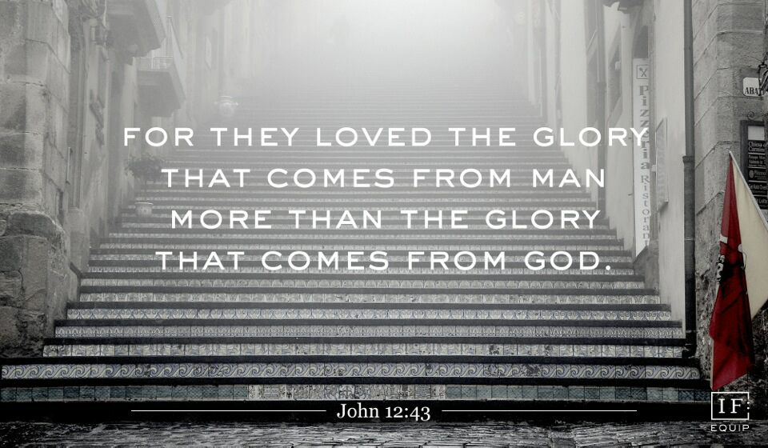
⁴⁴ Then Jesus cried out and said, “He who believes in Me, believes not in Me but in Him who sent Me. ⁴⁵ And he who sees Me sees Him who sent Me. ⁴⁶ I have come as a light into the world, that whoever believes in Me should not abide in darkness. ⁴⁷ And if anyone hears My words and does not believe, I do not judge him; for I did not come to judge the world but to save the world. ⁴⁸ He who rejects Me, and does not receive My words, has that which judges him—the word that I have spoken will judge him in the last day. ⁴⁹ For I have not spoken on My own authority; but the Father who sent Me gave Me a command, what I should say and what I should speak. ⁵⁰ And I know that His command is everlasting life. Therefore, whatever I speak, just as the Father has told Me, so I speak.”

Question 11
Do you think that you listen to the praise of men enough to persuade you away from following Jesus and listening to Him? What is more important for you?

Question 12
According to verse 47, what was the reason that Jesus came into the world?

PARENTS SECTION:
We kindly ask you as a parent to read (a little each day) in the Holy Bible with your family.
Now email your answers to your teacher, choose ONE of the email addresses below.
stthomas6b1@gmail.com Uncle George
stpeter6b2@gmail.com Uncle Mina or

stphilip6g@gmail.com Aunty Jacky

Click on the following link to see how many points you have.
Year 6B1 (St Thomas)
https://docs.google.com/spreadsheets/d/1B3hbaPWXLPr-bqV8YIabw159aKTkQlJ3I1pKK7mRhEI/edit?usp=sharing
Year 6B2 (St Peter)
https://docs.google.com/spreadsheets/d/1-3aY66NbtvgQdVxKQsLKIN32-mekY1UfV-fU-a6A3aE/edit?usp=sharing
Year 6G (StPhilip)
https://docs.google.com/spreadsheets/d/1KKS7TLUdMux972uO8yehkyA-gpRY7so_qA22MaRSM-I/edit?usp=sharing

