The GOSPEL according to St. JOHN
YEAR 6 Holy Bible Study, 2008

Name:
Class:

Chapter 7

- In chapter 7, John mentions that the Jews’ Feast was at hand, what was this feast and what did Jesus do at the time of this feast?

………………………………………………………………………………………………………………………………………………………………………………………………………………………………………………………………………………………………………

- Fill in the blank:
There was much debate amongst the Jews as to whether Jesus was the Christ. John records this discussion as follows: “Others said, ‘This is the Christ.’ But some said, ‘Will the Christ come out of Galilee? ‘Has not the Scripture said that the Christ comes from the seed of David and from the town of …………………., where David was?”

- Complete the cross word below:
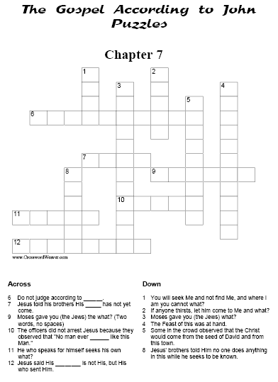

Chapter 8

- What was the reaction of our Lord Jesus Christ when they brought to Him the adulterous woman? Can you apply this to yourself when you hear of someone who did something wrong? ....................................................................................................................................................................................................................................................................................................................................................................................................................................................................................................................................................

- Fill in the blank:
In chapter 8, After all of the accusers of the adulterous women left, Jesus said to her, “Woman, where are those accusers of yours? Has no one condemned you?’ She said,‘No one Lord.’ And Jesus said to her, ‘Neither do I condemn you; go and …………………no more.

- Who does Jesus say is a slave to sin? (Circle one of the following)
a. whosoever commits a sin;
b. those who seek money;.
c. those who do not follow the law

- Look at verse 31, “If you abide in my word, you are my disciples indeed.” What do you think this means?

...............................................................................................................................................................................................................................................................................................................................................................................................................

- How can we abide in God’s word?

.............................................................................................................................................................................................................................................................................................................................................................................................................

