

**15 Points**

**The GOSPEL according to St. JOHN**

**YEAR 6 Holy Bible Study**

*Christ’s Prayer Betrayal, Arrest and Trial*

**Chapter 17**

1. **What work does Jesus Christ refer to as ‘finished’ in His prayer in verse 4?**

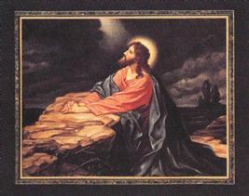___________________________________________________________________ ___________________________________________________________________ _____________________________________________________

1. **Who is Jesus referring to as the “son of perdition” in John 17:12? ______________________________________**
2. **What was Jesus’s final request from God? (Hint: Verse 24 onwards). What can we do in our daily lives to perform just that?** _____________________________________________________________

__________________________________________________________________

__________________________________________________________________

**Chapter 18**

1. **Who am I? (Please Name the following people)**
   1. 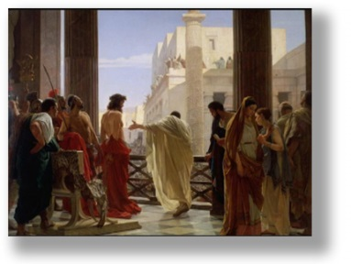***The soldier whose ear was cut off ___________________***
   2. ***The high priest the at year _____________________***
   3. ***The father-in-law of the high priest __________________***
   4. ***“another disciple” in John 18:15 ____________________***
2. **How many angels would be in 12 legions? _________________**
3. **What does Christ mean by His ‘kingdom’ in verse 36 when He replies to Pilot?**

**___________________________________________________________________ ___________________________________________________________________**

1. **Pontius Pilate saw Jesus as innocent and did not want to crucify him, what did**

**he try to do to avoid crucifying Christ? Did it work?**

**___________________________________________________________________ ___________________________________________________________________**

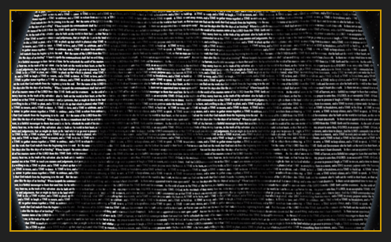

**Daily Readings:**

|  |  |  |
| --- | --- | --- |
| **Day** | **Reading** | **Tick** |
| Sunday | **John 17: 1-19** |  |
| Monday | **John 17: 20-26** |  |
| Tuesday | **John 18: 1-11** |  |
| Wednesday | **John 18: 12-27** |  |
| Thursday | **John 18: 28-40** |  |
| Friday | **BS complete☺** |  |

**PARENTS SECTION:**

This section is for the parents to sign the Holy Bible Study sheet.

X____________________

We kindly ask you as a parent to read (a little each day) in the Holy Bible with your family.

You may wish to read ay School.

P lease let us know below what you’re reading with your child and if you have any questions.