

**15 Points**

**The GOSPEL according to St. JOHN**

**YEAR 6 Holy Bible Study**

**Memory Verse:**

**“In the world you will have tribulation; but be of good cheer, I have overcome the world” John 16:33**

**Chapter 15**

1. 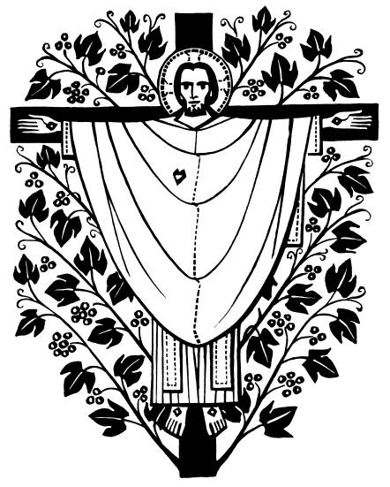***What do we have to do "bear fruit" (John 15:4) for God?***

________________________________________________________________________________________________________________

1. ***Our Lord Jesus gave his disciples and us a special commandment in this chapter. What commandment was that and in which verse was it mentioned?***

___________________________________________________________________ ___________________________________________________________________ ___________________________________________________________________

1. ***Jesus tells His disciples that He no longer calls them servants, what is the difference between a servant and his master? The Lord Jesus calls us (His disciples) friends, what privilege does that give us?***

___________________________________________________________________ ___________________________________________________________________ ___________________________________________________________________

**Chapter 16**

1. ***In verse 2, what did Jesus mean when he said “They will put you out of the synagogues” ? What can be a modern day example of being “put out of the synagogues” for our beliefs?***

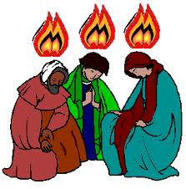___________________________________________________________________ ___________________________________________________________________ ________________________________________________________

1. ***Jesus speaks of the “Spirit of truth” in verse 13, who or what is that and on whose authority will He speak?***

________________________________________________________________________________________________________________

**Daily Readings:**

|  |  |  |
| --- | --- | --- |
| **Day** | **Reading** | **Tick** |
| Sunday | **John 15: 1-17** |  |
| Monday | **John 15: 18-27** |  |
| Tuesday | **John 16: 1-15** |  |
| Wednesday | **John 16: 16-24** |  |
| Thursday | **John 16: 25-33** |  |
| Friday | **BS complete☺** |  |

**PARENTS SECTION:**

This section is for the parents to sign the Holy Bible Study sheet.

X____________________

We kindly ask you as a parent to read (a little each day) in the Holy Bible with your family.

You may wish to read ay School.

P lease let us know below what you’re reading with your child and if you have any questions.