

**15 Points**

**The GOSPEL according to St. JOHN**

**YEAR 6 Holy Bible Study**

**Memory Verse:**

**“In my Father’s house are many mansions; if it were not so, I would have told you. I go to prepare a place for you. And if I go and prepare a place for you, I will come again and receive you to Myself; that where I am, there you may be also” John 14:2-3**

**Chapter 13**

1. ***Why did they celebrate the feast of the Passover? And how does it link to Christ?***

___________________________________________________________________ ___________________________________________________________________ ___________________________________________________________________

1. ***Why did Jesus choose to wash His disciples’ feet? What does it symbolise?***

___________________________________________________________________ ___________________________________________________________________ ___________________________________________________________________

**Chapter 14**

1. ***Why has anyone who has seen Christ, seen the Father? (14:7-11)***

___________________________________________________________________ ___________________________________________________________________ ___________________________________________________________________

1. ***In verse 14, Jesus speaks of sending a ‘Helper’, who is He referring to?***

___________________________________________________________________

1. ***In these two chapters there are a lot of different themes. Find at least one reference, themes listed below:***
   1. *Baptism:**_____________________________*_*__________________________*
   2. *The Trinity: _______________________________________________________*
   3. *Pentecost*: *_______________________________________________________*

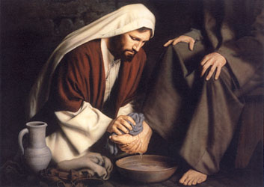

* 1. *Prophesies of Christ’s betrayal*: ________________

________________________________________

* 1. *Prophesies of what is to come after Christ’s departure:* ­­­­­­­­­­­­__________________________________

___________________________________________

**Daily Readings:**

|  |  |  |
| --- | --- | --- |
| **Day** | **Reading** | **Tick** |
| Sunday | **John 13: 1-20** |  |
| Monday | **John 13: 21-30** |  |
| Tuesday | **John 13: 31-38** |  |
| Wednesday | **John 14: 1-14** |  |
| Thursday | **John 14: 15-31** |  |
| Friday | **BS complete☺** |  |

**PARENTS SECTION:**

This section is for the parents to sign the Holy Bible Study sheet.

X____________________

We kindly ask you as a parent to read (a little each day) in the Holy Bible with your family.

You may wish to read ay School.

P lease let us know below what you’re reading with your child and if you have any questions.