MC900383922[1]Sunday 12th July, 2015

Name:

Class:

Finish Date: Saturday 18th July, 2015

Completed Bible Study = 15 points

Homework handed in by the due date = 5 points

Homework handed in as a hard copy and answers are hand written = 10 points

**Year 5 Memorisation homework**

For the festival you are required to learn the following memory verses. These will be tested in a written examination on Saturday 15th August.

If you are not enrolled in the festival you are also expected to do your best to learn the verses. This will replace your regular Bible Study homework.

* **Isaiah 7:14**
* **Psalm 22:16**
* **Psalm 16:10**
* **Psalm 68:18**
* **2 Timothy 3:16**
* **Matthew 28:19-20**
* **2 Peter 1 :21**
* **1Corinthians 14:26**
* **Joshua 1:5**
* **Matthew 21:22**
* **Psalm 142**
* **Prayer From 6th hour Agpeya Prayers**
* **Monday 13th July Read the verses then answer the questions that follow**

**Part 1: My Faith is strong and steady**

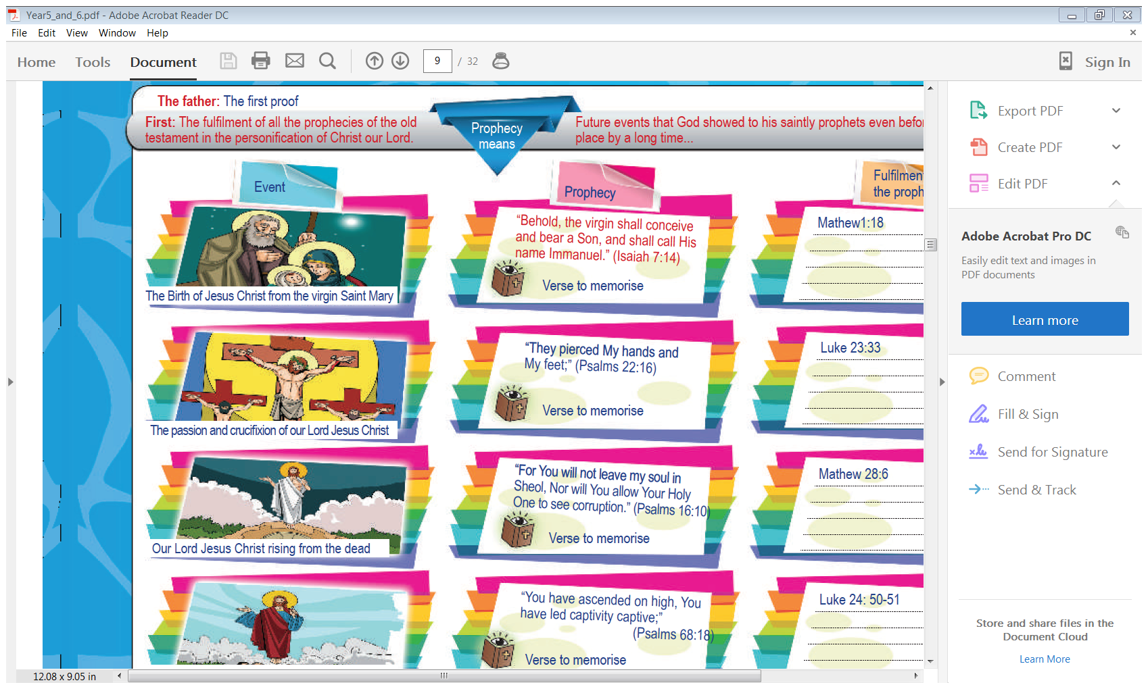 **Memory verses: Isaiah7:14, Psalm 22:16, Psalm 16:10, Psalm 68:18**

***“Behold, the virgin shall conceive and bear a Son, and shall call His name Immanuel.” (Isaiah 7:14)***

***“They pierced My hands and My feet;” (Psalm 22:16)***

***“For You will not leave my soul in Sheol, Nor will You allow Your Holy One to see corruption.” (Psalm 16:10)***

***“You have ascended on high, You have led captivity captive;” (Psalm 68:18)***

**Question 1**

Complete the table by finishing the sentences

|  |  |
| --- | --- |
| “Behold, the virgin shall conceive and bear a Son |  |
| “They pierced My hands |  |
| “For You will not leave my soul in Sheol, |  |
| “You have ascended on high, |  |

And again,

|  |  |
| --- | --- |
|  | and shall call His name Immanuel.” |
|  | and My feet;” |
|  | Nor will You allow Your Holy One to see corruption.” |
|  | You have led captivity captive;” |

**Question 2**

Complete each word in the sentence. Each box contains only one word. Some words have been added or the first letter of the word has been done for you. Boxes shaded in yellow do not have any words or they have been completed for you.

|  |  |  |  |  |  |  |  |  |  |  |
| --- | --- | --- | --- | --- | --- | --- | --- | --- | --- | --- |
| **Isaiah 7:14** | Behold | a | v | shall | c | a | bear | a | Son |  |
|  | And | c | H | name | I |  |  |  |  |  |
| **Psalm 22:16** | T | pierced | m | hands | a | m | f |  |  |  |
| **Psalm 16:10** | If | y | w | not | l | m | s | i | Sheol |  |
|  | Nor | w | Y | a | Your | H | O | t | s | corruption |
| **Psalm 68:18** | Y | have | ascended | o | h | You | h | l | captivity | c |

**Question 3**

Complete the sentences to help you learn:

a) “Behold, the virgin shall conceive and bear a Son,

”

**(Isaiah7:14)**

b) “They pierced

;” **(Psalm 22:16)**

c) “For You will not leave my soul in Sheol, Nor will You allow

**(Psalms 16:10)**

d) “You have ascended on high,

**(Psalms 68:18)**

**Do you know what Sheol means?**

When the Hebrew scriptures were translated into Greek the word "Hades" was substituted for **Sheol**.

**Question 4**

Can you remember the memory verses you learnt last night? Check by completing the sentences.

1. and shall call His name Immanuel.”

**(Isaiah 7:14)**

1. My hands and my feet,” **(Psalm 22:16)**
2. Your Holy one to see

corruption.” **(Psalms 16:10)**

1. You have led captivity captive” **(Psalm 68:18)**

* **Tuesday 14th July Read the verses then answer the questions that follow**

**Part 2: My Book is dear and precious**

**

**Memory verse: 2 Timothy 3:16**

***“All Scripture is given by inspiration of God, and is profitable for doctrine, for reproof, for correction, for instruction in righteousness.”***

**Question 5:**

Match the following words/phrases to their meaning.

Scripture, inspiration of God, profitable for doctrine, reproof, for correction, instruction in righteousness.

|  |  |
| --- | --- |
| **Word/phrase** | **Meaning** |
|  | Holy Bible |
|  | is useful for teaching God’s word |
|  | To show how to change bad behaviour into good behaviour pleasing to God |
|  | Warning, talking to, rebuke, reprimand, discipline. |
|  | The Word of God is given to you to learn how to be blameless and avoid sin. Study and apply God’s word to help you to be honest and good. |
|  | Given by God. It is from God's heart and His mind to the writers |

**Question 6**

Fill in the missing words

1. and is profitable for doctrine, for reproof, for correction, for instruction in righteousness.”
2. “All Scripture is given by inspiration of God,

**Question 7**

Complete each word in the sentence. Each box contains only one word. The first letter of each word, and the first and last word in each line has been done for you. Boxes shaded in yellow do not have any words.

|  |  |  |  |  |  |  |  |  |
| --- | --- | --- | --- | --- | --- | --- | --- | --- |
| All | s | h | b | g | b | i | o | God |
| and | i | p | f | d | f | reproof |  |  |
| for | c | i | i | righteouness |  |  |  |  |

* **Wednesday 15th July Read the verses then answer the questions that follow**

****Memory verse: Matthew 28:19-20**

***"Go therefore and make disciples of all the nations, baptizing them to observe all things that I have commanded you; and lo, I am with you always, even to the end of the age.”***

**Question 8**

After you have spent time learning the verse put the sentences in the correct order by numbering the phrases 1 to 5

baptizing them to observe all things

and lo, I am with you always

even to the end of the age

that I have commanded you;

Go therefore and make disciples of all the nations

**Question 9**

Complete the table by finishing the sentences

|  |  |
| --- | --- |
| "Go therefore and make disciples |  |
| baptizing them to observe |  |
| and lo, I am with you always |  |

And again,

|  |  |
| --- | --- |
|  | of all the nations, |
|  | all things that I have commanded you |
|  | and lo, I am with you always |

* **Thursday 16th July Revision of verses.**

**Question 10**

Complete the verses in the table. The first two words have been done for you to trigger your memory

|  |  |
| --- | --- |
| **Matthew 28:19-20** | Go therefore |
| **2 Timothy 3:16** | All Scripture |
| **(Isaiah 7:14)** | Behold, the |
| **(Psalm 22:16)** | “They pierced |
| **(Psalm 68:18)** | “You have |
| **(Psalm 16:10)** | “For You |

Suggestion: If you got any of the verses wrong go back and learn them again.

* **Friday 17th July Revision of verses.**

**Question 11**

Complete the verses in the table. This time try and remember them without any hints.

|  |  |
| --- | --- |
| **Matthew 28:19-20** |  |
| **2 Timothy 3:16** |  |
| **(Isaiah 7:14)** |  |
| **(Psalm 22:16)** |  |
| **(Psalm 68:18)** |  |
| **(Psalm 16:10)** |  |

* **Saturday 18th July**

**Question 12**

Can you remember the Bible references? Complete the table to test yourself.

|  |  |
| --- | --- |
| **Bible Reference** | **Bible Verse** |
|  | “You have ascended on high, You have led captivity captive;” |
|  | "Go therefore and make disciples of all the nations, baptizing them to observe all things that I have commanded you; and lo, I am with you always, even to the end of the age.” |
|  | “For You will not leave my soul in Sheol, Nor will You allow Your Holy One to see corruption.” |
|  | “Behold, the virgin shall conceive and bear a Son, and shall call His name Immanuel.” |
|  | “All Scripture is given by inspiration of God, and is profitable for doctrine, for reproof, for correction, for instruction in righteousness.” |
|  | “They pierced My hands and My feet;” |

***What to do when you finish your memorisation***

***Hand in a hard copy of the study to your Bible Study servants next Sunday.***

***Click on the following link to see how many points you have.***

***Click on the following link to see how many points you have.***

**Year 5B1 (St Matthew)**

[https://docs.google.com/spreadsheets/d/1YPfk0C0NBJv0XfLlXzhWewt5SbZHkTAmmAVEaydaUYo/edit?usp=sharing](https://webmail.meriden.nsw.edu.au/owa/redir.aspx?C=88057cf25a174c15b69cd7e5055a667f&URL=https%3a%2f%2fdocs.google.com%2fspreadsheets%2fd%2f1YPfk0C0NBJv0XfLlXzhWewt5SbZHkTAmmAVEaydaUYo%2fedit%3fusp%3dsharing)  
**Year 5B2 (St Mark)**

[https://docs.google.com/spreadsheets/d/1IU-qPhJOybm8AH80BISZtK-OVRM-f7DXrPzkonxcraU/edit?usp=sharing](https://webmail.meriden.nsw.edu.au/owa/redir.aspx?C=88057cf25a174c15b69cd7e5055a667f&URL=https%3a%2f%2fdocs.google.com%2fspreadsheets%2fd%2f1IU-qPhJOybm8AH80BISZtK-OVRM-f7DXrPzkonxcraU%2fedit%3fusp%3dsharing)

**Year 5G1 (St Luke)**

[https://docs.google.com/spreadsheets/d/1S9gmI4ZC4ctLiJjYsJGXg_p__H28tM8WXGWcHD8OBKc/edit?usp=sharing](https://webmail.meriden.nsw.edu.au/owa/redir.aspx?C=88057cf25a174c15b69cd7e5055a667f&URL=https%3a%2f%2fdocs.google.com%2fspreadsheets%2fd%2f1S9gmI4ZC4ctLiJjYsJGXg_p__H28tM8WXGWcHD8OBKc%2fedit%3fusp%3dsharing)

**Year 5G2 (St John)**

[https://docs.google.com/spreadsheets/d/1rlhsNVFRZ_MQ00H8UVw1Xb2kvxPZhKiZgdpHZZ9zZtY/edit?usp=sharing](https://webmail.meriden.nsw.edu.au/owa/redir.aspx?C=88057cf25a174c15b69cd7e5055a667f&URL=https%3a%2f%2fdocs.google.com%2fspreadsheets%2fd%2f1rlhsNVFRZ_MQ00H8UVw1Xb2kvxPZhKiZgdpHZZ9zZtY%2fedit%3fusp%3dsharing)