Handed out Sunday 17th May

Name:

Class:

To be emailed back to your Bible Study servant by 23th May

Completed Bible Study = 15 points,

Emailed by the due date = 5 points http://www.timshen.truepath.com/christian/goldcrosswhite.gif

**The GOSPEL according to St. Matthew**

**Year 5 – Bible Study- Matthew Chapter 13 Part 2**

* **Monday 18th May Read Matthew Chapter 13 verses 36 – 43**

### The Parable of the Tares Explained

*36Then Jesus sent the multitude away and went into the house. And His disciples came to Him, saying, “Explain to us the parable of the tares of the field.”*

*37He answered and said to them: “He who sows the good seed is the Son of Man. 38The field is the world, the good seeds are the sons of the kingdom, but the tares are the sons of the wicked one. 39The enemy who sowed them is the devil, the harvest is the end of the age, and the reapers are the angels. 40Therefore as the tares are gathered and burned in the fire, so it will be at the end of this age. 41The Son of Man will send out His angels, and they will gather out of His kingdom all things that offend, and those who practice lawlessness, 42and will cast them into the furnace of fire. There will be wailing and gnashing of teeth. 43Then the righteous will shine forth as the sun in the kingdom of their Father. He who has ears to hear, let him hear!*

**Question 1**

Do you remember the parable of the Tares? It was last Thursday night’s homework Matthew Chapter 13 verses 24-30.

Which label identifies the tare, good wheat?

Tare

Good wheat

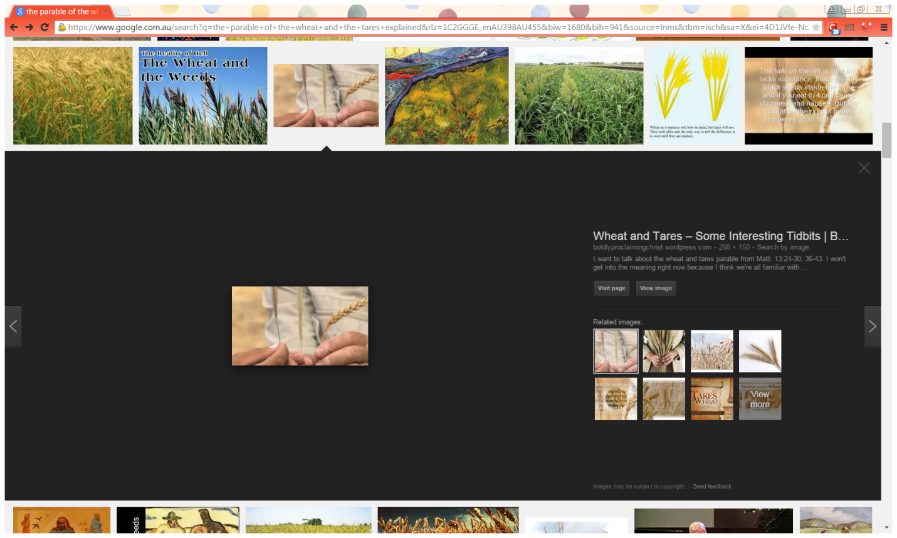

A

B

C

**Question 2**

Fill in the words from the list below to the meaning:

Good seeds, the harvest, the field, the tares, enemy, reapers

|  |  |
| --- | --- |
| **Word** | **Meaning** |
|  | the sons of the wicked one |
|  | The world |
|  | The devil |
|  | the end of the age (*the time of judgement*) |
|  | the sons of the kingdom |
|  | Angels |

* **Tuesday 19th May Read Matthew Chapter 13 verse 44**

### The Parable of the Hidden Treasure

### Question 3

### For this question I would like you to open a Bible you have at home and find the verse Matthew Chapter 13 verse 44, and copy into the textbox below. It is only one sentence. If you have trouble, ask your parents or an older brother or sister to help you.

### *HINT: New Testament, first Book (Matthew)*

**Do you understand what this hidden treasure is?**

*Treasure is something that is of great value to you.  There are many things in life that we treasure, but the Bible teaches us that Heaven is the greatest treasure that there is.  As Christians, we should be willing to give up all of our treasures so that we can have Heaven instead.  Heaven is the very best thing in the world.*

*The Bible teaches us that there is no greater treasure than Heaven.  Heaven is better than the best thing that you can imagine.*

*The Bible teaches us that Heaven is like buried treasure hidden in a field.  Heaven is hard to find.  Only Christians will get to go to Heaven someday.  To be a Christian you must believe that God is real and ask forgiveness for your sins so that God can forgive you, and you must be willing to give up everything in your life to follow God.*

*Being a Christian in this world is sometimes hard.  We have to give up things of the Earth.*

*God is in Heaven and will be there in all of His glory. We will be able to praise Him all day long.  There will be so sadness or pain in Heaven.  There will be great joy. It is better than anything that we can imagine.*

* **Wednesday 20th May Read Matthew Chapter 13 verses 45-46**

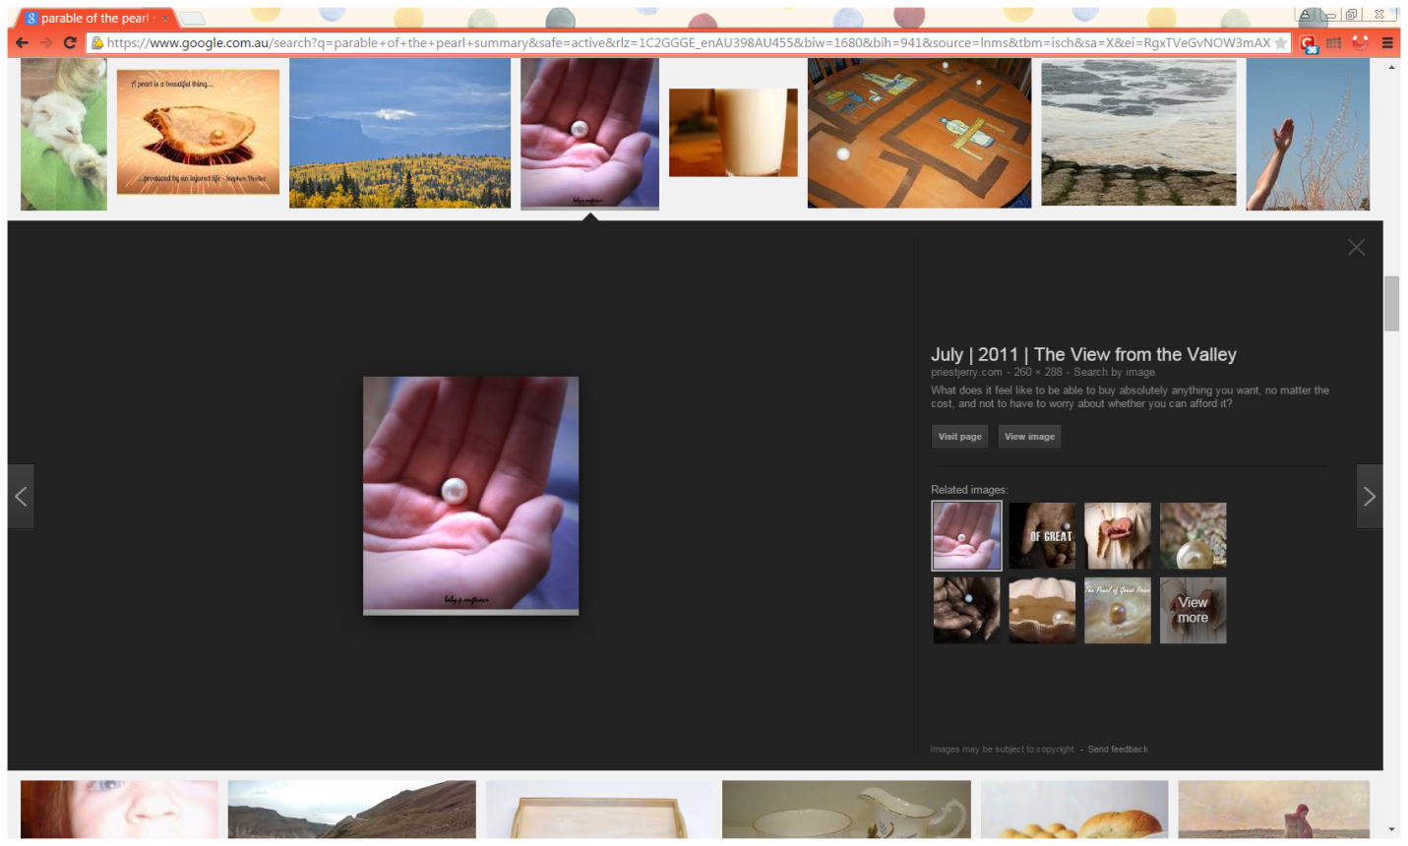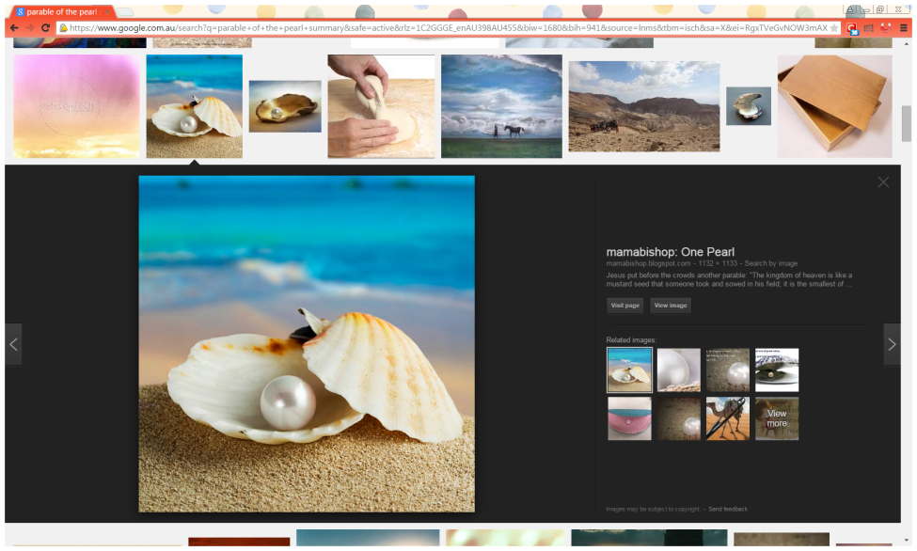

### The Parable of the Pearl of Great Price

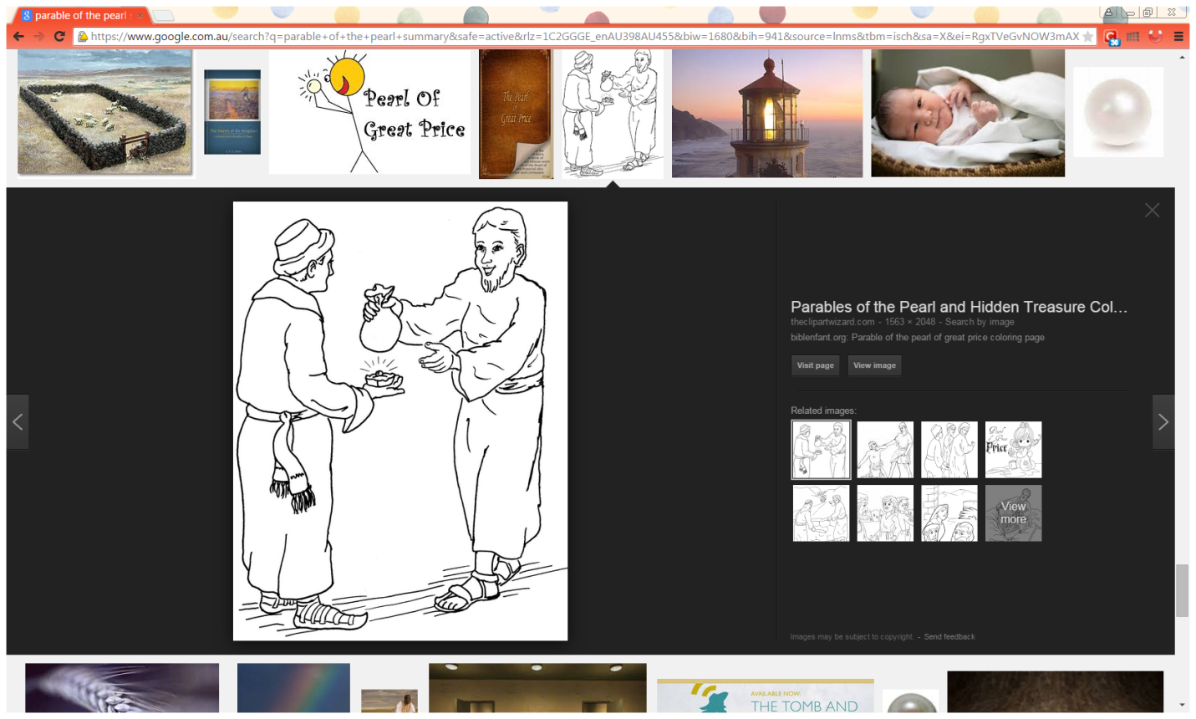*45“Again, the kingdom of heaven is like a merchant seeking beautiful pearls, 46who, when he had found one pearl of great price, went and sold all that he had and bought it.*

*The parable of the hidden treasure is very similar to the parable of the pearl of great price. However there is one major difference.*

**Do you know what this difference is?**

*In the parable of the hidden treasure the man found a treasure, but was not looking for it. The treasure was found by accident.*

*In The parable of the pearl of great price, a man is searching to find the kingdom of Heaven, he knows it*

*is the most valuable and prepared to give up all earthly treasures to have it.*

**Question 4**

True or False

1. The pearl is a very valuable stone. True/False
2. The man in the story sold the things he didn’t like so that he could buy the pearl. True/False
3. We should we be happy when we have to give up Earthly things so that we can have Heaven. True/False

* **Thursday 21th May Read Matthew Chapter 13 verses 47-52**

*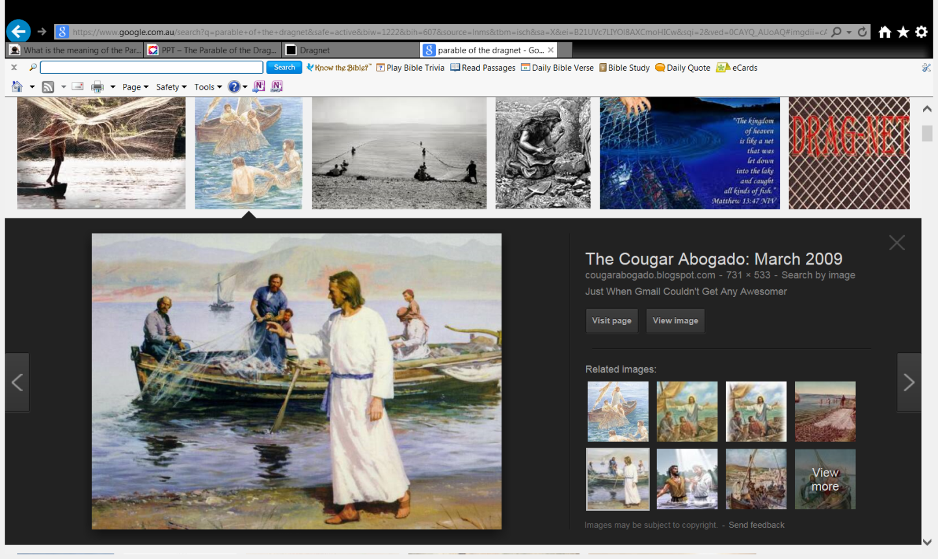***The Parable of the Dragnet**

(or the Parable of the Various Kinds of Fish)

*47“Again, the kingdom of heaven is like a dragnet that was cast into the sea and gathered some of every kind, 48which, when it was full, they drew to shore; and they sat down and gathered the good into vessels, but threw the bad away. 49So it will be at the end of the age. The angels will come forth, separate the wicked from among the just, 50and cast them into the furnace of fire. There will be wailing and gnashing of teeth.”*

*51Jesus said to them, “Have you understood all these things?”*

*They said to Him, “Yes, Lord.”*

*52Then He said to them, “Therefore every scribe instructed concerning the kingdom of heaven is like a householder who brings out of his treasure things new and old.”*

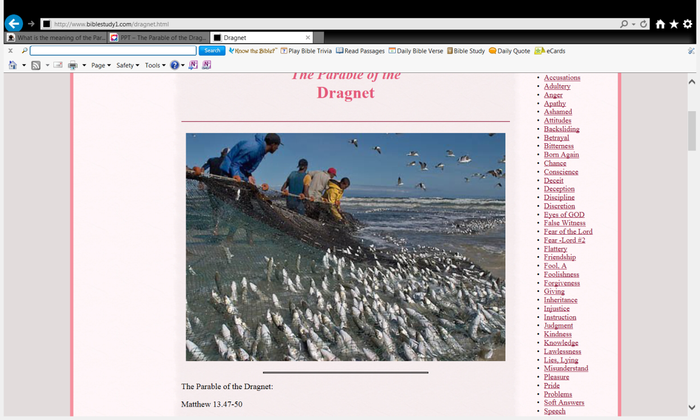

**Do you know what a dragnet is?**

*Fishermen using a dragnet, a weighted net dragged along the bottom of a body of water to collect an assortment of fish.*

*This is seen in the photo on the right.*

*In the parable, the dragnet is cast into the sea and pulled onto shore full of all kinds of fish. Then the fishermen sat down to the business of sorting the fish into the “good” and the “bad.” The fish worth keeping were gathered into containers, but the rest were tossed away.  
Jesus then interprets the parable for His disciples: “This is how it will be at the end of the age. The angels will come and separate the wicked from the righteous.*

**Question 6**

Cross out the incorrect word.

1. The dragnet **represents** the Kingdom of Heaven/earth.
2. “*Gathered some of every kind*” vs 47. Every kind of fish represents people/animals.
3. The fisherman who *gathered the good into vessels, but threw the bad away* **represents** God’s angels/ people who like big fish.

**Question 7**

Jesus compares the kingdom of heaven to three things, what are they?

a) Hidden treasure, mustard seed & beautiful pearl

b) Beautiful pearl, hidden treasure & dragnet

c) Dragnet, diamond & hidden pearl

d) Mustard seed, diamond & dragnet

* **Friday 15th May Read Matthew Chapter 13 verses 31-32**

### Jesus Rejected at Nazareth

*53Now it came to pass, when Jesus had finished these parables, that He departed from there. 54When He had come to His own country, He taught them in their synagogue, so that they were astonished and said, “Where did this Man get this wisdom and these mighty works? 55Is this not the carpenter’s son? Is not His mother called Mary? And His brothers James, Joses, Simon, and Judas? 56And His sisters, are they not all with us? Where then did this Man get all these things?” 57So they were offended at Him.*

*But Jesus said to them, “A prophet is not without honor except in his own country and in his own house.” 58Now He did not do many mighty works there because of their unbelief.*

**Question 7**

The people were astonished (surprised) at Jesus’ teaching in the synagogue. Explain why?

**Question 8**

Why didn’t Jesus perform many miracles (mighty works) when he returned back to His own country (Nazareth)?

* **Saturday 16th May Review**

**Question 9**

Which parable is it? Identify the parable to match the picture

|  |  |
| --- | --- |
| **Parable** | **Picture** |
|  |  |
|  |  |
|  |  |
|  |  |
|  |  |

**PARENTS SECTION:**

We kindly ask you as a parent to read (a little each day) the Holy Bible with your family.

**Now email your answers to your teacher, choose ONE of the email addresses below.**

[stmatthew5b1@gmail.com](mailto:stmatthew5b1@gmail.com) Uncle Andrew

or  
[stmark5b2@gmail.com](mailto:stmark5b2@gmail.com) Uncle Bassem

or  
[saintluke5g1@gmail.com](mailto:saintluke5g1@gmail.com) Aunty Merna

or  
[stjohn5g2@gmail.com](mailto:stjohn5g2@gmail.com) Aunty Angela

***Click on the following link to see how many points you have.***

**Year 5B1 (St Matthew)**

[https://docs.google.com/spreadsheets/d/1YPfk0C0NBJv0XfLlXzhWewt5SbZHkTAmmAVEaydaUYo/edit?usp=sharing](https://webmail.meriden.nsw.edu.au/owa/redir.aspx?C=88057cf25a174c15b69cd7e5055a667f&URL=https%3a%2f%2fdocs.google.com%2fspreadsheets%2fd%2f1YPfk0C0NBJv0XfLlXzhWewt5SbZHkTAmmAVEaydaUYo%2fedit%3fusp%3dsharing)  
**Year 5B2 (St Mark)**

[https://docs.google.com/spreadsheets/d/1IU-qPhJOybm8AH80BISZtK-OVRM-f7DXrPzkonxcraU/edit?usp=sharing](https://webmail.meriden.nsw.edu.au/owa/redir.aspx?C=88057cf25a174c15b69cd7e5055a667f&URL=https%3a%2f%2fdocs.google.com%2fspreadsheets%2fd%2f1IU-qPhJOybm8AH80BISZtK-OVRM-f7DXrPzkonxcraU%2fedit%3fusp%3dsharing)

**Year 5G1 (St Luke)**

[https://docs.google.com/spreadsheets/d/1S9gmI4ZC4ctLiJjYsJGXg_p__H28tM8WXGWcHD8OBKc/edit?usp=sharing](https://webmail.meriden.nsw.edu.au/owa/redir.aspx?C=88057cf25a174c15b69cd7e5055a667f&URL=https%3a%2f%2fdocs.google.com%2fspreadsheets%2fd%2f1S9gmI4ZC4ctLiJjYsJGXg_p__H28tM8WXGWcHD8OBKc%2fedit%3fusp%3dsharing)

**Year 5G2 (St John)**

[https://docs.google.com/spreadsheets/d/1rlhsNVFRZ_MQ00H8UVw1Xb2kvxPZhKiZgdpHZZ9zZtY/edit?usp=sharing](https://webmail.meriden.nsw.edu.au/owa/redir.aspx?C=88057cf25a174c15b69cd7e5055a667f&URL=https%3a%2f%2fdocs.google.com%2fspreadsheets%2fd%2f1rlhsNVFRZ_MQ00H8UVw1Xb2kvxPZhKiZgdpHZZ9zZtY%2fedit%3fusp%3dsharing)