Handed out Sunday 10th May

Name:

Class:

To be emailed back to your Bible Study servant by 16th May

Completed Bible Study = 15 points,

Emailed by the due date = 5 points http://www.timshen.truepath.com/christian/goldcrosswhite.gif

**The GOSPEL according to St. Matthew**

**Year 5 – Bible Study- Matthew Chapter 13 Part 1**

* **Monday 11th May Read Matthew Chapter 13 verses 1 – 9**

### The Parable of the Sower

*1On the same day Jesus went out of the house and sat by the sea. 2And great multitudes were gathered together to Him, so that He got into a boat and sat; and the whole multitude stood on the shore.*

*3Then He spoke many things to them in parables, saying: “Behold, a sower went out to sow. 4And as he sowed, some seed fell by the wayside; and the birds came and devoured them. 5Some fell on stony places, where they did not have much earth; and they immediately sprang up because they had no depth of earth. 6But when the sun was up they were scorched, and because they had no root they withered away. 7And some fell among thorns, and the thorns sprang up and choked them. 8But others fell on good ground and yielded a crop: some a hundredfold, some sixty, some thirty. 9He who has ears to hear, let him hear!”*

**Question 1**

Jesus taught the people because He loved them so much. Jesus taught them by telling them parables. What is a parable?

1. The name of a person
2. A parable is basically an earthly story with a spiritual meaning.
3. Explains how to grow a garden

**Question 2**

In the parable of the sower, the seeds were planted in 4 different ways. Find the verse that describes each of the pictures below.

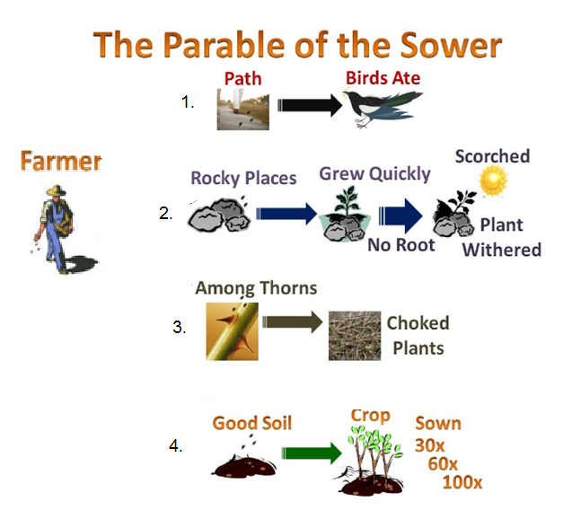

→ Verse

→ Verse

→ Verse

→ Verse

* **Tuesday 12th May Read Matthew Chapter 13 verses 10 – 16**

### The Purpose of Parables

*10And the disciples came and said to Him, “Why do You speak to them in parables?”*

*11He answered and said to them, “Because it has been given to you to know the mysteries of the kingdom of heaven, but to them it has not been given. 12For whoever has, to him more will be given, and he will have abundance; but whoever does not have, even what he has will be taken away from him. 13Therefore I speak to them in parables, because seeing they do not see, and hearing they do not hear, nor do they understand. 14And in them the prophecy of Isaiah is fulfilled, which says:*

*‘Hearing you will hear and shall not understand,  
And seeing you will see and not perceive;  
15For the hearts of this people have grown dull.  
Their ears are hard of hearing,  
And their eyes they have closed,  
Lest they should see with their eyes and hear with their ears,  
Lest they should understand with their hearts and turn,  
So that I should heal them.’*

*16But blessed are your eyes for they see, and your ears for they hear; 17for assuredly, I say to you that many prophets and righteous men desired to see what you see, and did not see it, and to hear what you hear, and did not hear it.*

**Question 3**

Jesus spoke in parables so that his disciples would understand his teachings and that unbelievers would not. Identify if the verse/phrase is for believers or unbelievers

|  |  |
| --- | --- |
| Word/phrase | For believer or unbeliever? |
| To know the mysteries of the kingdom of Heaven |  |
| but whoever does not have, even what he has will be taken away from him |  |
| seeing they do not see |  |
| hearing they do not hear |  |
| nor do they understand |  |
| But blessed are your eyes for they see, and your ears for they hear |  |

**Question 4**

**True or false**

1. Jesus teaches in parables to separate those who have "ears" and those who don't. True/False
2. The use of the word "ears" is another way of saying "those who want to know about God's kingdom". True/False.
3. Those who do not want to learn from Jesus will be able to understand what these parables are saying. True/False.
4. The knowledge of the secrets of the Kingdom of Heaven have been given to those who have ears to hear will hear. True/False
5. But those who do not want to know about God's kingdom or learn from Jesus just won't get it... even what they know will be taken away from them, so that even though they have ears - they won't be able to hear; and even though they have eyes - they won't be able to see... because they have hardened their heart against Jesus. True/False

* **Wednesday 13th May Read Matthew Chapter 13 verses 18-23**

### The Parable of the Sower Explained

*18“Therefore hear the parable of the sower: 19When anyone hears the word of the kingdom, and does not understand it, then the wicked one comes and snatches away what was sown in his heart. This is he who received seed by the wayside. 20But he who received the seed on stony places, this is he who hears the word and immediately receives it with joy; 21yet he has no root in himself, but endures only for a while. For when tribulation or persecution arises because of the word, immediately he stumbles. 22Now he who received seed among the thorns is he who hears the word, and the cares of this world and the deceitfulness of riches choke the word, and he becomes unfruitful. 23But he who received seed on the good ground is he who hears the word and understands it, who indeed bears fruit and produces: some a hundredfold, some sixty, some thirty.”*

**Question 5**

Match the following soil type with its meaning. The first one has been done for you.

|  |  |  |  |
| --- | --- | --- | --- |
| **Soil Type** | | **Explanation** | |
| **1** | The seed that fell among thorns | **3** | Satan comes immediately and takes away the word that was sown in their hearts |
| **2** | Stony ground |  | those who hear the word, accept it, and become good children and love God more than anything. They do many good things pleasing to God of God : some thirtyfold, some sixty, and some a hundred. |
| **3** | The wayside |  | when they hear the word, immediately receive it with gladness; but afterward, when they go through a difficult time they do not remember God’s words. |
| **4** | Good ground |  | they are the ones who hear God’s word,  they get distracted and worry about everything, cares of this world, the dishonesty of money, and do things that do not please God. |

* **Thursday 14th May Read Matthew Chapter 13 verses 24-30**

### The Parable of the Wheat and the Tares

*24Another parable He put forth to them, saying: “The kingdom of heaven is like a man who sowed good seed in his field; 25but while men slept, his enemy came and sowed tares among the wheat and went his way. 26But when the grain had sprouted and produced a crop, then the tares also appeared. 27So the servants of the owner came and said to him, ‘Sir, did you not sow good seed in your field? How then does it have tares?’ 28He said to them, ‘An enemy has done this.’ The servants said to him, ‘Do you want us then to go and gather them up?’ 29But he said, ‘No, lest while you gather up the tares you also uproot the wheat with them. 30Let both grow together until the harvest, and at the time of harvest I will say to the reapers, “First gather together the* tares and bind them in bundles to burn them, but gather the wheat into my barn.”’”

**Do you know what Tare is?**

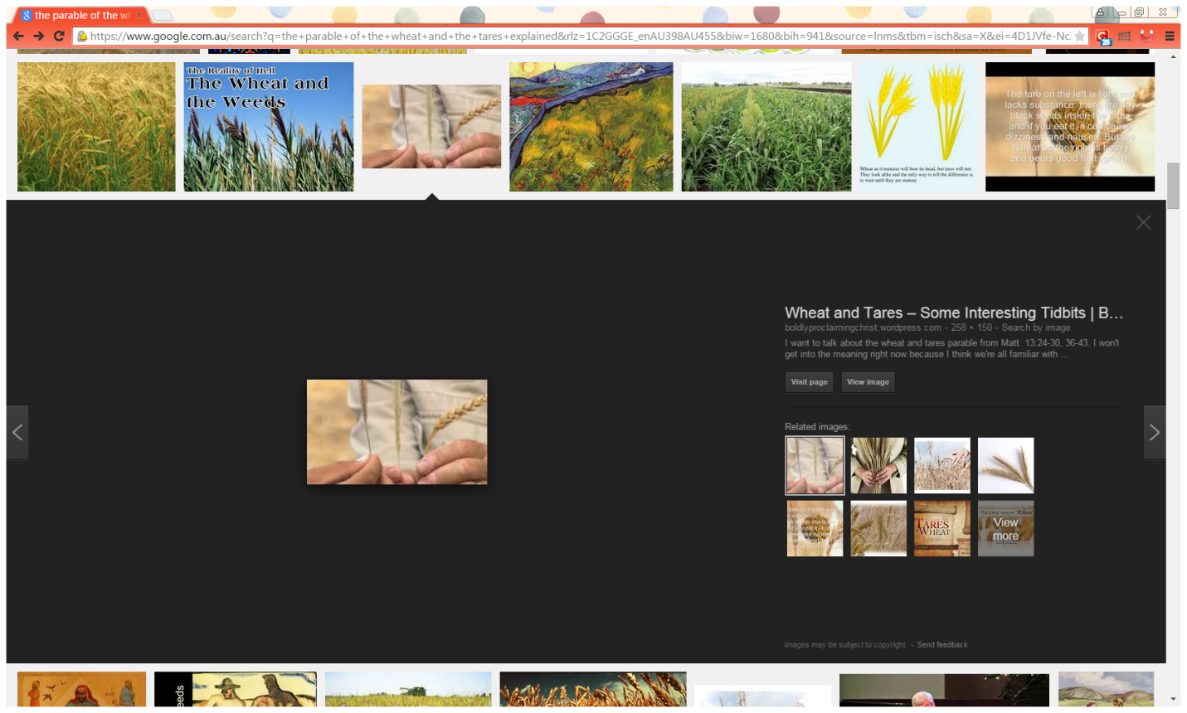

Wheat is heavy and bears good fruit (grain)

The tares are weeds that are light and have tiny black seeds inside. If you eat it, it can cause dizziness and nausea.

**Question 6**

Identify the tare and wheat

A

B

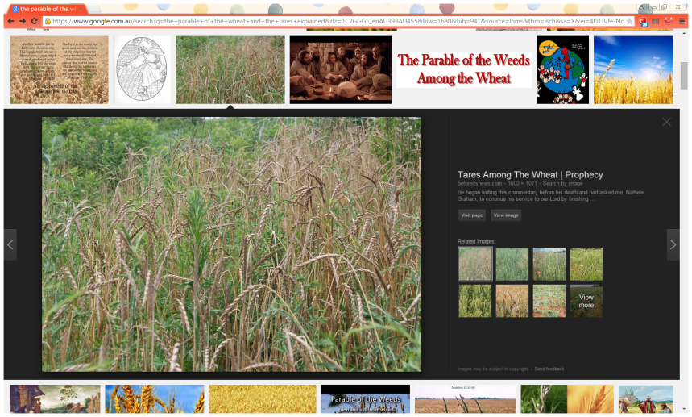

A

B

**Question 7**

Use the words in the word list below to match it with its meaning.

Harvest, Enemy, Reapers, Sower, Tares (weed), Good seed(wheat), Field.

|  |  |
| --- | --- |
| **Word** | **Meaning** |
|  | Jesus Christ and His Apostles |
|  | Followers of Jesus |
|  | World |
|  | Satan |
|  | Followers of Satan |
|  | Angels |
|  | Jesus’ second coming |

* **Friday 15th May Read Matthew Chapter 13 verses 31-32**

### The Parable of the Mustard Seed

*31Another parable He put forth to them, saying: “The kingdom of heaven is like a mustard seed, which a man took and sowed in his field, 32which indeed is the least of all the seeds; but when it is grown it is greater than the herbs and becomes a tree, so that the birds of the air come and nest in its branches.”*

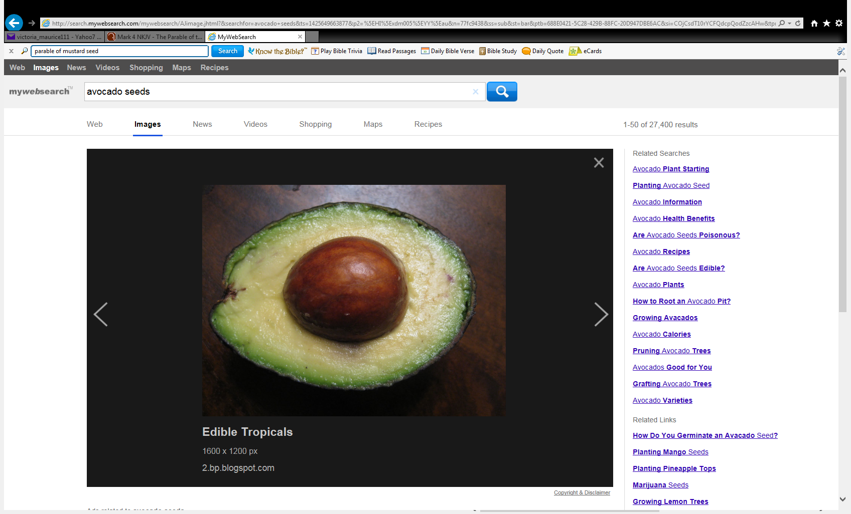

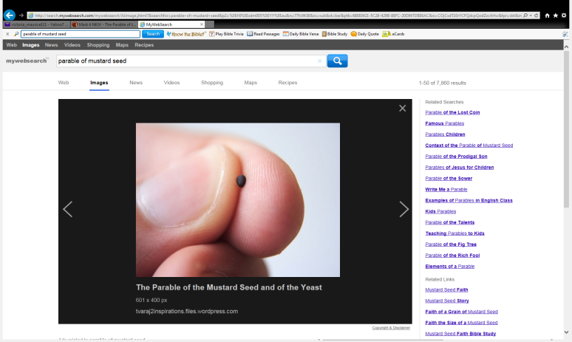

Look at the difference in size of a mustard seed and an avacado seed.

**Question 8**

Jesus said that the mustard seed symbolize the kingdom of God. TRUE / FALSE

**Question 9**

**Fill in the missing words from the word list below**

smallest, Gospel, refuge, rooted, Jesus, kingdom, people, forgive.

The sower is Himself. He is the planter who came to  our sins by dying on the cross.

The mustard seed was the  seed known at the time. While it becomes more of a shrub than a tree, it can reach about 10 feet high. The mustard seed represents the , starting very small but growing to reach millions throughout the world who will inherit the . The field represents all the  of the earth who will receive Him.

The tree is in Jesus Christ and has grown a harvest far beyond its initial planting.

The birds’ of the air signifying ”to understand, to hear.” The tree offers a for His faithful to rest in Him.

* **Saturday 16th May Read Matthew Chapter 13 verses 34-35**

### Prophecy and the Parables

*34All these things Jesus spoke to the multitude in parables; and without a parable He did not speak to them, 35that it might be fulfilled which was spoken by the prophet, saying:*

*“I will open My mouth in parables;  
I will utter things kept secret from the foundation of the world.”*

**Question 10**

The prophecy in verse 35 came from the Old Testament Book , Psalm 78:2.

This is another prophecy about Jesus that has been fulfilled.

1. What word in Tuesday night’s Bible reading mean “things kept secret”? Hint: Verse 11
2. Jesus told 46 parables. In this week’s Bible study you learned 3 parables.

Can you think of two other parables you know you didn’t read this week.

1.

2.

**PARENTS SECTION:**

We kindly ask you as a parent to read (a little each day) the Holy Bible with your family.

**Now email your answers to your teacher, choose ONE of the email addresses below.**

[stmatthew5b1@gmail.com](mailto:stmatthew5b1@gmail.com) Uncle Andrew

or  
[stmark5b2@gmail.com](mailto:stmark5b2@gmail.com) Uncle Bassem

or  
[saintluke5g1@gmail.com](mailto:saintluke5g1@gmail.com) Aunty Merna

or  
[stjohn5g2@gmail.com](mailto:stjohn5g2@gmail.com) Aunty Angela

***Click on the following link to see how many points you have.***

**Year 5B1 (St Matthew)**

[https://docs.google.com/spreadsheets/d/1YPfk0C0NBJv0XfLlXzhWewt5SbZHkTAmmAVEaydaUYo/edit?usp=sharing](https://webmail.meriden.nsw.edu.au/owa/redir.aspx?C=88057cf25a174c15b69cd7e5055a667f&URL=https%3a%2f%2fdocs.google.com%2fspreadsheets%2fd%2f1YPfk0C0NBJv0XfLlXzhWewt5SbZHkTAmmAVEaydaUYo%2fedit%3fusp%3dsharing)  
**Year 5B2 (St Mark)**

[https://docs.google.com/spreadsheets/d/1IU-qPhJOybm8AH80BISZtK-OVRM-f7DXrPzkonxcraU/edit?usp=sharing](https://webmail.meriden.nsw.edu.au/owa/redir.aspx?C=88057cf25a174c15b69cd7e5055a667f&URL=https%3a%2f%2fdocs.google.com%2fspreadsheets%2fd%2f1IU-qPhJOybm8AH80BISZtK-OVRM-f7DXrPzkonxcraU%2fedit%3fusp%3dsharing)

**Year 5G1 (St Luke)**

[https://docs.google.com/spreadsheets/d/1S9gmI4ZC4ctLiJjYsJGXg_p__H28tM8WXGWcHD8OBKc/edit?usp=sharing](https://webmail.meriden.nsw.edu.au/owa/redir.aspx?C=88057cf25a174c15b69cd7e5055a667f&URL=https%3a%2f%2fdocs.google.com%2fspreadsheets%2fd%2f1S9gmI4ZC4ctLiJjYsJGXg_p__H28tM8WXGWcHD8OBKc%2fedit%3fusp%3dsharing)

**Year 5G2 (St John)**

[https://docs.google.com/spreadsheets/d/1rlhsNVFRZ_MQ00H8UVw1Xb2kvxPZhKiZgdpHZZ9zZtY/edit?usp=sharing](https://webmail.meriden.nsw.edu.au/owa/redir.aspx?C=88057cf25a174c15b69cd7e5055a667f&URL=https%3a%2f%2fdocs.google.com%2fspreadsheets%2fd%2f1rlhsNVFRZ_MQ00H8UVw1Xb2kvxPZhKiZgdpHZZ9zZtY%2fedit%3fusp%3dsharing)