
15 POINTS

Jesus is the Messiah, the Saviour, the Son of Man

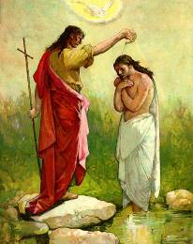
Chapter 11

- John sent two of his disciples to Jesus asking “ Are you the coming one
or do we look for others” What he meant by the coming one?

_______________________________________________________________________________________________________________________________________________________________________________________

- What was said about John the Baptist?
________________________________________________________________________________________________________________________________________________________________________________________________________________________

- Why did Jesus rebuke the cities?
________________________________________________________________________________________________________________________________________________

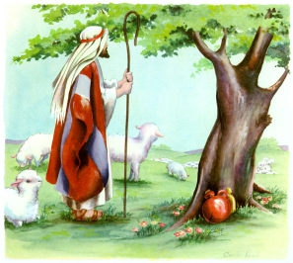
- Which verse talks about Jesus giving us comfort and rest in troublesome times? Write this here. (Hint: look towards the end of Chapter 11).

________________________________________________________________________________________________________________________________________________________________________________________________________________________________

Chapter 12

- Jesus teaches us that we can do good works in certain days only
True ( ) False ( )

- What Prophesy is fullfullind in Chapter 12?
________________________________________________________________________________________________________________________________________________________________________________________________________________________

- Who is Beelzebub? And why would?
________________________________________________________________________________________________________________________________________________

- How many miracles does Jesus perform in Chapter 12?
_________________________________________________________________________________________________________________________________________________________________________________________________

- Jesus described whom He considers His mother and His brothers at the end of chapter 12. Write the verse.
_________________________________________________________________________________________________________________________________________________________________________________________________________________

Parent Signature: __________________________

Dear Parents: We ask you to read (a little each day) in the Bible with your family. You may wish to read the St Matthew Gospel with Sunday School. Please let us know what you are reading with your child and if you have any questions. We will ask you to initial or sign the Bible study sheet each week from now on.

