MC900383922[1]Sunday 19th July, 2015

Name:

Class:

Finish Date: Saturday 25th July, 2015

Completed Bible Study = 15 points

Homework handed in by the due date = 5 points

Homework handed in as a hard copy and answers are hand written = 10 points

**Year 4 Memorisation homework**

* **Monday 20th July : Read Psalm 23**

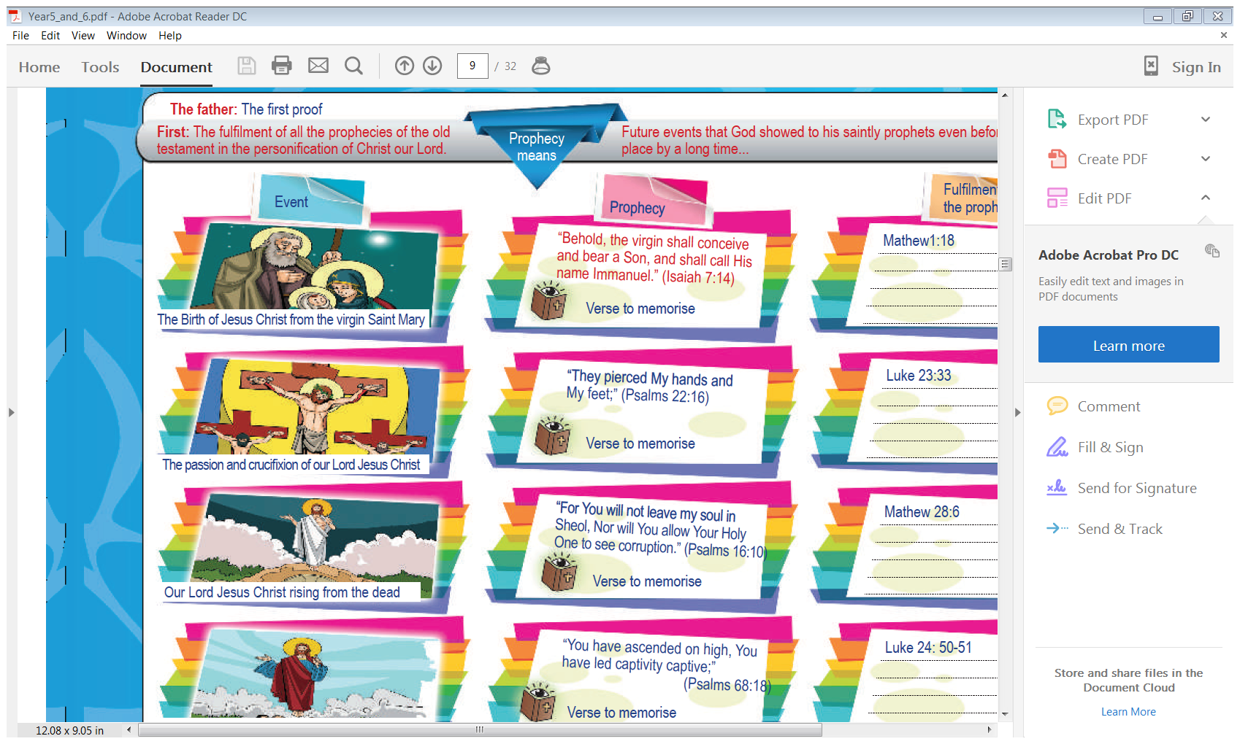**Memorisation: Psalm 23**

***1The Lord is my shepherd; I shall not want.  
2He makes me to lie down in green pastures;  
He leads me beside the still waters.***

***3He restores my soul;  
He leads me in the paths of righteousness for His name’s sake.***

***4Yea, though I walk through the valley of the shadow of death,  
I will fear no evil; For You are with me;  
Your rod and Your staff, they comfort me.***

***5You prepare a table before me in the presence of my enemies;  
You anoint my head with oil; My cup runs over.  
6Surely goodness and mercy shall follow me all the days of my life;  
And I will dwell in the house of the Lord Forever***

* **Tuesday 21st July**

**Learn Verses 1-2**

**Question 1**

Fill in the table by completing the sentences

|  |  |
| --- | --- |
| 1The Lord *is* my shepherd; |  |
|  | lie down in green pastures; |
| He leads |  |
|  | I shall not want. |
| 2He makes me to |  |
|  | lie down in green pastures; |

And again,

|  |  |
| --- | --- |
| 1The Lord *is* my shepherd; |  |
| 2He makes me |  |
| He leads me |  |
|  | I shall not want. |
|  | to lie down in green pastures; |
|  | beside the still waters. |

**Question 2**

**Fill in the missing words**

1The Lord *is* my ; I shall not

2He me to lie down in pastures;

He me beside the waters.

**Question 13**

Put the sentences in the correct order by numbering the phrases 1 to 3

He leads me beside the still waters.

1The Lord *is* my shepherd; I shall not want.

2He makes me to lie down in green pastures;

**Question 3**

Complete each word in the sentence. The first letter has been done for you.

|  |  |  |  |  |  |  |  |  |
| --- | --- | --- | --- | --- | --- | --- | --- | --- |
| T | L | i | m | S | I | s | n | w |
| H | m | m | l | i | g | p |  |  |
| H | l | m | b | t | s | w |  |  |

* **Wednesday 21st July**

**Verses 3-4**

**Question 4**

Fill in the table by completing the sentences

|  |  |
| --- | --- |
| 3He restores my soul; |  |
| He leads me in the paths |  |
| 4Yea, though I walk |  |
| I will fear no evil; |  |
| Your rod and Your staff |  |
|  | my soul; |
|  | of righteousness for His name’s sake. |
|  | through the valley of the shadow of death, |
|  | For You *are* with me; |
|  | they comfort me. |

**Question 5**

**Fill in the missing words**

3He my soul;

He leads me in the of for His sake.

4Yea, though I through the of the of death,

I will no evil; For *are* with me;

Your and Your , they me.

* **Thursday 23rd July**

**Question 6**

Put the sentences in the correct order by numbering the phrases 1 to 5

4Yea, though I walk through the valley of the shadow of death,

3He restores my soul;

He leads me in the paths of righteousness for His name’s sake.

Your rod and Your staff, they comfort me.

I will fear no evil; For You *are* with me;

**Question 7**

Complete each word in the sentence. The first letter has been done for you.

|  |  |  |  |  |  |  |  |  |  |  |  |
| --- | --- | --- | --- | --- | --- | --- | --- | --- | --- | --- | --- |
| H | r | m | s |  |  |  |  |  |  |  |  |
| H | l | m | i | t | p | o | r | f | H | n | s |
| Y | t | I | w | t | t | v | o | t | s | o | d |
| i | w | f | n | e | F | Y | a | w | m |  |  |
| Y | r | a | Y | s | t | c | m |  |  |  |  |

* **Friday 24th July**

**Verses 5-6**

**Question 8**

Fill in the table by completing the sentences

|  |  |
| --- | --- |
| 5You prepare a table before me |  |
| You anoint my head with oil; |  |
| 6Surely goodness and mercy |  |
| And I will dwell in the house |  |
|  | in the presence of my enemies; |
|  | My cup runs over. |
|  | shall follow me all the days of my life; |
|  | of the Lord forever |

And again,

|  |  |
| --- | --- |
| 5You prepare a table before me |  |
|  | My cup runs over. |
| 6Surely goodness and mercy |  |
|  | of the Lord forever |
|  | in the presence of my enemies; |
| You anoint my head with oil; |  |
|  | shall follow me all the days of my life; |
| And I will dwell in the house |  |

**Question 9**

**Fill in the missing words**

5You a table me in the presence of my

You my head with oil; cup runs over.

6Surely and mercy shall me all the days of my life;

And I will in the house of the Lord

* **Saturday 25th July**

**Question 10**

Put the sentences in the correct order by numbering the phrases 1 to 4

6Surely goodness and mercy shall follow me all the days of my life;

5You prepare a table before me in the presence of my enemies;

You anoint my head with oil; My cup runs over.

And I will dwell in the house of the Lord forever

**Question 11**

Complete each word in the sentence. The first letter has been done for you.

|  |  |  |  |  |  |  |  |  |  |  |  |  |
| --- | --- | --- | --- | --- | --- | --- | --- | --- | --- | --- | --- | --- |
| Y | p | a | t | b | m | i | t | p | o | m | e |  |
| Y | a | m | h | w | o | M | c | r | o |  |  |  |
| S | g | a | m | s | f | m | a | t | d | o | m | l |
| A | I | w | d | i | t | h | o | t | L | f |  |  |

***What to do when you finish your memorisation***

***Hand in a hard copy of the study to your Bible Study servants next Sunday.***

***Click on the following link to see how many points you have.***

***Click on the following link to see how many points you have.***

*(Hold Ctrl and left click with your mouse on the following link* ***OR*** *copy and paste the link into your browser)*

**Year 4A (St Makarios)**

<https://docs.google.com/spreadsheets/d/1svMXXIj8NwuUDGMm0bHIzMrBR62fWNYm9xXlsh6-I1w/edit?usp=sharing>

**Year 4B (St Bakhomios)**

<https://docs.google.com/spreadsheets/d/1wl6OeTuXpxy4T88ATrJOTiCu0HFlBZx9WyKmcOHHz9A/edit?usp=sharing>

**Year 4C (St Anthony)**

<https://docs.google.com/spreadsheets/d/1PgNO1gO77nfTJaty0VOmkZs9_do_XpLNpwpYZZht9I/edit?usp=sharing>