MC900383922[1]Sunday 5th July, 2015

Name:

Class:

Finish Date: Saturday 11th July, 2015

Completed Bible Study = 15 points

Email Homework by the due date = 5 points

**Year 4 St Mark’s Festival 2015 Bible Study 1**

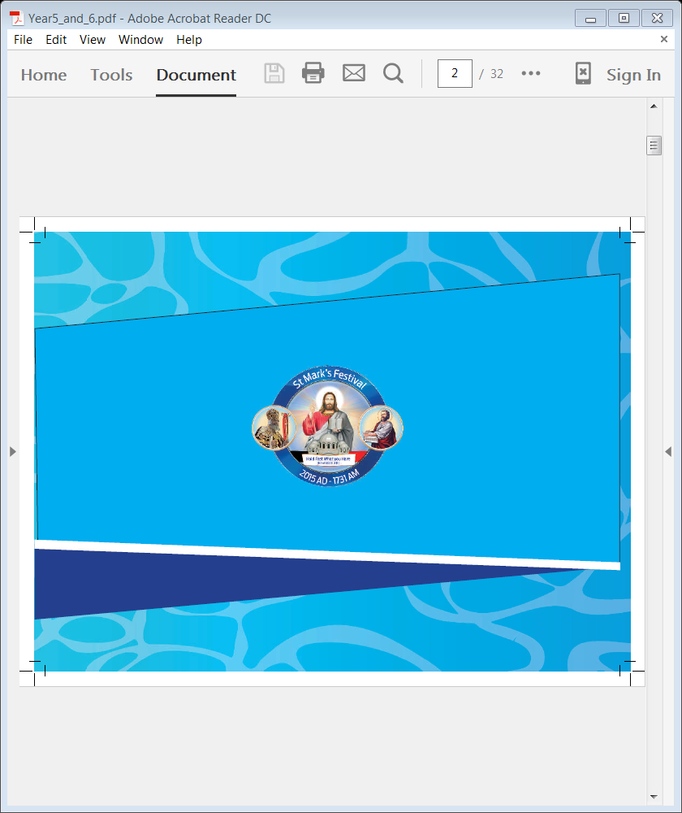

**For the questions below Highlight, underline or change the font colour to choose the correct answer.**

* Monday 6th July

**Part 1: My faith is steady and strong**

**Question 1: A verse to remember** 1 John 5:7

*For there are three that bear witness in heaven the Father, the Word, and the Holy Spirit”*

Learn the verse off by heart

Fill in the missing words

1. For there are three that bear witness in heaven:
2. the Father, the Word, and the Holy Spirit”

* Tuesday 7th July:

**Part 2: My Book is Dear and Precious**

**Question 2: A verse to remember 2 Timothy 3:16**

*“All Scripture is given by inspiration of God, and is profitable for doctrine, for reproof, for correction, for instruction in righteousness.”*

Match the following words/phrases to their meaning.

Scripture, inspiration of God, profitable for doctrine, reproof, for correction, instruction in righteousness.

|  |  |
| --- | --- |
| **Word/phrase** | **Meaning** |
|  | Holy Bible |
|  | is useful for teaching God’s word |
|  | To show how to change bad behaviour into good behaviour pleasing to God |
|  | Warning, talking to, rebuke, reprimand, discipline. |
|  | The Word of God is given to you to learn how to be blameless and avoid sin. Study and apply God’s word to help you to be honest and good. |
|  | Given by God. It is from God's heart and His mind to the writers |

**Question 3**

Fill in the missing words

1. and is profitable for doctrine, for reproof, for correction, for instruction in righteousness.”
2. “All Scripture is given by inspiration of God,

**Question 4 : A verse to remember Matthew 28:19-20**

*"Go therefore and make disciples of all the nations, baptizing them to observe all things that I have commanded you; and lo, I am with you always, even to the end of the age.”*

After you have spent time learning the verse put the sentences in the correct order by numbering the phrases 1 to 5

baptizing them to observe all things

and lo, I am with you always

even to the end of the age

that I have commanded you;

Go therefore and make disciples of all the nations

**Application**

Our Church depends on the Holy Bible; each prayer includes many readings from the Holy Bible. We read parts from the Holy Bible when performing any of the church’s mysteries.

* Wednesday 8th July:

**Question 5**

Read the Bible Verses Below

**Psalm 32: 1-2**

*Blessed is he whose transgression is forgiven,  
Whose sin is covered.  
2Blessed is the man to whom the Lord does not impute iniquity,  
And in whose spirit there is no deceit.*

**John 2:1-21**

**Water Turned to Wine**

*2 On the third day there was a wedding in Cana of Galilee, and the mother of Jesus was there. 2Now both Jesus and His disciples were invited to the wedding. 3And when they ran out of wine, the mother of Jesus said to Him, “They have no wine.”*

*4Jesus said to her, “Woman, what does your concern have to do with Me? My hour has not yet come.”*

*5His mother said to the servants, “Whatever He says to you, do it.”*

*6Now there were set there six waterpots of stone, according to the manner of purification of the Jews, containing twenty or thirty gallons apiece. 7Jesus said to them, “Fill the waterpots with water.” And they filled them up to the brim. 8And He said to them, “Draw some out now, and take it to the master of the feast.” And they took it. 9When the master of the feast had tasted the water that was made wine, and did not know where it came from (but the servants who had drawn the water knew), the master of the feast called the bridegroom. 10And he said to him, “Every man at the beginning sets out the good wine, and when the guests have well drunk, then the inferior. You have kept the good wine until now!”*

*11This beginning of signs Jesus did in Cana of Galilee, and manifested His glory; and His disciples believed in Him.*

*12After this He went down to Capernaum, He, His mother, His brothers, and His disciples; and they did not stay there many days.*

**Jesus Cleanses the Temple**

*13Now the Passover of the Jews was at hand, and Jesus went up to Jerusalem. 14And He found in the temple those who sold oxen and sheep and doves, and the money changers doing business. 15When He had made a whip of cords, He drove them all out of the temple, with the sheep and the oxen, and poured out the changers’ money and overturned the tables. 16And He said to those who sold doves, “Take these things away! Do not make My Father’s house a house of merchandise!” 17Then His disciples remembered that it was written, “Zeal for Your house has eaten Me up.”*

*18So the Jews answered and said to Him, “What sign do You show to us, since You do these things?”*

*19Jesus answered and said to them, “Destroy this temple, and in three days I will raise it up.”*

*20Then the Jews said, “It has taken forty-six years to build this temple, and will You raise it up in three days?”*

*21But He was speaking of the temple of His body.*

Which Sacrament matches the Bible readings above?

1. Anointing of the Sick
2. The Eucharist (Holy Communion)
3. Baptism
4. Matrimony (marriage)

* Thursday 9th July:

**Question 6**

Read the Bible Verses Below

**Matthew 26: 26-28**

### Jesus Institutes the Lord’s Supper

*26And as they were eating, Jesus took bread, blessedand broke it, and gave it to the disciples and said, “Take, eat; this is My body.”*

*27Then He took the cup, and gave thanks, and gave it to them, saying, “Drink from it, all of you. 28For this is My blood of the new[*[*b*](https://www.biblegateway.com/passage/?search=Matthew+26%3A+26-28&version=NKJV#fen-NKJV-24083b)*] covenant, which is shed for many for the remission of sins.*

Which Sacrament matches the Bible reading?

1. Anointing of the Sick
2. The Eucharist (Holy Communion)
3. Baptism
4. Matrimony (marriage)

* Friday 10th July:

**Question 7**

Read the 3 Bible passages below

* **Psalm 19:5-6**

*5Which is like a bridegroom coming out of his chamber,  
And rejoices like a strong man to run its race.  
6Its rising is from one end of heaven,  
And its circuit to the other end;  
And there is nothing hidden from its heat.*

* **Psalm 128: 3-4**

*3Your wife shall be like a fruitful vine  
In the very heart of your house,  
Your children like olive plants  
All around your table.  
4Behold, thus shall the man be blessed  
Who fears the Lord.*

* **Matthew 19: 2-6**

*2And great multitudes followed Him, and He healed them there.*

*3The Pharisees also came to Him, testing Him, and saying to Him, “Is it lawful for a man to divorce his wife for just any reason?”*

*4And He answered and said to them, “Have you not read that He who made[*[*a*](https://www.biblegateway.com/passage/?search=Matthew+19%3A2-6&version=NKJV#fen-NKJV-23767a)*] them at the beginning ‘made them male and female,’[*[*b*](https://www.biblegateway.com/passage/?search=Matthew+19%3A2-6&version=NKJV#fen-NKJV-23767b)*] 5and said, ‘For this reason a man shall leave his father and mother and be joined to his wife, and the two shall become one flesh’?[*[*c*](https://www.biblegateway.com/passage/?search=Matthew+19%3A2-6&version=NKJV#fen-NKJV-23768c)*] 6So then, they are no longer two but one flesh. Therefore what God has joined together, let not man separate.”*

Which Sacrament matches the Bible reading?

1. Anointing of the Sick
2. The Eucharist (Holy Communion)
3. Baptism
4. Matrimony (marriage)

* Saturday 11th July

**Question 8**

Read the Bible Verses Below

**James 5: 10-20**

*10My brethren, take the prophets, who spoke in the name of the Lord, as an example of suffering and patience. 11Indeed we count them blessed who endure. You have heard of the perseverance of Job and seen the end intended by the Lord—that the Lord is very compassionate and merciful.*

*12But above all, my brethren, do not swear, either by heaven or by earth or with any other oath. But let your “Yes” be “Yes,” and your “No,” “No,” lest you fall into judgment.*

### Meeting Specific Needs

*13Is anyone among you suffering? Let him pray. Is anyone cheerful? Let him sing psalms. 14Is anyone among you sick? Let him call for the elders of the church, and let them pray over him, anointing him with oil in the name of the Lord. 15And the prayer of faith will save the sick, and the Lord will raise him up. And if he has committed sins, he will be forgiven. 16Confess your trespasses[*[*b*](https://www.biblegateway.com/passage/?search=James+5%3A+10-20&version=NKJV#fen-NKJV-30371b)*] to one another, and pray for one another, that you may be healed. The effective, fervent prayer of a righteous man avails much. 17Elijah was a man with a nature like ours, and he prayed earnestly that it would not rain; and it did not rain on the land for three years and six months. 18And he prayed again, and the heaven gave rain, and the earth produced its fruit.*

### Bring Back the Erring One

*19Brethren, if anyone among you wanders from the truth, and someone turns him back, 20let him know that he who turns a sinner from the error of his way will save a soul[*[*c*](https://www.biblegateway.com/passage/?search=James+5%3A+10-20&version=NKJV#fen-NKJV-30375c)*] from death and cover a multitude of sins.*

Which Sacrament matches the Bible reading?

1. Anointing of the Sick
2. The Eucharist (Holy Communion)
3. Baptism
4. Matrimony (marriage)

***What to do when you finish your Bible Study.***

1. ***Either send it by email to your class email address or print and hand it to your servants next Sunday.***
2. ***If you want to send your Bible Study by email, please select your class email address below:***

[StMakarios4A@gmail.com](https://webmail.meriden.nsw.edu.au/owa/redir.aspx?C=4adc2b70e10f4d7a852971e205ecbf9c&URL=mailto%3aStMakarios4A%40gmail.com) – bible study servant Shady Alfy

[StBakhomios4B@gmail.com](https://webmail.meriden.nsw.edu.au/owa/redir.aspx?C=4adc2b70e10f4d7a852971e205ecbf9c&URL=mailto%3aStBakhomios4B%40gmail.com) bible study servant Victor Hanna

[StAnthony4C@gmail.com](https://webmail.meriden.nsw.edu.au/owa/redir.aspx?C=4adc2b70e10f4d7a852971e205ecbf9c&URL=mailto%3aStAnthony4C%40gmail.com) bible study servant Melaine Saleeb

1. ***Click on the following link to see how many points you have.***

*(Hold Ctrl and left click with your mouse on the following link* ***OR*** *copy and paste the link into your browser)*

**Year 4A (St Makarios)**

<https://docs.google.com/spreadsheets/d/1svMXXIj8NwuUDGMm0bHIzMrBR62fWNYm9xXlsh6-I1w/edit?usp=sharing>

**Year 4B (St Bakhomios)**

<https://docs.google.com/spreadsheets/d/1wl6OeTuXpxy4T88ATrJOTiCu0HFlBZx9WyKmcOHHz9A/edit?usp=sharing>

**Year 4C (St Anthony)**

<https://docs.google.com/spreadsheets/d/1PgNO1gO77nfTJaty0VOmkZs9_do_XpLNpwpYZZht9I/edit?usp=sharing>