MC900383922[1]Sunday 2nd August, 2015

Name:

Class:

Finish Date: Saturday 8th August, 2015

Completed Bible Study = 15 points

Homework handed in by the due date = 5 points

**Year 4 Memorisation homework**

* **Monday 3rd August Read the passage then answer the questions that follow**

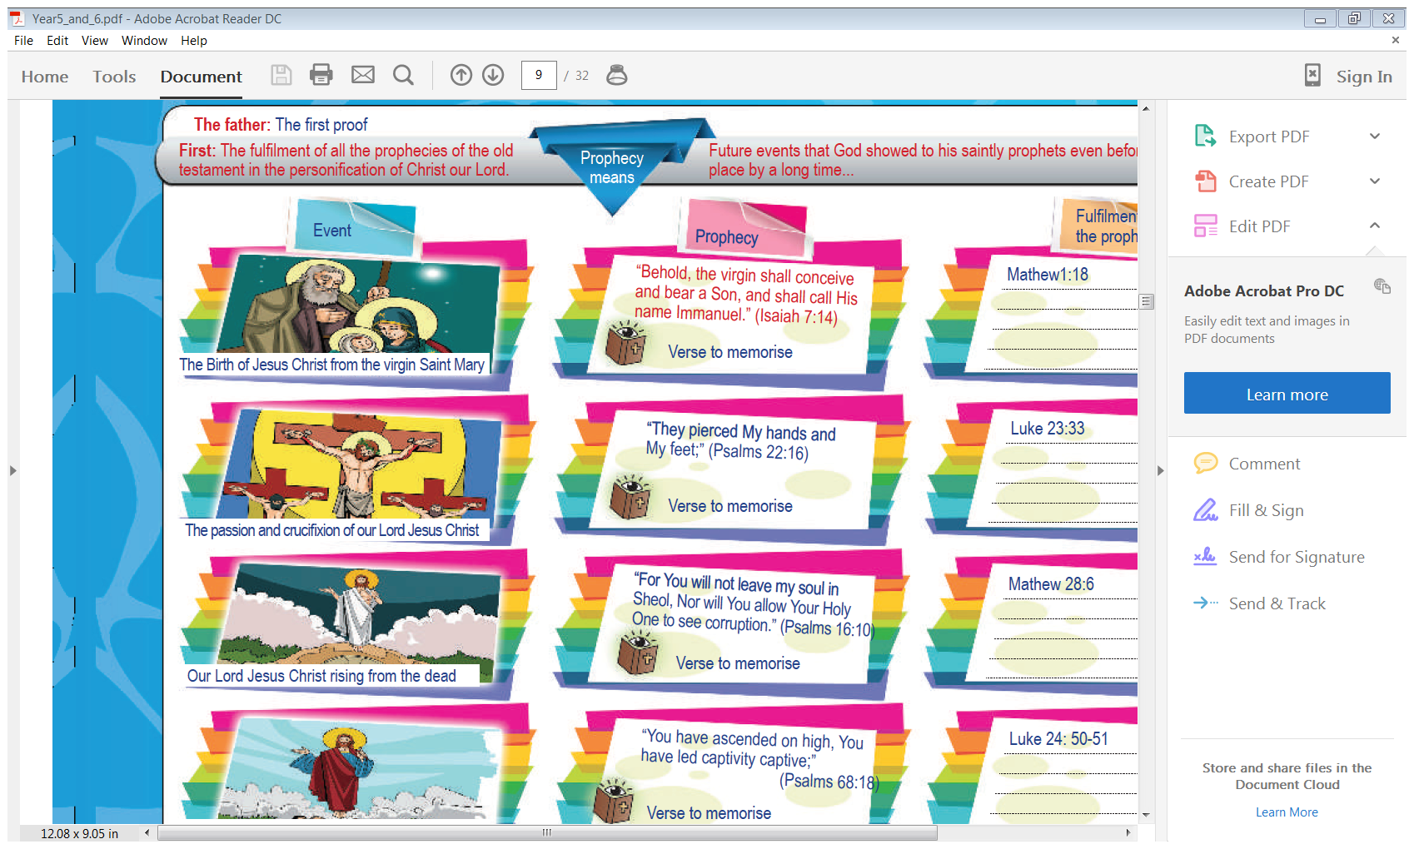**Memory Bible Passage: John 10: 11-18**

***11“I am the good shepherd. The good shepherd gives His life for the sheep.***

***12But a hireling, he who is not the shepherd, one who does not own the sheep,***

***sees the wolf coming and leaves the sheep and flees; and the wolf catches the sheep and scatters them.***

***13The hireling flees because he is a hireling and does not care about the sheep.***

***14I am the good shepherd; and I know My sheep, and am known by My own.***

***15As the Father knows Me, even so I know the Father; and I lay down My life for the sheep.***

***16And other sheep I have which are not of this fold;***

***them also I must bring, and they will hear My voice; and there will be one flock and one shepherd.***

***17“Therefore My Father loves Me, because I lay down My life that I may take it again.***

***18No one takes it from Me, but I lay it down of Myself.***

***I have power to lay it down, and I have power to take it again. This command I have received from My Father.”***

**Learn verse 11-13**

11“I am the good shepherd. The good shepherd gives His life for the sheep.

12But a hireling, *he who is* not the shepherd, one who does not own the sheep,

sees the wolf coming and leaves the sheep and flees; and the wolf catches the sheep and scatters them.

13The hireling flees because he is a hireling and does not care about the sheep.

**Question 1**

Complete the table by finishing the sentences.

|  |  |
| --- | --- |
| 11“I am the good shepherd. |  |
| 12But a hireling, *he who is* not the shepherd, |  |
| sees the wolf coming and leaves the sheep and flees; |  |
| 13The hireling flees because he is a hireling |  |

And Again,

|  |  |
| --- | --- |
|  | The good shepherd gives His life for the sheep. |
|  | one who does not own the sheep, |
|  | and the wolf catches the sheep and scatters them. |
|  | and does not care about the sheep. |

**Question 2**

Put the sentences in the correct order by numbering the lines 1 to 4

* The hireling flees because he is a hireling and does not care about the sheep.
* sees the wolf coming and leaves the sheep and flees; and the wolf catches the sheep and scatters them.
* “I am the good shepherd. The good shepherd gives His life for the sheep.
* But a hireling, *he who is* not the shepherd, one who does not own the sheep,

**Question 3**

Fill in the table by completing every second line

|  |
| --- |
| 11“I am the good shepherd. The good shepherd gives His life for the sheep. |
|  |
| sees the wolf coming and leaves the sheep and flees; and the wolf catches the sheep and scatters them. |
|  |

And again,

|  |
| --- |
|  |
| 12But a hireling, *he who is* not the shepherd, one who does not own the sheep, |
|  |
| 13The hireling flees because he is a hireling and does not care about the sheep. |

* **Tuesday 4th August**

**Learn verse 13-15**

14I am the good shepherd; and I know My *sheep,* and am known by My own.

15As the Father knows Me, even so I know the Father; and I lay down My life for the sheep.

16And other sheep I have which are not of this fold;

them also I must bring, and they will hear My voice; and there will be one flock *and* one shepherd.

**Question 4**

**Complete the table by finishing the sentences**

|  |  |
| --- | --- |
| 14I am the good shepherd; |  |
| 15As the Father knows Me, even so I know the Father; |  |
| 16And other sheep |  |
| them also I must bring, and they will hear My voice; |  |

And again,

|  |  |
| --- | --- |
|  | and am known by My own. |
|  | and I lay down My life for the sheep. |
|  | I have which are not of this fold; |
|  | and there will be one flock *and* one shepherd. |

**Question 5**

Put the sentences in the correct order by numbering the lines 1 to 4

* them also I must bring, and they will hear My voice; and there will be one flock *and* one shepherd.
* And other sheep I have which are not of this fold;
* I am the good shepherd; and I know My *sheep,* and am known by My own.
* As the Father knows Me, even so I know the Father; and I lay down My life for the sheep.

**Question 6**

Fill in the table by completing every second line

|  |
| --- |
| 14I am the good shepherd; and I know My *sheep,* and am known by My own. |
|  |
| 16And other sheep I have which are not of this fold; |
|  |

And again,

|  |
| --- |
|  |
| 15As the Father knows Me, even so I know the Father; and I lay down My life for the sheep. |
|  |
| them also I must bring, and they will hear My voice; and there will be one flock *and* one shepherd. |

* **Wednesday 5th August**

**Learn verse 17-18**

17“Therefore My Father loves Me, because I lay down My life that I may take it again.

18No one takes it from Me, but I lay it down of Myself.

I have power to lay it down, and I have power to take it again. This command I have received from My Father.”

**Question 7**

Complete the table by finishing the sentences

|  |  |
| --- | --- |
| 17“Therefore My Father loves Me, |  |
| 18No one takes it from Me, |  |
| I have power to lay it down, and I have power to take it again. |  |

And again,

|  |  |
| --- | --- |
|  | because I lay down My life that I may take it again. |
|  | but I lay it down of Myself. |
|  | This command I have received from My Father.” |

**Question 8**

Put the sentences in the correct order by numbering the lines 1 to 3

* No one takes it from Me, but I lay it down of Myself.
* 17“Therefore My Father loves Me, because I lay down My life that I may take it again.
* I have power to lay it down, and I have power to take it again. This command I have received from My Father.”

**Question 9**

Fill in the table by completing every second line

|  |
| --- |
| 17“Therefore My Father loves Me, because I lay down My life that I may take it again. |
|  |
| I have power to lay it down, and I have power to take it again. This command I have received from My Father.” |

And again,

|  |
| --- |
|  |
| 18No one takes it from Me, but I lay it down of Myself. |
|  |

**Thursday 6th August**

**Revision of Bible Passage**

**Question 10**

Complete the table by finishing the sentences

|  |  |
| --- | --- |
| 11“I am the good shepherd. |  |
| 12But a hireling, *he who is* not the shepherd, |  |
| sees the wolf coming and leaves the sheep and flees; |  |
| 13The hireling flees because he is a hireling |  |
| 14I am the good shepherd; |  |
| 15As the Father knows Me, even so I know the Father; |  |
| 16And other sheep |  |
| them also I must bring, and they will hear My voice; |  |
| 17“Therefore My Father loves Me, |  |
| 18No one takes it from Me, |  |
| I have power to lay it down, and I have power to take it again. |  |

And again,

|  |  |
| --- | --- |
|  | The good shepherd gives His life for the sheep. |
|  | one who does not own the sheep, |
|  | and the wolf catches the sheep and scatters them. |
|  | and does not care about the sheep. |
|  | and am known by My own. |
|  | and I lay down My life for the sheep. |
|  | I have which are not of this fold; |
|  | and there will be one flock *and* one shepherd. |
|  | because I lay down My life that I may take it again. |
|  | but I lay it down of Myself. |
|  | This command I have received from My Father.” |

**Friday 7th August**

**Question 11**

Fill in the table by completing every second line

|  |
| --- |
| 11“I am the good shepherd. The good shepherd gives His life for the sheep. |
|  |
| sees the wolf coming and leaves the sheep and flees; and the wolf catches the sheep and scatters them. |
|  |
| 14I am the good shepherd; and I know My *sheep,* and am known by My own. |
|  |
| 16And other sheep I have which are not of this fold; |
|  |
| 17“Therefore My Father loves Me, because I lay down My life that I may take it again. |
|  |
| I have power to lay it down, and I have power to take it again. This command I have received from My Father.” |

And again,

|  |
| --- |
|  |
| 12But a hireling, *he who is* not the shepherd, one who does not own the sheep, |
|  |
| 13The hireling flees because he is a hireling and does not care about the sheep. |
|  |
| 15As the Father knows Me, even so I know the Father; and I lay down My life for the sheep. |
|  |
| them also I must bring, and they will hear My voice; and there will be one flock *and* one shepherd. |
|  |
| 18No one takes it from Me, but I lay it down of Myself. |
|  |

**Question 12**

Test yourself by trying to write out the Bible passage without looking. The first 4 words have been written for you to trigger your memory. When you have finished go back and correct it and learn from your mistakes.

11“I am the good

12But a hireling, *he*

sees the wolf coming

13The hireling flees because

14I am the good

15As the Father knows

16And other sheep I

them also I must bring,

17“Therefore My Father loves

18No one takes it

I have power to

**Question 13**

Complete each word in the sentence. Each box contains only one word. Some words have been added or the first letter of the word has been done for you. Boxes shaded in pink do not have any words or they have been completed for you.

|  |  |  |  |  |  |  |  |  |  |  |  |  |  |  |
| --- | --- | --- | --- | --- | --- | --- | --- | --- | --- | --- | --- | --- | --- | --- |
| **I** | **a** | **t** | **good** | **s** | **T** | **g** | **shepherd** | **g** | **H** | **L** | **F** | **the** | **sheep** |  |
| **But** | **a** | **hireling** | **h** | **who** | **i** | **n** | **t** | **shepherd** |  |  |  |  |  |  |
| **one** | **who** | **d** | **n** | **o** | **t** | **sheep** |  |  |  |  |  |  |  |  |
| **Sees** | **the** | **w** | **coming** | **a** | **leaves** | **t** | **s** | **a** | **f** |  |  |  |  |  |
| **a** | **t** | **w** | **c** | **t** | **s** | **and** | **s** | **them** |  |  |  |  |  |  |
| **T** | **hireling** | **f** | **because** | **h** | **i** | **a** | **h** | **a** | **does** | **n** | **care** | **a** | **t** | **sheep** |
| **I** | **a** | **t** | **g** | **shepherd** |  |  |  |  |  |  |  |  |  |  |
| **And** | **I** | **k** | **M** | **sheep** | **a** | **a** | **k** | **b** | **M** | **o** |  |  |  |  |
| **As** | **t** | **F** | **k** | **me** | **e** | **s** | **I** | **know** | **t** | **Father** |  |  |  |  |
| **and** | **I** | **l** | **d** | **m** | **life** | **f** | **t** | **sheep** |  |  |  |  |  |  |
| **And** | **o** | **s** | **I** | **have** | **w** | **a** | **n** | **o** | **t** | **fold** |  |  |  |  |
| **them** | **a** | **I** | **must** | **b** | **a** | **t** | **w** | **h** | **M** | **voice** |  |  |  |  |
| **a** | **there** | **w** | **b** | **o** | **flock** | **a** | **o** | **s** |  |  |  |  |  |  |
| **Therefore** | **M** | **F** | **loves** | **M** |  |  |  |  |  |  |  |  |  |  |
| **because** | **I** | **l** | **d** | **M** | **l** | **t** | **I** | **m** | **t** | **i** | **again** |  |  |  |
| **No** | **o** | **t** | **it** | **from** | **M** | **b** | **I** | **l** | **i** | **d** | **myself** |  |  |  |
| **I** | **have** | **power** | **t** | **l** | **i** | **down** | **a** | **I** | **h** | **power** | **t** | **t** | **i** | **again** |
| **This** | **c** | **I** | **received** | **f** | **m** | **F** |  |  |  |  |  |  |  |  |

**Saturday 8th August**

**Last Challenging Memory Activity**

**Question 39**

Complete the table by writing down the Bible reference for each memorisation. The first part of each memorisation is included.

|  |  |
| --- | --- |
| **Memory verse/passage** | **Bible Reference** |
| The Lord is my shepherd; I shall not want……… |  |
| The Lord was with Joseph……. |  |
| “All Scripture is given by inspiration of God,…….. |  |
| “I am the good shepherd. |  |
| “For there are three that bear witness in heaven…….. |  |
| "Go therefore and make disciples of all the nations………… |  |
| “The God of Heaven Himself will prosper us……… |  |
| “All Scripture is given by inspiration of God………. |  |

***What to do when you finish your memorisation***

***Hand in a hard copy of the study to your Bible Study servants next Sunday.***

***Click on the following link to see how many points you have.***

***Click on the following link to see how many points you have.***

*(Hold Ctrl and left click with your mouse on the following link* ***OR*** *copy and paste the link into your browser)*

**Year 4A (St Makarios)**

<https://docs.google.com/spreadsheets/d/1svMXXIj8NwuUDGMm0bHIzMrBR62fWNYm9xXlsh6-I1w/edit?usp=sharing>

**Year 4B (St Bakhomios)**

<https://docs.google.com/spreadsheets/d/1wl6OeTuXpxy4T88ATrJOTiCu0HFlBZx9WyKmcOHHz9A/edit?usp=sharing>

**Year 4C (St Anthony)**

<https://docs.google.com/spreadsheets/d/1PgNO1gO77nfTJaty0VOmkZs9_do_XpLNpwpYZZht9I/edit?usp=sharing>