MC900383922[1]Sunday 26th July, 2015

Name:

Class:

Finish Date: Saturday 1st August, 2015

Completed Bible Study = 15 points

Homework handed in by the due date = 5 points

Homework handed in as a hard copy and answers are hand written = 10 points

**Year 3 Memorisation homework**

* **Monday 27th July**

**Revision of Psalm 23**

**Question 1**

Fill in the table by completing every second line

|  |
| --- |
| 1The Lord *is* my shepherd; I shall not want. |
|  |
| He leads me beside the still waters. |
|  |
| He leads me in the paths of righteousness for His name’s sake. |
|  |
| I will fear no evil; For You *are* with me; |
|  |
| 5You prepare a table before me in the presence of my enemies; |
|  |
| 6Surely goodness and mercy shall follow me all the days of my life; |
|  |

And again,

|  |
| --- |
|  |
| 2He makes me to lie down in green pastures; |
|  |
| 3He restores my soul; |
|  |
| 4Yea, though I walk through the valley of the shadow of death, |
|  |
| Your rod and Your staff, they comfort me. |
|  |
| You anoint my head with oil; My cup runs over. |
|  |
| And I will dwell in the house of the Lord Forever |

* **Tuesday 28th July**

**Question 2**

Test yourself by trying to write out the Psalm without looking. The first two words have been written for you to trigger your memory. When you have finished go back and correct it and learn from your mistakes.

*1The Lord   
2He makes   
He leads*

*3He restores   
He leads*

*4Yea, though   
I will   
Your rod*

*5You prepare   
You anoint   
6Surely goodness   
And I*

* **Wednesday 29th July**

**Question 3**

Complete each word in the sentence. Each box contains only one word. Some words have been added or the first letter has been done for you if it is missing. Boxes shaded in pink do not have any words or have been completed for you.

|  |  |  |  |  |  |  |  |  |  |  |  |  |
| --- | --- | --- | --- | --- | --- | --- | --- | --- | --- | --- | --- | --- |
| The | L | i | m | S | I | shall | n | want |  |  |  |  |
| He | m | m | l | d | i | g | pastures |  |  |  |  |  |
| H | leads | m | beside | t | s | w |  |  |  |  |  |  |
| H | restores | m | s |  |  |  |  |  |  |  |  |  |
| He | l | m | i | t | paths | o | righteousness | f | H | names | sake |  |
| Yea | t | I | w | through | t | valley | o | t | shadow | o | death |  |
| I | w | f | n | e | F | you | a | w | me |  |  |  |
| Your | r | and | s | t | comfort | m |  |  |  |  |  |  |
| Y | p | a | t | before | m | in | t | presence | o | m | enemies |  |
| Y | anoint | m | h | w | o | M | cup | r | over |  |  |  |
| Surely | goodness | a | m | s | f | m | all | t | d | o | m | life |
| A | I | w | d | i | the | house | o | t | L | forever |  |  |

* **Wednesday 29th July: Read the passage below.**

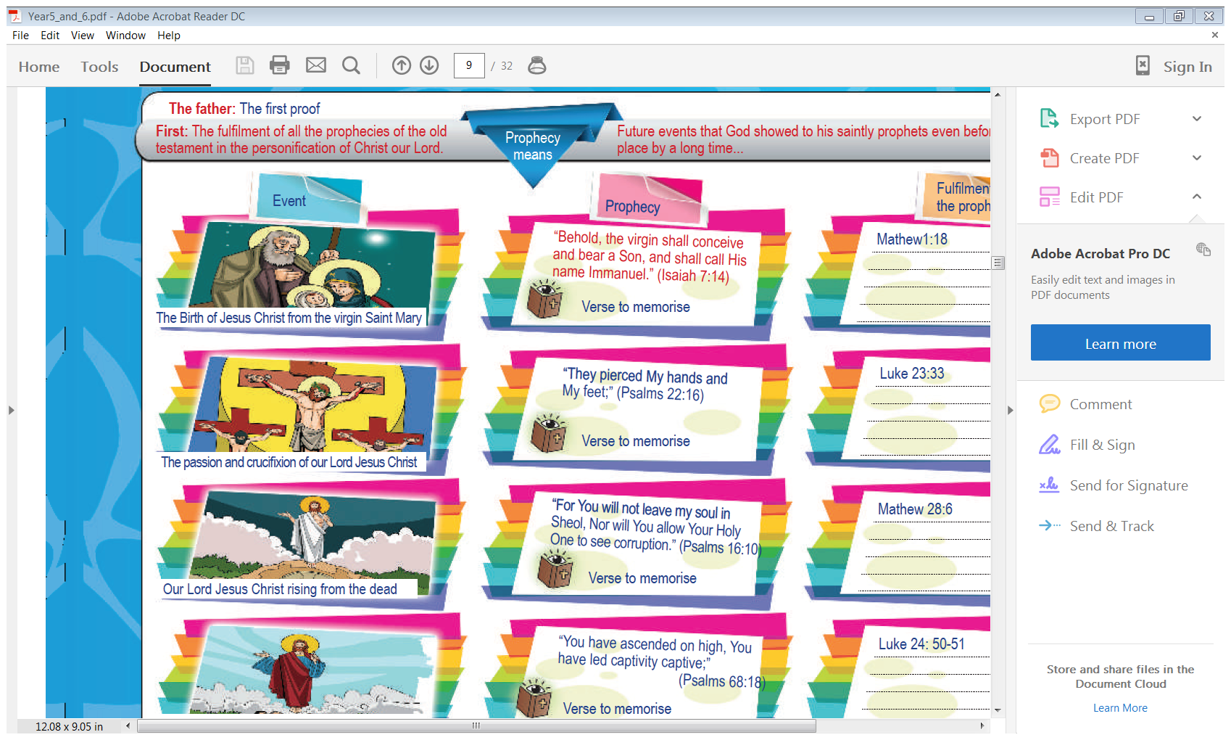**Memory Bible Passage: John 10: 11-18**

***11“I am the good shepherd. The good shepherd gives His life for the sheep.***

***12But a hireling, he who is not the shepherd, one who does not own the sheep,***

***sees the wolf coming and leaves the sheep and flees; and the wolf catches the sheep and scatters them.***

***13The hireling flees because he is a hireling and does not care about the sheep.***

***14I am the good shepherd; and I know My sheep, and am known by My own.***

***15As the Father knows Me, even so I know the Father; and I lay down My life for the sheep.***

***16And other sheep I have which are not of this fold;***

***them also I must bring, and they will hear My voice; and there will be one flock and one shepherd.***

***17“Therefore My Father loves Me, because I lay down My life that I may take it again.***

***18No one takes it from Me, but I lay it down of Myself.***

***I have power to lay it down, and I have power to take it again. This command I have received from My Father.”***

* **Thursday 29th July:**

**Learn verse 11-13**

11“I am the good shepherd. The good shepherd gives His life for the sheep.

12But a hireling, *he who is* not the shepherd, one who does not own the sheep,

sees the wolf coming and leaves the sheep and flees; and the wolf catches the sheep and scatters them.

13The hireling flees because he is a hireling and does not care about the sheep.

**Question 4**

**Complete the table by finishing the sentences**

|  |  |
| --- | --- |
| 11“I am the good shepherd. |  |
| 12But a hireling, *he who is* not the shepherd, |  |
| sees the wolf coming and leaves the sheep and flees; |  |
| 13The hireling flees because he is a hireling |  |

And Again,

|  |  |
| --- | --- |
|  | The good shepherd gives His life for the sheep. |
|  | one who does not own the sheep, |
|  | and the wolf catches the sheep and scatters them. |
|  | and does not care about the sheep. |

* **Friday 29th July:**

**Question 5**

Put the sentences in the correct order by numbering the lines 1 to 4

* The hireling flees because he is a hireling and does not care about the sheep.
* sees the wolf coming and leaves the sheep and flees; and the wolf catches the sheep and scatters them.
* “I am the good shepherd. The good shepherd gives His life for the sheep.
* But a hireling, *he who is* not the shepherd, one who does not own the sheep,

**Question 6**

**Fill in the table by completing every second line**

|  |
| --- |
| 11“I am the good shepherd. The good shepherd gives His life for the sheep. |
|  |
| sees the wolf coming and leaves the sheep and flees; and the wolf catches the sheep and scatters them. |
|  |

And again,

|  |
| --- |
|  |
| 12But a hireling, *he who is* not the shepherd, one who does not own the sheep, |
|  |
| 13The hireling flees because he is a hireling and does not care about the sheep. |

**Saturday 1st August:**

**Learn verse 13-15**

14I am the good shepherd; and I know My *sheep,* and am known by My own.

15As the Father knows Me, even so I know the Father; and I lay down My life for the sheep.

16And other sheep I have which are not of this fold;

them also I must bring, and they will hear My voice; and there will be one flock *and* one shepherd.

**Question 7**

**Complete the table by finishing the sentences**

|  |  |
| --- | --- |
| 14I am the good shepherd; |  |
| 15As the Father knows Me, even so I know the Father; |  |
| 16And other sheep |  |
| them also I must bring, and they will hear My voice; |  |

And again,

|  |  |
| --- | --- |
|  | and am known by My own. |
|  | and I lay down My life for the sheep. |
|  | I have which are not of this fold; |
|  | and there will be one flock *and* one shepherd. |

***What to do when you finish your memorisation***

***Hand in a hard copy of the study to your Bible Study servants next Sunday.***

***Click on the following link to see how many points you have.***

***Click on the following link to see how many points you have.***

*(Hold Ctrl and left click with your mouse on the following link* ***OR*** *copy and paste the link into your browser)*

**Year 3A (St Bishoy)**

<https://docs.google.com/spreadsheets/d/1n50G0dKZtJp9RWRK8pPrZBlwfk5FfJ4iVBSI9rw_vaY/edit?usp=sharing>

**Year 3B (St Shenouda)**

<https://docs.google.com/spreadsheets/d/1_95U1Mh8YbvfPowxk0A1nqM2bd9cfUAuH4pDQFjxKPE/edit?usp=sharing>