MC900383922[1]Sunday 12th July, 2015

Name:

Class:

Finish Date: Saturday 18th July, 2015

Completed Bible Study = 15 points

Homework handed in by the due date = 5 points

Homework handed in as a hard copy and answers are hand written = 10 points

**Year 3 Memorisation homework**

For the festival you are required to learn the following memory verses. These will be tested in a written examination on Saturday 15th August.

If you are not enrolled in the festival you are also expected to do your best to learn the verses. This will replace your regular Bible Study homework.

**Part 1: My faith is steady and strong**

For the festival you are required to learn the following memory verses. These will be tested in a written examination on Saturday 15th August.

* **1 John 5:7**
* **2 Timothy 3:16**
* **Matthew 28:19-20**
* **Acts 17: 27-28**
* **Genesis 39:2**
* **Nehemiah 2:20**
* **Psalm 23**
* **John 10: 11-1**
* **Monday 13th July**

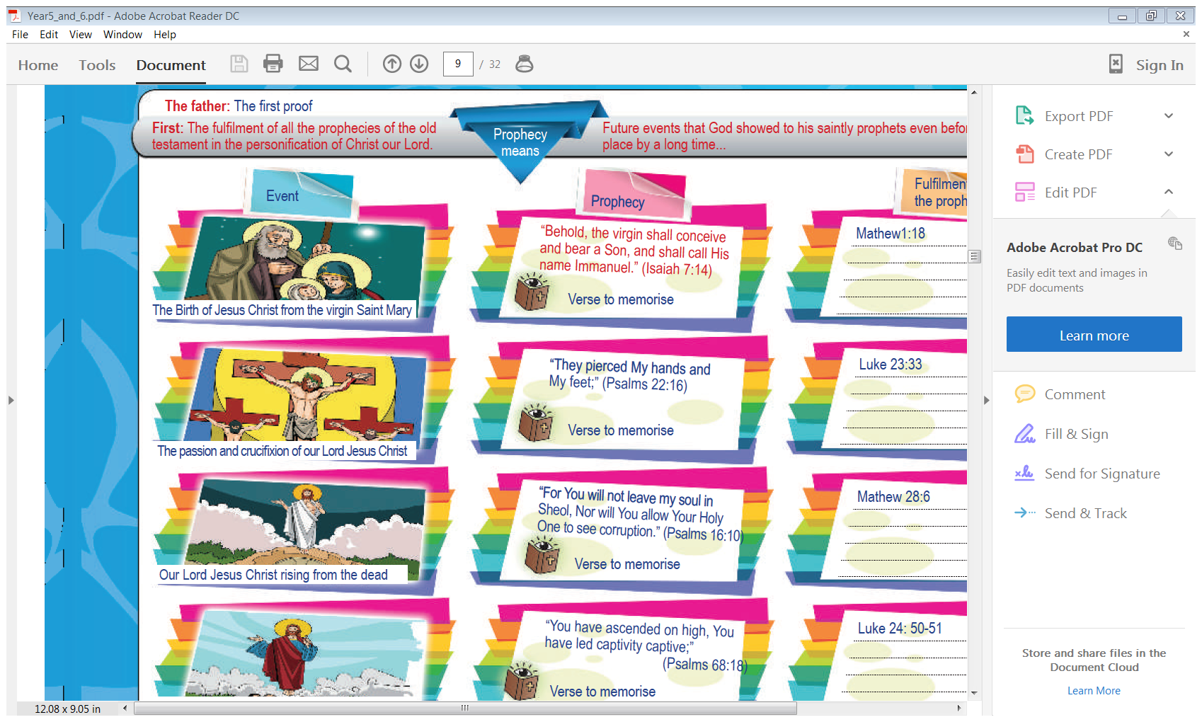

**Memory verse: 1 John 5:7**

**“For there are three that bear witness in heaven: the Father, the Word, and the Holy Spirit”**

**Question 1**

Complete the verses.

1. For there are three that bear witness in heaven:
2. the Father, the Word, and the Holy Spirit”

**Question 2**

Fill in the missing words.

“For there are that bear in heaven: the , the ,

and the Holy Spirit”.

**Question 3**

Complete each word in the sentence. Each box contains only one word. The first letter of each word has been done for you. Boxes shaded in pink do not have any words.

|  |  |  |  |  |  |  |  |  |
| --- | --- | --- | --- | --- | --- | --- | --- | --- |
| F | t | a | t | t | b | w | i | H |
| t | F | t | w | a | t | H | S |  |

* **Tuesday 14th July**

**Part 2: My Book is dear and precious**



**Memory verse: 2 Timothy 3:16**

***“All Scripture is given by inspiration of God, and is profitable for doctrine, for reproof, for correction, for instruction in righteousness.”***

**Question 4:**

Match the following words/phrases to their meaning.

Scripture, inspiration of God, profitable for doctrine, reproof, for correction, instruction in righteousness.

|  |  |
| --- | --- |
| **Word/phrase** | **Meaning** |
|  | Holy Bible |
|  | is useful for teaching God’s word |
|  | To show how to change bad behaviour into good behaviour pleasing to God |
|  | Warning, talking to, rebuke, reprimand, discipline. |
|  | The Word of God is given to you to learn how to be blameless and avoid sin. Study and apply God’s word to help you to be honest and good. |
|  | Given by God. It is from God's heart and His mind to the writers |

**Question 5**

Fill in the missing words

1. and is profitable for doctrine, for reproof, for correction, for instruction in righteousness.”
2. “All Scripture is given by inspiration of God,

**Question 6**

Complete each word in the sentence. Each box contains only one word. The first letter of each word, and the first and last word in each line has been done for you. Boxes shaded in yellow do not have any words.

|  |  |  |  |  |  |  |  |  |
| --- | --- | --- | --- | --- | --- | --- | --- | --- |
| All | s | h | b | g | b | i | o | God |
| and | i | p | f | d | f | reproof |  |  |
| for | c | i | i | righteouness |  |  |  |  |

* **Wednesday 15th July**

**Memory verse: Matthew 28:19-20**

***"Go therefore and make disciples of all the nations, baptizing them to observe all things that I have commanded you; and lo, I am with you always, even to the end of the age.”***

**Question 7**

Complete the table by finishing the sentences

|  |  |
| --- | --- |
| "Go therefore and make disciples |  |
| baptizing them to observe |  |
| and lo, I am with you always |  |

And again,

|  |  |
| --- | --- |
|  | of all the nations, |
|  | all things that I have commanded you |
|  | and lo, I am with you always |

**Question 7**

After you have spent time learning the verse put the sentences in the correct order by numbering the phrases 1 to 5

baptizing them to observe all things

and lo, I am with you always

even to the end of the age

that I have commanded you;

Go therefore and make disciples of all the nations

**Question 8**

Fill in the missing word.

"Go therefore and make of all the , baptizing them to

all things that I have you; and lo, I am with you , even to the

end of the .”

**Question 9**

Complete each word in the sentence. Each box contains only one word. The first letter of each word, and the first and last word in each line has been done for you. Boxes shaded in pink do not have any words.

|  |  |  |  |  |  |  |  |  |  |  |
| --- | --- | --- | --- | --- | --- | --- | --- | --- | --- | --- |
| **Go** | **t** | **a** | **m** | **d** | **o** | **a** | **nations** |  |  |  |
| **baptising** | **t** | **t** | **o** | **a** | **t** | **t** | **I** | **h** | **c** | **you** |
| **and** | **l** | **I** | **a** | **w** | **y** | **always** |  |  |  |  |
| **even** | **t** | **t** | **e** | **o** | **t** | **a** |  |  |  |  |

* **Thursday 16th July**

**Part 3: I will be Honest to my God**

**Memory verse: Acts 17: 27-28**

**“though He is not far from each one of us; for in Him we live and move and have our being”**

**Question 10**

Fill in the missing words

“though He is not ; for in Him we and and

**Question 11**

Complete the verses

|  |  |
| --- | --- |
| “though He is not far |  |
| for in Him we live |  |

And again,

|  |  |
| --- | --- |
|  | far from each one of us |
|  | and move and have our being” |

**Question 12**

Complete each word in the sentence. Each box contains only one word. The first letter of each word, and the first and last word in each line has been done for you. Boxes shaded in pink do not have any words.

|  |  |  |  |  |  |  |  |  |  |  |
| --- | --- | --- | --- | --- | --- | --- | --- | --- | --- | --- |
| though | H | i | n | f | f | e | o | o | us |  |
| for | i | H | w | l | a | m | a | h | o | being |

* **Friday 17th July**

 **Part 4: Let’s be successful**

**Memory verse: Genesis 39:2**

***2The Lord was with Joseph, and he was a successful man;***

**Question 13**

Learn the verse and fill in the missing phrases

1. 2The Lord was with Joseph
2. and he was a successful man;

**Question 14**

Complete each word in the sentence. The first letter has been done for you.

|  |  |  |  |  |  |  |  |  |  |  |
| --- | --- | --- | --- | --- | --- | --- | --- | --- | --- | --- |
| **T** | **L** | **w** | **w** | **J** | **a** | **h** | **w** | **a** | **s** | **m** |

**Question 15**

Where can you find this verse in the Bible?

* **Saturday 18th July**

**Part 5: We should help our nation**

**Memory verse: Nehemiah 2:20**

***“The God of Heaven Himself will prosper us: therefore we His servants will arise and build.”***

**Question 15**

Fill in the missing word

“The God of Himself will us: therefore we His will arise

and

**Question 16**

Complete the sentences in the table

|  |  |
| --- | --- |
| “The God of Heaven |  |
| therefore we His servants |  |
|  | Himself will prosper us |
|  | servants will arise and Build.” |

**Question 17**

Complete each word in the sentence. The first letter has been done for you.

|  |  |  |  |  |  |  |  |  |  |  |  |  |  |  |  |
| --- | --- | --- | --- | --- | --- | --- | --- | --- | --- | --- | --- | --- | --- | --- | --- |
| T | G | o | H | H | w | p | u | t | w | H | s | w | a | a | b |

**Question 18**

Complete the table by writing down the Bible reference for each memorisation. The first part of each memorisation is included.

|  |  |
| --- | --- |
| **Memory verse/passage** | **Bible Reference** |
| "Go therefore and make disciples of all the nations, baptizing them to observe all things that I have commanded you; and lo, I am with you always, even to the end of the age.” |  |
| “The God of Heaven Himself will prosper us: therefore we His servants will arise and build.” |  |
| “though He is not far from each one of us; for in Him we live and move and have our being” |  |
| 2The Lord was with Joseph, and he was a successful man; |  |
| “For there are three that bear witness in heaven: the Father, the Word, and the Holy Spirit” |  |

***What to do when you finish your memorisation***

***Hand in a hard copy of the study to your Bible Study servants next Sunday.***

***Click on the following link to see how many points you have.***

***Click on the following link to see how many points you have.***

*(Hold Ctrl and left click with your mouse on the following link* ***OR*** *copy and paste the link into your browser)*

**Year 3A (St Bishoy)**

<https://docs.google.com/spreadsheets/d/1n50G0dKZtJp9RWRK8pPrZBlwfk5FfJ4iVBSI9rw_vaY/edit?usp=sharing>

**Year 3B (St Shenouda)**

<https://docs.google.com/spreadsheets/d/1_95U1Mh8YbvfPowxk0A1nqM2bd9cfUAuH4pDQFjxKPE/edit?usp=sharing>