C:\Documents and Settings\suzy\Local Settings\Temporary Internet Files\Content.IE5\3JXW24R5\MC900383922[1].wmfSunday 16th August, 2015

Name:

Class:

Finish Date: Saturday 22nd August, 2015

Completed Bible Study = 15 points

Email Homework by the due date = 5 points

**Year 3 Bible Study Competition Revision Mark Chapters 1-8**

**For the questions below Highlight, underline or change the font colour to choose the correct answer.**

* Monday 17th August:

**Question 1**

John the Baptist was clothed with

* 1. Camel’s hair
  2. Oxen’s hair
  3. Cattle’s hair

**Question 2**

The book of Mark is the __________ book of the New Testament.

* 1. First
  2. Second
  3. Third

**Question 3**

John the Baptist came:

* + 1. Baptising in the wilderness
    2. Preaching a Baptism of Repentance for the remission of sins.
    3. All of the above

**Question 4**

“The time is fulfilled, and the Kingdom of God is at hand. Repent, and believe in the gospel.” Who said this?

* + 1. John The Baptist
    2. Herod
    3. Jesus

**Question 5**

How long was Jesus tempted in the wilderness:

* + 1. One day
    2. Twelve days.
    3. Forty days
    4. None of the above
* Tuesday 18th August:

**Question 6**

What did Jesus do for Peter’s mother-in-law?

* + 1. Stopped her bleeding
    2. Healed her withered arm
    3. Healed her of paralysis
    4. None of the above

**Question 7**

What was the first thing that Jesus said to the paralysed man when he was lowered down through the roof:

* + 1. Go and sin no more
    2. Take up your bed and walk
    3. Your sins are forgiven you
    4. None of the above

**Question 8**

Jesus healed a woman who was bleeding for many years. How many years did she bleed for?

* + 1. Seven years
    2. Twelve years
    3. Thirty-eight years
    4. None of the above

**Question 9**

Whose daughter did Jesus bring back to life?

* + 1. Jairus
    2. Nobleman
    3. Widow of Nain
    4. None of the above

**Question 10**

Who did Herod think Jesus was?

* + 1. Elijah
    2. John the Baptist
    3. Isaiah
    4. None of the above
* Wednesday 19th August:

**Question 11**

What did Jesus say would defile a man?

* + 1. Eat blood
    2. Eat with unwashed hands
    3. Eat unclean animals
    4. None of the above

**Question 12**

Jesus talked about Taking Up the Cross and Follow Him, He said:

* + 1. “Whoever desires to come after Me, let him deny himself, and take up his cross, and follow Me.
    2. For whoever desires to save his life will lose it, but whoever loses his life for My sake and the gospel’s will save it.
    3. For what will it profit a man if he gains the whole world, and loses his own soul?
    4. All of the above

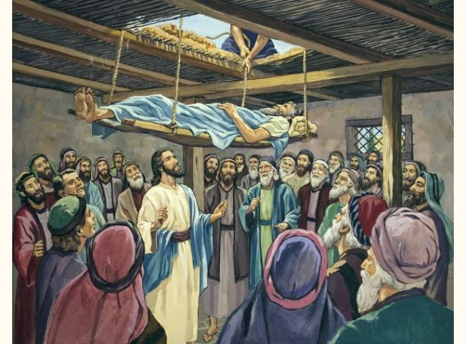**Question 13**

In the picture,

* 1. Who is the man lying on the bed?
  2. Who are letting the bed down?
  3. Why did they do that?

**Question 14**

**Match the following words to their meanings and pictures.**

***(The first one has been done for you)***

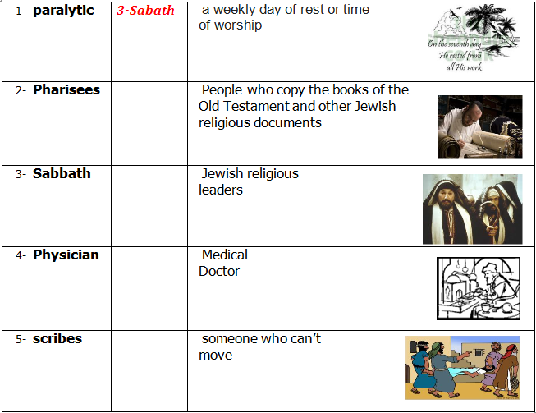

**Question 15**

**Fill in the missing words.**

Jesus said, “Here are My mother and My brothers! For whoever does

is My brother and My sister and mother.”

* Thursday 20th August:

**Question 16**

There is nothing that enters a man from which can defile him; but the

things which come him, those are the things that

If anyone has to hear, let him hear!”

**Question 17**

Match the meaning

|  |  |  |
| --- | --- | --- |
| A The Sower is | C | immediately receive it with gladness; 17and they have no root  in themselves, and so endure only for a time. Afterward, when  tribulation or persecution arises for the word’s sake,  immediately they stumble. |
| B these are the ones by the wayside where the word is sown. |  | God the Word |
| C the ones sown on stony ground who, when they hear the word, |  | *they are* the ones who hear the word, 19and the cares of this  world, the deceitfulness of riches, and the desires for other  things entering in choke the word, and it becomes unfruitful. |
| D Now these are the ones sown among thorns; |  | those who hear the word, accept *it,* and bear fruit: some  thirtyfold, some sixty, and some a hundred.” |
| E But these are the ones sown on good ground, |  | When they hear, Satan comes immediately and takes away  the word that was sown in their hearts. |

**Question 18**

Highlight the correct answer

1. The religious leaders of Jesus’ day thought that they were so good that they did not need (*the Grace of God / the Law*) to save them. As far as they were concerned, as long as they kept to their rituals and ceremonies.
2. “Then He charged them, saying, “Take heed, beware of the leaven of the Pharisees and the leaven of Herod.” As used by Jesus in Mark 8:15, "leaven" refers to a *(corrupting influence / good influence).*

**Question 19**

**Underline** the correct answer:

Jesus, when He spoke of the master who sent out his servants to collect what was due to him from his tenants. But instead of receiving the rents the servants were beaten before they were mockingly sent back empty handed! The master is *(God the Son / God the Father).*

**Question 20**

Underline the correct answer

Transgressors are *(means of transport / crime doers)*

* Friday 21st August:

**Question 21**

Underline the correct answer

Jesus said, “If you can believe, all things *are* *(possible / impossible)* to him who believes.”

**Question 22**

Underline the correct answer

And He sat down, called the twelve, and said to them, “If anyone desires to be first, he shall be *(best / last)* of all and *(servant / master)* of all.”

**Question 23**

Underline the correct answer

*(Salt / Sugar) is* good, but if the *(salt / sugar)* loses its flavour, how will you season it? Have salt in yourselves, and have peace with one another.”

**Question 24**

Who said the following?

“The Son of Man is being betrayed into the hands of men, and they will kill Him. And after He is killed, He will rise the third day.”

**Question 25**

Who said the following?

“There comes One after me who is mightier than I, whose sandal strap I am not worthy to stoop down and loose. I indeed baptized you with water, but He will baptize you with the Holy Spirit.”

* Saturday 22nd August: :

**Question 26**

Who said the following?

**“**Yes, Lord, yet even the little dogs under the table eat from the children’s crumbs.”

**Question 27**

Who said the following?

“Let us alone! What have we to do with You, Jesus of Nazareth? Did You come to destroy us? I know who You are—the Holy One of God!”

**Question 28**

Match the phrase with the picture

|  |  |  |  |
| --- | --- | --- | --- |
| **Phrase** |  |  | **Picture** |
| ***A “Be of good cheer! It is I; do not be afraid.”*** |  | **1** | **http://dailytimewithgod.com/http:/dailytimewithgod.com/wp-content/uploads/2012/2013/02/healing.jpg** |
| **B Then, looking up to heaven, He sighed, and said to him, “Ephphatha,” that is, “Be opened.”** |  | **2** | **http://christianselfstudy.com/moodle/pluginfile.php/232/mod_page/intro/HL%20Intro.jpg** |
| **C Then Jesus, moved with compassion, stretched out *His* hand and touched him, and said to him, “I am willing; be cleansed.”** |  | **3** | **http://www.covenanteyes.com/lemonade/wp-content/uploads/2008/04/blind.jpg** |
| **D A Blind Man Healed at Bethsaida** |  | **4** | **http://2.bp.blogspot.com/_cdQiqCoJkfs/TSQly4tIxAI/AAAAAAAAAos/eACOsmGBmzM/s1600/JesusWalkingOnWater.jpg** |

**Question 29**

In Mark 8, we read that Jesus was questioned about who He is .

1. To whom did Jesus ask “But who do you say that I am?”
2. What was the answer?

1. Who answered the question?

**Question 30**

Look up verse Mark 6:49-51

Write it down in the textbox below.

Happy Feast of St Mary

***What to do when you finish your Bible Study.***

1. ***Either send it by email to your class email address or print and hand it to your servants next Sunday.***
2. ***If you want to send your Bible Study by email, please select your class email address below:***

**Year 3A St Bishoy**

[stbishoy3a@gmail.com](mailto:stbishoy3a@gmail.com) Uncle Emil

**Year 3B St Shenouda**

[stshenouda3b@gmail.com](mailto:stshenouda3b@gmail.com) Aunty Carol

1. ***Click on the following link to see how many points you have.***

*(Hold Ctrl and left click with your mouse on the following link* ***OR*** *copy and paste the link into your browser)*

**Year 3A (St Bishoy)**

<https://docs.google.com/spreadsheets/d/1n50G0dKZtJp9RWRK8pPrZBlwfk5FfJ4iVBSI9rw_vaY/edit?usp=sharing>

**Year 3B (St Shenouda)**

<https://docs.google.com/spreadsheets/d/1_95U1Mh8YbvfPowxk0A1nqM2bd9cfUAuH4pDQFjxKPE/edit?usp=sharing>