Word List
Preparation,
Resurrection,
Samaritan Woman,
Lost Son,
Seek God,
Paralytic Man,
Temptation,
Man born Blind,
Palm Sunday,

Yr 6 Bible Study – John 9
Name: ____________ Total / 15
Q1) Use the word list on the right to identify the weeks of the Holy Lent fast:
(7 marks)
Week 0: Preparation, Week 1: _____________, Week 2: ______________,
Week 3: __________, Week 4: ____________, Week 5: ______________,
Week 6:__________, Week 7: _____________, Week 8: Resurrection

Q2) Which week of the lent does John 9 refer to? (1 mark)
________________________________________________________________________________
Q3) How did Jesus heal the blind man? (1 mark)
________________________________________________________________________________
Q4) Where in the Old Testament did God use the dust of the ground (ie clay) and what was it used for? (2 marks)
_______________________________________________________________________________________________________________________________________________________________________________________________________________________________________________
Q5) What did the Pharisees say Jesus did wrong? (1 mark)
_______________________________________________________________________________________
Q6) What did the man’s parents say to the Pharisees? Why? (Hint Read v 21&22) (2 marks)
_____________________________________________________________________________________________________________________________________________________________________________________________________________________________________________________________________
Q7) What did Jesus ask the man near the end? (1 mark)
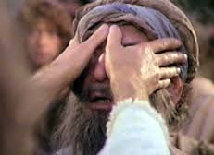
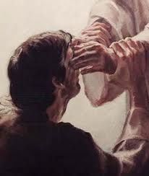
_______________________________________________________________________________________

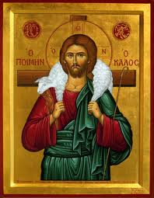
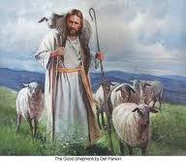
Yr 6 Bible Study – John 10
Name: ____________ Total / 15
Answer the following questions TRUE or FALSE. However each of your answers must have a least one verse as a reference.
For example: Q) Sheep will go to anyone who calls to them. Answer: FALSE (Verses 5, 8, 12-13)
Q1) A good shepherd will lay down his life to save his sheep. (1 mark)
________________________________________________________________________________

Q2) Strangers and hired men will kill a wolf trying to hurt the sheep. (1 mark)
________________________________________________________________________________

Q3) Good shepherd don’t have to enter the door to be good. (1.5 mark)
________________________________________________________________________________

Q4) Jesus describes Himself as the door and the good shepherd. (1.5 mark)
________________________________________________________________________________

Q5) The sheep recognize their own shepherd by his voice. (1.5 mark)
________________________________________________________________________________

Q6) Jesus is trying to figure out who His sheep are. (1.5 mark)
________________________________________________________________________________

Q7) Jesus says He knows His sheep like the Father knows Him. (1.5 mark)
________________________________________________________________________________

Q8) Jesus was forced to die for His sheep. (1.5 mark)
________________________________________________________________________________

Q9) The thief comes to steal, kill, and destroy Jesus’ sheep. (1.5 mark)
________________________________________________________________________________

Fill in the blank: (2.5 marks)
“ I am the good _ _ _ _ _ _ _ _ . The _ _ _ _ shepherd gives His _ _ _ _ for the _ _ _ _ _ ” John 10 : _ _
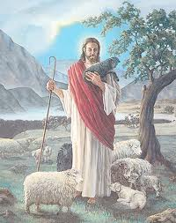
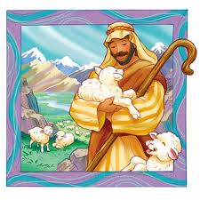
“I am the good shepherd, and I _ _ _ _ My _ _ _ _ _ and am _ _ _ _ _ by My _ _ _.” John 10 : _ _

