**Learn and Memorise Psalm 1**

**Bonus Points: 100 points**

C:\Documents and Settings\suzy\Local Settings\Temporary Internet Files\Content.IE5\3JXW24R5\MC900383922[1].wmfSunday 30th August, 2015

Name:

Class:

Finish Date: Saturday 29th August, 2015

Completed Bible Study = 15 points

Email Homework by the due date = 5 points

**Year 3 Bible Study Psalm 1 Part 1 Vs 1-2**

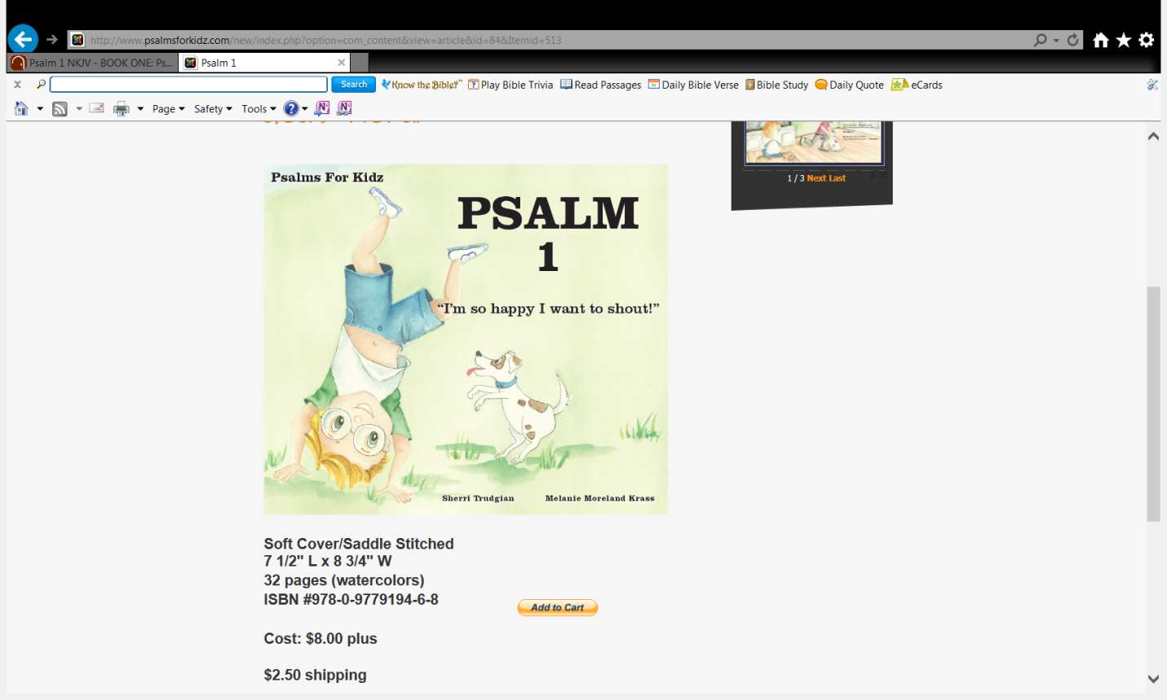

* Monday 31st August: Read **Psalm 1: 1** and answer the questions:

1Blessed *is* the man  
Who walks not in the counsel of the ungodly,  
Nor stands in the path of sinners,  
Nor sits in the seat of the scornful;

**Understand Meanings of words**

|  |  |
| --- | --- |
| Word | Meaning |
| counsel | Advice/guidance |
| ungodly | People who don't believe in God |
| path | way |
| scornful | Disrespectful/make fun of |

**Question 1**

What does Verse 1 tell us?

Use the words/phrases below to fill in the blanks

advice, Blessed , heavenly, Lord , make fun of , teachings

The first verse tells us that those who are “ ” or “happy” people **do not** do three things:

* Listen to that is only worldly and not ;
* Stand with people or ideas that care nothing about the ;
* Sit with people or ideas that or scorn the Lord’s .

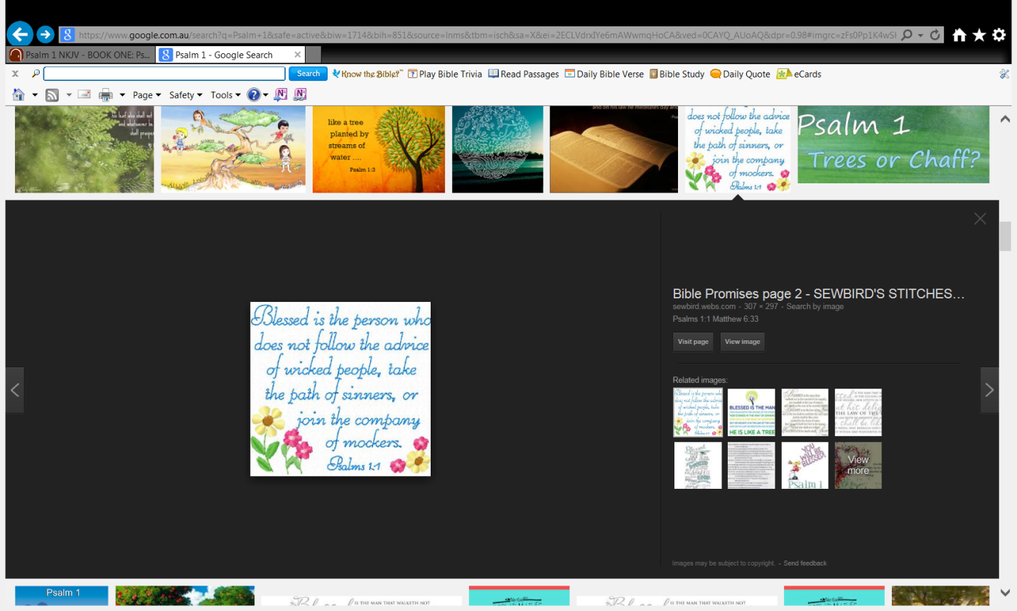

* Tuesday 1st September: Memorise **Psalm 1:1**

1Blessed *is* the man  
Who walks not in the counsel of the ungodly,  
Nor stands in the path of sinners,  
Nor sits in the seat of the scornful;

**Question 2**

To help you memorise Fill in the missing words:

1Blessed

Who walks not

Nor stands in

Nor sits

**And again**

1 *is* the man

in the counsel of the ungodly,

the path of sinners,

in the seat of the scornful;

* Wednesday 2nd September: Read **Psalm 1:2** and answer the questions:

2But his delight *is* in the law of the Lord,  
  And in His law he meditates day and night.

**Understand Meanings of words**

|  |  |
| --- | --- |
| Word | Meaning |
| delight | joy |
| meditates | Reflects and thinks deeply about the word of God |

**Question 3**

What does Verse 1 tell us?

Use the words/phrases below to fill in the blanks

truth, happy

The second versetells us that a blessed or person is one who looks to the Lord

and the for guidance.

* Thursday 3rd September: Memorise **Psalm 1:2** and answer the questions:

**Question 4**

To help you memorise Fill in the missing words:

2But his delight *is*

  And in His law he

**And again:**

2 in the law of the Lord,

   meditates day and night.

* Friday 4th September: Review **Psalm 1:1** and answer the questions:

**Question 5**

Finish the verse by filling in the table below

|  |  |
| --- | --- |
| **Beginning of verse** | **End of verse** |
| Blessed *is* |  |
| Who walks not |  |
| Nor stands in |  |
| Nor sits |  |
| But his delight *is* in |  |
| And in His law he |  |

* Saturday 5th September: Practise Memorisation. Psalm 1:1-2

**Question 6**

To help you memorise Fill in the missing words:

1Blessed

Who walks not

Nor stands in

Nor sits

To help you memorise Fill in the missing words:

2But his delight *is*

  And in His law he

**And again:**

1 *is* the man

in the counsel of the ungodly,

the path of sinners,

in the seat of the scornful;

2 in the law of the Lord,

   meditates day and night.

***What to do when you finish your Bible Study.***

1. ***Either send it by email to your class email address or print and hand it to your servants next Sunday.***
2. ***If you want to send your Bible Study by email, please select your class email address below:***

**Year 3A St Bishoy**

[stbishoy3a@gmail.com](mailto:stbishoy3a@gmail.com) Uncle Emil

**Year 3B St Shenouda**

[stshenouda3b@gmail.com](mailto:stshenouda3b@gmail.com) Aunty Carol

1. ***Click on the following link to see how many points you have.***

*(Hold Ctrl and left click with your mouse on the following link* ***OR*** *copy and paste the link into your browser)*

**Year 3A (St Bishoy)**

<https://docs.google.com/spreadsheets/d/1n50G0dKZtJp9RWRK8pPrZBlwfk5FfJ4iVBSI9rw_vaY/edit?usp=sharing>

**Year 3B (St Shenouda)**

<https://docs.google.com/spreadsheets/d/1_95U1Mh8YbvfPowxk0A1nqM2bd9cfUAuH4pDQFjxKPE/edit?usp=sharing>