**Learn and Memorise all Psalm 1**

**You have 3 weeks to learn it**

**Bonus Points: 100 points**

C:\Documents and Settings\suzy\Local Settings\Temporary Internet Files\Content.IE5\3JXW24R5\MC900383922[1].wmfSunday 6th September, 2015

Name: Edited

Class: Change dates

Finish Date: Saturday 12th September, 2015

Completed Bible Study = 15 points

Email Homework by the due date = 5 points

**Year 3 Bible Study Psalm 1 Part 1 Vs 3-4**

* Monday 7th September: Read **Psalm 1: 3** and answer the questions:

He shall be like a tree  
Planted by the rivers of water,  
That brings forth its fruit in its season,

Whose leaf also shall not wither;  
And whatever he does shall prosper

**Question 1**

Match the following words with the correct meanings.

Words: River, Season, forth, wither, prosper

(Hint: Use a dictionary will help you)

|  |  |
| --- | --- |
| **Word** | **Meaning** |
|  | To become dry and shrivelled |
|  | To flourish/make successful |
|  | Natural stream of water |
|  | Four divisions of the year (spring, summer, autumn and winter) |
|  | Forward |

* Tuesday 8th September: Memorise **Psalm 1:3**

He shall be like a tree  
Planted by the rivers of water,  
That brings forth its fruit in its season,

Whose leaf also shall not wither;  
And whatever he does shall prosper

**Question 2:**

Memorise Psalm 1 verse 3.

To help you do this, fill in the blanks below

(Hint: You will find all the missing words in verse 3)

He shall be like a

,

planted by the

That brings forth its fruit in

,

Whose leaf also shall wither;

And whatever shall

**Question 3:**

Identify the verse number on the picture below

(Hint: Read the verse you have just memorised)

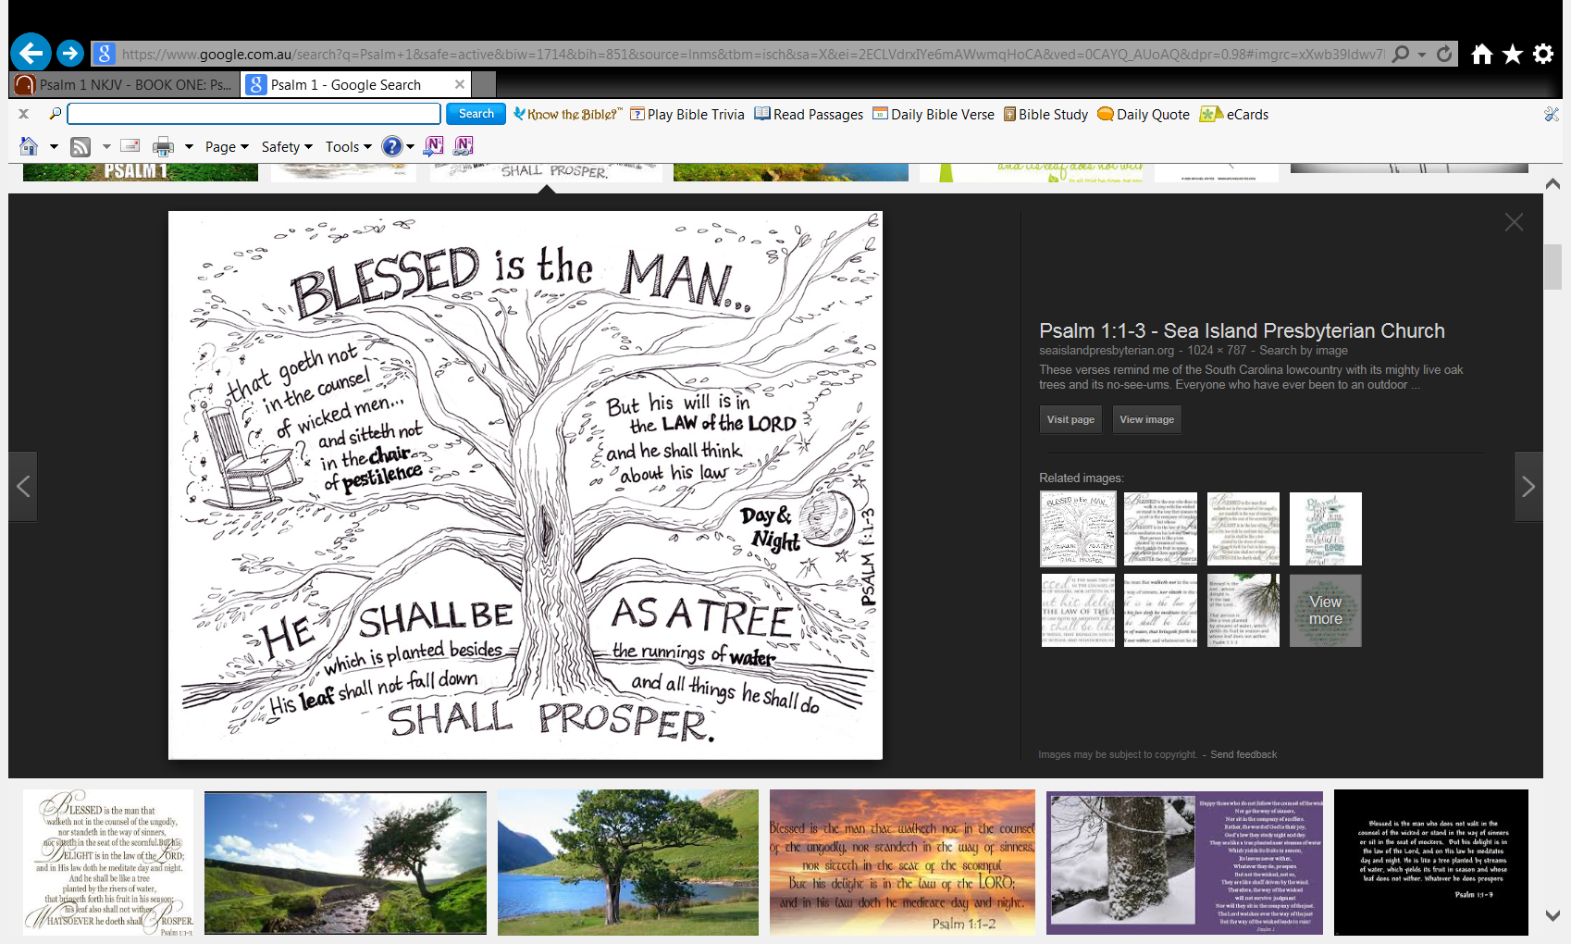

Verse:

Verse:

Verse:

Wednesday 9th September: Read **Psalm 1:4** and answer the questions:

The ungodly are not so,  
But are like the chaff which the wind drives away.

**Question 4**

Below is a picture of “chaff”. Chaff is the dry coverings of grains and grass seeds. It is very light and easily blown by the wind.

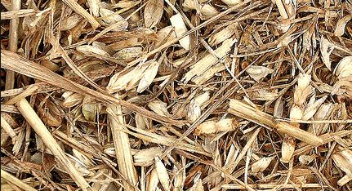

**What is compared to “chaff” in verse 4?**

**Question 5:**

**What does it mean to be “ungodly”?**

* Thursday 10th September: Memorise **Psalm 1:4** and answer the questions:

The ungodly are not so,  
But are like the chaff which the wind drives away.

**Question 6:**

**Why are the “ungodly” like the chaff that the wind drives away**

**Question 7**

The Ten commandments show us how we can be godly.

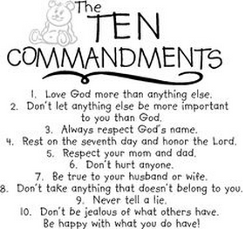

**Can you explain why it is important that we follow the Ten Commandments?**

* Friday 11th September: Review **Psalm 1:3-4** and answer the questions:

He shall be like a tree  
Planted by the rivers of water,  
That brings forth its fruit in its season,

Whose leaf also shall not wither;  
And whatever he does shall prosper

The ungodly are not so,  
But are like the chaff which the wind drives away.

**Question 8**

Have you learnt verse 3 and 4 off by heart. Test yourself, try and say it without looking.

* Saturday 12th September: Practise Memorisation. **Psalm 1:1-4**

**Question 9**

Do you remember verse 1 and 2 from last week’s homework?

Test yourself, try and say verses 1-4 without looking.

***What to do when you finish your Bible Study.***

1. ***Either send it by email to your class email address or print and hand it to your servants next Sunday.***
2. ***If you want to send your Bible Study by email, please select your class email address below:***

**Year 3A St Bishoy**

[stbishoy3a@gmail.com](mailto:stbishoy3a@gmail.com) Uncle Emil

**Year 3B St Shenouda**

[stshenouda3b@gmail.com](mailto:stshenouda3b@gmail.com) Aunty Carol

1. ***Click on the following link to see how many points you have.***

*(Hold Ctrl and left click with your mouse on the following link* ***OR*** *copy and paste the link into your browser)*

**Year 3A (St Bishoy)**

<https://docs.google.com/spreadsheets/d/1n50G0dKZtJp9RWRK8pPrZBlwfk5FfJ4iVBSI9rw_vaY/edit?usp=sharing>

**Year 3B (St Shenouda)**

<https://docs.google.com/spreadsheets/d/1_95U1Mh8YbvfPowxk0A1nqM2bd9cfUAuH4pDQFjxKPE/edit?usp=sharing>