Handed out Sunday 5th April
Name:
Class:
Date: 13th April
Completed Bible Study = 15 points
Handed in by the due date = 5 points
Passion Week
- Saturday 4th April- Lazarus Saturday
This day is not part of the Passion Week but it is interesting to know what happened the day before Palm Sunday
https://m.youtube.com/watch?v=eBY-3iXwwb0

- Jesus can raise Himself and other people from the dead.
Who did Jesus raise from the dead? How long was this person dead for?

- Sunday 5th April- Palm Sunday

https://m.youtube.com/watch?v=mq64oLGugp8

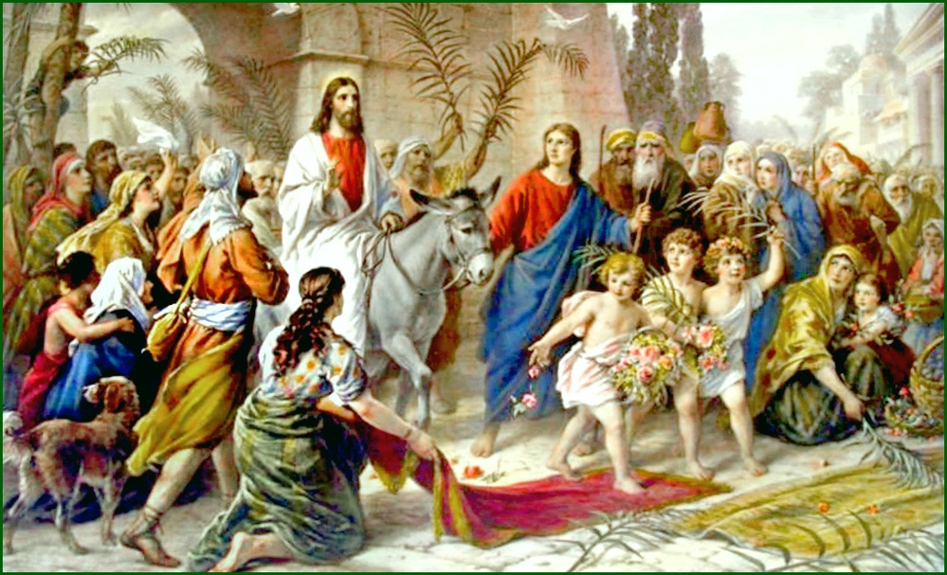
Jesus entered Jerusalem riding on a donkey. The people rejoiced at His coming and waved palms while shouting “Hosanna”.

- What does Hosanna mean?

- Sunday Night 5th April

https://vimeo.com/30389357

- What was the reason Jesus said why Mary poured very expensive fragrant oil on His feet?
To prepare for Jesus’s Buriel. True/False

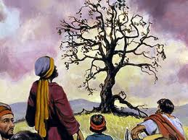
- Monday 6th April Monday of the Holy Pascha
Cursing of the Fig tree and cleansing of the Temple.
Jesus was hungry and he saw a fig tree, so he went to eat from it, but there were only leaves and no fruit. Jesus cursed the tree and said "you will never again bear fruits" and at once, the tree dried up.
https://vimeo.com/30387263
- Jesus cleansed the temple because people were treating the Holy Temple as a market place. People were buying and selling doves and other animals.
What should the Jews be doing instead?

- Tuesday 7th April of the Holy Pascha

Read Mark 11:27-33

Jesus’ Authority Questioned
²⁷ Then they came again to Jerusalem. And as He was walking in the temple, the chief priests, the scribes, and the elders came to Him. ²⁸ And they said to Him, “By what authority are You doing these things? And who gave You this authority to do these things?”
²⁹ But Jesus answered and said to them, “I also will ask you one question; then answer Me, and I will tell you by what authority I do these things: ³⁰ The baptism of John—was it from heaven or from men? Answer Me.”
³¹ And they reasoned among themselves, saying, “If we say, ‘From heaven,’ He will say, ‘Why then did you not believe him?’ ³² But if we say, ‘From men’”—they feared the people, for all counted John to have been a prophet indeed. ³³ So they answered and said to Jesus, “We do not know.”
And Jesus answered and said to them, “Neither will I tell you by what authority I do these things.”
- Jesus was given authority to heal, perform miracles and to forgive sins by God the Father.
True/False?

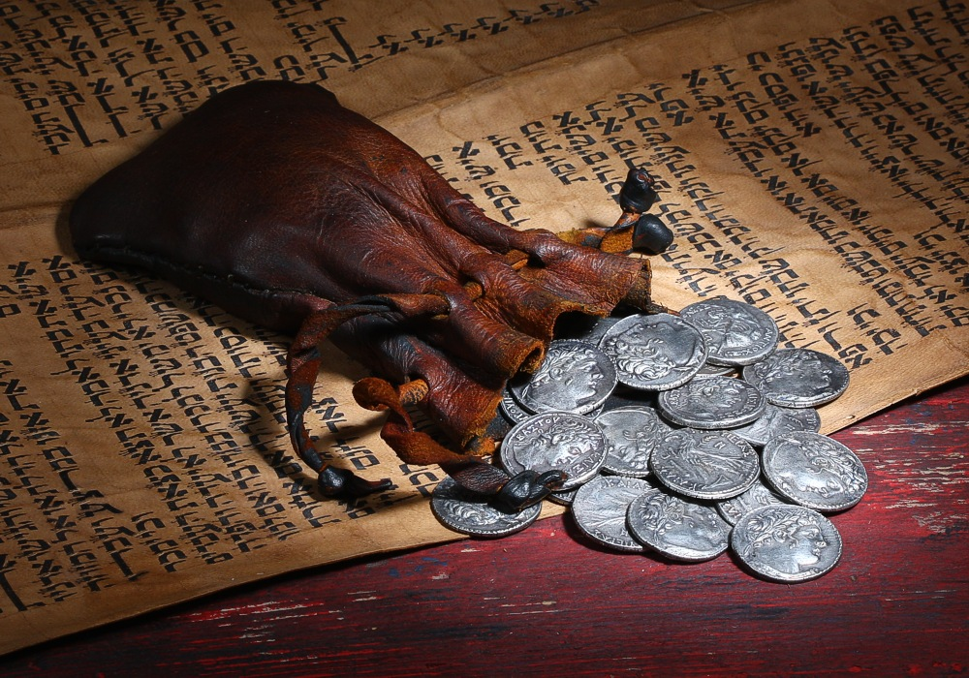
- Wednesday 8th April of the Holy Pascha

Luke 22:1-6 John 13:18-30 Matthew 26:47-50
https://www.youtube.com/watch?v=y6BGP17VmwI
- One of the twelve disciples went to the Chief priest and betrayed Jesus for 30 pieces of silver. That day also had the preparation for the Last Supper.
Name the disciple who betrayed Jesus.

- Thursday 9th April Covenant Thursday
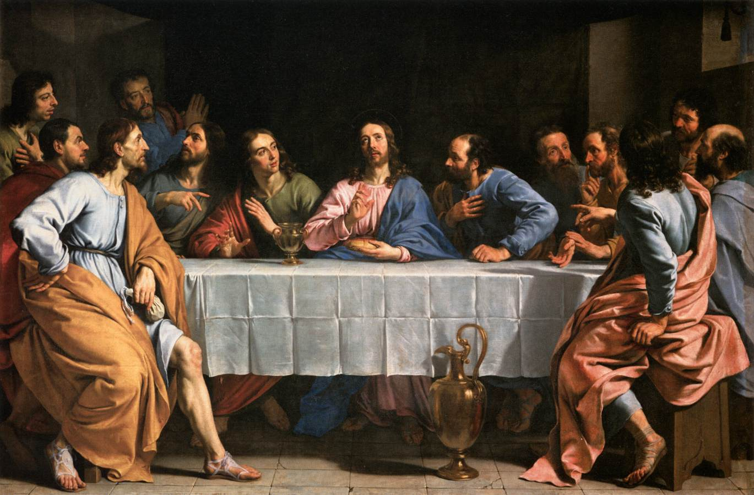
This was the night of the Last Supper.
Jesus washed the feet of His disciples and foretold them of His death and betrayal.
He went to Gethsemane that night and prayed to the Father until His sweat fell to the ground like great drops of blood.
He was betrayed by Judas with a kiss and arrested.

https://www.youtube.com/watch?v=vScHI_fxJGM

- When was the first Holy Communion given?

Summary of the week’s Events

https://www.youtube.com/watch?v=cTQ2ApEocuw

- Good Friday 10th April

The Crucifixion day

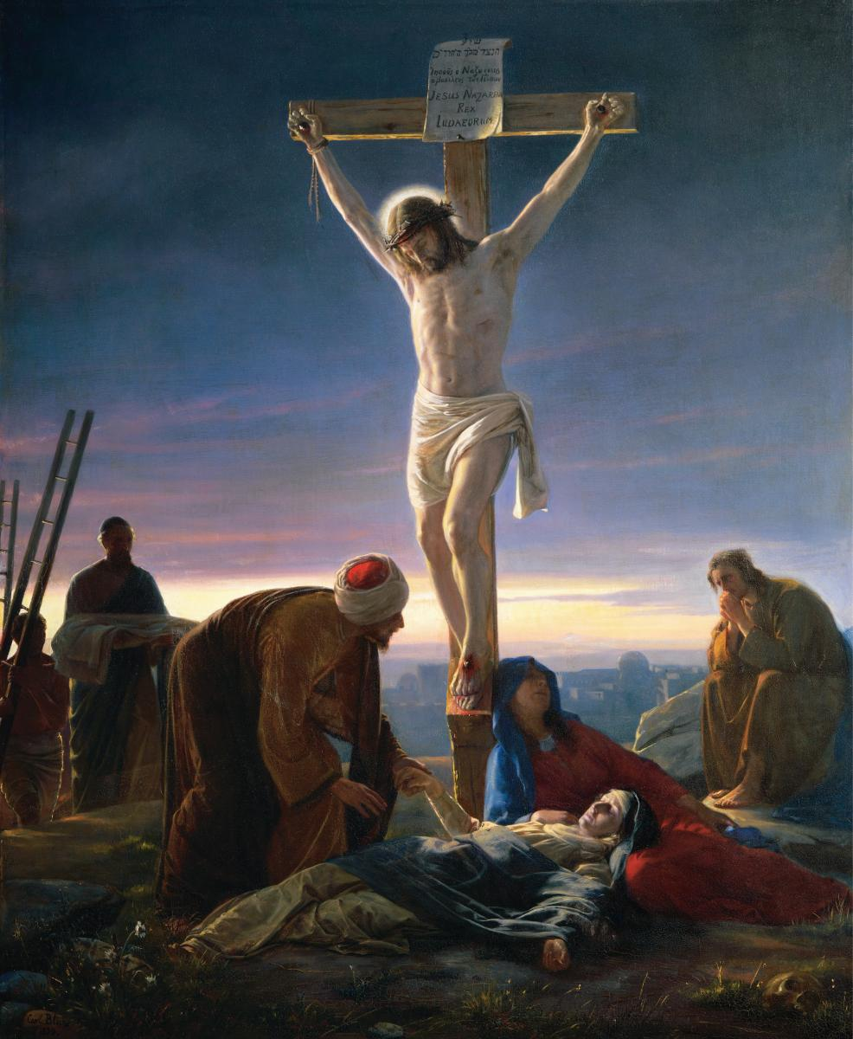
1st Hour
Jesus falsely accused of blasphemy. He was trialed in front of the chief priest and was sent to both Pilate and Herod

3rd Hour
Jesus was whipped 39 times
They placed a crown of thorns on His head, mocked Him and spat on His face
He carried His cross to Golgotha, falling underneath the weight of the cross.
Simon of Cyrene helped Jesus by carrying it with Him

6th Hour
The hour of Crucifixion
They nailed His hands and feet to the cross and placed a sign saying “King of the Jews”

9th Hour
Our Lord Jesus commanded His Spirit into the hands of the Father
The tombs opened and a lot of the dead were raised
The curtains in the temple were torn into two from top to bottom.
The rocks cracked and there was an earthquake

11th Hour
They pierced His side and both water and blood came gushing out.
Nicodemous and Joseph or Arimathea requested to take down the body of Christ

12th Hour
The hour of burial
Christ was laid in the tomb with

https://www.youtube.com/watch?v=gIDYvg73RuM

8. In this video Jesus is given a beam of wood to carry. This is not correct. What was Jesus given to carry?

- Joyous Saturday 11th April

Jesus entered into Hades and released the souls of the righteous people who were waiting for Christ to save them

- EASTER Sunday 12th April
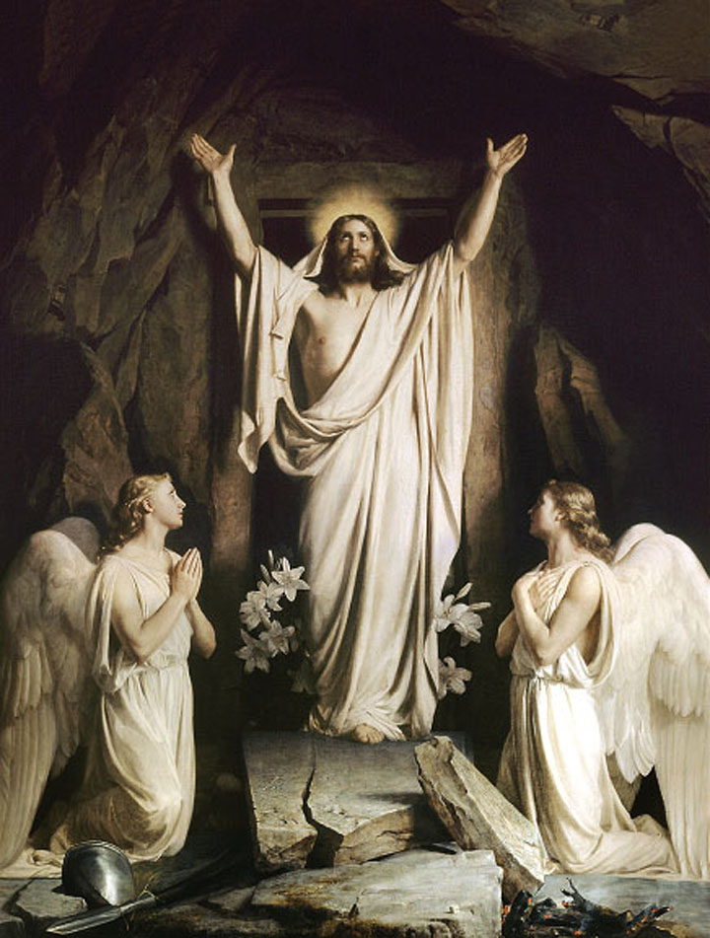

After 3 days in the tomb Christ rose from the dead.
He conquered death and brought us salvation

https://www.youtube.com/watch?v=G4g4qcFFwig

We say to each other after the mass on Easter Saturday
In Coptic (and Greek)
You say “Christos Anesti”:
Other people respond: Alethos Anesti
In English
You say “Christ has risen”:
Other people respond: “Indeed He has risen”

