C:\Documents and Settings\suzy\Local Settings\Temporary Internet Files\Content.IE5\3JXW24R5\MC900383922[1].wmfSunday 27th September, 2015

Name:

Class:

Finish Date: Saturday 3rd October, 2015

Completed Bible Study = 15 points

Email Homework by the due date = 5 points

**Year 5 Bible Study Matthew Chapter 26 Part 1 (Verse 1-35)**

**For the questions below Highlight, underline or change the font colour to choose the correct answer.**

* Monday 28th September: Read **Matthew Chapter 26: 1-5** and answer the questions:

### The Plot to Kill Jesus

*1 Now it came to pass, when Jesus had finished all these sayings, that He said to His disciples, 2“You know that after two days is the Passover, and the Son of Man will be delivered up to be crucified.”*

*3Then the chief priests, the scribes,and the elders of the people assembled at the palace of the high priest, who was called Caiaphas, 4and plotted to take Jesus by trickery and kill Him. 5But they said, “Not during the feast, lest there be an uproar among the people.”*

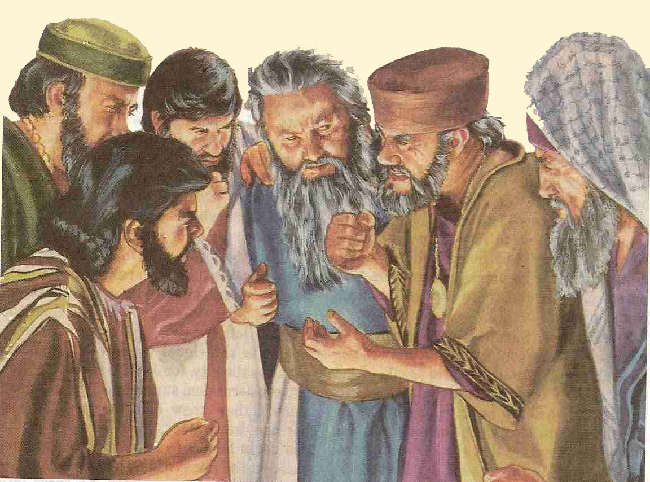**Question 1**

What was the Passover? You may need to ask someone at home to help.

1. The Jewish version of Christmas
2. A yearly celebration when the Jews remembered how God saved them from slavery in Egypt
3. A weekly dinner where Jews spent time with family

**Question 2**

Highlight TRUE or FALSE for the following questions:

1. In the passage above, Jesus predicted when He will be crucified TRUE / FALSE
2. The name of the high priest was called Cellophane TRUE / FALSE
3. The chief priests didn’t want to arrest Jesus straight away in case the people got angry with them TRUE / FALSE

* Tuesday 29th September: Read **Matthew Chapter 26: 6-13** and answer the questions:

### The Anointing at Bethany

*6And when Jesus was in Bethany at the house of Simon the leper, 7a woman came to Him having an alabaster flask of very costly fragrant oil, and she poured it on His head as He sat at the table. 8But when His disciples saw it, they were indignant, saying, “Why this waste? 9For this fragrant oil might have been sold for much and given to the poor.”*

*10But when Jesus was aware of it, He said to them, “Why do you trouble the woman? For she has done a good work for Me. 11For you have the poor with you always, but Me you do not have always. 12For in pouring this fragrant oil on My body, she did it for My burial. 13Assuredly, I say to you, wherever this gospel is preached in the whole world, what this woman has done will also be told as a memorial to her.”*

**Question 3**

Match the question in the left column with the correct answer in the right column by placing the correct letter next to the answer.

|  |  |  |
| --- | --- | --- |
| **Question** |  | **Answer** |
| A – What did the woman pour on Jesus’ head? |  | He told them to leave her alone as she was doing a good thing for Jesus. |
| B – Why were the disciples angry? |  | What she did has been recorded in the gospels so she will never been forgotten. |
| C – How did Jesus respond to them? |  | Because they wanted to sell the oil for money. |
| D – How was the woman rewarded for what she did? |  | Fragrant oil. |

**Question 4**

Read the following sentence and highlight or underline the correct option.

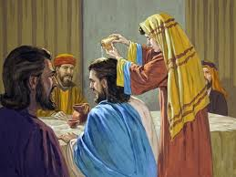

*The woman poured (cheap/expensive) oil on Jesus’ (head/feet). The disciples were (happy/unhappy) with the woman as they wanted to sell the oil and give the money to the (poor/church). Jesus was happy with the woman as she was preparing Him for His (ascention/burial). He was actually prophesying that He would be crucified.*

* Wednesday 30th September: Read **Matthew Chapter 26: 14-16** and answer the questions:

### Judas Agrees to Betray Jesus

*14Then one of the twelve, called Judas Iscariot, went to the chief priests 15and said, “What are you willing to give me if I deliver Him to you?” And they counted out to him thirty pieces of silver. 16So from that time he sought opportunity to betray Him.*

**Question 5**

Who said the following quote? *“What are you willing to give me if I deliver Him to you?”*

1. Jesus
2. Judas
3. The chief priest

**Question 6**

What did the Chief priests do with the 30 pieces of silver that was returned to them? You will need to look up the following bible verse – **Matthew 27 Verse 7** – to find the answer. Write your answer in the box below.

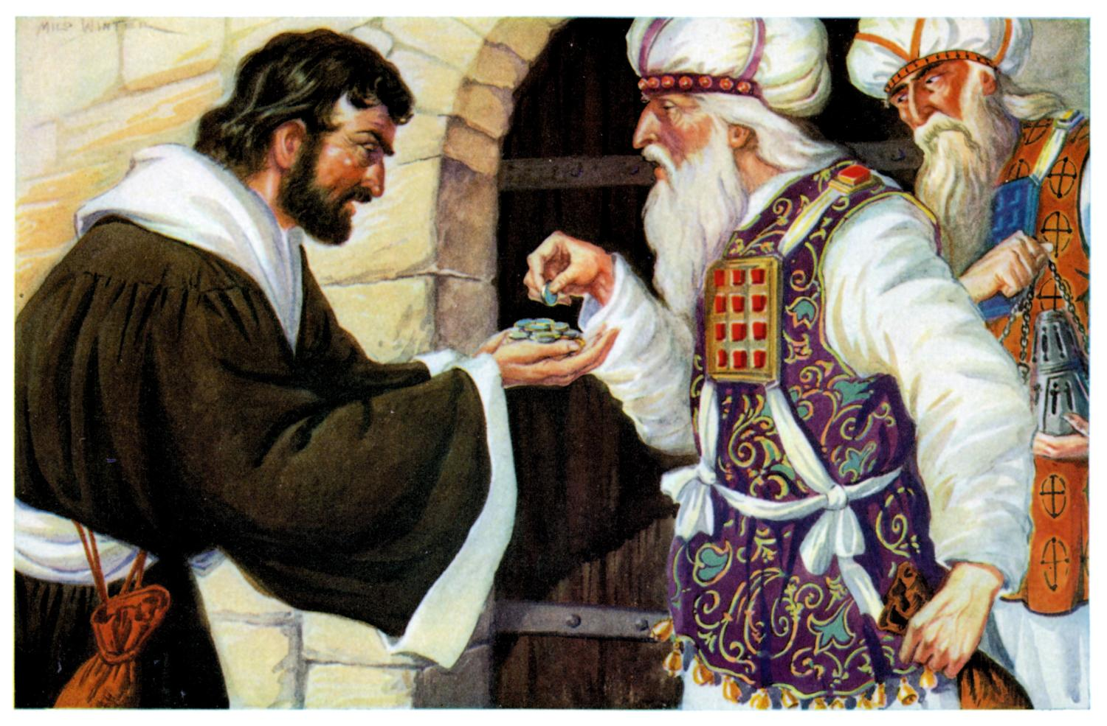

* Thursday 1st October: Read **Matthew Chapter 26: 17-25** and answer the questions:

### Jesus Celebrates Passover with His Disciples

*17Now on the first day of the Feast of Unleavened Bread the disciples came to Jesus, saying to Him, “Where do You want us to prepare for You to eat the Passover?”*

*18And He said, “Go into the city to a certain man, and say to him, ‘The Teacher says, “My time is at hand; I will keep the Passover at your house with My disciples.”’”*

*19So the disciples did as Jesus had directed them; and they prepared the Passover.*

*20When evening had come, He sat down with the twelve. 21Now as they were eating, He said, “Assuredly, I say to you, one of you will betray Me.”*

*22And they were exceedingly sorrowful, and each of them began to say to Him, “Lord, is it I?” 23He answered and said, “He who dipped his hand with Me in the dish will betray Me. 24The Son of Man indeed goes just as it is written of Him, but woe to that man by whom the Son of Man is betrayed! It would have been good for that man if he had not been born.”*

*25Then Judas, who was betraying Him, answered and said, “Rabbi, is it I?” He said to him, “You have said it.”*

**Question 7**

Complete the table by naming the person who said the statement. Choose the names from the following: Jesus, Disciples, Judas

|  |  |
| --- | --- |
| **Statement** | **Person who said it** |
| *“Where do You want us to prepare for You to eat the Passover?”* |  |
| *“Go into the city to a certain man, and say to him, ‘The Teacher says, “My time is at hand; I will keep the Passover at your house with My disciples.”* |  |
| *“Assuredly, I say to you, one of you will betray Me.”* |  |
| *“Lord, is it I?”* |  |
| *“He who dipped his hand with Me in the dish will betray Me.”* |  |
| *“Rabbi, is it I?”* |  |
| *“You have said it.”* |  |

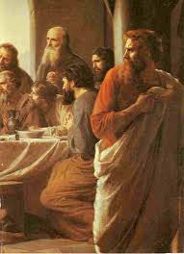

**Question 8**

Which verse shows that Jesus knows all things before they happen?

1. Verse 17
2. Verse 19
3. Verse 20
4. Verse 21

* Friday 2nd October: Read **Matthew Chapter 26: 26-30** and answer the questions:

### Jesus Institutes the Lord’s Supper

*26And as they were eating, Jesus took bread, blessed and broke it, and gave it to the disciples and said, “Take, eat; this is My body.”*

*27Then He took the cup, and gave thanks, and gave it to them, saying, “Drink from it, all of you. 28For this is My blood of the new covenant, which is shed for many for the remission of sins. 29But I say to you, I will not drink of this fruit of the vine from now on until that day when I drink it new with you in My Father’s kingdom.”*

*30And when they had sung a hymn, they went out to the Mount of Olives.*

**Question 9**

Our church repeats the events above through a sacrament. Which picture below shows this sacrament?

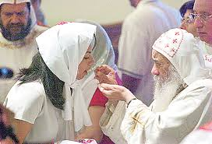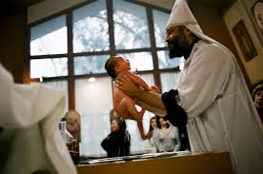

**A B C**

**Question 10**

Look up the definition of the following words and write their meanings in the space next to them.

|  |  |
| --- | --- |
| **Word** | **Definition** |
| *Covenant* |  |
| *Remission* |  |
| *Vine* |  |
| *Kingdom* |  |

* Saturday 3rd October: Read **Matthew Chapter 26: 31-35** and answer the questions:

### Jesus Predicts Peter’s Denial

*31Then Jesus said to them, “All of you will be made to stumble because of Me this night, for it is written:*

*‘I will strike the Shepherd,  
And the sheep of the flock will be scattered.’*

*32But after I have been raised, I will go before you to Galilee.”*

*33Peter answered and said to Him, “Even if all are made to stumble because of You, I will never be made to stumble.”*

*34Jesus said to him, “Assuredly, I say to you that this night, before the rooster crows, you will deny Me three times.”*

*35Peter said to Him, “Even if I have to die with You, I will not deny You!”*

***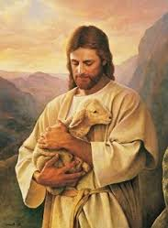****And so said all the disciples.*

**Question 11**

Select TRUE or FALSE for the following statements:

1. In verse 31, the ‘Shepherd’ refers to Jesus and the ‘flock’ refers to His disciples TRUE / FALSE
2. Jesus prophesised that He would rise again TRUE / FALSE
3. Peter was telling the truth when he said he would not deny knowing Jesus TRUE / FALSE *(you may need to read ahead to verses 69 and 70 to help you)*

**Question 12**

Look up **John Chapter 10 Verse 11** about Jesus being our shepherd, write the verse in the box below and learn it by heart.

***What to do when you finish your Bible Study.***

1. ***Either send it by email to your class email address or print and hand it to your servants next Sunday.***
2. ***If you want to send your Bible Study by email, please select your class email address below:***

[stmatthew5b1@gmail.com](mailto:stmatthew5b1@gmail.com) Uncle Andrew

or  
[stmark5b2@gmail.com](mailto:stmark5b2@gmail.com) Uncle Fady

or  
[saintluke5g1@gmail.com](mailto:saintluke5g1@gmail.com) Aunty Merna

or  
[stjohn5g2@gmail.com](mailto:stjohn5g2@gmail.com) Aunty Angela

***Click on the following link to see how many points you have.***

**Year 5B1 (St Matthew)**

[https://docs.google.com/spreadsheets/d/1YPfk0C0NBJv0XfLlXzhWewt5SbZHkTAmmAVEaydaUYo/edit?usp=sharing](https://webmail.meriden.nsw.edu.au/owa/redir.aspx?C=88057cf25a174c15b69cd7e5055a667f&URL=https%3a%2f%2fdocs.google.com%2fspreadsheets%2fd%2f1YPfk0C0NBJv0XfLlXzhWewt5SbZHkTAmmAVEaydaUYo%2fedit%3fusp%3dsharing)  
**Year 5B2 (St Mark)**

[https://docs.google.com/spreadsheets/d/1IU-qPhJOybm8AH80BISZtK-OVRM-f7DXrPzkonxcraU/edit?usp=sharing](https://webmail.meriden.nsw.edu.au/owa/redir.aspx?C=88057cf25a174c15b69cd7e5055a667f&URL=https%3a%2f%2fdocs.google.com%2fspreadsheets%2fd%2f1IU-qPhJOybm8AH80BISZtK-OVRM-f7DXrPzkonxcraU%2fedit%3fusp%3dsharing)

**Year 5G1 (St Luke)**

[https://docs.google.com/spreadsheets/d/1S9gmI4ZC4ctLiJjYsJGXg_p__H28tM8WXGWcHD8OBKc/edit?usp=sharing](https://webmail.meriden.nsw.edu.au/owa/redir.aspx?C=88057cf25a174c15b69cd7e5055a667f&URL=https%3a%2f%2fdocs.google.com%2fspreadsheets%2fd%2f1S9gmI4ZC4ctLiJjYsJGXg_p__H28tM8WXGWcHD8OBKc%2fedit%3fusp%3dsharing)

**Year 5G2 (St John)**

[https://docs.google.com/spreadsheets/d/1rlhsNVFRZ_MQ00H8UVw1Xb2kvxPZhKiZgdpHZZ9zZtY/edit?usp=sharing](https://webmail.meriden.nsw.edu.au/owa/redir.aspx?C=88057cf25a174c15b69cd7e5055a667f&URL=https%3a%2f%2fdocs.google.com%2fspreadsheets%2fd%2f1rlhsNVFRZ_MQ00H8UVw1Xb2kvxPZhKiZgdpHZZ9zZtY%2fedit%3fusp%3dsharing)