C:\Documents and Settings\suzy\Local Settings\Temporary Internet Files\Content.IE5\3JXW24R5\MC900383922[1].wmfSunday 13th September, 2015

Name:

Class:

Finish Date: Saturday 19th September, 2015

Completed Bible Study = 15 points

Email Homework by the due date = 5 points

**Year 5 Bible Study Matthew Chapter 24**

**For the questions below Highlight, underline or change the font colour to choose the correct answer.**

* Monday 14th September: Read **Matthew Chapter 24: 1-14** and answer the questions:

### Jesus Predicts the Destruction of the Temple

*1Then Jesus went out and departed from the temple, and His disciples came up to show Him the buildings of the temple. 2And Jesus said to them, “Do you not see all these things? Assuredly, I say to you, not one stone shall be left here upon another, that shall not be thrown down.”*

### The Signs of the Times and the End of the Age

*3Now as He sat on the Mount of Olives, the disciples came to Him privately, saying, “Tell us, when will these things be? And what will be the sign of Your coming, and of the end of the age?”*

*4And Jesus answered and said to them: “Take heed that no one deceives you. 5For many will come in My name, saying, ‘I am the Christ,’ and will deceive many. 6And you will hear of wars and rumors of wars. See that you are not troubled; for all these things must come to pass, but the end is not yet. 7For nation will rise against nation, and kingdom against kingdom. And there will be famines, pestilences, and earthquakes in various places. 8All these are the beginning of sorrows.*

*9“Then they will deliver you up to tribulation and kill you, and you will be hated by all nations for My name’s sake. 10And then many will be offended, will betray one another, and will hate one another. 11Then many false prophets will rise up and deceive many. 12And because lawlessness will abound, the love of many will grow cold. 13But he who endures to the end shall be saved. 14And this gospel of the kingdom will be preached in all the world as a witness to all the nations, and then the end will come.*

**Question 1**

Number the signs of the end of the world below in the order they are mentioned in the passage. One has been done for you.

Believers will be hated by others.

1

Many will deceive and claim they are Christ.

False prophets will trick people into believing other things.

There will be famines, pestilences, and earthquakes in various places.

Nations will fight against each other.

**Question 2**

Fill in the missing words and memorise the verse by heart.

‘But he who to the end will be ’ v13

* Tuesday 15th September: Read **Matthew Chapter 24: 15-28** and answer the questions:

### The Great Tribulation

*15“Therefore when you see the ‘abomination of desolation,’ spoken of by Daniel the prophet, standing in the holy place” (whoever reads, let him understand), 16“then let those who are in Judea flee to the mountains. 17Let him who is on the housetop not go down to take anything out of his house. 18And let him who is in the field not go back to get his clothes. 19But woe to those who are pregnant and to those who are nursing babies in those days! 20And pray that your flight may not be in winter or on the Sabbath. 21For then there will be great tribulation, such as has not been since the beginning of the world until this time, no, nor ever shall be. 22And unless those days were shortened, no flesh would be saved; but for the elect’s sake those days will be shortened.*

*23“Then if anyone says to you, ‘Look, here is the Christ!’ or ‘There!’ do not believe it. 24For false christs and false prophets will rise and show great signs and wonders to deceive, if possible, even the elect. 25See, I have told you beforehand.*

*26“Therefore if they say to you, ‘Look, He is in the desert!’ do not go out; or ‘Look, He is in the inner rooms!’ do not believe it. 27For as the lightning comes from the east and flashes to the west, so also will the coming of the Son of Man be. 28For wherever the carcass is, there the eagles will be gathered together.*

**Question 3**

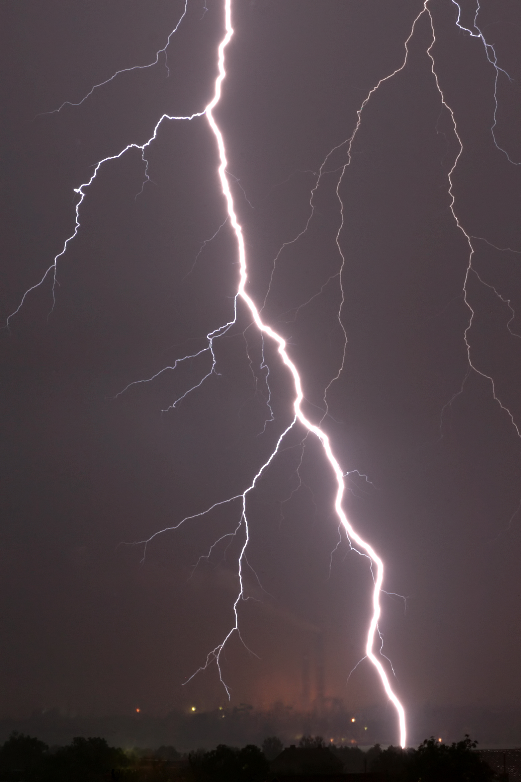One sign of the end of the world is that some people will try to convince others they are Christ. How will people know they are not *really* Christ?

1. They will look different to pictures we have seen.
2. They will be too young to be Christ.
3. Christ’s coming will be very very quick.
4. They will not be able to do miracles like Christ can.

**Question 4**

Although many people are scared about the end of the world, we as Christians should not be. In the box below, write down why we should look forward to Christ coming again.

* Wednesday 16th September: Read **Matthew Chapter 24: 29-31** and answer the questions:

### The Coming of the Son of Man

*29“Immediately after the tribulation of those days the sun will be darkened, and the moon will not give its light; the stars will fall from heaven, and the powers of the heavens will be shaken. 30Then the sign of the Son of Man will appear in heaven, and then all the tribes of the earth will mourn, and they will see the Son of Man coming on the clouds of heaven with power and great glory. 31And He will send His angels with a great sound of a trumpet, and they will gather together His elect from the four winds, from one end of heaven to the other.*

**Question 5**

In the bubbles below, write down five signs of the second coming of Christ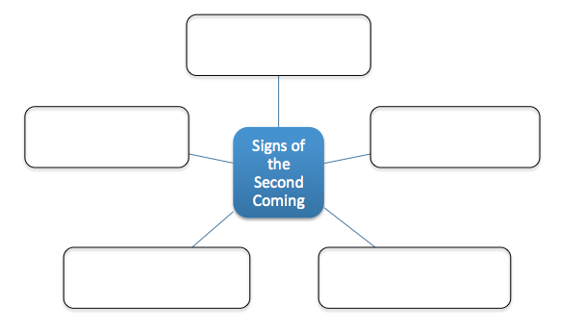

**Question 6**

Answer True or False to the following questions based on the passage you read:

1. The Son of Man refers to Jesus Christ. TRUE / FALSE
2. The angels will be playing a harp to announce the second coming. TRUE / FALSE
3. The sun will be shining bright when Christ comes. TRUE / FALSE
4. Christ will come from heaven on a cloud. TRUE / FALSE

* Thursday 17th September: Read **Matthew Chapter 24: 32-35** and answer the questions:

### The Parable of the Fig Tree

*32“Now learn this parable from the fig tree: When its branch has already become tender and puts forth leaves, you know that summer is near. 33So you also, when you see all these things, know that it is near—at the doors! 34Assuredly, I say to you, this generation will by no means pass away till all these things take place. 35Heaven and earth will pass away, but My words will by no means pass away.*

**Question 7**

Which verse is used to explain that when we see the signs of the second coming, it should be clear to us that Christ is coming again?

1. Verse 32
2. Verse 33
3. Verse 34
4. Verse 35

**Question 8**

Unscramble the verse below and type it in the box provided.

“means words pass my will but means no away heaven will away pass earth and by”

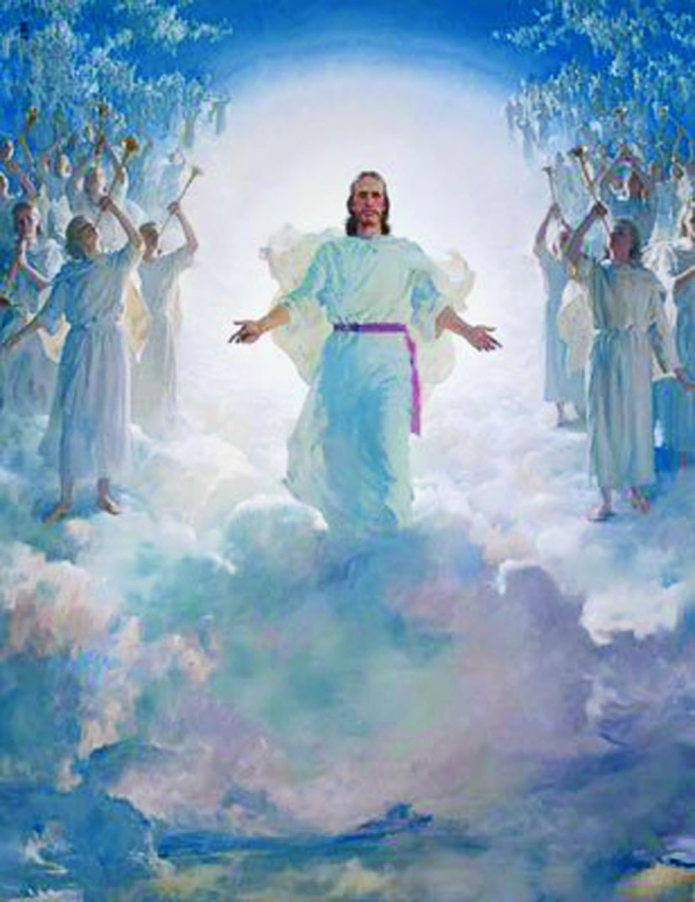

* Friday 18th September: Read **Matthew Chapter 24: 36-44** and answer the questions:

### No One Knows the Day or Hour

*36“But of that day and hour no one knows, not even the angels of heaven,[[e](https://www.biblegateway.com/passage/?search=Matthew+24&version=NKJV" \l "fen-NKJV-23994e" \o "See footnote e)] but My Father only. 37But as the days of Noah were, so also will the coming of the Son of Man be. 38For as in the days before the flood, they were eating and drinking, marrying and giving in marriage, until the day that Noah entered the ark, 39and did not know until the flood came and took them all away, so also will the coming of the Son of Man be. 40Then two men will be in the field: one will be taken and the other left. 41Two women will be grinding at the mill: one will be taken and the other left. 42Watch therefore, for you do not know what hour[*[*f*](https://www.biblegateway.com/passage/?search=Matthew+24&version=NKJV#fen-NKJV-24000f)*] your Lord is coming. 43But know this, that if the master of the house had known what hour the thief would come, he would have watched and not allowed his house to be broken into. 44Therefore you also be ready, for the Son of Man is coming at an hour you do not expect.*

**Question 9**

Match the question in the left column with the correct answer in the right column.

|  |  |  |
| --- | --- | --- |
| Question |  | Answer |
| A – how many people know when the Son of Man will return? |  | We must be watchful and always prepared to meet Christ. |
| B – what story in the Old Testament is the second coming compared to? |  | Only some people with enter God’s kingdom. |
| C – what are we told to do while waiting for the second coming? |  | The story of Noah. The whole world was destroyed and only the righteous were saved. |
| D – what do verses 40 and 41 mean? |  | None. Only God knows. |

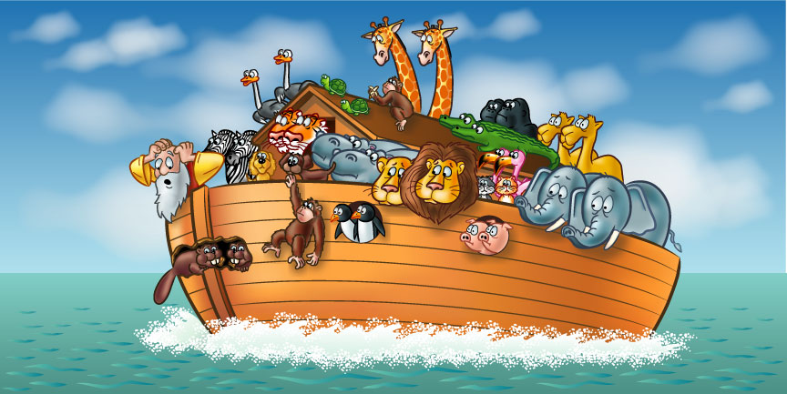

**Question 10**

What is something you can do each day to be ready for Christ’s return?

1. Stay at home looking out of the window.
2. Follow God’s commandments and keep a good relationship with God by praying to Him and reading the bible.
3. Try and calculate when you think He will come by looking for signs.

* Saturday 19th September: Read **Matthew Chapter 24: 45-51** and answer the questions:

### The Faithful Servant and the Evil Servant

*45“Who then is a faithful and wise servant, whom his master made ruler over his household, to give them food in due season? 46Blessed is that servant whom his master, when he comes, will find so doing. 47Assuredly, I say to you that he will make him ruler over all his goods. 48But if that evil servant says in his heart, ‘My master is delaying his coming,’ 49and begins to beat his fellow servants, and to eat and drink with the drunkards, 50the master of that servant will come on a day when he is not looking for him and at an hour that he is not aware of, 51and will cut him in two and appoint him his portion with the hypocrites. There shall be weeping and gnashing of teeth.*

**Question 11**

Highlight the correct words in the sentence below.

1. The master refers to **God/us**, and the servant refers to **God/us**.
2. If we **are/arent** prepared when Christ comes, He will welcome us into His kingdom.
3. We **should/shouldn’t** spend time with people who may distract us from focussing on God.

**Question 12**

Jesus often spoke in parables that are stories to help people understand a message. Can you think of another parable Jesus used? The image below has a few different parables to help you.

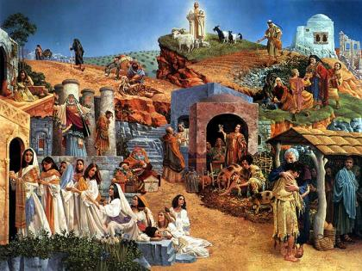

**Parable:**

***What to do when you finish your Bible Study.***

1. ***Either send it by email to your class email address or print and hand it to your servants next Sunday.***
2. ***If you want to send your Bible Study by email, please select your class email address below:***

[stmatthew5b1@gmail.com](mailto:stmatthew5b1@gmail.com) Uncle Andrew

or  
[stmark5b2@gmail.com](mailto:stmark5b2@gmail.com) Uncle Fady

or  
[saintluke5g1@gmail.com](mailto:saintluke5g1@gmail.com) Aunty Merna

or  
[stjohn5g2@gmail.com](mailto:stjohn5g2@gmail.com) Aunty Angela

***Click on the following link to see how many points you have.***

**Year 5B1 (St Matthew)**

[https://docs.google.com/spreadsheets/d/1YPfk0C0NBJv0XfLlXzhWewt5SbZHkTAmmAVEaydaUYo/edit?usp=sharing](https://webmail.meriden.nsw.edu.au/owa/redir.aspx?C=88057cf25a174c15b69cd7e5055a667f&URL=https%3a%2f%2fdocs.google.com%2fspreadsheets%2fd%2f1YPfk0C0NBJv0XfLlXzhWewt5SbZHkTAmmAVEaydaUYo%2fedit%3fusp%3dsharing" \t "_blank)  
**Year 5B2 (St Mark)**

[https://docs.google.com/spreadsheets/d/1IU-qPhJOybm8AH80BISZtK-OVRM-f7DXrPzkonxcraU/edit?usp=sharing](https://webmail.meriden.nsw.edu.au/owa/redir.aspx?C=88057cf25a174c15b69cd7e5055a667f&URL=https%3a%2f%2fdocs.google.com%2fspreadsheets%2fd%2f1IU-qPhJOybm8AH80BISZtK-OVRM-f7DXrPzkonxcraU%2fedit%3fusp%3dsharing" \t "_blank)

**Year 5G1 (St Luke)**

[https://docs.google.com/spreadsheets/d/1S9gmI4ZC4ctLiJjYsJGXg\_p\_\_H28tM8WXGWcHD8OBKc/edit?usp=sharing](https://webmail.meriden.nsw.edu.au/owa/redir.aspx?C=88057cf25a174c15b69cd7e5055a667f&URL=https%3a%2f%2fdocs.google.com%2fspreadsheets%2fd%2f1S9gmI4ZC4ctLiJjYsJGXg_p__H28tM8WXGWcHD8OBKc%2fedit%3fusp%3dsharing" \t "_blank)

**Year 5G2 (St John)**

[https://docs.google.com/spreadsheets/d/1rlhsNVFRZ\_MQ00H8UVw1Xb2kvxPZhKiZgdpHZZ9zZtY/edit?usp=sharing](https://webmail.meriden.nsw.edu.au/owa/redir.aspx?C=88057cf25a174c15b69cd7e5055a667f&URL=https%3a%2f%2fdocs.google.com%2fspreadsheets%2fd%2f1rlhsNVFRZ_MQ00H8UVw1Xb2kvxPZhKiZgdpHZZ9zZtY%2fedit%3fusp%3dsharing" \t "_blank)