C:\Documents and Settings\suzy\Local Settings\Temporary Internet Files\Content.IE5\3JXW24R5\MC900383922[1].wmfSunday 30th August, 2015

Name:

Class:

Finish Date: Saturday 5th September, 2015

Completed Bible Study = 15 points

Email Homework by the due date = 5 points

**Year 5 Bible Study Matthew Chapter 22**

**For the questions below Highlight, underline or change the font colour to choose the correct answer.**

* Monday 31st August: Read **Matthew Chapter 22: 1-10** and answer the questions:

**The Parable of the Wedding Feast**

*1 And Jesus answered and spoke to them again by parables and said: 2“The kingdom of heaven is like a certain king who arranged a marriage for his son, 3and sent out his servants to call those who were invited to the wedding; and they were not willing to come. 4Again, he sent out other servants, saying, ‘Tell those who are invited, “See, I have prepared my dinner; my oxen and fatted cattle are killed, and all things are ready. Come to the wedding.”’ 5But they made light of it and went their ways, one to his own farm, another to his business. 6And the rest seized his servants, treated them spitefully, and killed them. 7But when the king heard about it, he was furious. And he sent out his armies, destroyed those murderers, and burned up their city. 8Then he said to his servants, ‘The wedding is ready, but those who were invited were not worthy. 9Therefore go into the highways, and as many as you find, invite to the wedding.’ 10So those servants went out into the highways and gathered together all whom they found, both bad and good. And the wedding hall was filled with guests.*

**Question 1**

As you know every parable that Jesus spoke was to teach the people a spiritual lesson through symbolism or through a story. In each of Christ’s parables everything in the story represents something/someone in reality. In this parable of the wedding feast what do the following represent (choose from the options below)?

|  |  |
| --- | --- |
| The King |  |
| Those who were first invited |  |
| The feast |  |
| The servants |  |
| Those who were invited at the end of the parable. |  |

The Jews.

Heaven.

The prophets, disciples and Apostles.

The Gentiles

Jesus Christ (God)

**Question 2**

Christ told this parable during a very important week of His life. What week was it?

1. The week He was Baptised.
2. The week He chose His disciples.
3. The week of Christ’s passion.
4. The week of the wedding feast.

* Tuesday 1st September: Read **Matthew Chapter 22: 11-14** and answer the questions:

*11“But when the king came in to see the guests, he saw a man there who did not have on a wedding garment. 12So he said to him, ‘Friend, how did you come in here without a wedding garment?’ And he was speechless. 13Then the king said to the servants, ‘Bind him hand and foot, take him away, and cast him into outer darkness; there will be weeping and gnashing of teeth.’*

*14“For many are called, but few are chosen.”*

[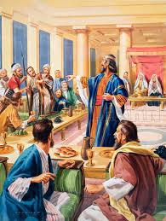](http://www.google.com.au/url?sa=i&rct=j&q=&esrc=s&source=images&cd=&cad=rja&uact=8&ved=0CAcQjRxqFQoTCOvUytO738YCFYPhpgod9P0ArQ&url=http://www.lookandlearn.com/blog/3133/the-wedding-feast-a-parable/&ei=loqnVeuxLYPDmwX0-4PoCg&psig=AFQjCNFyvJPSrbm0RJcwLfBGA1gvsb3rpA&ust=1437129722421728)**Question 3**

Does Christ care about our outward appearance(delete the incorrect answer)?

YES OR NO

**Question 4**

So why was this man thrown out of the wedding feast?

1. He wore the wrong clothes.
2. He came to a royal feast but did not prepare himself to meet the king.
3. He came through the window and not through the front door.
4. He was one of the ones who were first invited but he missed his chance.

**Question 5**

**[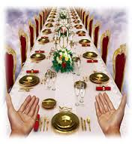](http://www.google.com.au/url?sa=i&rct=j&q=&esrc=s&source=images&cd=&cad=rja&uact=8&ved=0CAcQjRxqFQoTCLyy14C938YCFcWdpgodtE4BYQ&url=http://newsletter.followersofyah.com/read/2012/05/calling-all-temple-builders/&ei=AYynVfytLsW7mgW0nYWIBg&bvm=bv.97949915,d.dGY&psig=AFQjCNEVbfkCww0-UNOaYNZJ8c_F2BiUJg&ust=1437130071454872)**Here is a picture of the wedding feast that Christ has prepared for us in Heaven. Do you want to be at the feast? There is a lovely verse which says:

[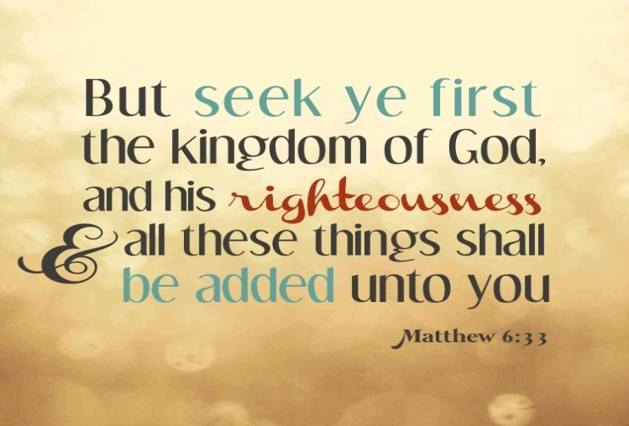](http://www.google.com.au/url?sa=i&rct=j&q=&esrc=s&source=images&cd=&cad=rja&uact=8&ved=0CAcQjRxqFQoTCJTXhrm-38YCFePYpgodJQsHhA&url=http://faithfuldevotions.com/finding-peace-as-a-new-mom/&ei=hI2nVZSFGeOxmwWllpygCA&bvm=bv.97949915,d.dGY&psig=AFQjCNGfWXsV8DZWuQ2V8gtE0Awm58_IJA&ust=1437130488418471)

List 3 practical things you can do each day to seek God’s kingdom:

|  |
| --- |
| *Example: Don’t let little things bother me because the main goal is Heaven.* |
| 1. |
| 2. |
| 3. |

**THIS WEEK’S CHALLENGE!**

FOCUS ON ONE OF YOUR THREE ANSWERS FROM QUESTION 5 AND TRY TO LIVE THAT WAY THIS WEEK.

[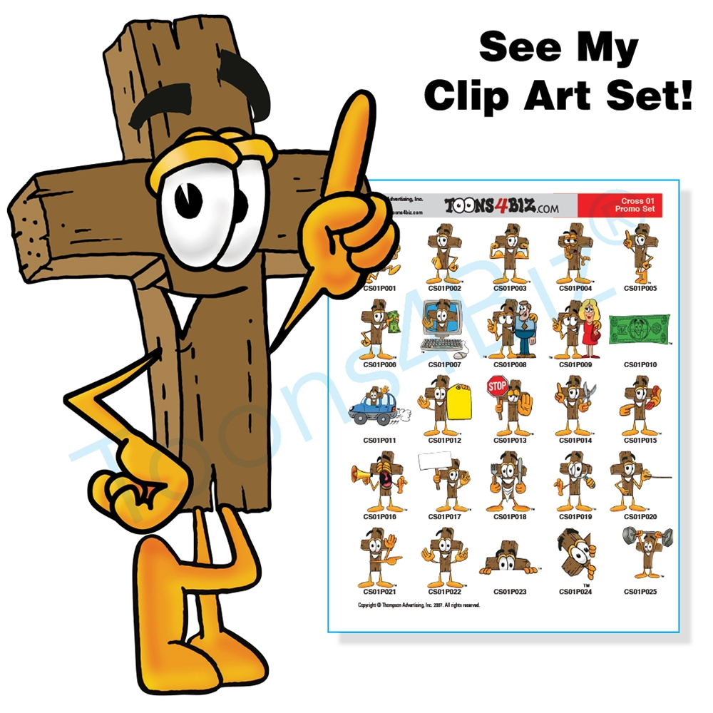](http://www.google.com.au/url?sa=i&rct=j&q=&esrc=s&source=images&cd=&cad=rja&uact=8&ved=0CAcQjRxqFQoTCJ3425zA38YCFWLlpgod1FMLQw&url=http://www.toons4biz.com/Cross-Clipart-Collection-CD-Set-p/crossset01.htm&ei=YY-nVd3DNOLKmwXUp62YBA&psig=AFQjCNH7BJMmXyYc9nlgudscmSw_9LUkqA&ust=1437130863662136)

* Wednesday 2nd September: Read **Matthew Chapter 22: 15-22** and answer the questions:

### The Pharisees: Is It Lawful to Pay Taxes to Caesar?

*15Then the Pharisees went and plotted how they might entangle Him in His talk. 16And they sent to Him their disciples with the Herodians, saying, “Teacher, we know that You are true, and teach the way of God in truth; nor do You care about anyone, for You do not regard the person of men. 17Tell us, therefore, what do You think? Is it lawful to pay taxes to Caesar, or not?”*

[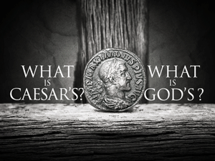](http://www.google.com.au/url?sa=i&rct=j&q=&esrc=s&source=images&cd=&cad=rja&uact=8&ved=0CAcQjRw&url=http://ourdebtfreechurch.org/render-to-caesar/&ei=85xeVZfgN8Xe8AXyrIPAAQ&bvm=bv.93990622,d.dGc&psig=AFQjCNEAus8lS-rsLWs1gwekwLSOFK_K0w&ust=1432350318815039)*18But Jesus perceived their wickedness, and said, “Why do you test Me, you hypocrites? 19Show Me the tax money.”*

*So they brought Him a denarius.*

*20And He said to them, “Whose image and inscription is this?”*

*21They said to Him, “Caesar’s.”*

*And He said to them, “Render therefore to Caesar the things that are Caesar’s, and to God the things that are God’s.” 22When they had heard these words, they marveled, and left Him and went their way.*

**Question 6**

Why did the Pharisees ask Jesus if they should pay taxes?

1. To see if Jesus was generous
2. To test Jesus and trick Him into saying that people shouldn’t pay taxes, which would get Jesus into trouble with Caesar.
3. To show that Jesus was not paying His taxes.
4. So that Jesus would get people in trouble for not paying their taxes.

**Question 7**

This question that the Pharisees asked Jesus was a trick question. Christ didn’t answer with a yes or a no. He knew they were trying to trick Him so He instructed them that the people should give Caesar what is his, and to give God what was God’s. Below are two scenarios. One is if Christ said YES and the other is if Christ said NO. Leave the correct answer (YES or NO) in each of the headings.

**IF JESUS SAID “YES” OR “NO”:** Many of the Jews would get very angry. The Jews didn’t like the Romans, and they didn’t like anyone who supported them either, so they would easily turn away from Jesus if He showed support for them.

**IF JESUS SAID “YES” OR “NO”:** The Jews would have been VERY happy. They probably would have even thought Jesus could make Caesar and the Romans stop. However, this would have sent Jesus straight to jail.

* Thursday 3rd September: Read **Matthew Chapter 22: 23-33** and answer the questions:

### The Sadducees: What about the Resurrection?

*23The same day the Sadducees, who say there is no resurrection, came to Him and asked Him, 24saying: “Teacher, Moses said that if a man dies, having no children, his brother shall marry his wife and raise up offspring for his brother. 25Now there were with us seven brothers. The first died after he had married, and having no offspring, left his wife to his brother. 26Likewise the second also, and the third, even to the seventh. 27Last of all the woman died also. 28Therefore, in the resurrection, whose wife of the seven will she be? For they all had her.”*

*29Jesus answered and said to them, “You are mistaken, not knowing the Scriptures nor the power of God. 30For in the resurrection they neither marry nor are given in marriage, but are like angels of God in heaven. 31But concerning the resurrection of the dead, have you not read what was spoken to you by God, saying, 32‘I am the God of Abraham, the God of Isaac, and the God of Jacob’? God is not the God of the dead, but of the living.” 33And when the multitudes heard this, they were astonished at His teaching.*

**Question 8**

Among the Jewish people there are Pharisees and Sadducees. Each group believed in different things about God and His teachings. After reading today’s verses, do you know which group believed in the Resurrection of the dead?

1. PHARISEES

**EXTRA RESOURCE!!!!**

1. 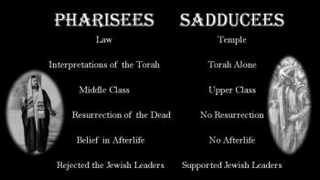SADDUCEES

**Question 9**

The Sadducees were questioning Christ about the afterlife (eternal life). How did Christ describe what happens to people in the afterlife (what do they become like)? Hint: Read verse30

**Question 10**

In the box below are three verses from the Old testament hinting in some way details of the resurrection after death. The Sadduccees did not accept the concept of the Resurrection. But there are events in the old testament which also hint to the Resurrection. When God raised certain people from the dead and the departure of Enoch and Elijah into another “realm”. Read the verses below.

“Multitudes who sleep in the dust of the earth will awake: some to everlasting life, others to shame and everlasting contempt.” Daniel 12:2

Hannah said in her prayer, “The LORD brings death and makes alive; he brings down to the grave and raises up” ([1 Samuel 2:6](http://www.doesgodexist.org/JanFeb11/1.Samuel.2.6.NIV.html)).

“But your dead will live; their bodies will rise. You who dwell in the dust, wake up and shout for joy. Your dew is like the dew of the morning; the earth will give birth to her dead.” Isaiah 26:19

Now try to think of a story, parable, miracle or event in the NEW testament which confirms that there is an afterlife and a Resurrection of the dead. Briefly write down what that event/story is (Feel free to ask mum and dad for some help).

**A NEW TESTAMENT REFERENCE TO THE RESURRECTION OF THE DEAD:**

* Friday 4th September: Read **Matthew Chapter 22: 34-40** and answer the questions:

### The Scribes: Which Is the First Commandment of All?

*34But when the Pharisees heard that He had silenced the Sadducees, they gathered together. 35Then one of them, a lawyer, asked Him a question, testing Him, and saying, 36“Teacher, which is the great commandment in the law?”*

*37Jesus said to him, “‘You shall love the Lord your God with all your heart, with all your soul, and with all your mind.’ 38This is the first and great commandment. 39And the second is like it: ‘You shall love your neighbor as yourself.’ 40On these two commandments hang all the Law and the Prophets.”*

**Question 11**

Jesus explains which are the two greatest commandments. Which commandments are they?

|  |
| --- |
| **1.** |
| **2.** |

**Question 12**

If we had to follow a slogan or rule in life we have learned from today’s passage that rule is – LOVE GOD AND LOVE OTHERS.

Everyday we see and hear slogans that encourage different behaviours.Below are 4 slogans that you may have heard or seen before. There are also 3 scenarios from our everyday lives. Read each scenario and select the slogan that you think we should follow in each scenario.

[](http://www.google.com.au/url?sa=i&rct=j&q=&esrc=s&source=images&cd=&cad=rja&uact=8&ved=0CAcQjRxqFQoTCNiLu-D96sYCFSGtpgodfgwPVQ&url=http://www.writingfordesigners.com/?p%3D1418&ei=S5StVZi6JaHamgX-mLyoBQ&bvm=bv.98197061,d.dGY&psig=AFQjCNGLDhmEFOVQSbCteKOUhZSi3ArfjQ&ust=1437525440800548)

[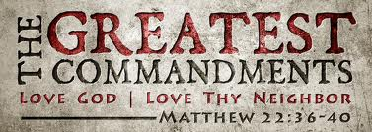](https://www.google.com.au/url?sa=i&rct=j&q=&esrc=s&source=images&cd=&cad=rja&uact=8&ved=0CAcQjRxqFQoTCNmw38D96sYCFahdpgodHaoK4A&url=https://hollyjjjarret.wordpress.com/2013/05/01/the-greatest-commandment/&ei=CZStVZmIBqi7mQWd1KqADg&bvm=bv.98197061,d.dGY&psig=AFQjCNGZVatSNK-B-yH4Lw5LSaoA-bgzug&ust=1437525312609690)

[](http://www.google.com.au/url?sa=i&rct=j&q=&esrc=s&source=images&cd=&cad=rja&uact=8&ved=0CAcQjRxqFQoTCJ7vo_X96sYCFUMWpgodBKkAZg&url=http://www.adweek.com/adfreak/if-brands-had-more-honest-slogans-153303&ei=d5StVd7XEMOsmAWE0oKwBg&bvm=bv.98197061,d.dGY&psig=AFQjCNGLDhmEFOVQSbCteKOUhZSi3ArfjQ&ust=1437525440800548)

[](http://www.google.com.au/url?sa=i&rct=j&q=&esrc=s&source=images&cd=&cad=rja&uact=8&ved=0CAcQjRxqFQoTCPjF-6n-6sYCFWTapgodk4YBPQ&url=http://www.theatlantic.com/business/archive/2011/07/the-science-of-slogans-the-best-and-worst-ad-campaigns-of-all-time/242591/&ei=5ZStVbi_LuS0mwWTjYboAw&bvm=bv.98197061,d.dGY&psig=AFQjCNHOGpfFeKQ_9_mhUkWY9nIuRe_ZRw&ust=1437525594886164)[](http://www.google.com.au/url?sa=i&rct=j&q=&esrc=s&source=images&cd=&cad=rja&uact=8&ved=0CAcQjRxqFQoTCMSK99v-6sYCFaQapgod3MUOBQ&url=http://www.tripwiremagazine.com/2011/01/50-examples-of-catchy-and-creative-slogans.html&ei=TpWtVcSrIaS1mAXci7so&bvm=bv.98197061,d.dGY&psig=AFQjCNHOGpfFeKQ_9_mhUkWY9nIuRe_ZRw&ust=1437525594886164)

**Your options**

1. **Love God and Love Others**
2. **“Connect with people for no reason”**
3. **“I’m lovin it” – Enjoy yourself**
4. **“Just do it.”**
5. **“Have it your way.”**

Scenarios

|  |  |
| --- | --- |
| 1.There is a person in your class at school that the other children pick on. They often tease that person. What do you do? |  |
| 2. You want to go to your friend’s house after school on Friday but your parents have told you that your not allowed. What do you do? | *(Hint: Consider how God feels about obedience)* |
| 3. There is a new student starting in your class. Your too embarrassed to talk to them because nobody thinks its cool to talk to the new kid. What do you do? |  |

* Saturday 5th September: Read **Matthew Chapter 22: 41-45** and answer the questions:

### Jesus: How Can David Call His Descendant Lord?

*41While the Pharisees were gathered together, Jesus asked them, 42saying, “What do you think about the Christ? Whose Son is He?”*

*They said to Him, “The Son of David.”*

*43He said to them, “How then does David in the Spirit call Him ‘Lord,’ saying:*

*44‘The Lord said to my Lord,  
“Sit at My right hand,  
Till I make Your enemies Your footstool”’?[*[*f*](https://www.biblegateway.com/passage/?search=Matthew+22&version=NKJV#fen-NKJV-23917f)*]*

*45If David then calls Him ‘Lord,’ how is He his Son?” 46And no one was able to answer Him a word, nor from that day on did anyone dare question Him anymore.*

**Question 13**

What did the Pharisees mean when they said Jesus is the “Son of David”?

1. He was not the Messiah but simply the son of a human.
2. He was a descendant of King David.
3. Joseph’s real name was David and that’s who they were referring to.
4. The Pharisees answered Christ incorrectly.

**Question 14**

What was Jesus trying to prove to the Jews by asking them these two questions?

1. **Whose son is He?**
2. **How then does David in the Spirit call Him Lord?**
3. That the Son of God would be a descendant of King David.
4. That the Messiah, although human is fully God because He existed before He became man.
5. Answers A and B
6. None of the above.

***What to do when you finish your Bible Study.***

1. ***Either send it by email to your class email address or print and hand it to your servants next Sunday.***
2. ***If you want to send your Bible Study by email, please select your class email address below:***

[stmatthew5b1@gmail.com](mailto:stmatthew5b1@gmail.com) Uncle Andrew

or  
[stmark5b2@gmail.com](mailto:stmark5b2@gmail.com) Uncle Fady

or  
[saintluke5g1@gmail.com](mailto:saintluke5g1@gmail.com) Aunty Merna

or  
[stjohn5g2@gmail.com](mailto:stjohn5g2@gmail.com) Aunty Angela

***Click on the following link to see how many points you have.***

**Year 5B1 (St Matthew)**

[https://docs.google.com/spreadsheets/d/1YPfk0C0NBJv0XfLlXzhWewt5SbZHkTAmmAVEaydaUYo/edit?usp=sharing](https://webmail.meriden.nsw.edu.au/owa/redir.aspx?C=88057cf25a174c15b69cd7e5055a667f&URL=https%3a%2f%2fdocs.google.com%2fspreadsheets%2fd%2f1YPfk0C0NBJv0XfLlXzhWewt5SbZHkTAmmAVEaydaUYo%2fedit%3fusp%3dsharing)  
**Year 5B2 (St Mark)**

[https://docs.google.com/spreadsheets/d/1IU-qPhJOybm8AH80BISZtK-OVRM-f7DXrPzkonxcraU/edit?usp=sharing](https://webmail.meriden.nsw.edu.au/owa/redir.aspx?C=88057cf25a174c15b69cd7e5055a667f&URL=https%3a%2f%2fdocs.google.com%2fspreadsheets%2fd%2f1IU-qPhJOybm8AH80BISZtK-OVRM-f7DXrPzkonxcraU%2fedit%3fusp%3dsharing)

**Year 5G1 (St Luke)**

[https://docs.google.com/spreadsheets/d/1S9gmI4ZC4ctLiJjYsJGXg_p__H28tM8WXGWcHD8OBKc/edit?usp=sharing](https://webmail.meriden.nsw.edu.au/owa/redir.aspx?C=88057cf25a174c15b69cd7e5055a667f&URL=https%3a%2f%2fdocs.google.com%2fspreadsheets%2fd%2f1S9gmI4ZC4ctLiJjYsJGXg_p__H28tM8WXGWcHD8OBKc%2fedit%3fusp%3dsharing)

**Year 5G2 (St John)**

[https://docs.google.com/spreadsheets/d/1rlhsNVFRZ_MQ00H8UVw1Xb2kvxPZhKiZgdpHZZ9zZtY/edit?usp=sharing](https://webmail.meriden.nsw.edu.au/owa/redir.aspx?C=88057cf25a174c15b69cd7e5055a667f&URL=https%3a%2f%2fdocs.google.com%2fspreadsheets%2fd%2f1rlhsNVFRZ_MQ00H8UVw1Xb2kvxPZhKiZgdpHZZ9zZtY%2fedit%3fusp%3dsharing)