C:\Documents and Settings\suzy\Local Settings\Temporary Internet Files\Content.IE5\3JXW24R5\MC900383922[1].wmfSunday 23rd August, 2015

Name:

Class:

Finish Date: Saturday 29th August, 2015

Completed Bible Study = 15 points

Email Homework by the due date = 5 points

**Year 5 Bible Study Matthew Chapter 21**

**For the questions below Highlight, underline or change the font colour to choose the correct answer.**

* Monday 24th August: Read **Matthew Chapter 21: 1-11** and answer the questions:

### The Triumphal Entry

*1 Now when they drew near Jerusalem, and came to Bethphage at the Mount of Olives, then Jesus sent two disciples, 2saying to them, “Go into the village opposite you, and immediately you will find a donkey tied, and a colt with her. Loose them and bring them to Me. 3And if anyone says anything to you, you shall say, ‘The Lord has need of them,’ and immediately he will send them.”*

*4All this was done that it might be fulfilled which was spoken by the prophet, saying:*

*5“Tell the daughter of Zion,  
‘Behold, your King is coming to you,  
Lowly, and sitting on a donkey,  
A colt, the foal of a donkey.’”*

*6So the disciples went and did as Jesus commanded them. 7They brought the donkey and the colt, laid their clothes on them, and set Him on them. 8And a very great multitude spread their clothes on the road; others cut down branches from the trees and spread them on the road. 9Then the multitudes who went before and those who followed cried out, saying:*

*“Hosanna to the Son of David!  
‘Blessed is He who comes in the name of the Lord!’  
Hosanna in the highest!”*

*10And when He had come into Jerusalem, all the city was moved, saying, “Who is this?”*

*11So the multitudes said, “This is Jesus, the prophet from Nazareth of Galilee.”*

**Question 1**

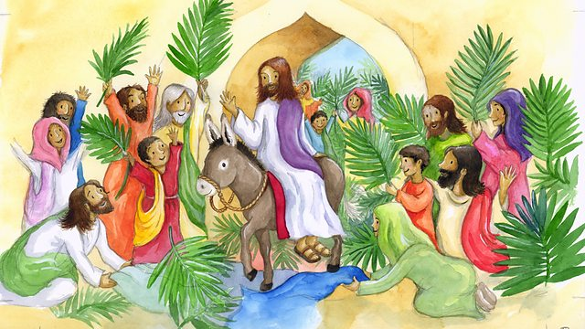Write down the correct order of what happened on the boat in the boxes below. The first one has been done for you.

A – Jesus rides through Jerusalem on the donkey.

B – The multitude spread clothes and palms on the road.

C – Jesus sends two disciples to collect a donkey for Him.

D – Everyone cries out ‘Hosanna to the Son of David!’.

|  |  |  |  |
| --- | --- | --- | --- |
| C |  |  |  |

**Question 2**

What does the word ‘hosanna’ mean? (You may need to search for the answer on the internet or ask someone.)

1. Pray for us
2. Save us
3. Halleluiah
4. We love You

* Tuesday 25th August: Read **Matthew Chapter 21: 12-17** and answer the questions:

### Jesus Cleanses the Temple

*12Then Jesus went into the temple of God and drove out all those who bought and sold in the temple, and overturned the tables of the money changers and the seats of those who sold doves. 13And He said to them, “It is written, ‘My house shall be called a house of prayer,’but you have made it a ‘den of thieves.’”*

*14Then the blind and the lame came to Him in the temple, and He healed them. 15But when the chief priests and scribes saw the wonderful things that He did, and the children crying out in the temple and saying, “Hosanna to the Son of David!” they were indignant 16and said to Him, “Do You hear what these are saying?”*

*And Jesus said to them, “Yes. Have you never read,*

*‘Out of the mouth of babes and nursing infants  
You have perfected praise’?”*

*17Then He left them and went out of the city to Bethany, and He lodged there.*

**Question 3**

It is very important to learn important verses in the Bible so we can refer to them when we need to. In the passage above, Jesus refers TWICE to verses found in the Old Testament. Which two verses above are they? (Hint: look for the times Jesus says ‘It is written…’ or ‘Have you never read…’).

Verse and Verse

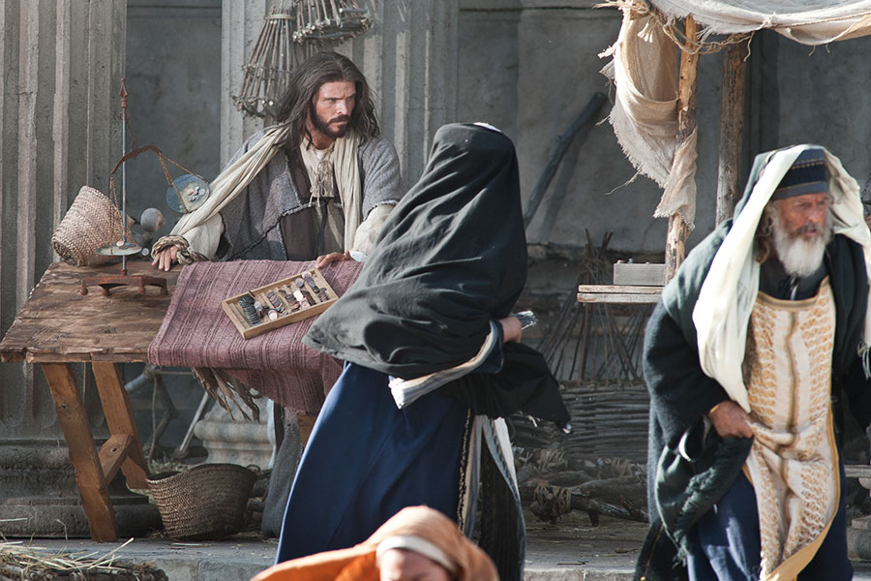**Question 4**

Watch the following video of Jesus cleansing the temple (Jewish house of worship) and answer the question below:

<https://www.youtube.com/watch?v=kyvTMggabJc>

Why was Jesus so upset with the people in the temple?

* Wednesday 26th August: Read **Matthew Chapter 21: 18-22** and answer the questions:

### The Fig Tree Withered

*18Now in the morning, as He returned to the city, He was hungry. 19And seeing a fig tree by the road, He came to it and found nothing on it but leaves, and said to it, “Let no fruit grow on you ever again.” Immediately the fig tree withered away.*

### The Lesson of the Withered Fig Tree

*20And when the disciples saw it, they marveled, saying, “How did the fig tree wither away so soon?”*

*21So Jesus answered and said to them, “Assuredly, I say to you, if you have faith and do not doubt, you will not only do what was done to the fig tree, but also if you say to this mountain, ‘Be removed and be cast into the sea,’ it will be done. 22And whatever things you ask in prayer, believing, you will receive.”*

**Question 5**

The word ‘wither’ (mentioned in verses 19 and 20) means to die away. Which picture below shows a withering fig tree?

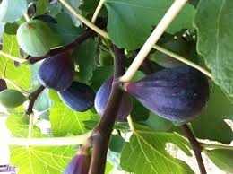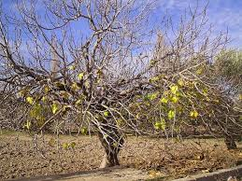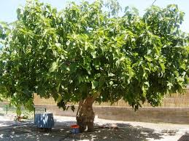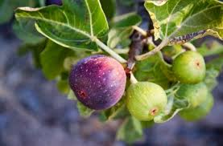

**A B C D**

**Question 6**

Just like the disciples, we often doubt just how much Jesus can do for us. But verse 22 reminds us the importance of prayer and having faith in God. Copy verse 22 into the box below and memorise it by heart.

* Thursday 27th August: Read **Matthew Chapter 21: 20-22** and answer the questions:

### Jesus’ Authority Questioned

*23Now when He came into the temple, the chief priests and the elders of the people confronted Him as He was teaching, and said, “By what authority are You doing these things? And who gave You this authority?”*

*24But Jesus answered and said to them, “I also will ask you one thing, which if you tell Me, I likewise will tell you by what authority I do these things: 25The baptism of John—where was it from? From heaven or from men?”*

*And they reasoned among themselves, saying, “If we say, ‘From heaven,’ He will say to us, ‘Why then did you not believe him?’ 26But if we say, ‘From men,’ we fear the multitude, for all count John as a prophet.” 27So they answered Jesus and said, “We do not know.”*

*And He said to them, “Neither will I tell you by what authority I do these things.”*

**Question 7**

Who said the following verses? (Highlight the correct answer)

|  |  |
| --- | --- |
| Verse | Who said it? |
| *“By what authority are You doing these things? And who gave You this authority?”* | Jesus / Chief priests |
| *“I also will ask you one thing, which if you tell Me, I likewise will tell you by what authority I do these things:The baptism of John—where was it from? From heaven or from men?”* | Jesus / Chief priests |
| *“If we say, ‘From heaven,’ He will say to us, ‘Why then did you not believe him?’ But if we say, ‘From men,’ we fear the multitude, for all count John as a prophet.”* | Jesus / Chief priests |
| *“We do not know.”* | Jesus / Chief priests |
| *“Neither will I tell you by what authority I do these things.”* | Jesus / Chief priests |

**Question 8**

John is mentioned in the passage above. Read it again carefully. Which John is Jesus referring to?

1. John the beloved
2. John the baptist
3. John the father of Peter

* Friday 28th August: Read **Matthew Chapter 21: 23-28** and answer the questions:

### The Parable of the Two Sons

*28“But what do you think? A man had two sons, and he came to the first and said, ‘Son, go, work today in my vineyard.’ 29He answered and said, ‘I will not,’ but afterward he regretted it and went. 30Then he came to the second and said likewise. And he answered and said, ‘I go, sir,’ but he did not go. 31Which of the two did the will of his father?”*

*They said to Him, “The first.”*

*Jesus said to them, “Assuredly, I say to you that tax collectors and harlots enter the kingdom of God before you. 32For John came to you in the way of righteousness, and you did not believe him; but tax collectors and harlots believed him; and when you saw it, you did not afterward relent and believe him.*

**Question 9**

The following comic goes through the importance of obedience. Read the comic and answer the question at the end. Write your answer and the reason for your answer in the box below.

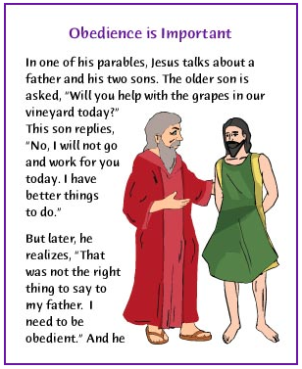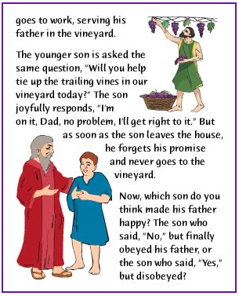

*Which son made his father happy?*

*Why?*

* Saturday 29th August: Read **Matthew Chapter 21: 29-34** and answer the questions:

### The Parable of the Wicked Vinedressers

*33“Hear another parable: There was a certain landowner who planted a vineyard and set a hedge around it, dug a winepress in it and built a tower. And he leased it to vinedressers and went into a far country. 34Now when vintage-time drew near, he sent his servants to the vinedressers, that they might receive its fruit. 35And the vinedressers took his servants, beat one, killed one, and stoned another. 36Again he sent other servants, more than the first, and they did likewise to them. 37Then last of all he sent his son to them, saying, ‘They will respect my son.’ 38But when the vinedressers saw the son, they said among themselves, ‘This is the heir. Come, let us kill him and seize his inheritance.’ 39So they took him and cast him out of the vineyard and killed him.*

*40“Therefore, when the owner of the vineyard comes, what will he do to those vinedressers?”*

*41They said to Him, “He will destroy those wicked men miserably, and lease his vineyard to other vinedressers who will render to him the fruits in their seasons.”*

*42Jesus said to them, “Have you never read in the Scriptures:*

*‘The stone which the builders rejected  
Has become the chief cornerstone.  
This was the Lord’s doing,  
And it is marvelous in our eyes’?*

*43“Therefore I say to you, the kingdom of God will be taken from you and given to a nation bearing the fruits of it. 44And whoever falls on this stone will be broken; but on whomever it falls, it will grind him to powder.”*

*45Now when the chief priests and Pharisees heard His parables, they perceived that He was speaking of them. 46But when they sought to lay hands on Him, they feared the multitudes, because they took Him for a prophet.*

**Question 10**

Match the words to their meaning:

*vineyard, vinedresser, heir, inheritance, cornerstone, parables, prophet*

|  |  |
| --- | --- |
| **Word** | **Meaning** |
|  | A person who inherits something from their parents |
|  | A stone that forms the base of a corner of a building joining 2 walls |
|  | Something you gain from your parents |
|  | A piece of land used to grow grapes |
|  | A person who predicts what will happen in the future |
|  | A simple story used to illustrate a spiritual lesson |
|  | A person who looks after a vineyard |

**Question 11**

Why couldn’t the chief priests lay hands on (arrest) Jesus?

1. They were scared of the multitude who loved Jesus
2. They knew He was God
3. They didn’t know how to arrest Him
4. They were worried He might run away

***What to do when you finish your Bible Study.***

1. ***Either send it by email to your class email address or print and hand it to your servants next Sunday.***
2. ***If you want to send your Bible Study by email, please select your class email address below:***

[stmatthew5b1@gmail.com](mailto:stmatthew5b1@gmail.com) Uncle Andrew

or  
[stmark5b2@gmail.com](mailto:stmark5b2@gmail.com) Uncle Bassem

or  
[saintluke5g1@gmail.com](mailto:saintluke5g1@gmail.com) Aunty Merna

or  
[stjohn5g2@gmail.com](mailto:stjohn5g2@gmail.com) Aunty Angela

***Click on the following link to see how many points you have.***

**Year 5B1 (St Matthew)**

[https://docs.google.com/spreadsheets/d/1YPfk0C0NBJv0XfLlXzhWewt5SbZHkTAmmAVEaydaUYo/edit?usp=sharing](https://webmail.meriden.nsw.edu.au/owa/redir.aspx?C=88057cf25a174c15b69cd7e5055a667f&URL=https%3a%2f%2fdocs.google.com%2fspreadsheets%2fd%2f1YPfk0C0NBJv0XfLlXzhWewt5SbZHkTAmmAVEaydaUYo%2fedit%3fusp%3dsharing)  
**Year 5B2 (St Mark)**

[https://docs.google.com/spreadsheets/d/1IU-qPhJOybm8AH80BISZtK-OVRM-f7DXrPzkonxcraU/edit?usp=sharing](https://webmail.meriden.nsw.edu.au/owa/redir.aspx?C=88057cf25a174c15b69cd7e5055a667f&URL=https%3a%2f%2fdocs.google.com%2fspreadsheets%2fd%2f1IU-qPhJOybm8AH80BISZtK-OVRM-f7DXrPzkonxcraU%2fedit%3fusp%3dsharing)

**Year 5G1 (St Luke)**

[https://docs.google.com/spreadsheets/d/1S9gmI4ZC4ctLiJjYsJGXg_p__H28tM8WXGWcHD8OBKc/edit?usp=sharing](https://webmail.meriden.nsw.edu.au/owa/redir.aspx?C=88057cf25a174c15b69cd7e5055a667f&URL=https%3a%2f%2fdocs.google.com%2fspreadsheets%2fd%2f1S9gmI4ZC4ctLiJjYsJGXg_p__H28tM8WXGWcHD8OBKc%2fedit%3fusp%3dsharing)

**Year 5G2 (St John)**

[https://docs.google.com/spreadsheets/d/1rlhsNVFRZ_MQ00H8UVw1Xb2kvxPZhKiZgdpHZZ9zZtY/edit?usp=sharing](https://webmail.meriden.nsw.edu.au/owa/redir.aspx?C=88057cf25a174c15b69cd7e5055a667f&URL=https%3a%2f%2fdocs.google.com%2fspreadsheets%2fd%2f1rlhsNVFRZ_MQ00H8UVw1Xb2kvxPZhKiZgdpHZZ9zZtY%2fedit%3fusp%3dsharing)