C:\Documents and Settings\suzy\Local Settings\Temporary Internet Files\Content.IE5\3JXW24R5\MC900383922[1].wmfSunday 23rd August, 2015

Name:

Class:

Finish Date: Saturday 29th August, 2015

Completed Bible Study = 15 points

Email Homework by the due date = 5 points

**Year 5 Bible Study Matthew Chapter 19**

**For the questions below Highlight, underline or change the font colour to choose the correct answer.**

* Monday 24th August: Read **Matthew Chapter 19: 1-6** and answer the questions:

### Marriage and Divorce

*1Now it came to pass, when Jesus had finished these sayings, that He departed from Galilee and came to the region of Judea beyond the Jordan. 2And great multitudes followed Him, and He healed them there.*

*3The Pharisees also came to Him, testing Him, and saying to Him, “Is it lawful for a man to divorce his wife for just any reason?”*

*4And He answered and said to them, “Have you not read that He who made them at the beginning ‘made them male and female, 5and said, ‘For this reason a man shall leave his father and mother and be joined to his wife, and the two shall become one flesh’? 6So then, they are no longer two but one flesh. Therefore what God has joined together, let not man separate.”*

**Question 1**

Who said the following quote?

*****“Is it lawful for a man to divorce his wife for just any reason?”*

1. Jesus
2. Moses
3. Pharisees

**Question 2**

In which book at the start of the Old Testament does the first marriage occur?

1. Genesis
2. Exodus
3. Leviticus
4. Numbers

* Tuesday 25th August: Read **Matthew Chapter 19: 7-9** and answer the questions:

### Jesus Teaches on Divorce

*7They said to Him, “Why then did Moses command to give a certificate of divorce, and to put her away?”*

*8He said to them, “Moses, because of the hardness of your hearts, permitted you to divorce your wives, but from the beginning it was not so. 9And I say to you, whoever divorces his wife, except for sexual immorality, and marries another, commits adultery; and whoever marries her who is divorced commits adultery.”*

**Question 3**

Complete the following verse:

Moses, because of the of your , permitted you to your wives, but from the it was not so.

* Wednesday 26th August: Read **Matthew Chapter 19: 13-15** and answer the questions:

### Jesus Blesses Little Children

*13Then little children were brought to Him that He might put His hands on them and pray, but the disciples rebuked them. 14But Jesus said, “Let the little children come to Me, and do not forbid them; for of such is the kingdom of heaven.” 15And He laid His hands on them and departed from there.*

**Question 4**

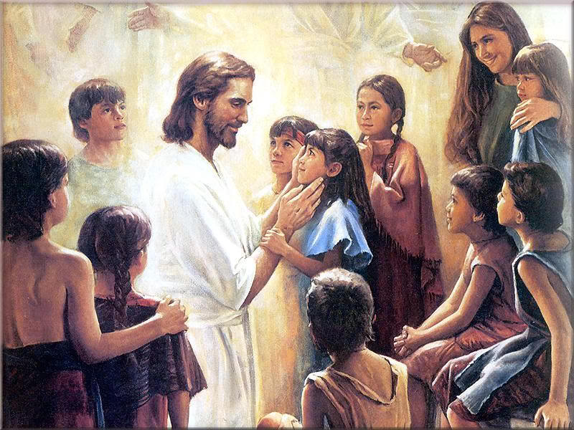As young children, you have been blessed by Jesus. How did Jesus bless children in the verses above?

1. He prayed for them
2. He laid His hands on them
3. He spoke to them
4. He cuddled them

**Question 5**

What do you think verse 14 (*14But Jesus said, “Let the little children come to Me, and do not forbid them; for of such is the kingdom of heaven.*) means?

1. Heaven is only filled with children.
2. You have to be young to go to heaven.
3. You have to be like a young innocent child to enter into heaven.

* Thursday 27th August: Read **Matthew Chapter 19: 16-22** and answer the questions:

### Jesus Counsels the Rich Young Ruler

*16Now behold, one came and said to Him, “Good Teacher, what good thing shall I do that I may have eternal life?”*

*17So He said to him, “Why do you call Me good? No one is good but One, that is, God. But if you want to enter into life, keep the commandments.”*

*18He said to Him, “Which ones?”*

*Jesus said, “‘You shall not murder,’ ‘You shall not commit adultery,’ ‘You shall not steal,’ ‘You shall not bear false witness,’ 19‘Honor your father and your mother,’ and, ‘You shall love your neighbor as yourself.’ ”*

*20The young man said to Him, “All these things I have kept from my youth. What do I still lack?”*

*21Jesus said to him, “If you want to be perfect, go, sell what you have and give to the poor, and you will have treasure in heaven; and come, follow Me.”*

*22But when the young man heard that saying, he went away sorrowful, for he had great possessions.*

**(Questions over the page)**

**Question 6**

Write down the correct order of what happened when Jesus met the rich man. The first one has been done for you.

A - Rich man says he follows all the commandments Jesus mentions.

B - Rich man leaves Jesus upset.

C - Jesus tells the rich man to sell all he has and follow Him.

D - Rich man asks Jesus what he should do to inherit eternal life.

E - Jesus recalls 6 different commandments.

F - Jesus tells the rich man to keep the commandments.

|  |  |  |  |  |  |
| --- | --- | --- | --- | --- | --- |
| D |  |  |  |  |  |

**Question 7**

Why was the young man upset when Jesus told him to sell everything he had and follow Him? Type your answer in the text box below.

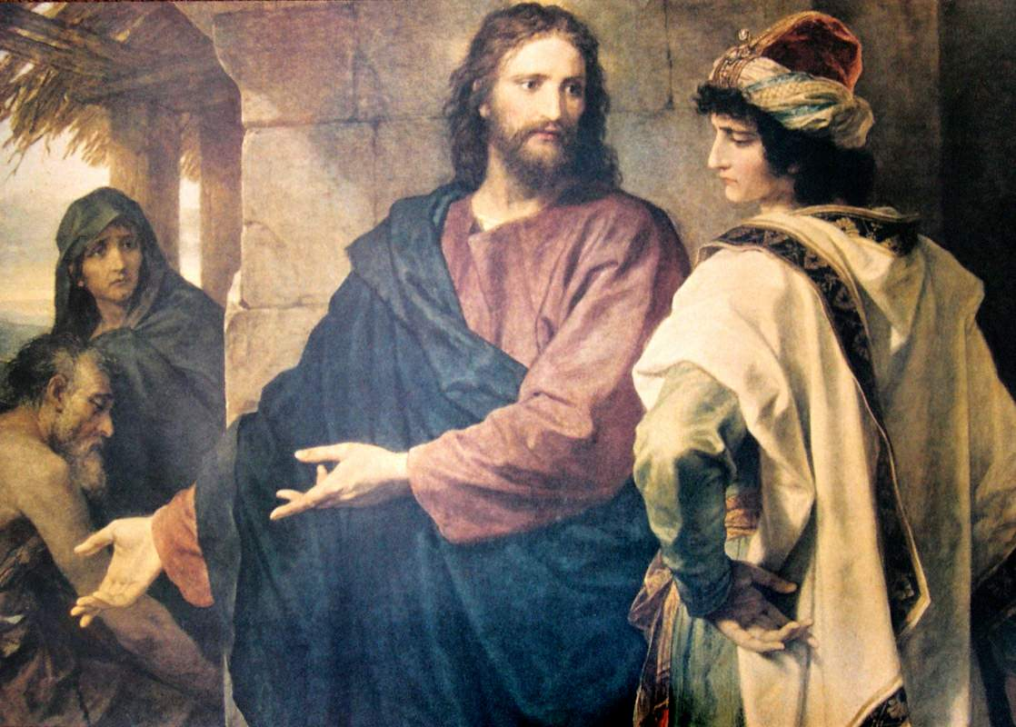

* Friday 28th August: Read **Matthew Chapter 19: 23-30** and answer the questions:

**With God All Things Are Possible**

**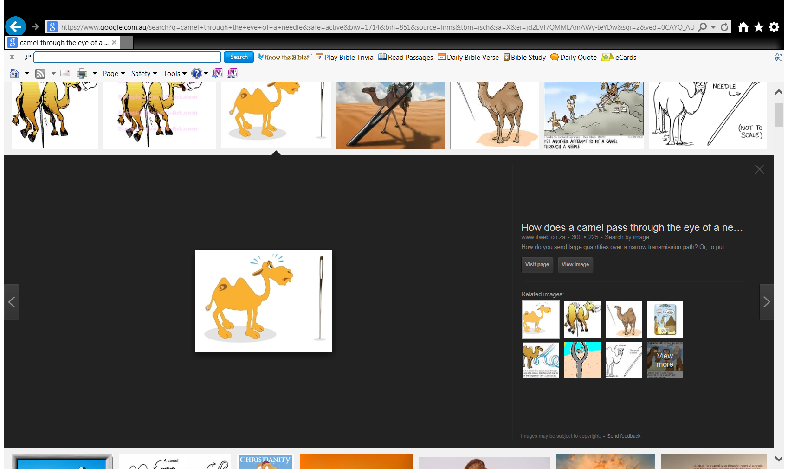*23****Then Jesus said to His disciples, “Assuredly, I say to you that it is hard for a rich man to enter the kingdom of heaven.****24****And again I say to you, it is easier for a camel to go through the eye of a needle than for a rich man to enter the kingdom of God.”*

***25****When His disciples heard it, they were greatly astonished, saying, “Who then can be saved?”*

***26****But Jesus looked at them and said to them, “With men this is impossible, but with God all things are possible.”*

***27****Then Peter answered and said to Him, “See, we have left all and followed You. Therefore what shall we have?”*

***28****So Jesus said to them, “Assuredly I say to you, that in the regeneration, when the Son of Man sits on the throne of His glory, you who have followed Me will also sit on twelve thrones, judging the twelve tribes of Israel.****29****And everyone who has left houses or brothers or sisters or father or mother or wife or children or lands, for My name’s sake, shall receive a hundredfold, and inherit eternal life.****30****But many who are first will be last, and the last first.*

**Question 8**

*Highlight the correct answer.*

What does Jesus compare a rich person entering heaven to?

A horse / camel going through the eye of a needle / door of a house.

**Question 9**

Complete the table by naming the person who said the statement. Choose the names from the list below:

*Jesus Peter Disciples*

|  |  |
| --- | --- |
| **Statement** | **Person who said this** |
| *“Assuredly, I say to you that it is hard for a rich man to enter the kingdom of heaven.”* |  |
| *“Who then can be saved?”* |  |
| *“See, we have left all and followed You. Therefore what shall we have?”* |  |
| *But many who are first will be last, and the last first.* |  |

* Saturday 29th August

**Question 10**

MEMORY VERSE: Copy and Learn by heart Matthew 19:26

***What to do when you finish your Bible Study.***

1. ***Either send it by email to your class email address or print and hand it to your servants next Sunday.***
2. ***If you want to send your Bible Study by email, please select your class email address below:***

[stmatthew5b1@gmail.com](mailto:stmatthew5b1@gmail.com) Uncle Andrew

or  
[stmark5b2@gmail.com](mailto:stmark5b2@gmail.com)

or  
[saintluke5g1@gmail.com](mailto:saintluke5g1@gmail.com) Aunty Merna

or  
[stjohn5g2@gmail.com](mailto:stjohn5g2@gmail.com) Aunty Angela

***Click on the following link to see how many points you have.***

**Year 5B1 (St Matthew)**

[https://docs.google.com/spreadsheets/d/1YPfk0C0NBJv0XfLlXzhWewt5SbZHkTAmmAVEaydaUYo/edit?usp=sharing](https://webmail.meriden.nsw.edu.au/owa/redir.aspx?C=88057cf25a174c15b69cd7e5055a667f&URL=https%3a%2f%2fdocs.google.com%2fspreadsheets%2fd%2f1YPfk0C0NBJv0XfLlXzhWewt5SbZHkTAmmAVEaydaUYo%2fedit%3fusp%3dsharing)  
**Year 5B2 (St Mark)**

[https://docs.google.com/spreadsheets/d/1IU-qPhJOybm8AH80BISZtK-OVRM-f7DXrPzkonxcraU/edit?usp=sharing](https://webmail.meriden.nsw.edu.au/owa/redir.aspx?C=88057cf25a174c15b69cd7e5055a667f&URL=https%3a%2f%2fdocs.google.com%2fspreadsheets%2fd%2f1IU-qPhJOybm8AH80BISZtK-OVRM-f7DXrPzkonxcraU%2fedit%3fusp%3dsharing)

**Year 5G1 (St Luke)**

[https://docs.google.com/spreadsheets/d/1S9gmI4ZC4ctLiJjYsJGXg_p__H28tM8WXGWcHD8OBKc/edit?usp=sharing](https://webmail.meriden.nsw.edu.au/owa/redir.aspx?C=88057cf25a174c15b69cd7e5055a667f&URL=https%3a%2f%2fdocs.google.com%2fspreadsheets%2fd%2f1S9gmI4ZC4ctLiJjYsJGXg_p__H28tM8WXGWcHD8OBKc%2fedit%3fusp%3dsharing)

**Year 5G2 (St John)**

[https://docs.google.com/spreadsheets/d/1rlhsNVFRZ_MQ00H8UVw1Xb2kvxPZhKiZgdpHZZ9zZtY/edit?usp=sharing](https://webmail.meriden.nsw.edu.au/owa/redir.aspx?C=88057cf25a174c15b69cd7e5055a667f&URL=https%3a%2f%2fdocs.google.com%2fspreadsheets%2fd%2f1rlhsNVFRZ_MQ00H8UVw1Xb2kvxPZhKiZgdpHZZ9zZtY%2fedit%3fusp%3dsharing)