C:\Documents and Settings\suzy\Local Settings\Temporary Internet Files\Content.IE5\3JXW24R5\MC900383922[1].wmfSunday 24th May, 2015

Name:

Class:

Finish Date: Saturday 30th May, 2015

Completed Bible Study = 15 points

Email Homework by the due date = 5 points

**Year 5 Bible Study Matthew Chapter 14**

For the questions below Highlight, underline or change the font colour to choose the correct answer.

□ Monday 25th May: Read **Matthew Chapter 14: 13-15** and answer the questions:

### Jesus has compassion for the thousands of people who were following Him

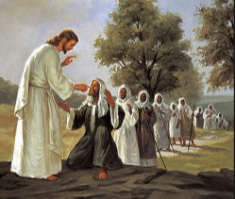***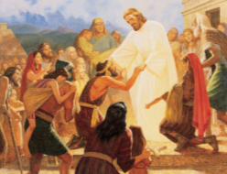****13When Jesus heard it, He departed from there by boat to a deserted place by Himself. But when the multitudes heard it, they followed Him on foot from the cities. 14And when Jesus went out He saw a great multitude; and He was moved with compassion for them, and healed their sick. 15When it was evening, His disciples came to Him, saying, “This is a deserted place, and the hour is already late. Send the multitudes away, that they may go into the villages and buy themselves food.”*

**Question 1**

**True or False**

1. Jesus’ followers loved Him so much that they followed Him by boat. True/ False
2. Jesus wanted to be by himself for a while so was unhappy to be followed by the people. True/ False
3. Jesus performed miracles. True/ False
4. The disciples were worried about how to feed the people that followed Jesus. True / False

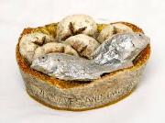□ Tuesday 26th May: Read **Matthew Chapter 14: 16-21** and answer the questions:

### Feeding the Five Thousand

*16But Jesus said to them, “They do not need to go away. You give them something to eat.”*

*17And they said to Him, “We have here only five loaves and two fish.”*

*18He said, “Bring them here to Me.” 19Then He commanded the multitudes to sit down on the grass. And He took the five loaves and the two fish, and looking up to heaven, He blessed and broke and gave the loaves to the disciples; and the disciples gave to the multitudes. 20So they all ate and were filled, and they took up twelve baskets full of the fragments that remained. 21Now those who had eaten were about five thousand men, besides women and children.*

**Question 2**

The disciples came to Jesus with only two fish and five loaves. What did Jesus do to make sure that this little food would be enough to feed everyone? Fill in the missing words:

Jesus and the food and the disciples gave it to the

people.

**Question 3**

How many baskets were left after the disciples fed the 5000 people?

□ Wednesday 27th May: Read **Matthew Chapter 14: 22-27** and answer the questions:

### Jesus Walks on the Sea

*22Immediately Jesus made His disciples get into the boat and go before Him to the other side, while He sent the multitudes away. 23And when He had sent the multitudes away, He went up on the mountain by Himself to pray. Now when evening came, He was alone there. 24But the boat was now in the middle of the sea,tossed by the waves, for the wind was contrary.*

*25Now in the fourth watch of the night Jesus went to them, walking on the sea. 26And when the disciples saw Him walking on the sea, they were troubled, saying, “It is a ghost!” And they cried out for fear.*

*27But immediately Jesus spoke to them, saying, “Be of good cheer! It is I; do not be afraid.”*

**Question 4**

What was Jesus doing whilst the disciples took the boat ahead to the other side?

1. praying
2. sleeping
3. performing a miracle

□Thursday 28th May: Read **Matthew Chapter 14: 28-33** and answer the questions:

*28And Peter answered Him and said, “Lord, if it is You, command me to come to You on the water.”*

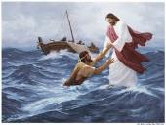*29So He said, “Come.” And when Peter had come down out of the boat, he walked on the water to go to Jesus. 30But when he saw that the wind was boisterous (fierce) he was afraid; and beginning to sink he cried out, saying, “Lord, save me!”*

*31And immediately Jesus stretched out His hand and caught him, and said to him, “O you of little faith, why did you doubt?” 32And when they got into the boat, the wind ceased.*

*33Then those who were in the boat came and worshiped Him, saying, “Truly You are the Son of God.*

**Question 5**

Jesus came to the disciples on the boat walking on water in the midst of the storm. Peter, believing that it was Jesus was also able to walk on the water. What was it that made Jesus realise that Peter’s faith in Him was shaken for a moment?

□ Friday 29th May: Read **Matthew Chapter 14: 34-36** and answer the questions:

### Many Touch Him and Are Made Well

*34When they had crossed over, they came to the land of Gennesaret. 35And when the men of that place recognized Him, they sent out into all that surrounding region, brought to Him all who were sick, 36and begged Him that they might only touch the hem of His garment. And as many as touched it were made perfectly well*

**Question 6**

Jesus heals all those you simply touch his clothes. This also happened in Matthew 9 when a lady who had been bleeding for 12 years came behind Him and touched His garment. What did Jesus say had healed her? (Hint- Matt 9:22) Complete the missing word:

**“Be of good cheer, daughter; your has made you well.”**

□ Saturday 30th May: **MEMORY VERSE**:

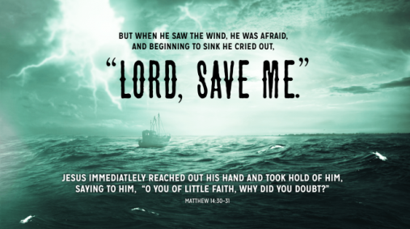

**Do you know this little prayer?**

*Even when Peter’s faith fails him and he finds himself sinking, he cries quickly*

***“LORD, SAVE ME.”*** *His prayer was as full as it was short and Jesus did not delay in responding. He immediately reached out His hand… Peter was nearer to our Lord when He was sinking than when he was walking. Then he resumed the walk of faith. How easy it is to have faith when Christ Himself is at our side! Lord, when our faith fails us hear us cry “Lord, save me” and we shall walk on the wave.*

***What to do when you finish your Bible Study.***

1. ***Either send it by email to your class email address or print and hand it to your servants next Sunday.***
2. ***If you want to send your Bible Study by email, please select your class email address below:***

[stmatthew5b1@gmail.com](mailto:stmatthew5b1@gmail.com) Uncle Andrew

or  
[stmark5b2@gmail.com](mailto:stmark5b2@gmail.com) Uncle Bassem

or  
[saintluke5g1@gmail.com](mailto:saintluke5g1@gmail.com) Aunty Merna

or  
[stjohn5g2@gmail.com](mailto:stjohn5g2@gmail.com) Aunty Angela

***Click on the following link to see how many points you have.***

**Year 5B1 (St Matthew)**

[https://docs.google.com/spreadsheets/d/1YPfk0C0NBJv0XfLlXzhWewt5SbZHkTAmmAVEaydaUYo/edit?usp=sharing](https://webmail.meriden.nsw.edu.au/owa/redir.aspx?C=88057cf25a174c15b69cd7e5055a667f&URL=https%3a%2f%2fdocs.google.com%2fspreadsheets%2fd%2f1YPfk0C0NBJv0XfLlXzhWewt5SbZHkTAmmAVEaydaUYo%2fedit%3fusp%3dsharing" \t "_blank)  
**Year 5B2 (St Mark)**

[https://docs.google.com/spreadsheets/d/1IU-qPhJOybm8AH80BISZtK-OVRM-f7DXrPzkonxcraU/edit?usp=sharing](https://webmail.meriden.nsw.edu.au/owa/redir.aspx?C=88057cf25a174c15b69cd7e5055a667f&URL=https%3a%2f%2fdocs.google.com%2fspreadsheets%2fd%2f1IU-qPhJOybm8AH80BISZtK-OVRM-f7DXrPzkonxcraU%2fedit%3fusp%3dsharing" \t "_blank)

**Year 5G1 (St Luke)**

[https://docs.google.com/spreadsheets/d/1S9gmI4ZC4ctLiJjYsJGXg\_p\_\_H28tM8WXGWcHD8OBKc/edit?usp=sharing](https://webmail.meriden.nsw.edu.au/owa/redir.aspx?C=88057cf25a174c15b69cd7e5055a667f&URL=https%3a%2f%2fdocs.google.com%2fspreadsheets%2fd%2f1S9gmI4ZC4ctLiJjYsJGXg_p__H28tM8WXGWcHD8OBKc%2fedit%3fusp%3dsharing" \t "_blank)

**Year 5G2 (St John)**

[https://docs.google.com/spreadsheets/d/1rlhsNVFRZ\_MQ00H8UVw1Xb2kvxPZhKiZgdpHZZ9zZtY/edit?usp=sharing](https://webmail.meriden.nsw.edu.au/owa/redir.aspx?C=88057cf25a174c15b69cd7e5055a667f&URL=https%3a%2f%2fdocs.google.com%2fspreadsheets%2fd%2f1rlhsNVFRZ_MQ00H8UVw1Xb2kvxPZhKiZgdpHZZ9zZtY%2fedit%3fusp%3dsharing" \t "_blank)