Handed out Sunday 19th April
Name:
Class:
To be emailed back to your Bible Study servant by 25th April
Completed Bible Study = 15 points,

Emailed by the due date = 5 points

The GOSPEL according to St. Matthew
Year 5 – Bible Study- Matthew Chapter 10

- Monday 20th April Read Matthew Chapter 10 verses 1 – 4

The Twelve Apostles
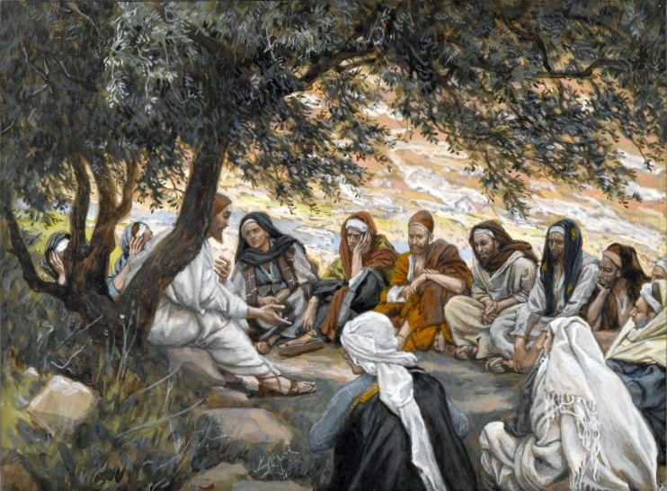
And when He had called His twelve disciples to Him, He gave them power over unclean spirits, to cast them out, and to heal all kinds of sickness and all kinds of disease. ² Now the names of the twelve apostles are these:
first, Simon, who is called Peter, and Andrew his brother; James the son of Zebedee, and John his brother; ³ Philip and Bartholomew; Thomas and Matthew the tax collector; James the son of Alphaeus, and Lebbaeus, whose surname was Thaddaeus; ⁴ Simon the Cananite, and Judas Iscariot, who also betrayed Him.

Question 1
How many sets of brothers are there, and who are they?

Question 2

Which of the two disciples wrote Gospels?

- Tuesday 21st April Read Matthew Chapter 10 verses 5-15.
Sending Out the Twelve
⁵ These twelve Jesus sent out and commanded them, saying: “Do not go into the way of the Gentiles, and do not enter a city of the Samaritans. ⁶ But go rather to the lost sheep of the house of Israel. ⁷ And as you go, preach, saying, ‘The kingdom of heaven is at hand.’ ⁸ Heal the sick, cleanse the lepers, raise the dead, cast out demons. Freely you have received, freely give. ⁹ Provide neither gold nor silver nor copper in your money belts, ¹⁰ nor bag for your journey, nor two tunics, nor sandals, nor staffs; for a worker is worthy of his food.
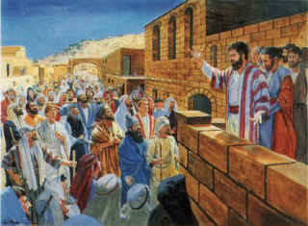
¹¹ “Now whatever city or town you enter, inquire who in it is worthy, and stay there till you go out. ¹² And when you go into a household, greet it. ¹³ If the household is worthy, let your peace come upon it. But if it is not worthy, let your peace return to you. ¹⁴ And whoever will not receive you nor hear your words, when you depart from that house or city, shake off the dust from your feet. ¹⁵ Assuredly, I say to you, it will be more tolerable for the land of Sodom and Gomorrah in the Day of Judgment than for that city!
What happened to Sodom and Gomorrah?
The people that lived in Sodom and Gomorrah in the Old Testament were people that did not follow the commandments, and disrespected God. God sent down a FIRE from heaven, and everybody in that town was DESTROYED.
Question 3
What were the disciples told to preach? (Hint v7)

Question 4
True or false?

- The apostles had to take gold, money and clothes with them when they were preaching? TRUE / FALSE

- Jesus told the apostles to stay in the cities that did not accept the words that they preached? TRUE / FALSE

- The people that did not accept the words that were preached will be destroyed on the day of judgement? TRUE / FALSE

- Wednesday 22nd April Read Matthew Chapter 10 verses 16-26
Persecutions are coming
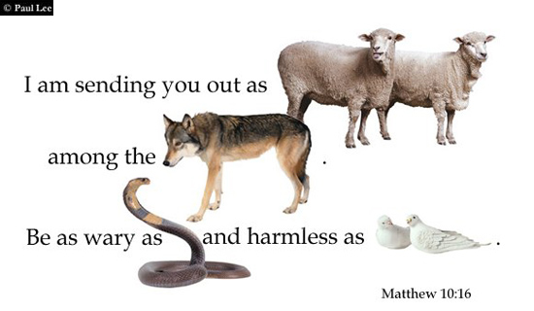
¹⁶ “Behold, I send you out as sheep among the wolves. Therefore be wary as serpents and harmless as doves.
¹⁷ But beware of men, for they will deliver you up to councils and scourge you in their synagogues. ¹⁸ You will be brought before governors and kings for My sake, as a testimony to them and to the Gentiles. ¹⁹ But when they deliver you up, do not worry about how or what you should speak. For it will be given to you in that hour what you should speak; ²⁰ for it is not you who speak, but the Spirit of your Father who speaks in you.
²¹ “Now brother will deliver up brother to death, and a father his child; and children will rise up against parents and cause them to be put to death. ²² And you will be hated by all for My name’s sake. But he who endures to the end will be saved. ²³ When they persecute you in this city, flee to another. For assuredly, I say to you, you will not have gone through the cities of Israel before the Son of Man comes.
²⁴ “A disciple is not above his teacher, nor a servant above his master. ²⁵ It is enough for a disciple that he be like his teacher, and a servant like his master. If they have called the master of the house Beelzebub, how much more will they call those of his household! ²⁶ Therefore do not fear them. For there is nothing covered that will not be revealed, and hidden that will not be known.
Question 6
Who is it that gives you the words to speak if you are brought in front of Governors and kings to defend your faith for the sake of God? (Hint v18-20)

Question 7
Fill in the blanks

“But he who to the end will be .” (v22)

To endure in the passage above means to suffer, never give up, bearing all difficult times.
Just like Jesus endured the cross to save us from sin.

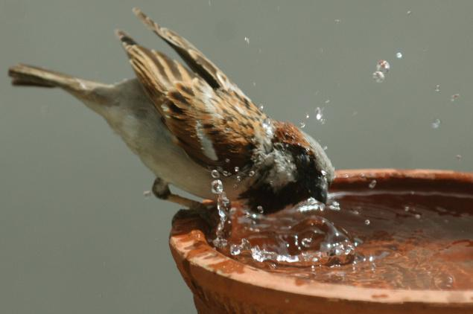
Sparrow
- Thursday 23rd April Read Matthew Chapter 10 verses 27-31

Jesus Teaches the Fear of God
²⁷ “Whatever I tell you in the dark, speak in the light; and what you hear in the ear, preach on the housetops. ²⁸ And do not fear those who kill the body but cannot kill the soul. But rather fear Him who is able to destroy both soul and body in hell. ²⁹ Are not two sparrows sold for a copper coin? And not one of them falls to the ground apart from your Father’s will. ³⁰ But the very hairs of your head are all numbered. ³¹ Do not fear therefore; you are of more value than many sparrows.
Question 8
According to Verse 28 who are we supposed to fear? Why do you think this is so?

- Friday 24th April Read Matthew Chapter 10 verses 32-39

Confess Christ Before Men
³² “Therefore whoever confesses Me before men, him I will also confess before My Father who is in heaven. ³³ But whoever denies Me before men, him I will also deny before My Father who is in heaven.
³⁴ “Do not think that I came to bring peace on earth. I did not come to bring peace but a sword. ³⁵ For I have come to ‘set a man against his father, a daughter against her mother, and a daughter-in-law against her mother-in-law’; ³⁶ and ‘a man’s enemies will be those of his own household.’ ³⁷ He who loves father or mother more than Me is not worthy of Me. And he who loves son or daughter more than Me is not worthy of Me. ³⁸ And he who does not take his cross and follow after Me is not worthy of Me. ³⁹ He who finds his life will lose it, and he who loses his life for My sake will find it.
Question 9
What will happen to a person that denies Christ in front of men?
- They will receive praise from people
- God will accept them in heaven
- Christ will also deny them in heaven
- They will live eternally

Question 10
Explain, in your own words, the importance of living only for God (Verse 39: He who loses his life for My sake will find it)

- Saturday 25th April Read Matthew Chapter 10 verses 40-42

A Cup of Cold Water

⁴⁰ “He who receives you receives Me, and he who receives Me receives Him who sent Me. ⁴¹ He who receives a prophet in the name of a prophet shall receive a prophet’s reward. And he who receives a righteous man in the name of a righteous man shall receive a righteous man’s reward. ⁴² And whoever gives one of these little ones only a cup of cold water in the name of a disciple, assuredly, I say to you, he shall by no means lose his reward

Question 11
As Christians, who are we called to receive/ welcome? How do we do this?

PARENTS SECTION:
We kindly ask you as a parent to read (a little each day) in the Holy Bible with your family.
Now email your answers to your teacher, choose ONE of the email addresses below.

stmatthew5b1@gmail.com Uncle Andrew
or
stmark5b2@gmail.com Uncle Bassem
or
saintluke5g1@gmail.com Aunty Merna
or
stjohn5g2@gmail.com Aunty Angela

Click on the following link to see how many points you have.
Year 5B1 (St Matthew)
https://docs.google.com/spreadsheets/d/1YPfk0C0NBJv0XfLlXzhWewt5SbZHkTAmmAVEaydaUYo/edit?usp=sharing
Year 5B2 (St Mark)
https://docs.google.com/spreadsheets/d/1IU-qPhJOybm8AH80BISZtK-OVRM-f7DXrPzkonxcraU/edit?usp=sharing
Year 5G1 (St Luke)
https://docs.google.com/spreadsheets/d/1S9gmI4ZC4ctLiJjYsJGXg_p__H28tM8WXGWcHD8OBKc/edit?usp=sharing
Year 5G2 (St John)
https://docs.google.com/spreadsheets/d/1rlhsNVFRZ_MQ00H8UVw1Xb2kvxPZhKiZgdpHZZ9zZtY/edit?usp=sharing

