
Handed out Sunday 8th March Name …………………………. Due Date: 15th March Class …………………………. Completed Bible Study = 15 points, Handed in by the due date = 5 points

The GOSPEL according to ST. Matthew
Year 5 – Bible study 3

Monday 9th March Read Chapter 5 verses 1 – 16

And seeing the multitudes, He went up on a mountain, and when He was seated His disciples came to Him. ² Then He opened His mouth and taught them, saying:
³ “Blessed are the poor in spirit,
For theirs is the kingdom of heaven.
⁴ Blessed are those who mourn,
For they shall be comforted.
⁵ Blessed are the meek,
For they shall inherit the earth.
⁶ Blessed are those who hunger and thirst for righteousness,
For they shall be filled.
⁷ Blessed are the merciful,
For they shall obtain mercy.
⁸ Blessed are the pure in heart,
For they shall see God.
⁹ Blessed are the peacemakers,
For they shall be called sons of God.
¹⁰ Blessed are those who are persecuted for righteousness’ sake,
For theirs is the kingdom of heaven.
¹¹ “Blessed are you when they revile and persecute you, and say all kinds of evil against you falsely for My sake. ¹² Rejoice and be exceedingly glad, for great is your reward in heaven, for so they persecuted the prophets who were before you.

Believers Are Salt and Light
¹³ “You are the salt of the earth; but if the salt loses its flavor, how shall it be seasoned? It is then good for nothing but to be thrown out and trampled underfoot by men.
¹⁴ “You are the light of the world. A city that is set on a hill cannot be hidden. ¹⁵ Nor do they light a lamp and put it under a basket, but on a lampstand, and it gives light to all who are in the house. ¹⁶ Let your light so shine before men, that they may see your good works and glorify your Father in heaven.

- What is the reward for those who are pure in heart?

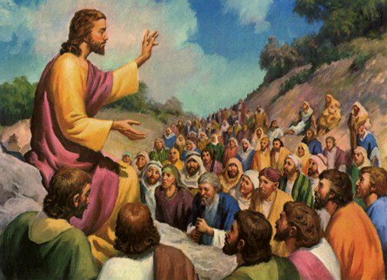
Jesus calls us to be the salt of the earth and the light of the world. This means that we should witness to Christ by being model Christians, by doing good works and refraining from sin. By this people know that we are the followers of Christ.

Tuesday 10th March Read Chapter 5 verses 17 – 26

Christ Fulfills the Law
¹⁷ “Do not think that I came to destroy the Law or the Prophets. I did not come to destroy but to fulfill. ¹⁸ For assuredly, I say to you, till heaven and earth pass away, one jot or one tittle will by no means pass from the law till all is fulfilled. ¹⁹ Whoever therefore breaks one of the least of these commandments, and teaches men so, shall be called least in the kingdom of heaven; but whoever does and teaches them, he shall be called great in the kingdom of heaven. ²⁰ For I say to you, that unless your righteousness exceeds the righteousness of the scribes and Pharisees, you will by no means enter the kingdom of heaven.

Murder Begins in the Heart
²¹ “You have heard that it was said to those of old, ‘You shall not murder,^{[a]} and whoever murders will be in danger of the judgment.’ ²² But I say to you that whoever is angry with his brother without a cause^{[b]} shall be in danger of the judgment. And whoever says to his brother, ‘Raca!’ shall be in danger of the council. But whoever says, ‘You fool!’ shall be in danger of hell fire. ²³ Therefore if you bring your gift to the altar, and there remember that your brother has something against you, ²⁴ leave your gift there before the altar, and go your way. First be reconciled to your brother, and then come and offer your gift. ²⁵ Agree with your adversary quickly, while you are on the way with him, lest your adversary deliver you to the judge, the judge hand you over to the officer, and you be thrown into prison. ²⁶ Assuredly, I say to you, you will by no means get out of there till you have paid the last penny.
- True or false (underline correct answer):
Christ did not come to destroy the Law of the prophets True False

Wednesday 11th March Read Chapter 5 verses 33 – 48

Jesus Forbids Oaths
³³ “Again you have heard that it was said to those of old, ‘You shall not swear falsely, but shall perform your oaths to the Lord.’ ³⁴ But I say to you, do not swear at all: neither by heaven, for it is God’s throne; ³⁵ nor by the earth, for it is His footstool; nor by Jerusalem, for it is the city of the great King. ³⁶ Nor shall you swear by your head, because you cannot make one hair white or black. ³⁷ But let your ‘Yes’ be ‘Yes,’ and your ‘No,’ ‘No.’ For whatever is more than these is from the evil one.

Go the Second Mile
³⁸ “You have heard that it was said, ‘An eye for an eye and a tooth for a tooth.’^{[f]} ³⁹ But I tell you not to resist an evil person. But whoever slaps you on your right cheek, turn the other to him also. ⁴⁰ If anyone wants to sue you and take away your tunic, let him have your cloak also. ⁴¹ And whoever compels you to go one mile, go with him two. ⁴² Give to him who asks you, and from him who wants to borrow from you do not turn away.

Love Your Enemies
⁴³ “You have heard that it was said, ‘You shall love your neighbor^{[g]} and hate your enemy.’ ⁴⁴ But I say to you, love your enemies, bless those who curse you, do good to those who hate you, and pray for those who spitefully use you and persecute you,^{[h]} ⁴⁵ that you may be sons of your Father in heaven; for He makes His sun rise on the evil and on the good, and sends rain on the just and on the unjust. ⁴⁶ For if you love those who love you, what reward have you? Do not even the tax collectors do the same? ⁴⁷ And if you greet your brethren^{[i]} only, what do you do more than others? Do not even the tax collectors^{[j]} do so? ⁴⁸ Therefore you shall be perfect, just as your Father in heaven is perfect
3. Complete the verses:

“But I say to you, do not at all: neither by , for it is

God’s ” (Matthew 5:34)

“But let your ‘ ’ be ‘ ,’ and your ‘No,’ ‘No.’ For whatever is

more than these is from the evil one.” (Matthew 5:37)

- The Lord tells us to go an extra mile with others. So if someone slaps us on the cheek what should we do?

Thursday 12th March Read Chapter 6 verses 1 – 15

Do Good to Please God
6 “Take heed that you do not do your charitable deeds before men, to be seen by them. Otherwise you have no reward from your Father in heaven. ² Therefore, when you do a charitable deed, do not sound a trumpet before you as the hypocrites do in the synagogues and in the streets, that they may have glory from men. Assuredly, I say to you, they have their reward. ³ But when you do a charitable deed, do not let your left hand know what your right hand is doing, ⁴ that your charitable deed may be in secret; and your Father who sees in secret will Himself reward you openly.^{[a]}

The Model Prayer
⁵ “And when you pray, you shall not be like the hypocrites. For they love to pray standing in the synagogues and on the corners of the streets, that they may be seen by men. Assuredly, I say to you, they have their reward. ⁶ But you, when you pray, go into your room, and when you have shut your door, pray to your Father who is in the secret place; and your Father who sees in secret will reward you openly.^{[b]} ⁷ And when you pray, do not use vain repetitions as the heathen do. For they think that they will be heard for their many words.
⁸ “Therefore do not be like them. For your Father knows the things you have need of before you ask Him. ⁹ In this manner, therefore, pray:
Our Father in heaven,
Hallowed be Your name.
¹⁰ Your kingdom come.
Your will be done
On earth as it is in heaven.
¹¹ Give us this day our daily bread.
¹² And forgive us our debts,
As we forgive our debtors.
¹³ And do not lead us into temptation,
But deliver us from the evil one.
For Yours is the kingdom and the power and the glory forever. Amen.^{[c]}
¹⁴ “For if you forgive men their trespasses, your heavenly Father will also forgive you. ¹⁵ But if you do not forgive men their trespasses, neither will your Father forgive your trespasses.

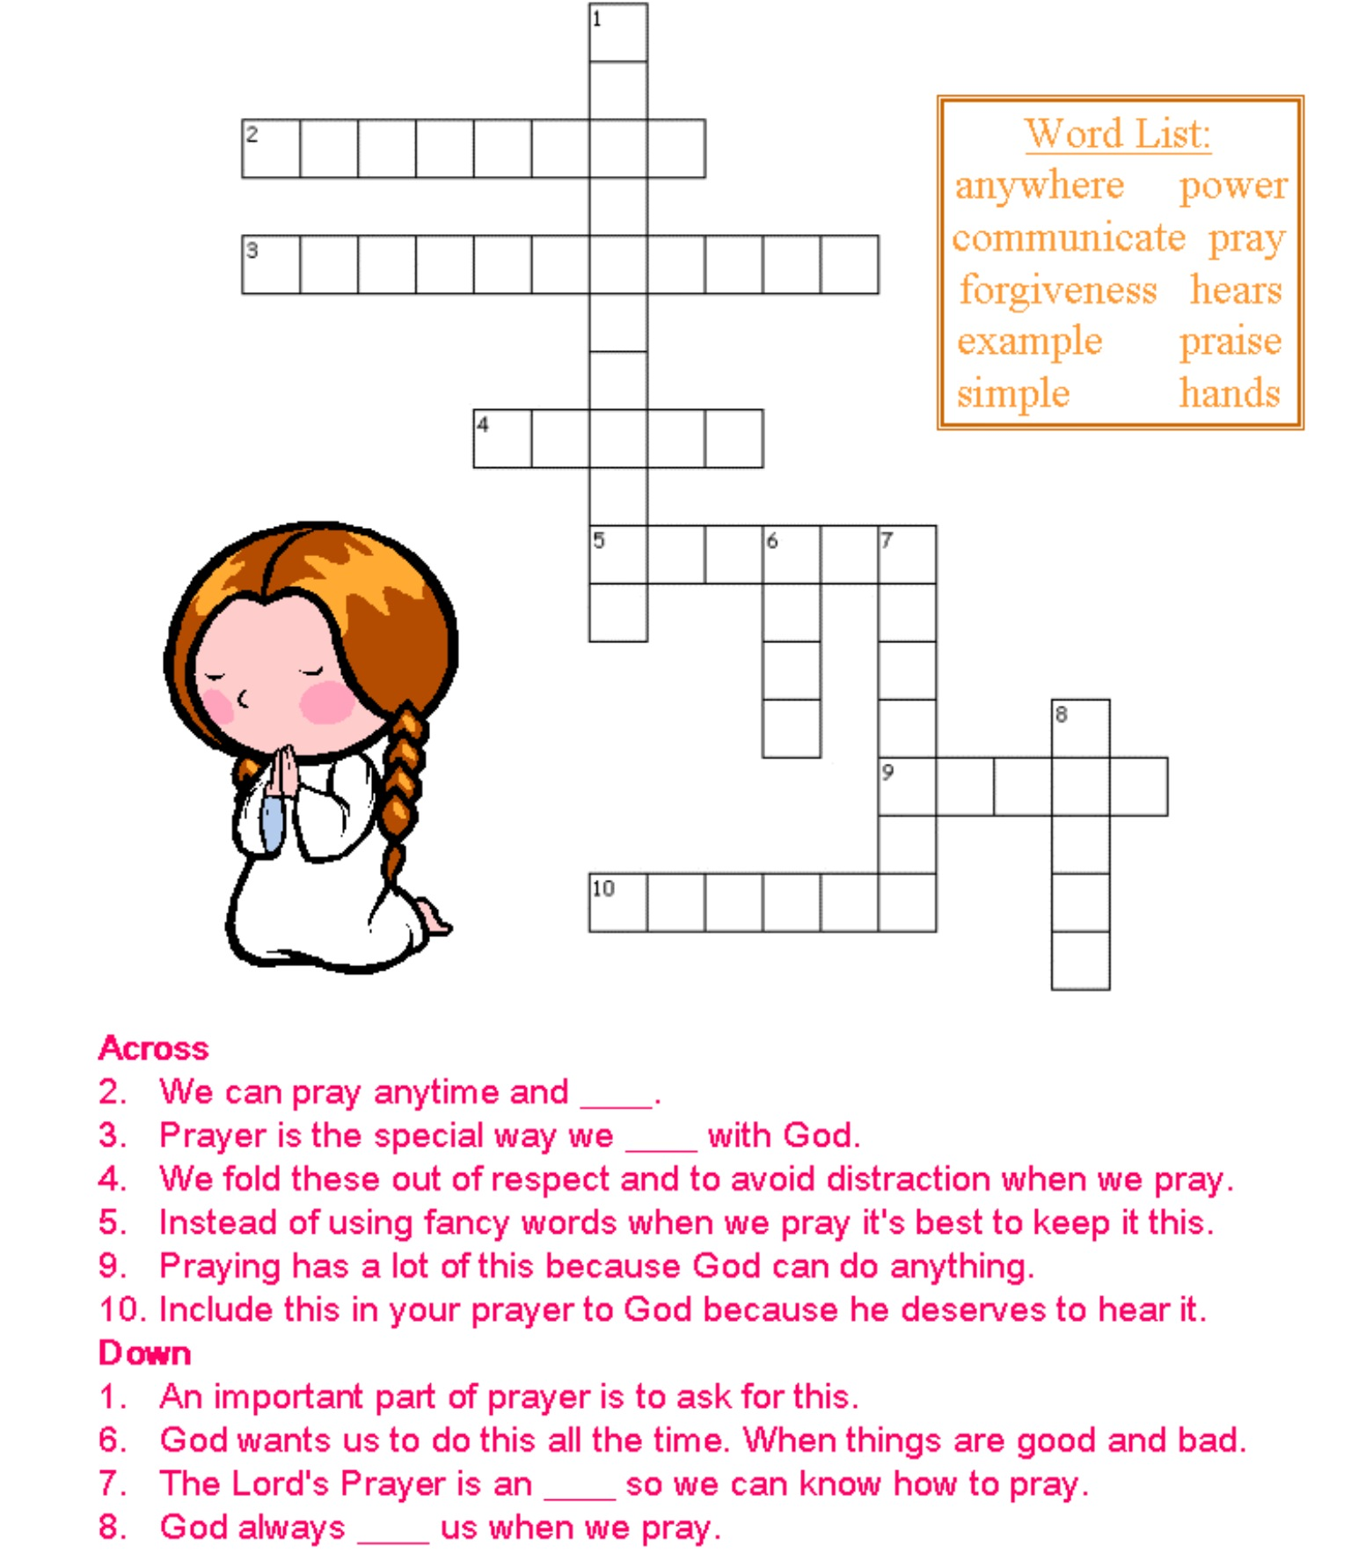
- Complete the below crossword, putting the correct answers in the table below the crossword.
INSERT ANSWERS
1 |  | 6
2 |  | 7
3 |  | 8
4 |  | 9
5 |  | 10
Friday 13th March Read Chapter 6 verses 16 – 34

Fasting to Be Seen Only by God
¹⁶ “Moreover, when you fast, do not be like the hypocrites, with a sad countenance. For they disfigure their faces that they may appear to men to be fasting. Assuredly, I say to you, they have their reward. ¹⁷ But you, when you fast, anoint your head and wash your face, ¹⁸ so that you do not appear to men to be fasting, but to your Father who is in the secret place; and your Father who sees in secret will reward you openly.^{[d]}

Lay Up Treasures in Heaven
¹⁹ “Do not lay up for yourselves treasures on earth, where moth and rust destroy and where thieves break in and steal; ²⁰ but lay up for yourselves treasures in heaven, where neither moth nor rust destroys and where thieves do not break in and steal. ²¹ For where your treasure is, there your heart will be also.

The Lamp of the Body
²² “The lamp of the body is the eye. If therefore your eye is good, your whole body will be full of light. ²³ But if your eye is bad, your whole body will be full of darkness. If therefore the light that is in you is darkness, how great is that darkness!

You Cannot Serve God and Riches
²⁴ “No one can serve two masters; for either he will hate the one and love the other, or else he will be loyal to the one and despise the other. You cannot serve God and mammon.

Do Not Worry
²⁵ “Therefore I say to you, do not worry about your life, what you will eat or what you will drink; nor about your body, what you will put on. Is not life more than food and the body more than clothing? ²⁶ Look at the birds of the air, for they neither sow nor reap nor gather into barns; yet your heavenly Father feeds them. Are you not of more value than they? ²⁷ Which of you by worrying can add one cubit to his stature?
²⁸ “So why do you worry about clothing? Consider the lilies of the field, how they grow: they neither toil nor spin; ²⁹ and yet I say to you that even Solomon in all his glory was not arrayed like one of these. ³⁰ Now if God so clothes the grass of the field, which today is, and tomorrow is thrown into the oven, will He not much more clothe you, O you of little faith?
³¹ “Therefore do not worry, saying, ‘What shall we eat?’ or ‘What shall we drink?’ or ‘What shall we wear?’ ³² For after all these things the Gentiles seek. For your heavenly Father knows that you need all these things. ³³ But seek first the kingdom of God and His righteousness, and all these things shall be added to you. ³⁴ Therefore do not worry about tomorrow, for tomorrow will worry about its own things. Sufficient for the day is its own trouble.

- What is the lamp of the body?
- Jesus tells us not to worry about our clothes or food for God will look after us. What should we be seeking instead?

Saturday 15th March: Memory verse
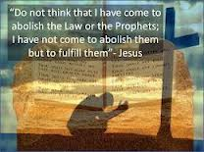

To try to remember the verse, write it out below:

PARENTS SECTION:
We kindly ask you as a parent to read (a little each day) in the Holy Bible with your family.
Now email your answers to your teacher, choose ONE of the email addresses below.

stmatthew5b1@gmail.com Uncle Andrew
or
stmark5b2@gmail.com Uncle Bassem
or
saintluke5g1@gmail.com Aunty Merna
or
stjohn5g2@gmail.com Aunty Angela

