Name
Class
Sunday 26th April
Finish Date: Saturday 2nd May

Completed Bible Study = 15 points
Handed in by the due date = 5 points

Year 3 Bible study 8 – 2015

The Gospel of Mark : Chapter 8

For the questions below Highlight or underline the correct answers

□ Monday 27th April: Read Mark 8:1-10 and answer the questions:
Feeding the Four Thousand

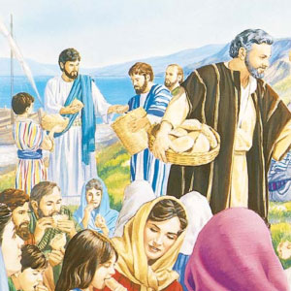
¹In those days, the multitude being very great and having nothing to eat, Jesus called His disciples to Him and said to them, ² “I have compassion on the multitude, because they have now continued with Me three days and have nothing to eat. ³ And if I send them away hungry to their own houses, they will faint on the way; for some of them have come from afar.” ⁴ Then His disciples answered Him, “How can one satisfy these people with bread here in the wilderness?” ⁵ He asked them, “How many loaves do you have?”
And they said, “Seven.” ⁶ So He commanded the multitude to sit down on the ground. And He took the seven loaves and gave thanks, broke them and gave them to His disciples to set before them; and they set them before the multitude. ⁷ They also had a few small fish; and having blessed them, He said to set them also before them. ⁸ So they ate and were filled, and they took up seven large baskets of leftover fragments. ⁹ Now those who had eaten were about four thousand. And He sent them away, ¹⁰ immediately got into the boat with His disciples, and came to the region of Dalmanutha.
- Jesus has compassion on people who try and follow Him. (TRUE / FALSE)
- They continued to follow Jesus for five days away from their houses. (TRUE / FALSE)
- All what was there to eat were seven loaves of bread and a few small fish. (TRUE / FALSE)
- Jesus fed 7000 people and after they finished eating they collected 12 baskets of leftover food.
(TRUE / FALSE)

□ Tuesday 28th April: Read Mark 8: 13-16 and answer the questions:
Beware of the Leaven of the Pharisees and Herod

¹³ And He left them, and getting into the boat again, departed to the other side.¹⁴ Now the disciples had forgotten to take bread, and they did not have more than one loaf with them in the boat. ¹⁵ Then He charged them, saying, “Take heed, beware of the leaven of the Pharisees and the leaven of Herod.”
¹⁶ And they reasoned among themselves, saying, “It is because we have no bread.”

Why did Jesus say to His disciples to be careful of the leaven of the Pharasees?
‘Leaven’ is a substance called yeast that people use to add to flour to make bread. The small uncooked bread dough would rise to make it look much bigger when it is cooked. The Jews used ‘leaven’ as a sign of something evil. A small amount of leaven makes bread rise. It spreads through all the bread. Because the Pharisees didn’t like Jesus and they did not believe the truth about Jesus, they wanted everyone not to believe in Jesus too. The bad things that the Pharisees taught could change everyone’s belief about Jesus.

→
The yeast (leaven) added to bread dough makes it rise (expand, bigger)

- Jesus told His disciples to be aware of the Leaven of the Pharisees, what did He mean by the ‘Leaven’?
- Bad teaching
- One Pharisee could teach false teaching about Jesus to hundreds of people.
- Leaven of the bread
- None of the above

□ Wednesday 29th April: Read Mark 8: 22-26 and answer the questions:
A Blind Man Healed at Bethsaida
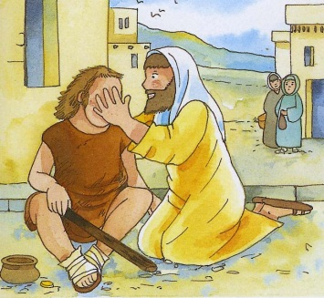
²² Then He came to Bethsaida; and they brought a blind man to Him, and begged Him to touch him. ²³ So He took the blind man by the hand and led him out of the town. And when He had spit on his eyes and put His hands on him, He asked him if he saw anything. ²⁴ And he looked up and said, “I see men like trees, walking.” ²⁵ Then He put His hands on his eyes again and made him look up. And he was restored and saw everyone clearly. ²⁶ Then He sent him away to his house, saying, “Neither go into the town, nor tell anyone in the town.”

- The people believed Jesus could heal the blind man. This is why they begged Jesus to put His hands on the blind man’s eyes. (TRUE / FALSE)
- When Jesus put His hands on the blind man the first time, the blind man saw every man clearly.
(TRUE / FALSE)
- What happened when Jesus touched the blind man the second time?
- Saw men as trees walking
- Saw every man clearly
- None of the above

□ Thursday 30th April: Read Mark 8: 27-31 and answer the questions:
Peter Confesses Jesus as the Christ

²⁷ Now Jesus and His disciples went out to the towns of Caesarea Philippi; and on the road He asked His disciples, saying to them, “Who do men say that I am?” ²⁸ So they answered, “John the Baptist; but some say, Elijah; and others, one of the prophets.” ²⁹ He said to them, “But who do you say that I am?”
Peter answered and said to Him, “You are the Christ.” ³⁰ Then He strictly warned them that they should tell no one about Him. ³¹ And He began to teach them that the Son of Man must suffer many things, and be rejected by the elders and chief priests and scribes, and be killed, and after three days rise again.

- Although Jesus had performed miracles in front of many people, they didn’t know that Jesus was the Christ; some of them thought that Jesus was someone else. Who did they think Jesus was? There are three possible answers.
1.
2.
3.

- Who did Peter think Jesus is?

□ Friday 1st April: Read Mark 8: 34- 38 and answer the questions:
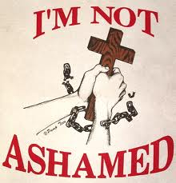
Take Up the Cross and Follow Him

³⁴ When He had called the people to Himself, with His disciples also, He said to them, “Whoever desires to come after Me, let him deny himself, and take up his cross, and follow Me. ³⁵ For whoever desires to save his life will lose it, but whoever loses his life for My sake and the gospel’s will save it. ³⁶ For what will it profit a man if he gains the whole world, and loses his own soul? ³⁷ Or what will a man give in exchange for his soul? ³⁸ For whoever is ashamed of Me and My words in this adulterous and sinful generation, of him the Son of Man also will be ashamed when He comes in the glory of His Father with the holy angels.”

Should we be afraid to tell people about Jesus?
In verse 38 Jesus teaches us a very important lesson in our lives. Fear of the opinion or laughter of other people may make us ashamed to declare our faith. Jesus said that He would then be ashamed of us. He referred to the time when he will come again.

- Is it right or wrong to be ashamed to tell our friends at school about our church?
- Are you scard your friends will laugh at you if you tell them you love Jesus and that you believe Jesus is the Son of God?

□ Saturday 2nd April: MEMORY VERSE: Copy and Learn by heart: (Mark 8:38). You will find it in Friday’s Bible Study

What to do when you finish your Bible Study.
- Either send it by email to your class email address or print and hand it to your servants next Sunday.
- If you want to send your Bible Study by email, please select your class email address below:

Year 3A St Bishoy
stbishoy3a@gmail.com Uncle Emil

Year 3B St Shenouda
stshenouda3b@gmail.com Uncle Victor

- Click on the following link to see how many points you have.
(Hold Ctrl and left click with your mouse on the following link OR copy and paste the link into your browser)
Year 3A (St Bishoy)

https://docs.google.com/spreadsheets/d/1n50G0dKZtJp9RWRK8pPrZBlwfk5FfJ4iVBSI9rw_vaY/edit?usp=sharing

Year 3B (St Shenouda)

https://docs.google.com/spreadsheets/d/1_95U1Mh8YbvfPowxk0A1nqM2bd9cfUAuH4pDQFjxKPE/edit?usp=sharing

