Name
Class
Sunday 5th April
Finish Date: Saturday 11th April

Completed Bible Study = 15 points
Handed in by the due date = 5 points

Year 3 Bible study 7 – 2015

The Gospel of Mark : Chapter 7
defile | Ruin, spoils | pitchers | 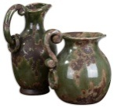  jugs | covetousness | greed
perceive | recognize | is eliminated | Gotten rid of | deceit | trickery

For the questions below Highlight or underline the correct answers

□ Monday 6th April: Read Mark 7:1-9 and answer the questions:

Defilement Comes from Within
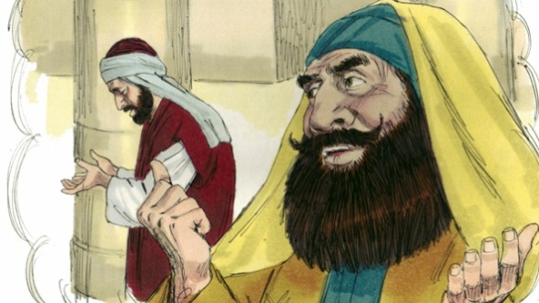
¹ Then the Pharisees and some of the scribes came together to Him, having come from Jerusalem. ² Now when^{[a]} they saw some of His disciples eat bread with defiled, that is, with unwashed hands, they found fault. ³ For the Pharisees and all the Jews do not eat unless they wash their hands in a special way, holding the tradition of the elders. ⁴ When they come from the marketplace, they do not eat unless they wash. And there are many other things which they have received and hold, like the washing of cups, pitchers, copper vessels, and couches.
⁵ Then the Pharisees and scribes asked Him, “Why do Your disciples not walk according to the tradition of the elders, but eat bread with unwashed hands?”
⁶ He answered and said to them, “Well did Isaiah prophesy of you hypocrites, as it is written:
‘This people honors Me with their lips,
But their heart is far from Me.
⁷ And in vain they worship Me,
Teaching as doctrines the commandments of men.’^{[b]}
⁸ For laying aside the commandment of God, you hold the tradition of men^{[c]} —the washing of pitchers and cups, and many other such things you do.”
⁹ He said to them, “All too well you reject the commandment of God, that you may keep your tradition. ¹⁰ For Moses said, ‘Honor your father and your mother’;[

- The Pharisees and all the other Jews never eat before washing their hands in a special way. They do this to follow the traditions they have from their great leaders who lived long ago.
(TRUE / FALSE)
- The Pharasees wanted to find anything they could blame Jesus for.They found that Jesus disciples do not wash their hands in the same way Jews do before they eat. Who was this law for washing before you eat given by?
- Jesus
- Jewish Elders
- Moses

- What commandment given by God should they obey?

□ Tuesday 7th April: Read Mark 7: 14-15 and answer the questions:

¹⁴ When He had called all the multitude to Himself, He said to them, “Hear Me, everyone, and understand: ¹⁵ There is nothing that enters a man from outside which can defile him; but the things which come out of him, those are the things that defile a man. ¹⁶ If anyone has ears to hear, let him hear!”.
- Jesus teaches that there is nothing people can put in their mouth that will make them wrong but people are made wrong by what comes from inside them. Which of the following 2 pictures can make someone wrong? (write a or b in the following box)

- Eating food
- Saying bad words

- What sort of things that come from the inside that makes you unclean? Choose the incorrect answer.
- Bad Thoughts
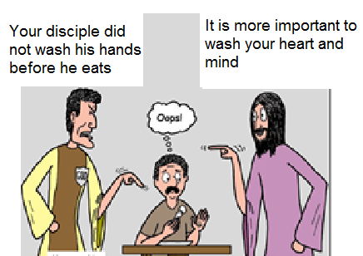
- How much you love Jesus
Person A
Person B
Person C
- The words you say that hurt people
- Lying
- Sweating after exercise?

- Identify

- Person A

- Person B

- Person
□ Wednesday 8th April: Read Mark 7: 17-23 and answer the questions:
¹⁷ When He had entered a house away from the crowd, His disciples asked Him concerning the parable. ¹⁸ So He said to them, “Are you thus without understanding also? Do you not perceive that whatever enters a man from outside cannot defile him, ¹⁹ because it does not enter his heart but his stomach, and is eliminated, thus purifying all foods?” ²⁰ And He said, “What comes out of a man, that defiles a man. ²¹ For from within, out of the heart of men, proceed evil thoughts, adulteries, …………….. murders, ²² thefts, covetousness, wickedness, deceit, lewdness, an evil eye, blasphemy, pride, foolishness. ²³ All these evil things come from within and defile a man.
- Put down 7 sins Jesus mentioned that make people unacceptable to God. (The answer is in verse 21)

1 |  | 3 |  | 5 |  | 7
2 |  | 4 |  | 6

□ Thursday 9th April: Read Mark 7: 24-30 and answer the questions:
A Gentile woman Shows Her Faith
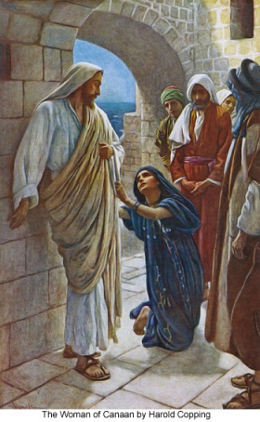
²⁴ From there He arose and went to the region of Tyre and Sidon. And He entered a house and wanted no one to know it, but He could not be hidden.²⁵ For a woman whose young daughter had an unclean spirit heard about Him, and she came and fell at His feet. ²⁶ The woman was a Greek, a Syro-Phoenician by birth, and she kept asking Him to cast the demon out of her daughter. ²⁷ But Jesus said to her, “Let the children be filled first, for it is not good to take the children’s bread and throw it to the little dogs.”
²⁸ And she answered and said to Him, “Yes, Lord, yet even the little dogs under the table eat from the children’s crumbs.” ²⁹ Then He said to her, “For this saying go your way; the demon has gone out of your daughter.” ³⁰ And when she had come to her house, she found the demon gone out, and her daughter lying on the bed.
Note: People who were not Jews were called Gentiles
- Match the question in the left side with the correct answer in the right side.
Question |  | Answer
A Was the woman a Jew? |  | to cast the demon out of her daughter
B What did she ask Jesus to do? |  | “Yes, Lord, yet even the little dogs under the table eat from the children’s crumbs.”
C What was Jesus’ answer? |  | No, she was a Gentile
D What was her reply to Jesus’ answer? |  | “For this saying go your way; the demon has gone out of your daughter.”
E How did Jesus praise her? |  | “Let the children be filled first, for it is not good to take the children’s bread and throw it to the little dogs.”

□ Friday 10th April: Read Mark 7: 32- 35 and answer the questions:
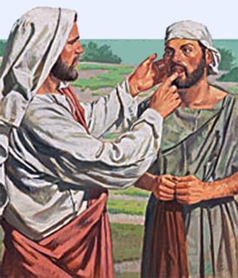
³² Then they brought to Him one who was deaf and had an impediment in his speech, and they begged Him to put His hand on him. ³³ And He took him aside from the multitude, and put His fingers in his ears, and He spat and touched his tongue. ³⁴ Then, looking up to heaven, He sighed, and said to him, “Ephphatha,” that is, “Be opened.” ³⁵ Immediately his ears were opened, and the impediment of his tongue was loosed, and he spoke plainly.

- What did Jesus do to the deaf – mute man?
- He put his fingers in his ears, touched his tongue and said “Ephphatha”.
- He healed him without touching him.
- All of the above

- Jesus can heal any sickness, we just need to ask Him to do so. (TRUE / FALSE)

□ Saturday 11th April: MEMORY VERSE: Copy and Learn by heart: (Mark 7:15). You will find it in Tuesday’s Bible Study

- After completing your Bible Study worksheet, you can either send it by email to your class email address or print and hand it to your servants next Sunday.
- If you want to send your Bible Study by email, please select your class email address below:
Year 3A: stbishoy3a@gmail.com Uncle Emil
Year 3B: stshenouda3b@gmail.com Uncle Victor

- Click on the following link to see how many points you have so far.
Year 3A (St Bishoy)
https://docs.google.com/spreadsheets/d/11Y0LUIInt01JfOeGTkMgwfML3d2vZVlgXOuldFP1y34/edit?usp=sharing
Year 3B (St Shenouda)
https://docs.google.com/spreadsheets/d/1yyIpvndVC0ln5cILBXlPoWL7V4t2aPZbE_d14s25GeY/edit?usp=sharing

