Name
Class
Sunday 22nd March
Finish Date: Saturday 28st March

Completed Bible Study = 15 points
Handed in by the due date = 5 points

Year 3 Bible study 5 – 2015

The Gospel of Mark : Chapter 5
swine | Pigs | synagogue | 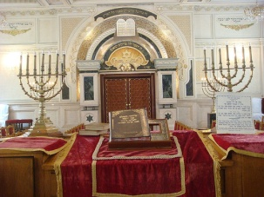  Where the Jews worship and study
herd | flock or group
For the questions below Highlight or underline the correct answers
□ Monday 22nd March: Read Mark 5:2-7 and answer the questions:

² And when He had come out of the boat, immediately there met Him out of the tombs a man with an unclean spirit, ³ who had his dwelling among the tombs; and no one could bind him, not even with chains ⁴ because he had often been bound with shackles and chains. And the chains had been pulled apart by him, and the shackles broken in pieces; neither could anyone tame him. ⁵ And always, night and day, he was in the mountains and in the tombs, crying out and cutting himself with stones.
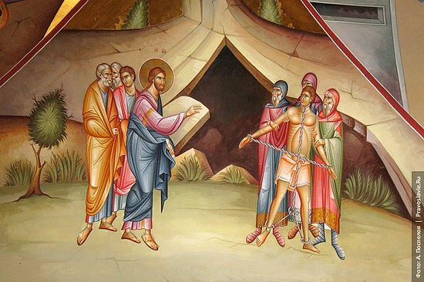
⁶ When he saw Jesus from afar, he ran and worshiped Him. ⁷ And he cried out with a loud voice and said, “What have I to do with You, Jesus, Son of the Most High God?
- The man with the unclean spirit was miserable and mad.

a.True
b. False

- The man with unclean spirit did something good when he saw Jesus, he ran and worshiped Him.
When you are in trouble what is the best thing you can do? (The answer starts with P)
P

□ Tuesday 23rd March: Read Mark 5: 11-13 and answer the questions:

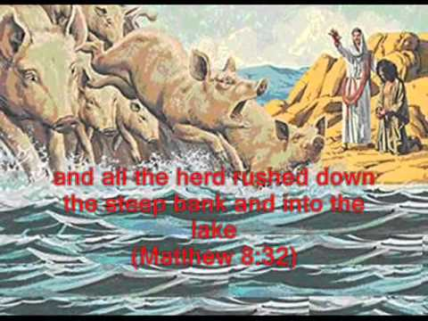
¹¹ Now a large herd of swine was feeding there near the mountains. ¹² So all the demons begged Him, saying, “Send us to the swine, that we may enter them.”¹³ And at once Jesus gave them permission. Then the unclean spirits went out and entered the swine (there were about two thousand); and the herd ran violently down the steep place into the sea, and drowned in the sea.

- Jesus can do everything because he has power on all the creatures and even bad spirits. Which animals did Jesus allowed the demons to enter?

□ Wednesday 24th March: Read Mark 5: 21-24 and answer the questions:
²¹ Now when Jesus had crossed over again by boat to the other side, a great multitude gathered to Him; and He was by the sea. ²² And behold, one of the rulers of the synagogue came, Jairus by name. And when he saw Him, he fell at His feet ²³ and begged Him earnestly, saying, “My little daughter lies at the point of death. Come and lay Your hands on her, that she may be healed, and she will live.” ²⁴ So Jesus went with him, and a great multitude followed Him and thronged Him.

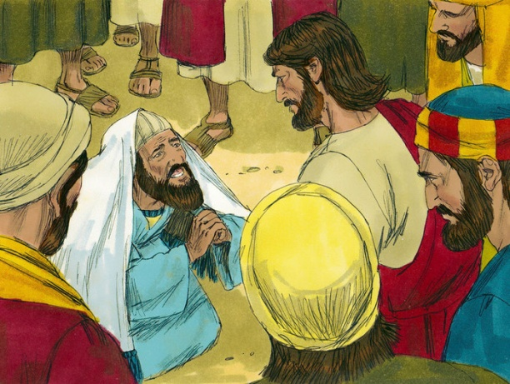
- Jairus knew that his daughter was ver sick and was dying. Only one person could heal Jairus’ daughter, who is this person?

- Jairus was a Jewish religious leader who worshiped God and taught God’s Word to others.

a.True
b. False

□ Thursday 25th March: Read Mark 5: 25-30 and answer the questions:

Jesus performed another miracle: healing a woman who had been very sick for twelve long years

²⁵ Now a certain woman had a flow of blood for twelve years, ²⁶ and had suffered many things from many physicians. She had spent all that she had and was no better, but rather grew worse. ²⁷ When she heard about Jesus, she came behind Him in the crowd and touched His garment. ²⁸ For she said, “If only I may touch His clothes, I shall be made well.”
²⁹ Immediately the fountain of her blood was dried up, and she felt in her body that she was healed of the affliction.³⁰ And Jesus, immediately knowing in Himself that power had gone out of Him, turned around in the crowd and said, “Who touched My clothes?”

- The lady said to herself “If only I may touch His clothes, I shall be made well”.
Do you think the lady had a strong faith in God?

- As soon as the sick lady touched Jesus’ clothes she was healed. (True/False)

□ Friday 26th March: Read Mark 5: 35-36, 41-42 and answer the questions:
³⁵ While He was still speaking, some came from the ruler of the synagogue’s house who said, “Your daughter is dead. Why trouble the Teacher any further?”
³⁶ As soon as Jesus heard the word that was spoken, He said to the ruler of the synagogue, “Do not be afraid; only believe.”
⁴¹ Then He took the child by the hand, and said to her, “Talitha, cumi,” which is translated, “Little girl, I say to you, arise.”⁴² Immediately the girl arose and walked, for she was twelve years of age. And they were overcome with great amazement.

- It’s never too late with God, He can fix anything.
What did Jesus say to Jairus when they heard the bad news about his daughter death?

- Chapter 5 reveals to us again that Jesus was not just a man who could do special things. He is God, and He has authority over all!
Copy the following events and paste them in the table below in the correct order as it’s mentioned in Chapter 5
Jesus healed a very sick lady
Jesus healed a demon possessed man
Jesus raised Jairus’ daughter from death

□ Saturday 27th March: MEMORY VERSE: Copy and Learn by heart: (Mark 5:34).

- After completing your Bible Study worksheet, you can either send it by email to your class email address or print and hand it to your servants next Sunday.
- If you want to send your Bible Study by email, please select your class email address below:
Year 3A: stbishoy3a@gmail.com Uncle Emil
Year 3B: stshenouda3b@gmail.com Uncle Victor

- Click on the following link to see how many points you have so far.
Year 3A (St Bishoy)
https://docs.google.com/spreadsheets/d/11Y0LUIInt01JfOeGTkMgwfML3d2vZVlgXOuldFP1y34/edit?usp=sharing

Year 3B (St Shenouda)
https://docs.google.com/spreadsheets/d/1yyIpvndVC0ln5cILBXlPoWL7V4t2aPZbE_d14s25GeY/edit?usp=sharing

