Name
Class
Sunday 15th March
Finish Date: Saturday 21st March

Completed Bible Study = 15 points
Handed in by the due date = 5 points

Year 3 Bible study 4 – 2015

The Gospel of Mark : Chapter 4
Glossary
devoured | Ate something quickly | revealed | made known
sprang up | germinated | Take heed | Be careful
scorched | dry as a bone | scatter | fly away
yielded | produced | He puts in the sickle | indicating being ready for harvest
thirtyfold | Times thirty (X30) | liken | compare
Parables | moral or religious stories | perishing | freezing
the stern | unstressed | exceedingly | extremely

For the questions below Highlight or underline the correct answers
□ Monday 15th March: Read the following verses and answer the questions:

And again He began to teach by the sea. And a great multitude was gathered to Him, so that He got into a boat and sat in it on the sea; and the whole multitude was on the land facing the sea. ² Then He taught them many things by parables, and said to them in His teaching:

- So many hundreds of people wanted to hear Jesus speak . He was an excellent Teacher. Jesus taught them how to be good and how to have a relationship with God. Because there were so many people came to hear Jesus teach, where was the safest place for Jesus to teach them.

- Where did the people sit and listen?

- Jesus taught the people because He loved them so much. Jesus taught them by telling them parables. What is a parable?
- The name of a person
- A short story that teaches people the truth and how to behave to please God.
- Explains how to grow a garden

□ Tuesday 16th March: Read the following verses and answer the questions:

³ “Listen! Behold, a sower went out to sow. ⁴ And it happened, as he sowed, that some seed fell by the wayside; and the birds of the air came and devoured it. ⁵ Some fell on stony ground, where it did not have much earth; and immediately it sprang up because it had no depth of earth. ⁶ But when the sun was up it was scorched, and because it had no root it withered away. ⁷ And some seed fell among thorns; and the thorns grew up and choked it, and it yielded no crop. ⁸ But other seed fell on good ground and yielded a crop that sprang up, increased and produced: some thirtyfold, some sixty, and some a hundred.” ⁹ And He said to them,^{[b]} “He who has ears to hear, let him hear!”

- A person who is a sower
- eats seeds
- plants seeds
- buys seeds

- In the parable of the sower, the seeds were planted in 4 different ways. Find the
verse that describes each of the pictures below.
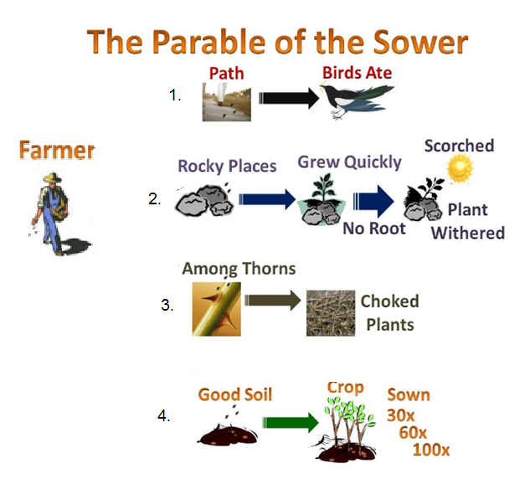
→ Verse

→ Verse

→ Verse

→ Verse

□ Wednesday 17th March: Read the following verses and answer the questions:
¹³ And He said to them, “Do you not understand this parable? How then will you understand all the parables? ¹⁴ The sower sows the word. ¹⁵ And these are the ones by the wayside where the word is sown. When they hear, Satan comes immediately and takes away the word that was sown in their hearts. ¹⁶ These likewise are the ones sown on stony ground who, when they hear the word, immediately receive it with gladness; ¹⁷ and they have no root in themselves, and so endure only for a time. Afterward, when tribulation or persecution arises for the word’s sake, immediately they stumble. ¹⁸ Now these are the ones sown among thorns; they are the ones who hear the word, ¹⁹ and the cares of this world, the deceitfulness of riches, and the desires for other things entering in choke the word, and it becomes unfruitful. ²⁰ But these are the ones sown on good ground, those who hear the word, accept it, and bear fruit: some thirtyfold, some sixty, and some a hundred.”

- Match the following soil type with its meaning. The first one has been done for you.
Soil Type |  | Explanation
1 | The seed that fell among thorns | 3 | Satan comes immediately and takes away the word that was sown in their hearts
2 | Stony ground |  | those who hear the word, accept it, and become good children and love God more than anything. They do many good things pleasing to God of God : some thirtyfold, some sixty, and some a hundred.
3 | The wayside |  | when they hear the word, immediately receive it with gladness; but afterward, when they go through a difficult time they do not remember God’s words.
4 | Good ground |  | they are the ones who hear God’s word, they get distracted and worry about everything, cares of this world, the dishonesty of money, and do things that do not please God.

□ Thursday 18th March: Read the following verses and answer the questions:

Jesus told them another parable : Light under a basket

²¹ Also He said to them, “Is a lamp brought to be put under a basket or under a bed? Is it not to be set on a lampstand? ²² For there is nothing hidden which will not be revealed, nor has anything been kept secret but that it should come to light. ²³ If anyone has ears to hear, let him hear.”
In the picture we see one man trying to hide his light under a basket. What use is that light? The other man is holding his light up high for all to see. The true light is Jesus. When we do good works in Jesus' name we are letting the light of Jesus shine through us. Then people will praise Him. Many people will not listen to what we say, but they will see what we do. Our lives often show God's love more than our words do. We are not doing good works so that people will praise us, but that God will be praised.

- A lamp is to be set where?
- Under a basket
- On a lampstand
- Under a bed

Read Mark Chapter 4 verse 21 - 25 to find the complete story

□ Friday 19th March: Read the following verses and answer the questions:

Look at the diffrerence in size of a mustard seed and an avacado seed.

Jesus told them another story : The parable of the mustard seed.

³⁰ Then He said, “To what shall we liken the kingdom of God? Or with what parable shall we picture it? ³¹ It is like a mustard seed which, when it is sown on the ground, is smaller than all the seeds on earth; ³² but when it is sown, it grows up and becomes greater than all herbs, and shoots out large branches, so that the birds of the air may nest under its shade.”

- Jesus said that the mustard seed symbolize the kingdom of God
TRUE / FALSE
- When the mustard seed grows up it becomes:
- Small tree
- Big Tree

Read Mark Chapter 4 verse 26 - 34 to find the complete story

□ Friday 19th March: Read the following verses and answer the questions:
³⁷ And a great windstorm arose, and the waves beat into the boat, so that it was already filling. ³⁸ But He was in the stern, asleep on a pillow. And they awoke Him and said to Him, “Teacher, do You not care that we are perishing?”
³⁹ Then He arose and rebuked the wind, and said to the sea, “Peace, be still!” And the wind ceased and there was a great calm. ⁴⁰ But He said to them, “Why are you so fearful? How is it that you have no faith?” ⁴¹ And they feared exceedingly, and said to one another, “Who can this be, that even the wind and the sea obey Him!”

- Arrange the following in chronological order and write down the correct order in the boxes below. The first one has been done for you.
- Then he arose and rebuked the wind
- And the wind ceased and there was a great calm
- And a great wind storm arose
- And He said to the sea, “Peace, be still!”
C

Read Mark Chapter 4 verse 35 - 41 to find the complete story

□ Saturday 20th March: Read the following verses and answer the questions:
MEMORY VERSE:
II Copy and Learn by heart: (Mark 4:20).

- After completing your Bible Study worksheet, you can either send it by email to your class email address or print and hand it to your servants next Sunday.
- If you want to send your Bible Study by email, please select your class email address below:
Year 3A: stbishoy3a@gmail.com Uncle Emil
Year 3B: stshenouda3b@gmail.com Uncle Victor

- Click on the following link to see how many points you have so far.
Year 3A (St Bishoy)
https://docs.google.com/spreadsheets/d/11Y0LUIInt01JfOeGTkMgwfML3d2vZVlgXOuldFP1y34/edit?usp=sharing

Year 3B (St Shenouda)
https://docs.google.com/spreadsheets/d/1yyIpvndVC0ln5cILBXlPoWL7V4t2aPZbE_d14s25GeY/edit?usp=sharing

