C:\Documents and Settings\suzy\Local Settings\Temporary Internet Files\Content.IE5\3JXW24R5\MC900383922[1].wmfSunday 21st June, 2015

Name:

Class:

Finish Date: Saturday 27th June, 2015

Completed Bible Study = 15 points

Email Homework by the due date = 5 points

**Year 3 Bible Study Mark Chapter 15**

**For the questions below Highlight, underline or change the font colour to choose the correct answer.**

* Monday 22nd June: Read **Mark Chapter 15: 1-4** and answer the questions:

### Jesus Faces Pilate

*1 Immediately, in the morning, the chief priests held a consultation with the elders and scribes and the whole council; and they bound Jesus, led Him away, and delivered Him to Pilate. 2Then Pilate asked Him, “Are You the King of the Jews?”*

*He answered and said to him, “It is as you say.”*

*3And the chief priests accused Him of many things, but He answered nothing. 4Then Pilate asked Him again, saying, “Do You answer nothing? See how many things they testify against You!” 5But Jesus still answered nothing, so that Pilate marveled.*

**Question 1**

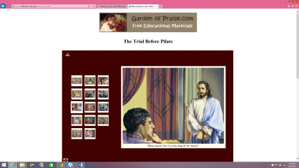Move each picture into the correct box.

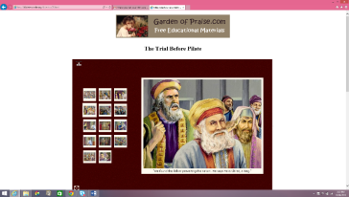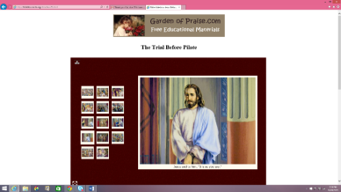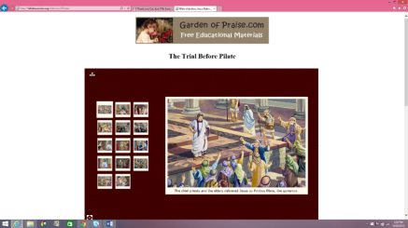

|  |  |  |  |
| --- | --- | --- | --- |
| The chief priests and the elders delivered Jesus to Pontus Pilate, the governor. | “We found this fellow perverting the nation. He says He is Christ, a King.” | Pilate asked, “Are You the King of the Jews?” | Jesus said to him, “It is as you say.” |

**Question 2**

**Why did the Jewish leaders take Jesus to Pilate?**

1. Because they didnot have the legal right to execute their own criminals.
2. Because Pilate was the leader of the Jews.
3. Because it was the Passover and Herod was busy.
4. Because they wanted his advice about how to deal with Jesus.

**Question 3**

In verses 3 to 5 Jesus doesn’t answer Pilate’s questions. Do you think Pilate would have saved Him if Jesus answered him? YES/NO

* Tuesday 23rd June: Read **Mark Chapter 15: 6-15** and answer the questions:

### Taking the Place of Barabbas

*6Now at the feast he was accustomed to releasing one prisoner to them, whomever they requested. 7And there was one named Barabbas, who was chained with his fellow rebels; they had committed murder in the rebellion. 8Then the multitude, crying aloud, began to ask him to do just as he had always done for them. 9But Pilate answered them, saying, “Do you want me to release to you the King of the Jews?” 10For he knew that the chief priests had handed Him over because of envy.*

*11But the chief priests stirred up the crowd, so that he should rather release Barabbas to them. 12Pilate answered and said to them again, “What then do you want me to do with Him whom you call the King of the Jews?”*

*13So they cried out again, “Crucify Him!”*

*14Then Pilate said to them, “Why, what evil has He done?”*

*But they cried out all the more, “Crucify Him!”*

*15So Pilate, wanting to gratify the crowd, released Barabbas to them; and he delivered Jesus, after he had scourged Him, to be crucified.*

**Question 4**

Move each picture into the correct box.

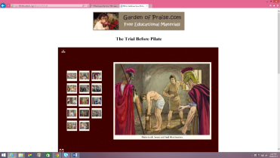

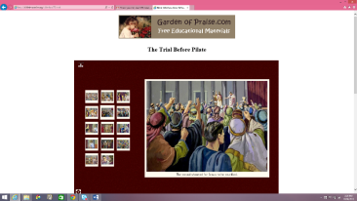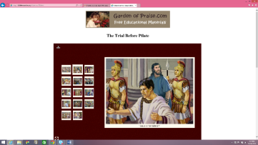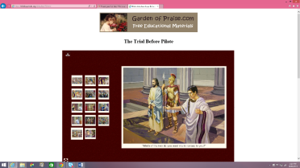

|  |  |  |  |
| --- | --- | --- | --- |
| “Which of the two do you want me to release to you?” | “Jesus or Barabbas?” | The crowd shouted for Jesus to be crucified. | Pilate took Jesus and had Him beaten. |

**Question 5**

**Why was it a difficult decision for Pilate to release or kill Jesus?**

1. Because Pilate wanted to join in the feast of the Passover
2. Because Pilate was **not** convinced that Jesus should be killed but he didn’t want the Jews to cause uproar.
3. Answers A and B
4. None of the above.

**Question 6**

**Who did Pilate release to the people instead of Jesus?**

**Question 7**

What was the Barabbas’ crime? hint: copy out verse 7

* Wednesday 24th June: Read **Mark Chapter 15:16-20** and answer the questions:

### The Soldiers Mock Jesus

[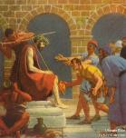](http://www.google.com.au/url?sa=i&rct=j&q=&esrc=s&source=images&cd=&cad=rja&uact=8&ved=0CAcQjRxqFQoTCPr01s78g8YCFZGOkgod7AQBFA&url=http://bibleencyclopedia.com/pictures/John_19_The_mocking_of_Jesus.htm&ei=rJJ3VfruMpGdygTsiYSgAQ&bvm=bv.95277229,d.dGY&psig=AFQjCNFvY49TFUKqHQoyaWHNOwJnj7gZdg&ust=1433986084334728)*16Then the soldiers led Him away into the hall called Praetorium, and they called together the whole garrison. 17And they clothed Him with purple; and they twisted a crown of thorns, put it on His head, 18and began to salute Him, “Hail, King of the Jews!” 19Then they struck Him on the head with a reed and spat on Him; and bowing the knee, they worshiped Him. 20And when they had mocked Him, they took the purple off Him, put His own clothes on Him, and led Him out to crucify Him.*

**Question 8**

What is the name of the hall that Christ was taken to by the soldiers?

# 

**Question 9**

The soldiers mocked Christ by clothing Him in a purple robe, which is the colour of royalty, and by putting a crown of thorns on His head. These soldiers did not accept or understand that Jesus is the Son of God, the King of Kings. Jesus has many names and through His life we can see how Jesus is the true **KING**, the true **SHEPHERD**, and the true **TEACHER**. Below is a picture with many of the names of Jesus. Pick 3 of those names that you really like and type them into the box below.

[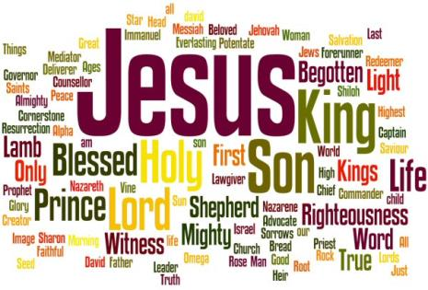](http://www.google.com.au/url?sa=i&rct=j&q=&esrc=s&source=images&cd=&cad=rja&uact=8&ved=0CAcQjRw&url=http://www.middlewall.co.uk/jesus.html&ei=Ov2DVcTQL8TXmAW375yYAQ&bvm=bv.96042044,d.dGY&psig=AFQjCNF0tHwYjicGuRbqW8Nte5znSb_3qQ&ust=1434799780892669)

**1.**

**2.**

**3.**

**When you pray tonight think about these three names of Jesus Christ and thank God for being all of those things in your life.**

* Thursday 25th June: Read **Mark Chapter 15: 21-32** and answer the questions:

### The King on a Cross

*21Then they compelled a certain man, Simon a Cyrenian, the father of Alexander and Rufus, as he was coming out of the country and passing by, to bear His cross. 22And they brought Him to the place Golgotha, which is translated, Place of a Skull. 23Then they gave Him wine mingled with myrrh to drink, but He did not take it. 24And when they crucified Him, they divided His garments, casting lots for them to determine what every man should take.*

*25Now it was the third hour, and they crucified Him. 26And the inscription of His accusation was written above:*

*THE KING OF THE JEWS.*

*27With Him they also crucified two robbers, one on His right and the other on His left. 28So the Scripture was fulfilled which says, “And He was numbered with the transgressors.”*

*29And those who passed by blasphemed Him, wagging their heads and saying, “Aha! You who destroy the temple and build it in three days, 30save Yourself, and come down from the cross!”*

*31Likewise the chief priests also, mocking among themselves with the scribes, said, “He saved others; Himself He cannot save. 32Let the Christ, the King of Israel, descend now from the cross, that we may see and believe.”*

*Even those who were crucified with Him reviled Him.*

**Question 10**

What was the name of the man who was asked to carry the cross of Christ?

**Question 11**

***CARRY YOUR CROSS***

***“When He had called the people to Himself, with His disciples also, He said to them, “Whoever desires to come after Me, let him deny himself, and take up his cross, and follow Me.”***

***Mark 8:34***

We are asked to carry our cross every day. What does that mean – “to carry your cross”

1. It’s bad if you don’t wear a cross around your neck.
2. Every day we should be struggling to do the right thing and accept whatever God gives us or puts us through.
3. It’s not Holy to be happy.
4. We should think about Jesus on the cross every day.

**Question 12**

Below are the pictures of the stations of the cross. Type in the boxes below what happens at the following stations.

**WHAT ARE THE STATIONS OF THE CROSS?**

These were the 14 steps that we remember that Christ went through from the time Pilate condemned Jesus to death, until Christ’s burial.

|  |  |
| --- | --- |
| **The Second Station** |  |
| **The Fifth Station** |  |
| **The Eleventh Station** |  |

[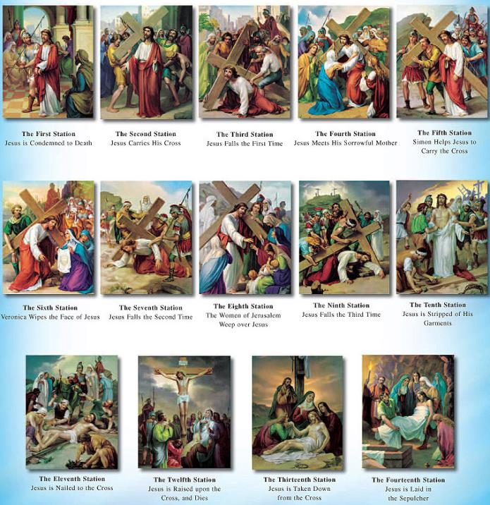](http://www.google.com.au/url?sa=i&rct=j&q=&esrc=s&source=images&cd=&cad=rja&uact=8&ved=0CAcQjRw&url=http://www.discountcatholicstore.com/catholic_posters.htm&ei=I3R2VZXZGMO9mgXCwIOQAQ&bvm=bv.95039771,d.dGY&psig=AFQjCNHjlRGMn9D3AwS3etq1BCcD0hp2Ug&ust=1433912632586983)

* Friday 26th June: Read **Mark Chapter 15 : 33-41** and answer the questions:

### Jesus Dies on the Cross

*33Now when the sixth hour had come, there was darkness over the whole land until the ninth hour. 34And at the ninth hour Jesus cried out with a loud voice, saying, “Eloi, Eloi, lama sabachthani?” which is translated, “My God, My God, why have You forsaken Me?”*

*35Some of those who stood by, when they heard that, said, “Look, He is calling for Elijah!” 36Then someone ran and filled a sponge full of sour wine, put it on a reed, and offered it to Him to drink, saying, “Let Him alone; let us see if Elijah will come to take Him down.”*

*37And Jesus cried out with a loud voice, and breathed His last.*

*38Then the veil of the temple was torn in two from top to bottom. 39So when the centurion, who stood opposite Him, saw that He cried out like this and breathed His last, he said, “Truly this Man was the Son of God!”*

*40There were also women looking on from afar, among whom were Mary Magdalene, Mary the mother of James the Less and of Joses, and Salome, 41who also followed Him and ministered to Him when He was in Galilee, and many other women who came up with Him to Jerusalem.*

**Question 13**

At what hour was there “darkness over the whole land”?

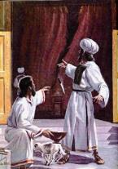

**Question 14**

**What is happening in this picture? Hint Read verse 38**

**Question 15**

**List the names of 3 of the women who were present at Christ’s crucifixion.**

**Hint: Read verse 40.**

|  |
| --- |
| **1**. |
| **2.** |
| **3.** |

[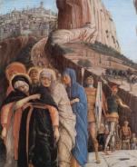](http://www.google.com.au/url?sa=i&rct=j&q=&esrc=s&source=images&cd=&cad=rja&uact=8&ved=0CAcQjRw&url=http://en.wikipedia.org/wiki/Matthew_27:55-56&ei=WnJ2Ve2-B4SgmQWHtIHQAQ&bvm=bv.95039771,d.dGY&psig=AFQjCNHxauI6nq7ge4TMQ0wZh5BNMs5LmQ&ust=1433912242968069)

* Saturday 27th June: Read **Mark Chapter 15: 42-47** and answer the questions:

### Jesus Buried in Joseph’s Tomb

*42Now when evening had come, because it was the Preparation Day, that is, the day before the Sabbath, 43Joseph of Arimathea, a prominent council member, who was himself waiting for the kingdom of God, coming and taking courage, went in to Pilate and asked for the body of Jesus. 44Pilate marveled that He was already dead; and summoning the centurion, he asked him if He had been dead for some time. 45So when he found out from the centurion, he granted the body to Joseph. 46Then he bought fine linen, took Him down, and wrapped Him in the linen. And he laid Him in a tomb which had been hewn out of the rock, and rolled a stone against the door of the tomb. 47And Mary Magdalene and Mary the mother of Joses observed where He was laid.*

**Question 16**

[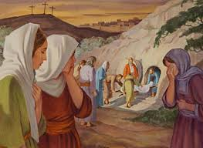](http://www.google.com.au/url?sa=i&rct=j&q=&esrc=s&source=images&cd=&cad=rja&uact=8&ved=0CAcQjRw&url=http://www.ellenwhite.info/books/ellen-g-white-book-desire-of-ages-da-80.htm&ei=4HJ2VfL_BaiomgXFhYPADg&bvm=bv.95039771,d.dGY&psig=AFQjCNG6krQ6nGEKFjgHnGYo7026edSyRA&ust=1433912395190746)

**What is the preparation day?**

1. The day before you bury someone
2. The day before the passover
3. The day before a sacrfice was made
4. The day before the Sabbath.

**Question 17**

**Who’s tomb was Jesus buried in?**

**Hint for question 18**

**DID YOU KNOW?**

**It would usually take a long time for people who were crucified to die. so it was common that the soldiers would break the legs of those who were crucified so that they would die quicker.**

**Question 18**

Jesus’ legs were not broken. Why is that?

1. Because the Jews did not believe in that
2. Because He was already dead when they were taking Him off the cross.
3. Because in the Old Testament it says that none of Jesus’ bones would be broken.
4. Answers B and C

***What to do when you finish your Bible Study.***

1. ***Either send it by email to your class email address or print and hand it to your servants next Sunday.***
2. ***If you want to send your Bible Study by email, please select your class email address below:***

**Year 3A St Bishoy**

[stbishoy3a@gmail.com](mailto:stbishoy3a@gmail.com) Uncle Emil

**Year 3B St Shenouda**

[stshenouda3b@gmail.com](mailto:stshenouda3b@gmail.com) Aunty Carol

1. ***Click on the following link to see how many points you have.***

*(Hold Ctrl and left click with your mouse on the following link* ***OR*** *copy and paste the link into your browser)*

**Year 3A (St Bishoy)**

<https://docs.google.com/spreadsheets/d/1n50G0dKZtJp9RWRK8pPrZBlwfk5FfJ4iVBSI9rw_vaY/edit?usp=sharing>

**Year 3B (St Shenouda)**

<https://docs.google.com/spreadsheets/d/1_95U1Mh8YbvfPowxk0A1nqM2bd9cfUAuH4pDQFjxKPE/edit?usp=sharing>