C:\Documents and Settings\suzy\Local Settings\Temporary Internet Files\Content.IE5\3JXW24R5\MC900383922[1].wmfSunday 24th May, 2015

Name:

Class:

Finish Date: Saturday 30th May, 2015

Completed Bible Study = 15 points

Email Homework by the due date = 5 points

**Year 3 Bible Study Mark Chapter 12**

For the questions below Highlight, underline or change the font colour to choose the correct answer.

□ Monday 25th May: Read **Mark Chapter 12: 1-12** and answer the questions:

**The Parable of the Wicked Vinedressers**

*1Then He began to speak to them in parables: “A man planted a vineyard and set a hedge around it, dug a place for the wine vat and built a tower. And he leased it to vinedressers and went into a far country. 2Now at vintage-time he sent a servant to the vinedressers, that he might receive some of the fruit of the vineyard from the vinedressers. 3And they took him and beat him and sent him away empty-handed. 4Again he sent them another servant, and at him they threw stones, wounded him in the head, and sent him away shamefully treated. 5And again he sent another, and him they killed; and many others, beating some and killing some. 6Therefore still having one son, his beloved, he also sent him to them last, saying, ‘They will respect my son.’ 7But those vinedressers said among themselves, ‘This is the heir. Come, let us kill him, and the inheritance will be ours.’ 8So they took him and killed him and cast him out of the vineyard.*

*9“Therefore what will the owner of the vineyard do? He will come and destroy the vinedressers, and give the vineyard to others.*

*10Have you not even read this Scripture:*

*‘The stone which the builders rejected Has become the chief cornerstone. 11This was the Lord’s doing, And it is marvelous in our eyes’?”*

*12And they sought to lay hands on Him, but feared the multitude, for they knew He had spoken the parable against them. So they left Him and went away.*

**Question 1**

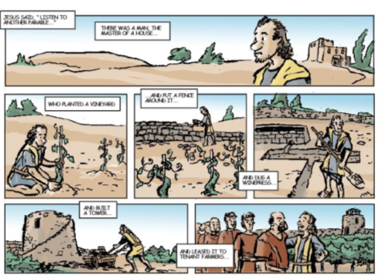Find the verse in the passage above that describes the story below.

**Do you know what a parable is?**

*A parable is a make-belief story that Christ used to teach the people a Christian lesson.*

**Question 2**

In the table below match the character/s in the parable to the person/people that Christ was really talking about. Use the word list below:

The Prophets, God, Jesus Christ, unbelieving Jews

|  |  |
| --- | --- |
| **Character in the Parable** | **Person/people that Christ was really talking about** |
| The Man (verse 1) or the owner of the vineyard (verse 9) |  |
| Vinedressers |  |
| The Servants that the man sent |  |
| “His beloved” (verse 6) |  |

[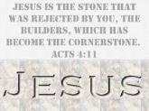](http://www.google.com.au/imgres?imgurl=https://erikbuys.files.wordpress.com/2014/06/jesus-rejected-cornerstone.jpg&imgrefurl=https://erikbuys.wordpress.com/tag/rene-girard/&h=262&w=350&tbnid=A91qM1cIbudRAM:&zoom=1&docid=aVPwStzMy-CPNM&ei=WHZeVayWL5Dr8AWfw4LoBw&tbm=isch&ved=0CG8QMyhMMEw)**Question 3**

In verse 10, who is the “chief cornerstone”?

**Clue!**

□ Tuesday 26th May: Read **Mark Chapter 12: 13-17** and answer the questions:

**The Pharisees: Is It Lawful to Pay Taxes to Caesar?**

*13Then they sent to Him some of the Pharisees and the Herodians, to catch Him in His words. 14When they had come, they said to Him, “Teacher, we know that You are true, and care about no one; for You do not regard the person of men, but teach the way of God in truth. Is it lawful to pay taxes to Caesar, or not? 15Shall we pay, or shall we not pay?”*

*But He, knowing their hypocrisy, said to them, “Why do you test Me? Bring Me a denarius that I may see it.” 16So they brought it.*

*And He said to them, “Whose image and inscription is this?” They said to Him, “Caesar’s.”*

*17And Jesus answered and said to them, “Render to Caesar the things that are Caesar’s, and to God the things that are God’s.”*

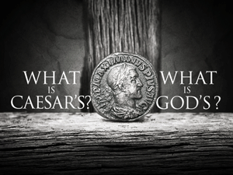

This coin is called a denarius

It has the image of Caesar.

*And they marveled at Him.*

**Question 4**

Why did the Pharisees ask Jesus if they should pay taxes?

1. To see if Jesus was generous
2. To test Jesus and trick Him into saying that people shouldn’t pay taxes, which would get Jesus into trouble with Caesar.
3. To show that Jesus was not paying His taxes.
4. So that Jesus would get people in trouble for not paying their taxes.

**Question 5**

What was Jesus’s answer? (hint: copy out verse 17)

□ Wednesday 27th May: Read **Mark Chapter 12: 18-27** and answer the questions:

### *The Sadducees: What About the Resurrection?*

*18Then some Sadducees, who say there is no resurrection, came to Him; and they asked Him, saying: 19“Teacher, Moses wrote to us that if a man’s brother dies, and leaves his wife behind, and leaves no children, his brother should take his wife and raise up offspring for his brother. 20Now there were seven brothers. The first took a wife; and dying, he left no offspring. 21And the second took her, and he died; nor did he leave any offspring. And the third likewise. 22So the seven had her and left no offspring. Last of all the woman died also. 23Therefore, in the resurrection, when they rise, whose wife will she be? For all seven had her as wife.”*

*24Jesus answered and said to them, “Are you not therefore mistaken, because you do not know the Scriptures nor the power of God? 25For when they rise from the dead, they neither marry nor are given in marriage, but are like angels in heaven. 26But concerning the dead, that they rise, have you not read in the book of Moses, in the burning bush passage, how God spoke to him, saying, ‘I am the God of Abraham, the God of Isaac, and the God of Jacob’? 27He is not the God of the dead, but the God of the living. You are therefore greatly mistaken.”*

**Question 6**

Among the Jewish people there Pharisees and Sadducees. Each group believed in different things about God and His teachings. After reading today’s verses, do you know which group believed in the Resurrection of the dead?

1. PHARISEES
2. SADDUCEES

[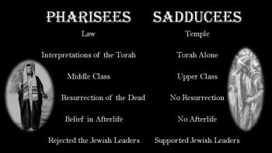](http://www.google.com.au/url?sa=i&rct=j&q=&esrc=s&source=images&cd=&cad=rja&uact=8&ved=0CAcQjRw&url=http://www.youtube.com/watch?v=O2s7a2ANZxk&ei=XaReVYzcMJTi8AWzt4LgBw&bvm=bv.93990622,d.dGc&psig=AFQjCNGw4_MsDwrnWXPGqfEVEVXR-s40QQ&ust=1432352213962281)

**EXTRA RESOURCE!!!!**

**Do you know what the “Torah” is?**

*It is the book for the of the Jews .*

*The Holy Bible is the book for Christians.*

**Do you know what “Afterlife” is?**

*It is the eternal life we have with Jesus in heaven.*

**Question 7:**

Complete this verse

“For when they rise from the dead, they neither marry nor are given in marriage, but are like

□ Thursday 28th May: Read **Mark Chapter 12 : 28-34** and answer the questions:

### *The Scribes: Which Is the First Commandment of All?*

*28Then one of the scribes came, and having heard them reasoning together, perceiving that He had answered them well, asked Him, “Which is the first commandment of all?”*

*29Jesus answered him, “The first of all the commandments is: ‘Hear, O Israel, the Lord our God, the Lord is one. 30And you shall love the Lord your God with all your heart, with all your soul, with all your mind, and with all your strength.’ This is the first commandment. 31And the second, like it, is this: ‘You shall love your neighbor as yourself.’ There is no other commandment greater than these.”*

*32So the scribe said to Him, “Well said, Teacher. You have spoken the truth, for there is one God, and there is no other but He. 33And to love Him with all the heart, with all the understanding, with all the soul, and with all the strength, and to love one’s neighbor as oneself, is more than all the whole burnt offerings and sacrifices.”*

*34Now when Jesus saw that he answered wisely, He said to him, “You are not far from the kingdom of God.”*

*But after that no one dared question Him.*

**Question 8**

Open your Bible at Exodus 20:1-17 (Exodus is the 2nd book of the Old Testament).

This is the passage where God gives Moses the 10 commandements. Use this passage to write down the order of the commandments as they were given to Moses. Commandment 7 has been done for you.Ask your family for help if you need.





Always say God’s name with love and respect.

Love and respect your mum and dad.

Don’t make anything in your life more important than God.

Always tell the truth.



**7**Always be faithful to your husband or wife.

Don’t take anything that isn’t yours.









Honour the Lord by resting on the seventh day of the week.

Never hurt anyone.

Be happy with that you have. Don’t wish for other people’s things.

Love God more than you love anything else.





**Question 9:**

Pick one of the commandments and give an example of how you can achieve this commandment in your life.

**Commandment:**

**Example:**

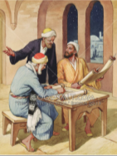□ Friday 29th May: Read **Mark Chapter 12 : 38-40** and answer the questions:

### Beware of the Scribes

*38Then He said to them in His teaching, “Beware of the scribes, who desire to go around in long robes, love greetings in the marketplaces, 39the best seats in the synagogues, and the best places at feasts, 40who devour widows’ houses, and for a pretense make long prayers. These will receive greater condemnation.”*

**Question 10**

The scribes were the teachers of the law. Jesus was upset with what they were doing because:

* They pretended to pray for a long time.
* They always took the best seats in the temple.
* They always wore the best clothes
* They were too focused on looking holy but they were not really holy.

Do you think Jesus would be happy if we do the following. Yes/No

1. Think we are better than anyone else. Yes/No
2. Carry our Bible every where we go but don’t read it. Yes/No
3. Collect money for the poor and spend it on ourselves. Yes/No
4. Put some of your spending money away to give to the poor. Yes/No

□ Saturday 30th May: Read **Mark Chapter 12: 41-44** and answer the questions:

### *The Widow’s Two Mites*

*41Now Jesus sat opposite the treasury and saw how the people put money into the treasury. And many who were rich put in much. 42Then one poor widow came and threw in two mites,which make a quadrans. 43So He called His disciples to Himself and said to them, “Assuredly, I say to you that this poor widow has put in more than all those who have given to the treasury; 44for they all put in out of their abundance, but she out of her poverty put in all that she had, her whole livelihood.”*

**Question 11**

If the widow was poor and only gave 2 coins, how could Jesus say she gave “more than all” of the other people?

1. Because everyone gave 1 coin.
2. The widow only had 2 coins and she gave all she had to the treasury.
3. The rich gave more coins, but it was nothing compared to how much money they have at home.

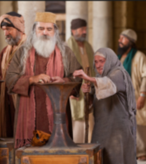

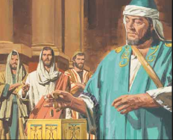

**Question 12**

What is the lesson that Christ was giving to his disciples?

1. It is important to give with love than to give because you have to.
2. Rich people should give more than poor people.
3. Poor people should give only 2 coins.
4. Rich people like their coins more than poor people.

***What to do when you finish your Bible Study.***

1. ***Either send it by email to your class email address or print and hand it to your servants next Sunday.***
2. ***If you want to send your Bible Study by email, please select your class email address below:***

**Year 3A St Bishoy**

[stbishoy3a@gmail.com](mailto:stbishoy3a@gmail.com) Uncle Emil

**Year 3B St Shenouda**

[stshenouda3b@gmail.com](mailto:stshenouda3b@gmail.com) Aunty Carol

1. ***Click on the following link to see how many points you have.***

*(Hold Ctrl and left click with your mouse on the following link* ***OR*** *copy and paste the link into your browser)*

**Year 3A (St Bishoy)**

<https://docs.google.com/spreadsheets/d/1n50G0dKZtJp9RWRK8pPrZBlwfk5FfJ4iVBSI9rw_vaY/edit?usp=sharing>

**Year 3B (St Shenouda)**

[*https://docs.google.com/spreadsheets/d/1_95U1Mh8YbvfPowxk0A1nqM2bd9cfUAuH4pDQFjxKPE/edit?usp=sharing*](https://docs.google.com/spreadsheets/d/1_95U1Mh8YbvfPowxk0A1nqM2bd9cfUAuH4pDQFjxKPE/edit?usp=sharing)