


The Model Christian Life

- What does it mean to be poor is Spirit, and what is their reward?
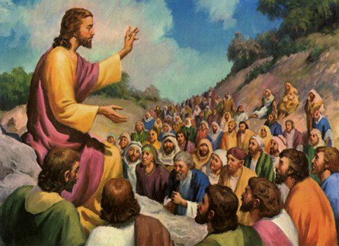
_______________________________________________________________________________________________________________________________________________________________________
Jesus calls us to be the salt of the earth and the light of the world. This means that we should witness to Christ by being model Christians, by doing good works and refraining from sin. By this people know that we are the followers of Christ.
- True or false (circle correct answer):
He who teaches the law is more righteous than he who follows the law. True False
“Unless your righteousness exceeds the righteousness of the scribes and Pharisees, you will by no means enter the kingdom of heaven” (Matthew 5:20)

- Complete the verse:
“Again you have heard that it was said to those of old, ‘You shall not ______ _________, but shall perform your oaths to the Lord.’ But I say to you, do not _________ at all: neither by __________, for it is God’s _________; nor by the earth, for it is His ____________; nor by Jerusalem, for it is the city of the great King. Nor shall you __________ by your head, because you cannot make ____________ __________ white or black. But let your ‘_______’ be ‘______,’ and your ‘No,’ ‘No.’ For whatever is more than these is from the evil one. (Matthew 5:33-37)

- Complete the Lord’s prayer crossword below:
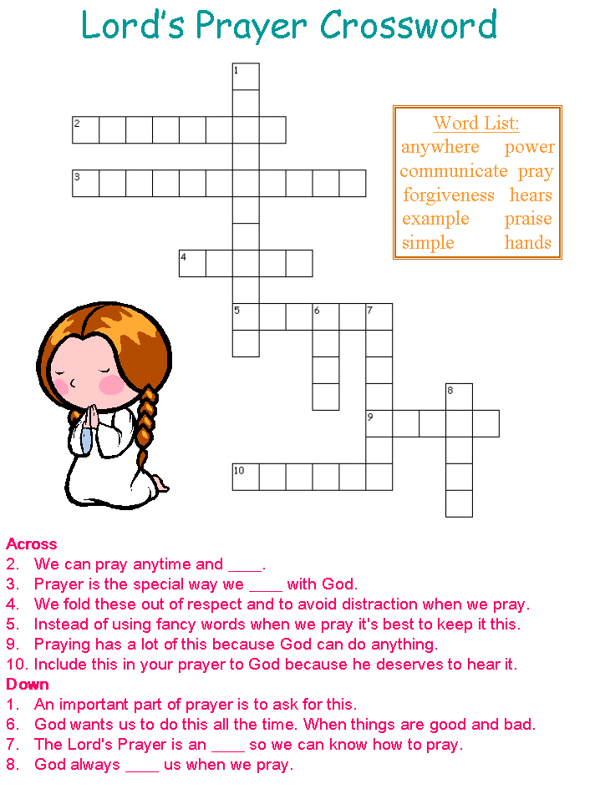

PARENTS SECTION:
This section is for the parents to sign the Holy Bible Study sheet. X____________________
We kindly ask you as a parent to read (a little each day) in the Holy Bible with your family.
You may wish to read Genesis with Sunday School.
Please let us know below what you’re reading with your child and if you have any questions.

