C:\Documents and Settings\suzy\Local Settings\Temporary Internet Files\Content.IE5\3JXW24R5\MC900383922[1].wmfSunday 4th October, 2015

Name:

Class:

Finish Date: Saturday 10th October, 2015

Completed Bible Study = 15 points

Email Homework by the due date = 5 points

**Year 6 Bible Study Joshua Chapter 8**

**For the questions below Highlight, underline or change the font colour to choose the correct answer.**

* Monday 5th October: Read **Joshua Chapter 8: 1-8** and answer the questions:

**The Lord commands Joshua to be ready for war**

*1 Now the Lord said to Joshua: “Do not be afraid, nor be dismayed; take all the people of war with you, and arise, go up to Ai. See, I have given into your hand the king of Ai, his people, his city, and his land. 2And you shall do to Ai and its king as you did to Jericho and its king. Only its spoil and its cattle you shall take for yourselves. Lay an ambush for the city behind it.”*

*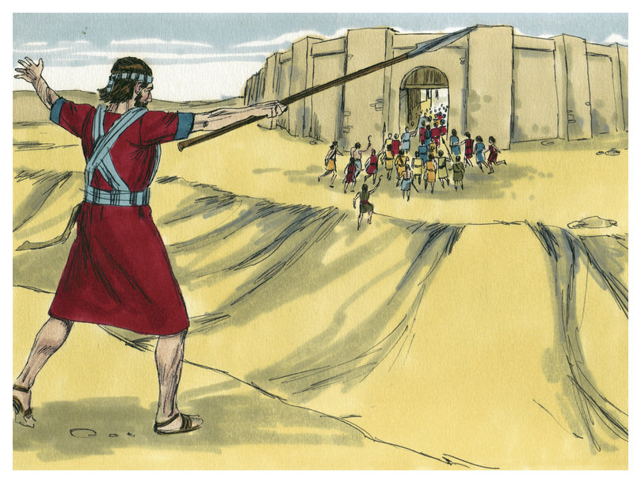3So Joshua arose, and all the people of war, to go up against Ai; and Joshua chose thirty thousand mighty men of valor and sent them away by night. 4And he commanded them, saying: “Behold, you shall lie in ambush against the city, behind the city. Do not go very far from the city, but all of you be ready. 5Then I and all the people who are with me will approach the city; and it will come about, when they come out against us as at the first, that we shall flee before them. 6For they will come out after us till we have drawn them from the city, for they will say, ‘They are fleeing before us as at the first.’ Therefore we will flee before them. 7Then you shall rise from the ambush and seize the city, for the Lord your God will deliver it into your hand. 8And it will be, when you have taken the city, that you shall set the city on fire. According to the commandment of the Lord you shall do. See, I have commanded you.”*

**Question 1**

What did the Lord ask the people of Israel to keep after they defeated Ai?

a) Everything

b) Spoil and cattle

c) Fire

d) The men of the city

* Tuesday 6th October: Read **Joshua Chapter 8: 9-13** and answer the questions:

**Joshua instructs the people where to position themselves to get ready for war**

*9Joshua therefore sent them out; and they went to lie in ambush, and stayed between Bethel and Ai, on the west side of Ai; but Joshua lodged that night among the people. 10Then Joshua rose up early in the morning and mustered the people, and went up, he and the elders of Israel, before the people to Ai. 11And all the people of war who were with him went up and drew near; and they came before the city and camped on the north side of Ai. Now a valley lay between them and Ai. 12So he took about five thousand men and set them in ambush between Bethel and Ai, on the west side of the city. 13And when they had set the people, all the army that was on the north of the city, and its rear guard on the west of the city, Joshua went that night into the midst of the valley.*

**Question 2**

Identify the valley that Joshua and his army hid in on the night before they attacked Ai (Read Verse 9)

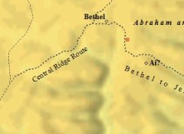

A

B

C

D

1. A
2. B
3. C
4. D

**Question 3**

After the sin of Achan was taken care of, The Lord asked the people to fight the city of Ai once more, this time how many men were sent in the war against Ai?

* Wednesday 7th October: Read **Joshua Chapter 8:14-17** and answer the questions:

*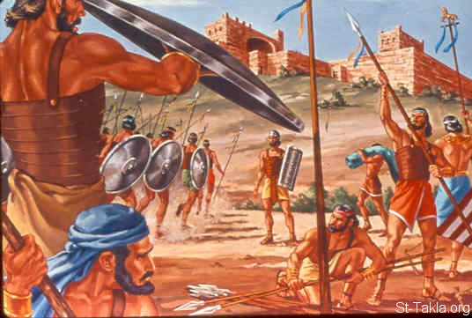***People of Ai go after Israel**

*14Now it happened, when the king of Ai saw it, that the men of the city hurried and rose early and went out against Israel to battle, he and all his people, at an appointed place before the plain. But he did not know that there was an ambush against him behind the city. 15And Joshua and all Israel made as if they were beaten before them, and fled by the way of the wilderness. 16So all the people who were in Ai were called together to pursue them. And they pursued Joshua and were drawn away from the city. 17There was not a man left in Ai or Bethel who did not go out after Israel. So they left the city open and pursued Israel.*

**What does it mean to pursue?**

*To pursue is to chase somebody or something consistently*

**So what was Joshua’s plan?**

*Joshua split the army into 2 parts. The first part was to stay with him, and attack the city of Ai as though they would any other city- straight away from the front, and then pretend to be defeated.*

*The second half of the army was to sneak to the back of the city of Ai, and wait until all the people of Ai went to attack the first half of the army of Israel, and then the Israelites would destroy Ai.*

**Question 4**

How many people were left in the cities of Ai or Bethel that did not go out to attack the Israelites? (HINT: Verse 17)

* Thursday 8th October: Read **Joshua Chapter 8: 18-24** and answer the questions:

**Lord tells Joshua what to do in order to defeat Ai**

*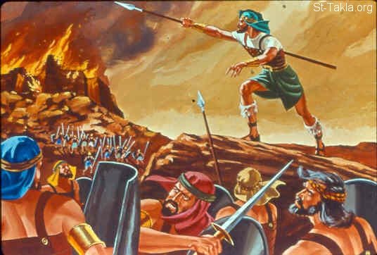18Then the Lord said to Joshua, “Stretch out the spear that is in your hand toward Ai, for I will give it into your hand.” And Joshua stretched out the spear that was in his hand toward the city. 19So those in ambush arose quickly out of their place; they ran as soon as he had stretched out his hand, and they entered the city and took it, and hurried to set the city on fire. 20And when the men of Ai looked behind them, they saw, and behold, the smoke of the city ascended to heaven. So they had no power to flee this way or that way, and the people who had fled to the wilderness turned back on the pursuers.*

*21Now when Joshua and all Israel saw that the ambush had taken the city and that the smoke of the city ascended, they turned back and struck down the men of Ai. 22Then the others came out of the city against them; so they were caught in the midst of Israel, some on this side and some on that side. And they struck them down, so that they let none of them remain or escape. 23But the king of Ai they took alive, and brought him to Joshua. 24And it came to pass when Israel had made an end of slaying all the inhabitants of Ai in the field, in the wilderness where they pursued them, and when they all had fallen by the edge of the sword until they were consumed, that all the Israelites returned to Ai and struck it with the edge of the sword.*

**Question 5**

Match the person or city to their role/ event

**Joshua, King of Ai, Israel, Ai**

|  |  |
| --- | --- |
| The army that was split in two |  |
| The person that spoke with the Lord |  |
| The city that was set on fire to be destroyed |  |
| The only person to remain alive after their city was destroyed |  |

**Question 6**

What was the sign that Joshua was to give the men of Israel in order to ambush the city of Ai?

* Friday 9th October: Read **Joshua Chapter 8: 25-29** and answer the questions:

**Ai is destroyed**

*25So it was that all who fell that day, both men and women, were twelve thousand—all the people of Ai. 26For Joshua did not draw back his hand, with which he stretched out the spear, until he had utterly destroyed all the inhabitants of Ai. 27Only the livestock and the spoil of that city Israel took as booty for themselves, according to the word of the Lord which He had commanded Joshua. 28So Joshua burned Ai and made it a heap forever, a desolation to this day.*

**Question 7**

1. 12,000 people died from the city of Ai. True/ False
2. The Israelites did not obey the Lord and took more than the livestock and the spoil. True/ False
3. The Israelites defeated Ai without the help of the Lord. True/ False

**Question 8**

After the destruction of Ai, what did the Lord allow the people of Israel to take from the people

of Ai?

* Saturday 10th October: Read **Joshua Chapter 8: 30-35** and answer the questions:

### Joshua Renews the Covenant

*30Now Joshua built an altar to the Lord God of Israel in Mount Ebal, 31as Moses the servant of the Lord had commanded the children of Israel, as it is written in the Book of the Law of Moses: “an altar of whole stones over which no man has wielded an iron tool.”And they offered on it burnt offerings to the Lord, and sacrificed peace offerings. 32And there, in the presence of the children of Israel, he wrote on the stones a copy of the law of Moses, which he had written. 33Then all Israel, with their elders and officers and judges, stood on either side of the ark before the priests, the Levites, who bore the ark of the covenant of the Lord, the stranger as well as he who was born among them. Half of them were in front of Mount Gerizim and half of them in front of Mount Ebal, as Moses the servant of the Lord had commanded before, that they should bless the people of Israel. 34And afterward he read all the words of the law, the blessings and the cursings, according to all that is written in the Book of the Law. 35There was not a word of all that Moses had commanded which Joshua did not read before all the assembly of Israel, with the women, the little ones, and the strangers who were living among them.*

**Question 9**

List the three main things that Joshua did after the defeat of Ai (HINTS: Verse 30, Verse 31 and Verse 32)

1)

2)

3)

***What to do when you finish your Bible Study.***

1. ***Either send it by email to your class email address or print and hand it to your servants next Sunday.***
2. ***If you want to send your Bible Study by email, please select your class email address below:***

[stthomas6b1@gmail.com](mailto:stthomas6b1@gmail.com) Uncle George

[stpeter6b2@gmail.com](mailto:stpeter6b2@gmail.com) Uncle Mina

[stphilip6g@gmail.com](mailto:stphilip6g@gmail.com) Aunty Jacky

***Click on the following link to see how many points you have.***

**Year 6B1 (St Thomas)**  
[https://docs.google.com/spreadsheets/d/1B3hbaPWXLPr-bqV8YIabw159aKTkQlJ3I1pKK7mRhEI/edit?usp=sharing](https://webmail.meriden.nsw.edu.au/owa/redir.aspx?C=b6b7aaaa4ff64c008d6db035dc9d08cb&URL=https%3a%2f%2fdocs.google.com%2fspreadsheets%2fd%2f1B3hbaPWXLPr-bqV8YIabw159aKTkQlJ3I1pKK7mRhEI%2fedit%3fusp%3dsharing)

**Year 6B2 (St Peter)**

[https://docs.google.com/spreadsheets/d/1-3aY66NbtvgQdVxKQsLKIN32-mekY1UfV-fU-a6A3aE/edit?usp=sharing](https://webmail.meriden.nsw.edu.au/owa/redir.aspx?C=b6b7aaaa4ff64c008d6db035dc9d08cb&URL=https%3a%2f%2fdocs.google.com%2fspreadsheets%2fd%2f1-3aY66NbtvgQdVxKQsLKIN32-mekY1UfV-fU-a6A3aE%2fedit%3fusp%3dsharing)

**Year 6G (StPhilip)**

[https://docs.google.com/spreadsheets/d/1KKS7TLUdMux972uO8yehkyA-gpRY7so_qA22MaRSM-I/edit?usp=sharing](https://webmail.meriden.nsw.edu.au/owa/redir.aspx?C=b6b7aaaa4ff64c008d6db035dc9d08cb&URL=https%3a%2f%2fdocs.google.com%2fspreadsheets%2fd%2f1KKS7TLUdMux972uO8yehkyA-gpRY7so_qA22MaRSM-I%2fedit%3fusp%3dsharing)