C:\Documents and Settings\suzy\Local Settings\Temporary Internet Files\Content.IE5\3JXW24R5\MC900383922[1].wmfSunday 20th September, 2015

Name:

Class:

Finish Date: Saturday 26th September, 2015

Completed Bible Study = 15 points

Email Homework by the due date = 5 points

**Year 6 Bible Study Joshua Chapter 6**

**For the questions below Highlight, underline or change the font colour to choose the correct answer.**

* Monday 21st September: Read **Joshua Chapter 6: 1-7** and answer the questions:

**Our Lord speaks to Joshua**

*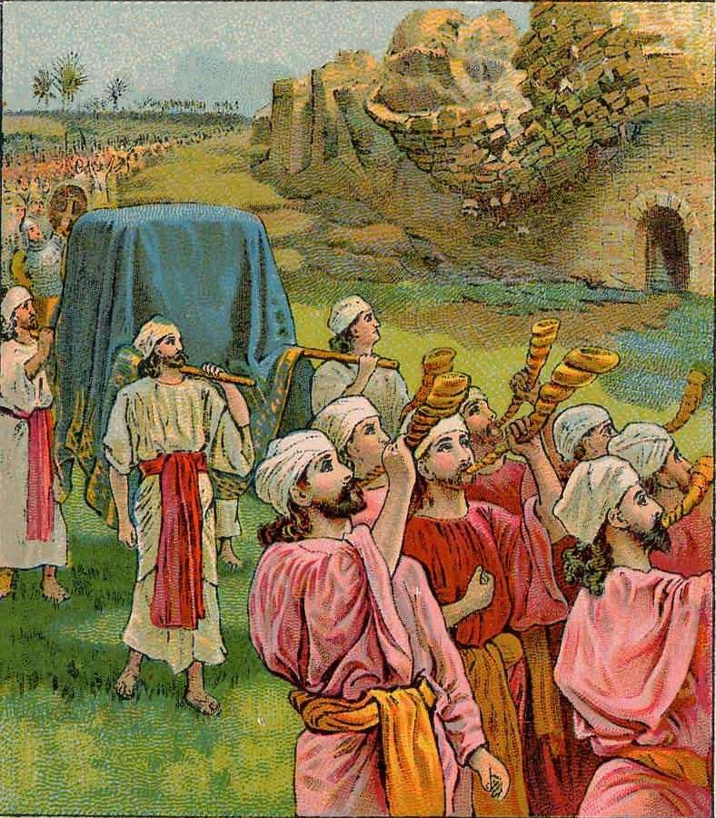1 Now Jericho was securely shut up because of the children of Israel; none went out, and none came in. 2And the Lord said to Joshua: “See! I have given Jericho into your hand, its king, and the mighty men of valor. 3You shall march around the city, all you men of war; you shall go all around the city once. This you shall do six days. 4And seven priests shall bear seven trumpets of rams’ horns before the ark. But the seventh day you shall march around the city seven times, and the priests shall blow the trumpets. 5It shall come to pass, when they make a long blast with the ram’s horn, and when you hear the sound of the trumpet, that all the people shall shout with a great shout; then the wall of the city will fall down flat. And the people shall go up every man straight before him.”*

**Question 1**

How many times did God tell the Israelites to march around Jericho? (HINT: 6x1 + 7)

* Tuesday 22nd September: Read **Joshua Chapter 6: 6-11** and answer the questions:

**Joshua obeys the Lord.**

*6Then Joshua the son of Nun called the priests and said to them, “Take up the Ark of the Covenant, and let seven priests bear seven trumpets of rams’ horns before the ark of the Lord.” 7And he said to the people, “Proceed, and march around the city, and let him who is armed advance before the ark of the Lord.”*

*8So it was, when Joshua had spoken to the people, that the seven priests bearing the seven trumpets of rams’ horns before the Lord advanced and blew the trumpets, and the ark of the covenant of the Lord followed them. 9The armed men went before the priests who blew the trumpets, and the rear guard came after the ark, while the priests continued blowing the trumpets. 10Now Joshua had commanded the people, saying, “You shall not shout or make any noise with your voice, nor shall a word proceed out of your mouth, until the day I say to you, ‘Shout!’ Then you shall shout.” 11So he had the ark of the Lord circle the city, going around it once. Then they came into the camp and lodged in the camp.*

**Question 2**

Label the image below using Verse 9 to help you

**Armed men, priests blowing trumpets, priests carrying the Ark of the Covenant, rear guard**

**1.**

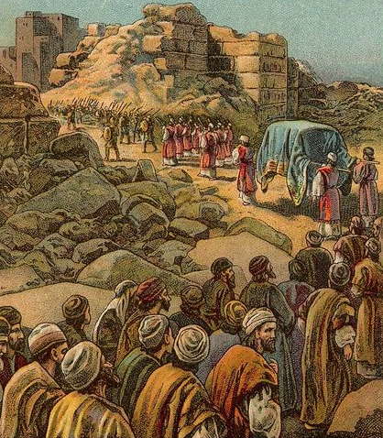

**2.**

**4.**

**3.**

|  |  |
| --- | --- |
| **Arrow 1** |  |
| **Arrow 2** |  |
| **Arrow 3** |  |
| **Arrow 4** |  |

* Wednesday 23rd September: Read **Joshua Chapter 6:12-19** and answer the questions:

**Israelites march around the city of Jericho**

*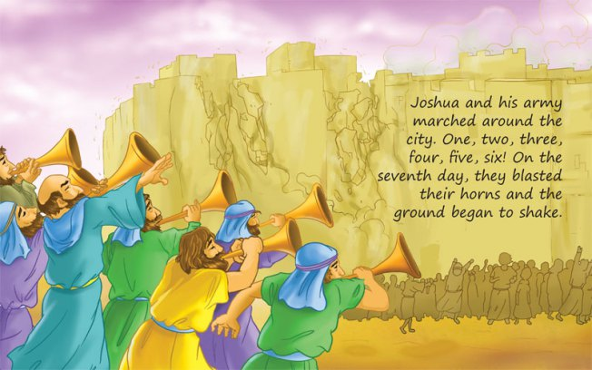12And Joshua rose early in the morning, and the priests took up the ark of the Lord. 13Then seven priests bearing seven trumpets of rams’ horns before the ark of the Lord went on continually and blew with the trumpets. And the armed men went before them. But the rear guard came after the ark of the Lord, while the priests continued blowing the trumpets. 14And the second day they marched around the city once and returned to the camp. So they did six days.*

*15But it came to pass on the seventh day that they rose early, about the dawning of the day, and marched around the city seven times in the same manner. On that day only they marched around the city seven times. 16And the seventh time it happened, when the priests blew the trumpets, that Joshua said to the people: “Shout, for the Lord has given you the city! 17Now the city shall be doomed by the Lord to destruction, it and all who are in it. Only Rahab the harlot shall live, she and all who are with her in the house, because she hid the messengers that we sent. 18And you, by all means abstain from the accursed things, lest you become accursed when you take of the accursed things, and make the camp of Israel a curse, and trouble it. 19But all the silver and gold, and vessels of bronze and iron, are consecrated to the Lord; they shall come into the treasury of the Lord.”*

**Question 3**

What did the Israelites do differently on the seventh day, compared to the previous six?

1. The sang
2. They marched louder
3. They marched around Jericho seven times
4. They woke up early

**Question 4**

Even though the Israelites were the ones that marched around the city, it was not due to their actions that they were able to defeat Jericho. According to Verse 16, who gave Jericho to Joshua and the people?

1. The Lord
2. Rahab the Harlot
3. Joshua
4. The Priests carrying the Ark

**Question 5**

What were the Israelites to do with any silver, gold, bronze and iron that they found in Jericho?

1. Keep it
2. Give it to Rahab the Harlot
3. Put it in the treasury of the Lord
4. Throw it away

* Thursday 24th September: Read **Joshua Chapter 6: 20-20** and answer the questions:

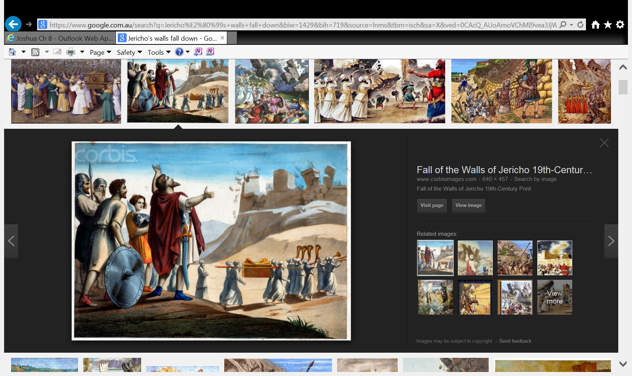**Jericho’s walls fall down**

*20So the people shouted when the priests blew the trumpets. And it happened when the people heard the sound of the trumpet, and the people shouted with a great shout, that the wall fell down flat. Then the people went up into the city, every man straight before him, and they took the city.*

**Question 6**

How did the walls of Jericho fall down?

**Question 7**

Do you think the shout of the Israelites and the trumpets blowing will make the walls of Jericho

fall if the Lord was not with them?

* Friday 25th September: Read **Joshua Chapter 6: 22-26** and answer the questions:

**God keeps promise to save Rahab and her family**

*22But Joshua had said to the two men who had spied out the country, “Go into the harlot’s house, and from there bring out the woman and all that she has, as you swore to her.” 23And the young men who had been spies went in and brought out Rahab, her father, her mother, her brothers, and all that she had. So they brought out all her relatives and left them outside the camp of Israel. 24But they burned the city and all that was in it with fire. Only the silver and gold, and the vessels of bronze and iron, they put into the treasury of the house of the Lord. 25And Joshua spared Rahab the harlot, her father’s household, and all that she had. So she dwells in Israel to this day, because she hid the messengers whom Joshua sent to spy out Jericho.*

*26Then Joshua charged them at that time, saying, “Cursed be the man before the Lord who rises up and builds this city Jericho; he shall lay its foundation with his firstborn, and with his youngest he shall set up its gates.”*

**Question 8**

1. Rahab and her family, were spared from death because she hid the spies in Chapter 3 True/False
2. The Israelites burned the rest of Jericho. True/False
3. Silver, gold, the vessels of bronze and iron were taken by the Israelites for pleasure. True/False
4. Anybody that builds the city of Jericho again would be cursed. True/False.

* Saturday 26th September: Look up **Joshua Chapter 6: 27**:

**Question 8**

Joshua Chapter 6 has ONE more verse.

Open up a Bible that you have at home, and look up Joshua 6: 27, and write it out in the text box below.

***What to do when you finish your Bible Study.***

1. ***Either send it by email to your class email address or print and hand it to your servants next Sunday.***
2. ***If you want to send your Bible Study by email, please select your class email address below:***

[stthomas6b1@gmail.com](mailto:stthomas6b1@gmail.com) Uncle George

[stpeter6b2@gmail.com](mailto:stpeter6b2@gmail.com) Uncle Mina

[stphilip6g@gmail.com](mailto:stphilip6g@gmail.com) Aunty Jacky

***Click on the following link to see how many points you have.***

**Year 6B1 (St Thomas)**  
[https://docs.google.com/spreadsheets/d/1B3hbaPWXLPr-bqV8YIabw159aKTkQlJ3I1pKK7mRhEI/edit?usp=sharing](https://webmail.meriden.nsw.edu.au/owa/redir.aspx?C=b6b7aaaa4ff64c008d6db035dc9d08cb&URL=https%3a%2f%2fdocs.google.com%2fspreadsheets%2fd%2f1B3hbaPWXLPr-bqV8YIabw159aKTkQlJ3I1pKK7mRhEI%2fedit%3fusp%3dsharing)

**Year 6B2 (St Peter)**

[https://docs.google.com/spreadsheets/d/1-3aY66NbtvgQdVxKQsLKIN32-mekY1UfV-fU-a6A3aE/edit?usp=sharing](https://webmail.meriden.nsw.edu.au/owa/redir.aspx?C=b6b7aaaa4ff64c008d6db035dc9d08cb&URL=https%3a%2f%2fdocs.google.com%2fspreadsheets%2fd%2f1-3aY66NbtvgQdVxKQsLKIN32-mekY1UfV-fU-a6A3aE%2fedit%3fusp%3dsharing)

**Year 6G (StPhilip)**

[https://docs.google.com/spreadsheets/d/1KKS7TLUdMux972uO8yehkyA-gpRY7so_qA22MaRSM-I/edit?usp=sharing](https://webmail.meriden.nsw.edu.au/owa/redir.aspx?C=b6b7aaaa4ff64c008d6db035dc9d08cb&URL=https%3a%2f%2fdocs.google.com%2fspreadsheets%2fd%2f1KKS7TLUdMux972uO8yehkyA-gpRY7so_qA22MaRSM-I%2fedit%3fusp%3dsharing)