C:\Documents and Settings\suzy\Local Settings\Temporary Internet Files\Content.IE5\3JXW24R5\MC900383922[1].wmfSunday 13th September, 2015

Name:

Class:

Finish Date: Saturday 19th September, 2015

Completed Bible Study = 15 points

Email Homework by the due date = 5 points

**Year 6 Bible Study Joshua Chapter 4-5**

**For the questions below Highlight, underline or change the font colour to choose the correct answer.**

* Monday 14th September: Read **Joshua Chapter 4: 1-7** and answer the questions:

### The Memorial Stones

*1 And it came to pass, when all the people had completely crossed over the Jordan, that the Lord spoke to Joshua, saying: 2“Take for yourselves twelve men from the people, one man from every tribe, 3and command them, saying, ‘Take for yourselves twelve stones from here, out of the midst of the Jordan, from the place where the priests’ feet stood firm. You shall carry them over with you and leave them in the lodging place where you lodge tonight.’”*

*4Then Joshua called the twelve men whom he had appointed from the children of Israel, one man from every tribe; 5and Joshua said to them: “Cross over before the ark of the Lord your God into the midst of the Jordan, and each one of you take up a stone on his shoulder, according to the number of the tribes of the children of Israel, 6that this may be a sign among you when your children ask in time to come, saying, ‘What do these stones mean to you?’ 7Then you shall answer them that the waters of the Jordan were cut off before the ark of the covenant of the Lord; when it crossed over the Jordan, the waters of the Jordan were cut off. And these stones shall be for a memorial to the children of Israel forever.”*

***Who are the twelve tribes of Israel?***

*The Israelites were called so because they were descendants from Jacob (Israel) who had twelve sons. Each of the descendants, of each of the sons, was called a tribe. The names of the twelve are: Reuben, Simeon, Levi, Judah, Dan, Naphtali, Gad, Asher, Issachar, Zebulun, Joseph and Benjamin*

**Question 1**

What are the stones to represent to future generations? (HINT: Verse 7)

* Tuesday 15th September: Read **Joshua Chapter 4: 8-14** and answer the questions:

*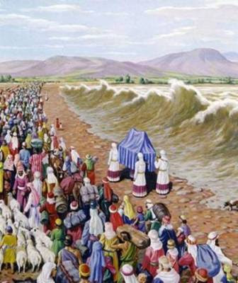***Israel prepares for war**

***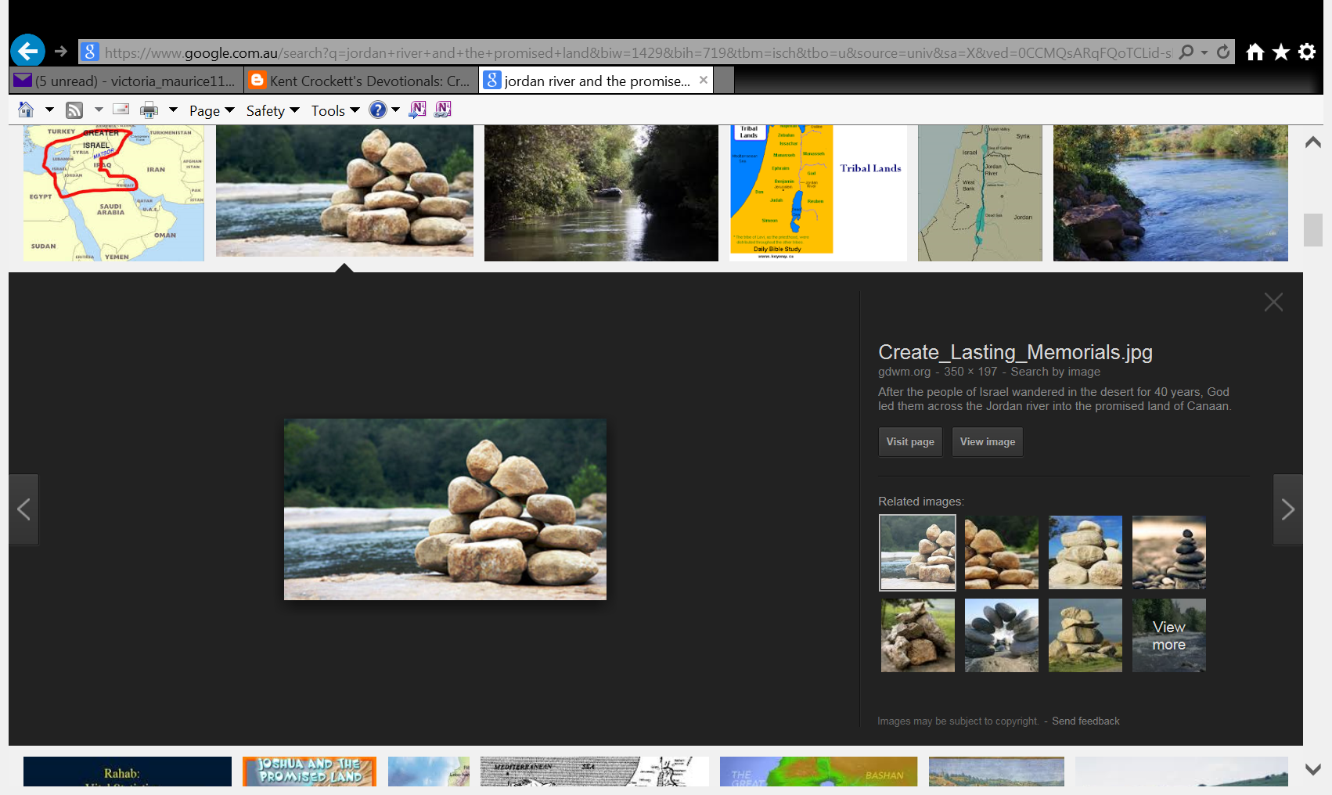****8And the children of Israel did so, just as Joshua commanded, and took up twelve stones from the midst of the Jordan, as the Lord had spoken to Joshua, according to the number of the tribes of the children of Israel, and carried them over with them to the place where they lodged, and laid them down there. 9Then Joshua set up twelve stones in the midst of the Jordan, in the place where the feet of the priests who bore the Ark of the Covenant stood; and they are there to this day.*

*10So the priests who bore the ark stood in the midst of the Jordan until everything was finished that the Lord had commanded Joshua to speak to the people, according to all that Moses had commanded Joshua; and the people hurried and crossed over. 11Then it came to pass, when all the people had completely crossed over, that the ark of the Lord and the priests crossed over in the presence of the people. 12And the men of Reuben, the men of Gad, and half the tribe of Manasseh crossed over armed before the children of Israel, as Moses had spoken to them. 13About forty thousand prepared for war crossed over before the Lord for battle, to the plains of Jericho. 14On that day the Lord exalted Joshua in the sight of all Israel; and they feared him, as they had feared Moses, all the days of his life.*

**Question 2**

Match the number to the description

**12, 1, 40000, 2.5**

|  |  |
| --- | --- |
|  | The number of tribes that were armed, and crossed before the children of Israel |
|  | The number of tribes of Israel, and the number of stones that were set in the middle of the river |
|  | The number of people leading Israel |
|  | The number of people prepared for war/ battle crossing over before the Lord |

* Wednesday 16th September: Read **Joshua Chapter 4:15-24** and answer the questions:

**Israel crosses the Jordan**

*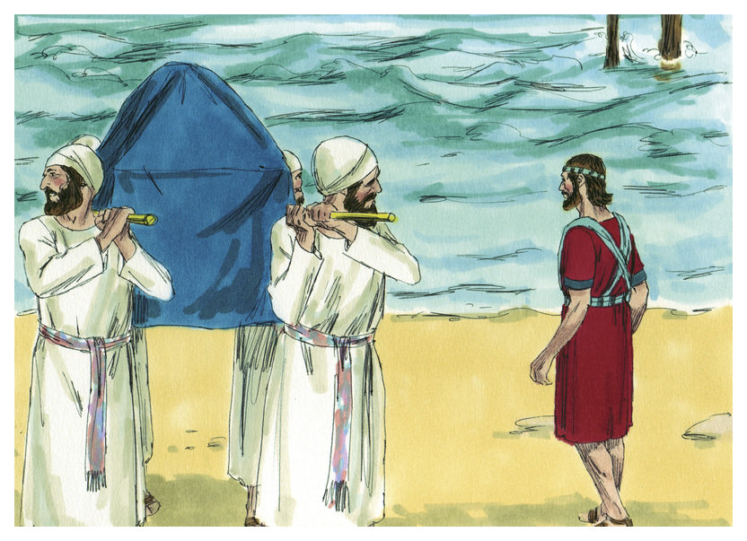15Then the Lord spoke to Joshua, saying, 16“Command the priests who bear the ark of the Testimony to come up from the Jordan.” 17Joshua therefore commanded the priests, saying, “Come up from the Jordan.” 18And it came to pass, when the priests who bore the ark of the covenant of the Lord had come from the midst of the Jordan, and the soles of the priests’ feet touched the dry land, that the waters of the Jordan returned to their place and overflowed all its banks as before.*

*19Now the people came up from the Jordan on the tenth day of the first month, and they camped in Gilgal on the east border of Jericho. 20And those twelve stones which they took out of the Jordan, Joshua set up in Gilgal. 21Then he spoke to the children of Israel, saying: “When your children ask their fathers in time to come, saying, ‘What are these stones?’ 22then you shall let your children know, saying, ‘Israel crossed over this Jordan on dry land’; 23for the Lord your God dried up the waters of the Jordan before you until you had crossed over, as the Lord your God did to the Red Sea, which He dried up before us until we had crossed over, 24that all the peoples of the earth may know the hand of the Lord, that it is mighty, that you may fear the Lord your God forever.”*

**Question 3**

When else had God dried up a sea for the Israelites to walk across?

a) When they crossed the Red Sea to escape the Egyptians

b) When Jesus saved Peter from drowning

c) When Jesus helped the disciples catch the a lot of fish

d) When Noah was about to start building the ark

* Thursday 17th September: Read **Joshua Chapter 5: 1-7** and answer the questions:

### The Second Generation Circumcised

*1 So it was, when all the kings of the Amorites who were on the west side of the Jordan, and all the kings of the Canaanites who were by the sea, heard that the Lord had dried up the waters of the Jordan from before the children of Israel until wehad crossed over, that their heart melted; and there was no spirit in them any longer because of the children of Israel.*

*2At that time the Lord said to Joshua, “Make flint knives for yourself, and circumcise the sons of Israel again the second time.” 3So Joshua made flint knives for himself, and circumcised the sons of Israel at the hill of the foreskins. 4And this is the reason why Joshua circumcised them: All the people who came out of Egypt who were males, all the men of war, had died in the wilderness on the way, after they had come out of Egypt. 5For all the people who came out had been circumcised, but all the people born in the wilderness, on the way as they came out of Egypt, had not been circumcised. 6For the children of Israel walked forty years in the wilderness, till all the people who were men of war, who came out of Egypt, were consumed, because they did not obey the voice of the Lord—to whom the Lord swore that He would not show them the land which the Lord had sworn to their fathers that He would give us, “a land flowing with milk and honey.” 7Then Joshua circumcised their sons whom He raised up in their place; for they were uncircumcised, because they had not been circumcised on the way.*

**What is circumcision?**

*Circumcision is like Baptism is for us nowadays. It was a sign between God and the descendants of Abraham, that these people (the Israelites) were the people that belonged to God. If the Israelites were circumcised they kept the promise that God made to Abraham about his descendants being the people of God.*

**Question 4**

Why were all the men of war (who came out of Egypt) “consumed” by God, and not allowed to see the Promised Land? What does this tell us about people that do not obey commandments?

* Friday 18th September: Read **Joshua Chapter 5: 8-12** and answer the questions:

*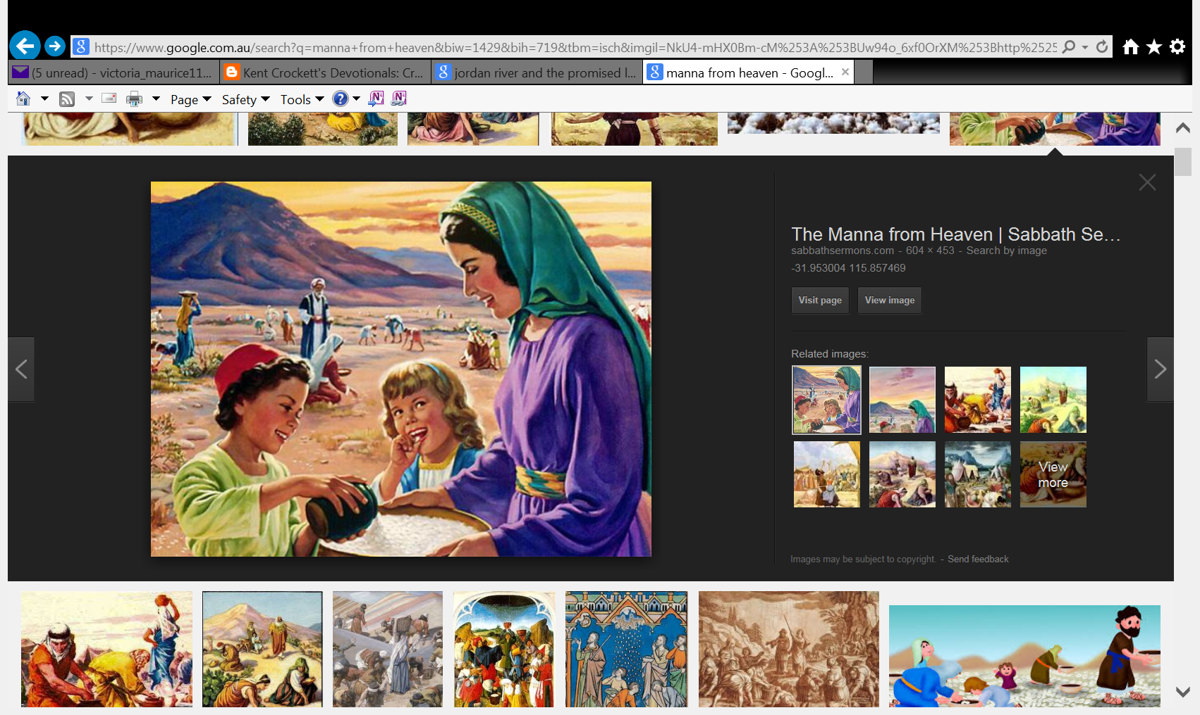***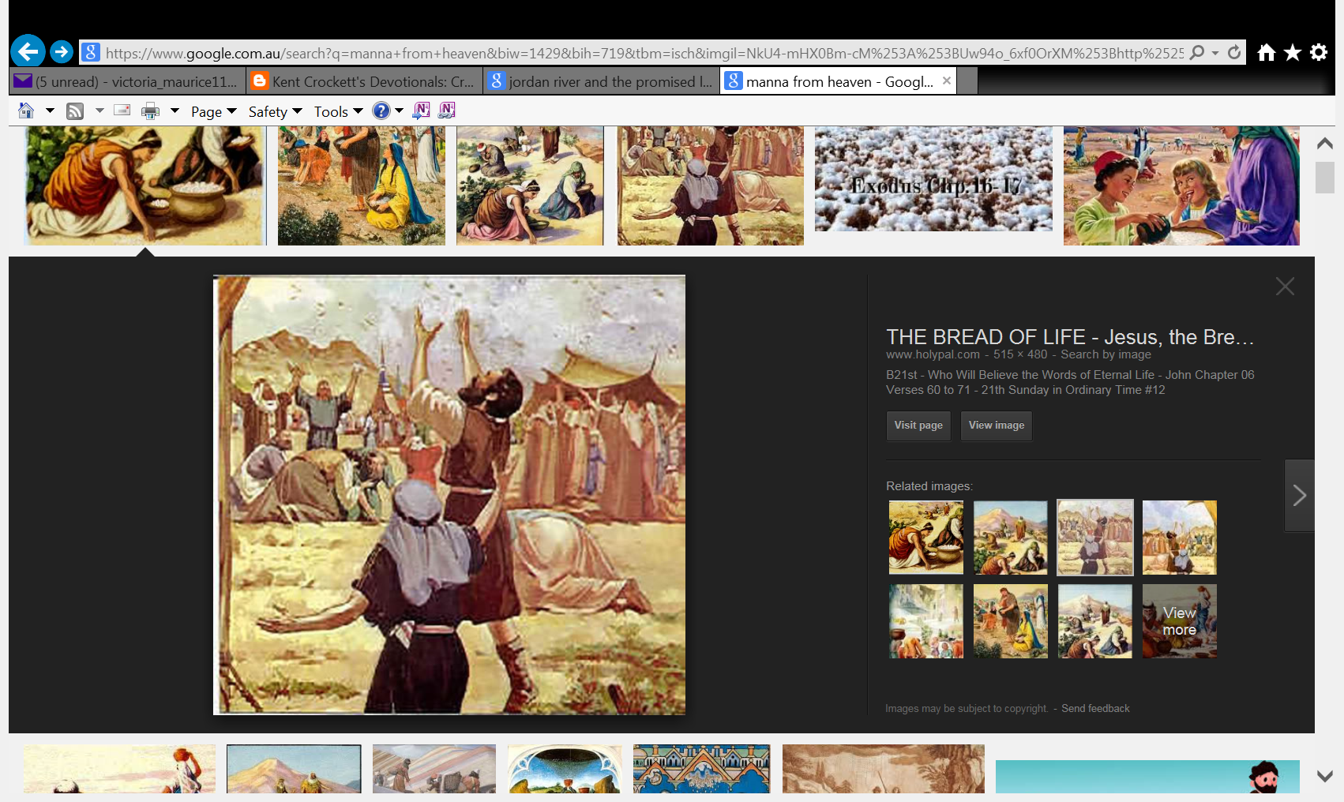Israel keeps the Passover**

*8So it was, when they had finished circumcising all the people, that they stayed in their places in the camp till they were healed. 9Then the Lord said to Joshua, “This day I have rolled away the reproach of Egypt from you.” Therefore the name of the place is called Gilgal to this day.*

*10Now the children of Israel camped in Gilgal, and kept the Passover on the fourteenth day of the month at twilight on the plains of Jericho. 11And they ate of the produce of the land on the day after the Passover, unleavened bread and parched grain, on the very same day. 12Then the manna ceased on the day after they had eaten the produce of the land; and the children of Israel no longer had manna, but they ate the food of the land of Canaan that year.*

**What is the Passover?**

*The Passover is a feast that the Israelites celebrated in commemoration of being freed from slavery in Egypt.*

**Question 5**

1. What was the name of the food that God gave the Israelites when they were in the wilderness for 40 years? This food came daily from heaven. What did it taste like? Hint: Look up Exodus 16:31
2. What did the Israelites eat after they entered the promised land.

* Saturday 19th September: Read **Joshua Chapter 5: 13-15** and answer the questions:

### The Commander of the Army of the Lord

*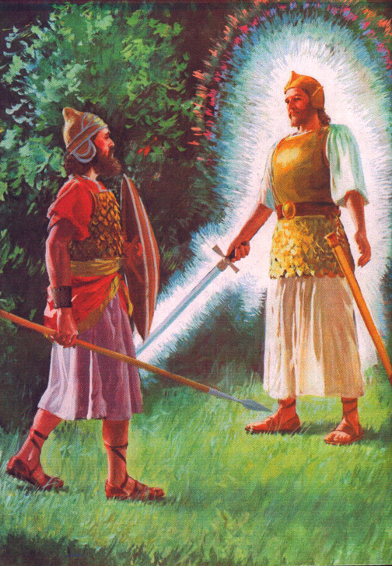13And it came to pass, when Joshua was by Jericho, that he lifted his eyes and looked, and behold, a Man stood opposite him with His sword drawn in His hand. And Joshua went to Him and said to Him, “Are You for us or for our adversaries?”*

*14So He said, “No, but as Commander of the army of the Lord I have now come.”*

*And Joshua fell on his face to the earth and worshiped, and said to Him, “What does my Lord say to His servant?”*

*15Then the Commander of the Lord’s army said to Joshua, “Take your sandal off your foot, for the place where you stand is holy.” And Joshua did so.*

**Question 6**

What was the occupation of the Man that stood opposite Joshua? (HINT: Verse 14)

**Question 7**

Why was Joshua asked to take off his sandals?

**Question 8**

Why do you think we need to take off our shoes when we enter the Alter in Church and have Holy Communion?

***What to do when you finish your Bible Study.***

1. ***Either send it by email to your class email address or print and hand it to your servants next Sunday.***
2. ***If you want to send your Bible Study by email, please select your class email address below:***

[stthomas6b1@gmail.com](mailto:stthomas6b1@gmail.com) Uncle George

[stpeter6b2@gmail.com](mailto:stpeter6b2@gmail.com) Uncle Mina

[stphilip6g@gmail.com](mailto:stphilip6g@gmail.com) Aunty Jacky

***Click on the following link to see how many points you have.***

**Year 6B1 (St Thomas)**  
[https://docs.google.com/spreadsheets/d/1B3hbaPWXLPr-bqV8YIabw159aKTkQlJ3I1pKK7mRhEI/edit?usp=sharing](https://webmail.meriden.nsw.edu.au/owa/redir.aspx?C=b6b7aaaa4ff64c008d6db035dc9d08cb&URL=https%3a%2f%2fdocs.google.com%2fspreadsheets%2fd%2f1B3hbaPWXLPr-bqV8YIabw159aKTkQlJ3I1pKK7mRhEI%2fedit%3fusp%3dsharing)

**Year 6B2 (St Peter)**

[https://docs.google.com/spreadsheets/d/1-3aY66NbtvgQdVxKQsLKIN32-mekY1UfV-fU-a6A3aE/edit?usp=sharing](https://webmail.meriden.nsw.edu.au/owa/redir.aspx?C=b6b7aaaa4ff64c008d6db035dc9d08cb&URL=https%3a%2f%2fdocs.google.com%2fspreadsheets%2fd%2f1-3aY66NbtvgQdVxKQsLKIN32-mekY1UfV-fU-a6A3aE%2fedit%3fusp%3dsharing)

**Year 6G (StPhilip)**

[https://docs.google.com/spreadsheets/d/1KKS7TLUdMux972uO8yehkyA-gpRY7so_qA22MaRSM-I/edit?usp=sharing](https://webmail.meriden.nsw.edu.au/owa/redir.aspx?C=b6b7aaaa4ff64c008d6db035dc9d08cb&URL=https%3a%2f%2fdocs.google.com%2fspreadsheets%2fd%2f1KKS7TLUdMux972uO8yehkyA-gpRY7so_qA22MaRSM-I%2fedit%3fusp%3dsharing)