C:\Documents and Settings\suzy\Local Settings\Temporary Internet Files\Content.IE5\3JXW24R5\MC900383922[1].wmfSunday 6th September, 2015

Name:

Class:

Finish Date: Saturday 12th September, 2015

Completed Bible Study = 15 points

Email Homework by the due date = 5 points

**Year 6 Bible Study Joshua Chapter 3**

**For the questions below Highlight, underline or change the font colour to choose the correct answer.**

* Monday 7th September: Read **Joshua Chapter 3: 1-3** and answer the questions:

*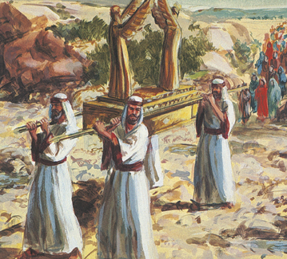1 Then Joshua rose early in the morning; and they set out from Acacia Grove and came to the Jordan, he and all the children of Israel, and lodged there before they crossed over. 2So it was, after three days, that the officers went through the camp; 3and they commanded the people, saying, “When you see the ark of the covenant of the Lord your God, and the priests, the Levites, bearing it, then you shall set out from your place and go after it. 4Yet there shall be a space between you and it, about two thousand cubits by measure. Do not come near it, that you may know the way by which you must go, for you have not passed this way before.”*

**What is a cubit?**

*A cubit is an ancient measure of length, approximately equal to 44 cm.*

*So 2000 cubits = 915 metres*

**Question 1**

Which tribe was to be “bearing” (carrying) the Ark?

1. Judah
2. Israel
3. Levites
4. Acacia

**Question 2**

How far behind did Joshua tell the Israelites they must be when they follow the Ark?

* Tuesday 8th September: Read **Joshua Chapter 3: 4-7** and answer the questions:

*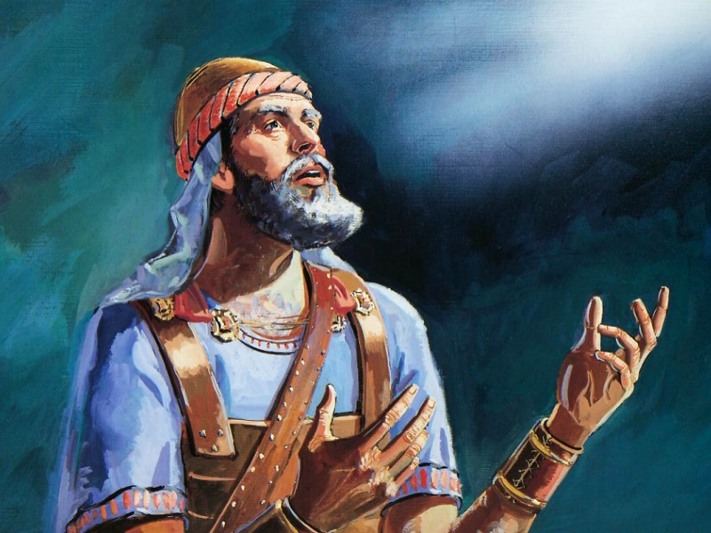***Israelites reaches the Jordan River**

*5And Joshua said to the people, “Sanctify yourselves, for tomorrow the Lord will do wonders among you.” 6Then Joshua spoke to the priests, saying, “Take up the Ark of the Covenant and cross over before the people.”*

*So they took up the Ark of the Covenant and went before the people.*

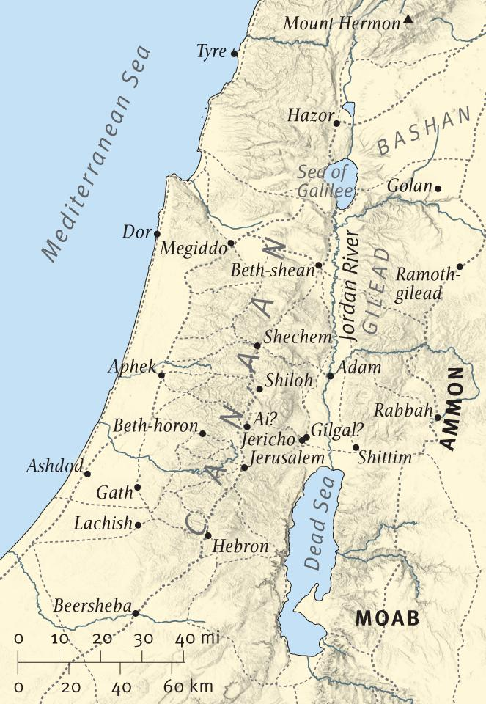

**Question 3**

Study the map on the right the answer the questions below

1. Jordan River flows from the Dead Sea to the Sea of Galilee. True/False
2. To cross the Jordan River you need to travel from Moab to Ammon. True/False
3. Two cities in in Canaan are Jerusalem and Shecham. True/False
4. The Sea of Galilee is much bigger than the Mediterranean Sea. True/False
5. The red arrow on the map shows us where the Israelites crossed the Jordan. True/False

Question 4

What does the word sanctify mean? There is more than one answer

1. set apart as or declare holy; consecrate.
2. sing a song
3. Pack your bags for travelling
4. free from sin; purify.

* Wednesday 9th September: Read **Joshua Chapter 3: 8-13** and answer the questions

*7And the Lord said to Joshua, “This day I will begin to exalt you in the sight of all Israel, that they may know that, as I was with Moses, so I will be with you. 8You shall command the priests who bear the ark of the covenant, saying, ‘When you have come to the edge of the water of the Jordan, you shall stand in the Jordan.’”*

**What is the Jordan?**

The Jordan is a river that separated the Israelites from the Promised Land

**Question 5**

When did the Priests, bearing the Ark of the Covenant have to stop, as instructed by the Lord? (HINT: Verse 8)

* Thursday 10th September: Read **Joshua Chapter 3: 8-13** and answer the questions:

**Joshua instructs Israelites how to cross the Jordan River**

*9So Joshua said to the children of Israel, “Come here, and hear the words of the Lord your God.” 10And Joshua said, “By this you shall know that the living God is among you, and that He will without fail drive out from before you the Canaanites and the Hittites and the Hivites and the Perizzites and the Girgashites and the Amorites and the Jebusites: 11Behold, the ark of the covenant of the Lord of all the earth is crossing over before you into the Jordan.*

*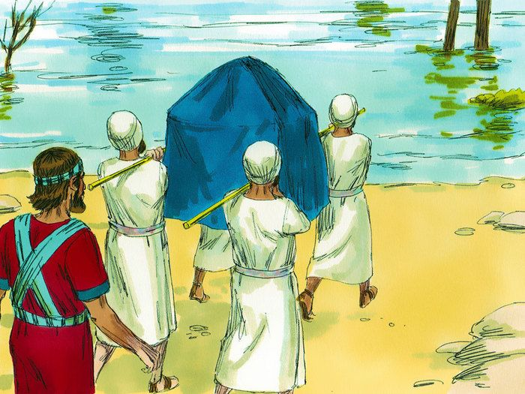 12Now therefore, take for yourselves twelve men from the tribes of Israel, one man from every tribe. 13And it shall come to pass, as soon as the soles of the feet of the priests who bear the ark of the Lord, the Lord of all the earth, shall rest in the waters of the Jordan, that the waters of the Jordan shall be cut off, the waters that come down from upstream, and they shall stand as a heap.”*

**Question 6**

What will happen for the Israelites to know that “the living God is among (Verse 10)” them?

1. There will be 12 men from each of the tribes of Israel
2. The Ark of the Coventant shall fall into the Jordan
3. The waters of the Jordan shall stand as a heap
4. The soles of the Priests that are carrying the Ark of the Covenant shall touch the Jordan

**Question 7**

List at least 3 tribes that the Isrealites shall defeat with the help of God… “*He will without fail drive out from before you…”*

1.

2.

3.

* Friday 11th September: Read **Joshua Chapter 3: 14-16** and answer the questions:

### Israel Crosses the Jordan

*14So it was, when the people set out from their camp to cross over the Jordan, with the priests bearing the ark of the covenant before the people, 15and as those who bore the ark came to the Jordan, and the feet of the priests who bore the ark dipped in the edge of the water (for the Jordan overflows all its banks during the whole time of harvest), 16that the waters which came down from upstream stood still, and rose in a heap very far away at Adam, the city that is beside Zaretan. So the waters that went down into the Sea of the Arabah, the Salt Sea, failed, and were cut off; and the people crossed over opposite Jericho. 17Then the priests who bore the ark of the covenant of the Lord stood firm on dry ground in the midst of the Jordan; and all Israel crossed over on dry ground, until all the people had crossed completely over the Jordan.*

**Question 8**

Number the events in the order that they happened. The first one has been done for you

|  |  |
| --- | --- |
|  | A small part of the Ark of the Covenant touched the water because the Jordan was overflowing during the time of harvest |
|  | All of the Israelites crossed over on dry land |
|  | The water was cut off, and stood still allowing the priests to cross on dry land |
| 1 | The priests led the way to the Jordan, and the Israelites followed |

* Saturday 12th September

**Question 9**

Identify the following characters/ things/ places in the image below.

Israelites , Joshua , Jordan River , Ark of the Covenant, Levite Priests

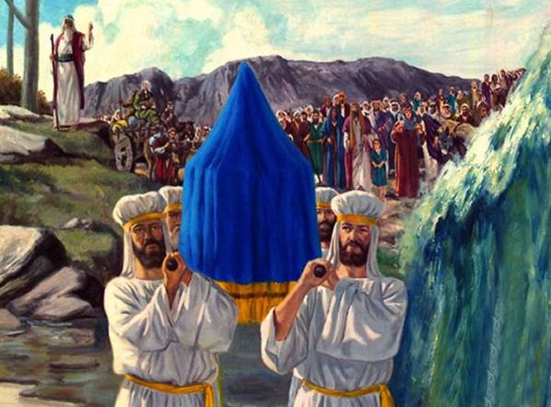

**What 4 lessons we learn from crossing the Jordan River to the Promised Land**

*The children of Israel had spent 40 years in the wilderness and now they were about to enter into the Promised Land. The Jordan River was the barrier keeping them out, so they had to cross the Jordan to get there. Sometimes we need to leave the past behind and enter new territory. Usually we will encounter a barrier that keeps us from the new land, and we must break through that barrier to get to what God has for us.*

1. ***You must believe that God has given you the land.*** *God had promised their fathers that He would give them their own land (Josh. 1:6).  Many of those people died in the wilderness and could not enter it due to unbelief (Heb. 3:19).  Before you can enter any new territory, you must believe that it's God's will and that He has given it to you.*
2. ***You must believe that the Promised Land is better than the wilderness.****Why would you go into the land, unless you believed it was better than the wilderness?  The 12 men that Moses had sent to spy out the land said that it was "an exceedingly good land" (Num. 14:7).  Some people probably said, "I kind of like it here in the wilderness.  This is what I'm used to. I like all the sand, rocks, and dirt out here. I'm not sure I want to go into a land full of green grass and fruit trees."  It's easy to stay with what you're familiar with instead of doing something new. But then you miss out on the blessings God has for you.*
3. ***You must believe that God is with you.****Joshua said, "Be strong and courageous...for the Lord your God is with you wherever you go" (Josh. 1:9).  To leave your comfort zone and tread into new territory, you must believe that God is with you and that you're not on your own. "God is with you" means that He is there to help and guide you through all situations, both good and bad.*
4. ***You must take a step of faith into the Jordan.*** *Imagine standing at the Jordan River, and you don't know how you're going to get an entire nation across it.  There isn't a bridge over the river. There aren't any boats. But God told them to take a step of faith and He would open the way.  As soon as the priests put their feet in the river, the Lord stopped the water and they crossed over (Josh. 3:13).  Sometimes God wants us to take the step of faith first, and then He will come through.*

***What to do when you finish your Bible Study.***

1. ***Either send it by email to your class email address or print and hand it to your servants next Sunday.***
2. ***If you want to send your Bible Study by email, please select your class email address below:***

[stthomas6b1@gmail.com](mailto:stthomas6b1@gmail.com) Uncle George

[stpeter6b2@gmail.com](mailto:stpeter6b2@gmail.com) Uncle Mina

[stphilip6g@gmail.com](mailto:stphilip6g@gmail.com) Aunty Jacky

***Click on the following link to see how many points you have.***

**Year 6B1 (St Thomas)**  
[https://docs.google.com/spreadsheets/d/1B3hbaPWXLPr-bqV8YIabw159aKTkQlJ3I1pKK7mRhEI/edit?usp=sharing](https://webmail.meriden.nsw.edu.au/owa/redir.aspx?C=b6b7aaaa4ff64c008d6db035dc9d08cb&URL=https%3a%2f%2fdocs.google.com%2fspreadsheets%2fd%2f1B3hbaPWXLPr-bqV8YIabw159aKTkQlJ3I1pKK7mRhEI%2fedit%3fusp%3dsharing)

**Year 6B2 (St Peter)**

[https://docs.google.com/spreadsheets/d/1-3aY66NbtvgQdVxKQsLKIN32-mekY1UfV-fU-a6A3aE/edit?usp=sharing](https://webmail.meriden.nsw.edu.au/owa/redir.aspx?C=b6b7aaaa4ff64c008d6db035dc9d08cb&URL=https%3a%2f%2fdocs.google.com%2fspreadsheets%2fd%2f1-3aY66NbtvgQdVxKQsLKIN32-mekY1UfV-fU-a6A3aE%2fedit%3fusp%3dsharing)

**Year 6G (StPhilip)**

[https://docs.google.com/spreadsheets/d/1KKS7TLUdMux972uO8yehkyA-gpRY7so_qA22MaRSM-I/edit?usp=sharing](https://webmail.meriden.nsw.edu.au/owa/redir.aspx?C=b6b7aaaa4ff64c008d6db035dc9d08cb&URL=https%3a%2f%2fdocs.google.com%2fspreadsheets%2fd%2f1KKS7TLUdMux972uO8yehkyA-gpRY7so_qA22MaRSM-I%2fedit%3fusp%3dsharing)