C:\Documents and Settings\suzy\Local Settings\Temporary Internet Files\Content.IE5\3JXW24R5\MC900383922[1].wmfSunday 25th October, 2015

Name:

Class:

Finish Date: Saturday 31st October, 2015

Completed Bible Study = 15 points

Email Homework by the due date = 5 points

**Year 6 Bible Study Joshua Chapter 23**

**For the questions below Highlight, underline or change the font colour to choose the correct answer.**

* Monday 26th October: Read **Joshua Chapter 24: 1-5** and answer the questions:

### The Covenant at Shechem

*1 Then Joshua gathered all the tribes of Israel to Shechem and called for the elders of Israel, for their heads, for their judges, and for their officers; and they presented themselves before God. 2And Joshua said to all the people, “Thus says the Lord God of Israel: ‘Your fathers, including Terah, the father of Abraham and the father of Nahor, dwelt on the other side of the River[*[*a*](https://www.biblegateway.com/passage/?search=Joshua+24&version=NKJV#fen-NKJV-6479a)*] in old times; and they served other gods. 3Then I took your father Abraham from the other side of the River, led him throughout all the land of Canaan, and multiplied his descendants and gave him Isaac. 4To Isaac I gave Jacob and Esau. To Esau I gave the mountains of Seir to possess, but Jacob and his children went down to Egypt. 5Also I sent Moses and Aaron, and I plagued Egypt, according to what I did among them. Afterward I brought you out.*

**Question 1**

Fill in the family tree that Joshua described to the Israelites (**Isaac, Abraham, 12 Tribes of Israel and Easu)**

**Terah**

**A**

**Nahor**

**I**

**E**

**Jacob**

**1**

* Tuesday 27th October: Read **Joshua Chapter 24: 6-7** and answer the questions:

***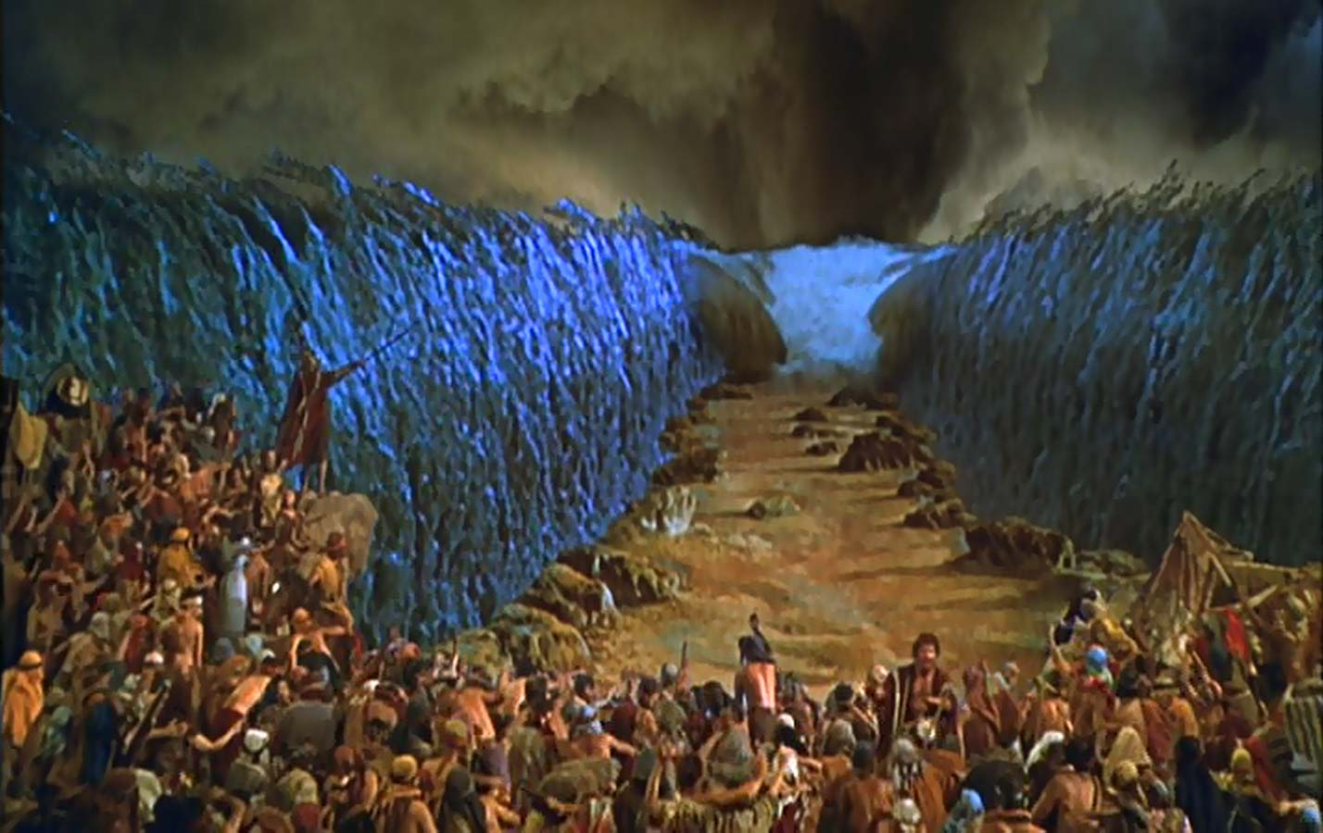****6‘Then I brought your fathers out of Egypt, and you came to the sea; and the Egyptians pursued your fathers with chariots and horsemen to the Red Sea. 7So they cried out to the Lord; and He put darkness between you and the Egyptians, brought the sea upon them, and covered them. And your eyes saw what I did in Egypt. Then you dwelt in the wilderness a long time.*

**Question 2**

What did the Lord do to protect the Israelites as they were fleeing from the Egyptians?

a) He gave them horsemen

b) He put darkness between them

c) He split the sea

d) He sent them into the wilderness

* Wednesday 28th October: Read **Joshua Chapter 24:8-13** and answer the questions:

*8And I brought you into the land of the Amorites, who dwelt on the other side of the Jordan, and they fought with you. But I gave them into your hand, that you might possess their land, and I destroyed them from before you. 9Then Balak the son of Zippor, king of Moab, arose to make war against Israel, and sent and called Balaam the son of Beor to curse you. 10But I would not listen to Balaam; therefore he continued to bless you. So I delivered you out of his hand. 11Then you went over the Jordan and came to Jericho. And the men of Jericho fought against you—also the Amorites, the Perizzites, the Canaanites, the Hittites, the Girgashites, the Hivites, and the Jebusites. But I delivered them into your hand. 12I sent the hornet before you which drove them out from before you, also the two kings of the Amorites, but not with your sword or with your bow. 13I have given you a land for which you did not labor, and cities which you did not build, and you dwell in them; you eat of the vineyards and olive groves which you did not plant.’*

**Question 3**

List the 4 nations that the Israelites defeated until they had reached the Promised Land

(i)

(ii)

(iii)

(iv)

* Thursday 29th October: Read **Joshua Chapter 24: 14-24** and answer the questions:

*14“Now therefore, fear the Lord, serve Him in sincerity and in truth, and put away the gods which your fathers served on the other side of the River and in Egypt. Serve the Lord! 15And if it seems evil to you to serve the Lord, choose for yourselves this day whom you will serve, whether the gods which your fathers served that were on the other side of the River, or the gods of the Amorites, in whose land you dwell. But as for me and my house, we will serve the Lord.”*

*16So the people answered and said: “Far be it from us that we should forsake the Lord to serve other gods; 17for the Lord our God is He who brought us and our fathers up out of the land of Egypt, from the house of bondage, who did those great signs in our sight, and preserved us in all the way that we went and among all the people through whom we passed. 18And the Lord drove out from before us all the people, including the Amorites who dwelt in the land. We also will serve the Lord, for He is our God.”*

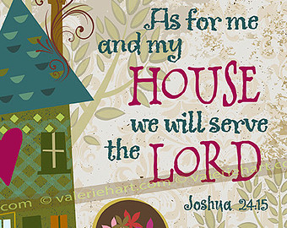

*19But Joshua said to the people, “You cannot serve the Lord, for He is a holy God. He is a jealous God; He will not forgive your transgressions nor your sins. 20If you forsake the Lord and serve foreign gods, then He will turn and do you harm and consume you, after He has done you good.”*

*21And the people said to Joshua, “No, but we will serve the Lord!”*

*22So Joshua said to the people, “You are witnesses against yourselves that you have chosen the Lord for yourselves, to serve Him.”*

*And they said, “We are witnesses!”*

*23“Now therefore,” he said, “put away the foreign gods which are among you, and incline your heart to the Lord God of Israel.”*

*24And the people said to Joshua, “The Lord our God we will serve, and His voice we will obey!”*

**Question 4**

What are the two ways that we should serve the Lord? (HINT: Verse 14)

**Question 5**

In this passage, Joshua gives the Israelites a choice to serve the Lord, or to serve other gods. The Israelites tell him that they can never go against the Lord after all He has done for them. However, we know that this is not true, because they served other gods before and also after this talk.

What are some worldly gods that we choose to worship instead of serving the Lord?

List at least 2

(Examples: Not going to church because we have a birthday party, not reading the Bible because we have too much homework)

(i)

(ii)

* Friday 30th October: **Joshua Chapter 24: 25-28** and answer the questions:

*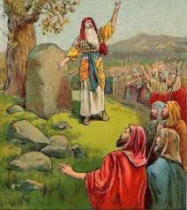25So Joshua made a covenant with the people that day, and made for them a statute and an ordinance in Shechem.*

*26Then Joshua wrote these words in the Book of the Law of God. And he took a large stone, and set it up there under the oak that was by the sanctuary of the Lord. 27And Joshua said to all the people, “Behold, this stone shall be a witness to us, for it has heard all the words of the Lord which He spoke to us. It shall therefore be a witness to you, lest you deny your God.” 28So Joshua let the people depart, each to his own inheritance.*

**Question 6**

True/ False

Joshua wrote that all Israel should serve the Lord on a stone True/ False

The stone was set under a tree True/ Flase

The stone was NOT there to remind the Israelities to serve the Lord True/ False

* Saturday 31st October: Read **Joshua Chapter 24: 29-33** and answer the questions:

### Death of Joshua and Eleazar

*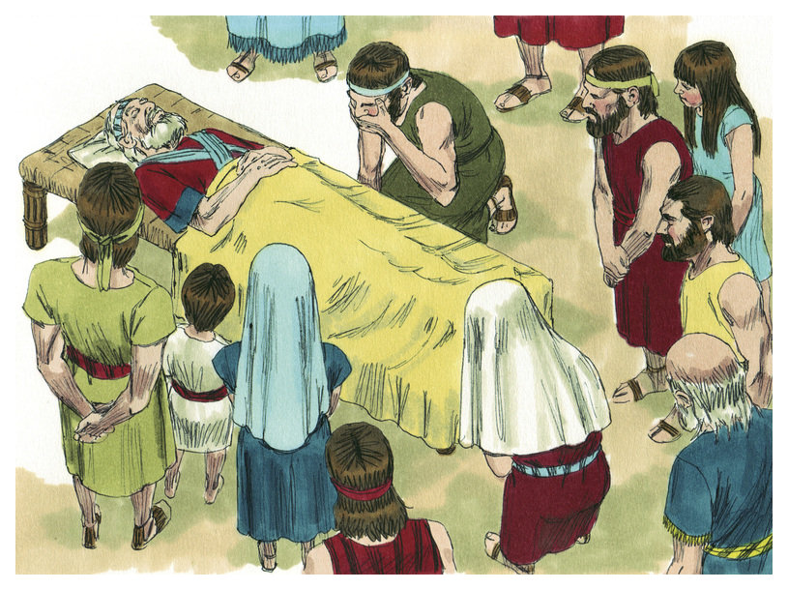29Now it came to pass after these things that Joshua the son of Nun, the servant of the Lord, died, being one hundred and ten years old. 30And they buried him within the border of his inheritance at Timnath Serah, which is in the mountains of Ephraim, on the north side of Mount Gaash.*

*31Israel served the Lord all the days of Joshua, and all the days of the elders who outlived Joshua, who had known all the works of the Lord which He had done for Israel.*

*32The bones of Joseph, which the children of Israel had brought up out of Egypt, they buried at Shechem, in the plot of ground which Jacob had bought from the sons of Hamor the father of Shechem for one hundred pieces of silver, and which had become an inheritance of the children of Joseph.*

*33And Eleazar the son of Aaron died. They buried him in a hill belonging to Phinehas his son, which was given to him in the mountains of Ephraim.*

**Question 7**

How old was Joshua when he passed away?

***What to do when you finish your Bible Study.***

1. ***Either send it by email to your class email address or print and hand it to your servants next Sunday.***
2. ***If you want to send your Bible Study by email, please select your class email address below:***

[stthomas6b1@gmail.com](mailto:stthomas6b1@gmail.com) Uncle George   
[stpeter6b2@gmail.com](mailto:stpeter6b2@gmail.com) Uncle Mina

[stphilip6g@gmail.com](mailto:stphilip6g@gmail.com) Aunty Jacky

***Click on the following link to see how many points you have.***

**Year 6B1 (St Thomas)**  
[https://docs.google.com/spreadsheets/d/1B3hbaPWXLPr-bqV8YIabw159aKTkQlJ3I1pKK7mRhEI/edit?usp=sharing](https://webmail.meriden.nsw.edu.au/owa/redir.aspx?C=b6b7aaaa4ff64c008d6db035dc9d08cb&URL=https%3a%2f%2fdocs.google.com%2fspreadsheets%2fd%2f1B3hbaPWXLPr-bqV8YIabw159aKTkQlJ3I1pKK7mRhEI%2fedit%3fusp%3dsharing)

**Year 6B2 (St Peter)**

[https://docs.google.com/spreadsheets/d/1-3aY66NbtvgQdVxKQsLKIN32-mekY1UfV-fU-a6A3aE/edit?usp=sharing](https://webmail.meriden.nsw.edu.au/owa/redir.aspx?C=b6b7aaaa4ff64c008d6db035dc9d08cb&URL=https%3a%2f%2fdocs.google.com%2fspreadsheets%2fd%2f1-3aY66NbtvgQdVxKQsLKIN32-mekY1UfV-fU-a6A3aE%2fedit%3fusp%3dsharing)

**Year 6G (StPhilip)**

[https://docs.google.com/spreadsheets/d/1KKS7TLUdMux972uO8yehkyA-gpRY7so_qA22MaRSM-I/edit?usp=sharing](https://webmail.meriden.nsw.edu.au/owa/redir.aspx?C=b6b7aaaa4ff64c008d6db035dc9d08cb&URL=https%3a%2f%2fdocs.google.com%2fspreadsheets%2fd%2f1KKS7TLUdMux972uO8yehkyA-gpRY7so_qA22MaRSM-I%2fedit%3fusp%3dsharing)