C:\Documents and Settings\suzy\Local Settings\Temporary Internet Files\Content.IE5\3JXW24R5\MC900383922[1].wmfSunday 18th October, 2015

Name:

Class:

Finish Date: Saturday 24th October, 2015

Completed Bible Study = 15 points

Email Homework by the due date = 5 points

**Year 6 Bible Study Joshua Chapter 23**

**For the questions below Highlight, underline or change the font colour to choose the correct answer.**

* Monday 19th October: Read **Joshua Chapter 23: 1-3** and answer the questions:

**Joshua’s Farewell Address**

*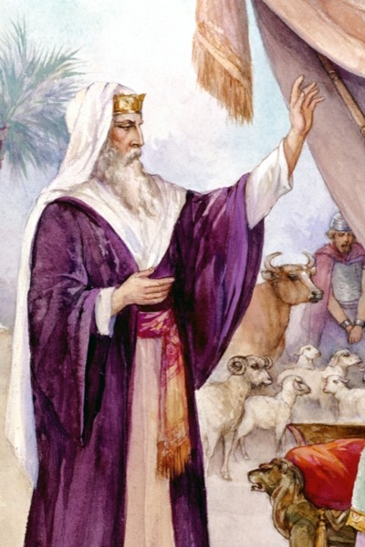1Now it came to pass, a long time after the Lord had given rest to Israel from all their enemies round about, that Joshua was old, advanced in age. 2And Joshua called for all Israel, for their elders, for their heads, for their judges, and for their officers, and said to them:*

*“I am old, advanced in age. 3You have seen all that the Lord your God has done to all these nations because of you, for the Lord your God is He who has fought for you.*

**Question 1**

What had the Lord done for Israel from all their enemies?

* Tuesday 20th October: Read **Joshua Chapter 23: 4-7** and answer the questions:

**Joshua’s Farewell Address continued:**

*4See, I have divided to you by lot these nations that remain, to be an inheritance for your tribes, from the Jordan, with all the nations that I have cut off, as far as the Great Sea westward. 5And the Lord your God will expel them from before you and drive them out of your sight. So you shall possess their land, as the Lord your God promised you. 6Therefore be very courageous to keep and to do all that is written in the Book of the Law of Moses, lest you turn aside from it to the right hand or to the left, 7and lest you go among these nations, these who remain among you.*

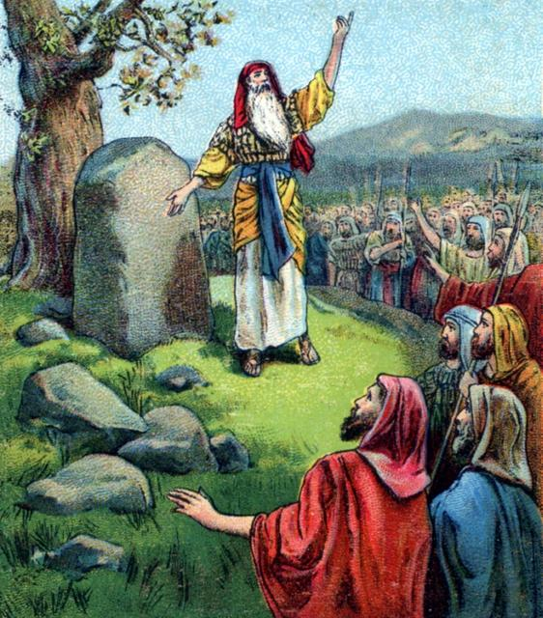

**Question 2**

Highlight the correct commandments that Joshua told the people of Israel to follow:

* Fight off all other nations
* Be courageous
* Cut off the hands of other people
* Keep all that is written in the law
* Do not communicate or marry (go among) people from other nations
* Split into different tribes
* Wednesday 21st October: Read **Joshua Chapter 23:7-10** and answer the questions:

**Joshua’s Farewell Address continued:**

*You shall not make mention of the name of their gods, nor cause anyone to swear by them; you shall not serve them nor bow down to them, 8but you shall hold fast to the Lord your God, as you have done to this day. 9For the Lord has driven out from before you great and strong nations; but as for you, no one has been able to stand against you to this day. 10One man of you shall chase a thousand, for the Lord your God is He who fights for you, as He promised you.*

**Question 3**

Why were the Israelites told to “… Hold fast to the Lord?”

1. To not make mention of the name of other gods
2. For the Lord drove out other strong nations away from the Israelites
3. To fight a thousand men
4. To let the Lord fight for them

* Thursday 22nd October: Read **Joshua Chapter 23: 11-13** and answer the questions:

**

**Joshua’s Farewell Address continued:**

*11Therefore take careful heed to yourselves, that you love the Lord your God. 12Or else, if indeed you do go back, and cling to the remnant of these nations—these that remain among you—and make marriages with them, and go in to them and they to you, 13know for certain that the Lord your God will no longer drive out these nations from before you. But they shall be snares and traps to you, and scourges on your sides and thorns in your eyes, until you perish from this good land which the Lord your God has given you.*

**Question 4**

True/ False

1. The Israelites did not need to love the Lord. True/ False
2. The Israelites were to marry people from other nations. True/ False
3. If the Israelites married other people the God would stop helping them defeat other armies. True/ False
4. The people that the Israelites married from other nations would be thorns in their side. True/ False

* Friday 23rd October: **Joshua Chapter 23: 14** and answer the questions:

Look up Joshua 23 verse 14 and write it in the textbox below



**Question 6**

What does this verse tell you about God’s promises to you?

* Saturday 24th October: Read **Joshua Chapter 23: 15-16** and answer the questions:

**Conclusion of Joshua’s Farewell Address**

*15Therefore it shall come to pass, that as all the good things have come upon you which the Lord your God promised you, so the Lord will bring upon you all harmful things, until He has destroyed you from this good land which the Lord your God has given you. 16When you have transgressed the covenant of the Lord your God, which He commanded you, and have gone and served other gods, and bowed down to them, then the anger of the Lord will burn against you, and you shall perish quickly from the good land which He has given you.”*

**Question 7**

Why do you think that God would punish the Israelites if they did not follow the covenant (commandments)? Does this still happen to us today?

***What to do when you finish your Bible Study.***

1. ***Either send it by email to your class email address or print and hand it to your servants next Sunday.***
2. ***If you want to send your Bible Study by email, please select your class email address below:***

[stthomas6b1@gmail.com](mailto:stthomas6b1@gmail.com) Uncle George

[stpeter6b2@gmail.com](mailto:stpeter6b2@gmail.com) Uncle Mina

[stphilip6g@gmail.com](mailto:stphilip6g@gmail.com) Aunty Jacky

***Click on the following link to see how many points you have.***

**Year 6B1 (St Thomas)**  
[https://docs.google.com/spreadsheets/d/1B3hbaPWXLPr-bqV8YIabw159aKTkQlJ3I1pKK7mRhEI/edit?usp=sharing](https://webmail.meriden.nsw.edu.au/owa/redir.aspx?C=b6b7aaaa4ff64c008d6db035dc9d08cb&URL=https%3a%2f%2fdocs.google.com%2fspreadsheets%2fd%2f1B3hbaPWXLPr-bqV8YIabw159aKTkQlJ3I1pKK7mRhEI%2fedit%3fusp%3dsharing)

**Year 6B2 (St Peter)**

[https://docs.google.com/spreadsheets/d/1-3aY66NbtvgQdVxKQsLKIN32-mekY1UfV-fU-a6A3aE/edit?usp=sharing](https://webmail.meriden.nsw.edu.au/owa/redir.aspx?C=b6b7aaaa4ff64c008d6db035dc9d08cb&URL=https%3a%2f%2fdocs.google.com%2fspreadsheets%2fd%2f1-3aY66NbtvgQdVxKQsLKIN32-mekY1UfV-fU-a6A3aE%2fedit%3fusp%3dsharing)

**Year 6G (StPhilip)**

[https://docs.google.com/spreadsheets/d/1KKS7TLUdMux972uO8yehkyA-gpRY7so_qA22MaRSM-I/edit?usp=sharing](https://webmail.meriden.nsw.edu.au/owa/redir.aspx?C=b6b7aaaa4ff64c008d6db035dc9d08cb&URL=https%3a%2f%2fdocs.google.com%2fspreadsheets%2fd%2f1KKS7TLUdMux972uO8yehkyA-gpRY7so_qA22MaRSM-I%2fedit%3fusp%3dsharing)