C:\Documents and Settings\suzy\Local Settings\Temporary Internet Files\Content.IE5\3JXW24R5\MC900383922[1].wmfSunday 30th August, 2015

Name:

Class:

Finish Date: Saturday 5th September, 2015

Completed Bible Study = 15 points

Email Homework by the due date = 5 points

**Year 6 Bible Study Joshua Chapter2**

**For the questions below Highlight, underline or change the font colour to choose the correct answer.**

* Monday 31st August: Read **Joshua Chapter 2: 1-3** and answer the questions:

**Joshua sends two men to Jericho**

*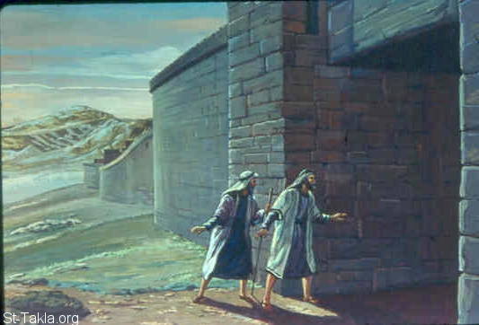1Now Joshua the son of Nun sent out two men from Acacia Grove to spy secretly, saying, “Go, view the land, especially Jericho.” So they went, and came to the house of a harlot named Rahab, and lodged there. 2And it was told the king of Jericho, saying, “Behold, men have come here tonight from the children of Israel to search out the country.”*

*3So the king of Jericho sent to Rahab, saying, “Bring out the men who have come to you, who have entered your house, for they have come to search out all the country.”*

**Question 1**

What was the job of the two spies that were sent out by Joshua?

* Tuesday 1st September: Read **Joshua Chapter 2: 4-7** and answer the questions:

**Rahab hides the two men**

*4Then the woman took the two men and hid them. So she said, “Yes, the men came to me, but I did not know where they were from. 5And it happened as the gate was being shut, when it was dark, that the men went out. Where the men went I do not know; pursue them quickly, for you may overtake them.”*

*6(But she had brought them up to the roof and hidden them with the stalks of flax, which she had laid in order on the roof.) 7Then the men pursued them by the road to the Jordan, to the fords. And as soon as those who pursued them had gone out, they shut the gate.*

***What is Flax?***

*Flax is a type of wheat or crop, used to make linen (fabric)*

**Question 2**

Identify the following people or items in the picture on the right, by writing one of the following answers in each box.

**Rahab, Two Spies, Flax, Rooftop**

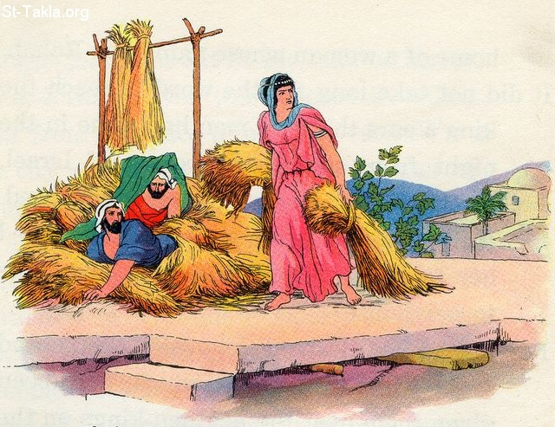

**Question 3**

Where did Rahab hide the two men?

a) In her bed

b) Outside the gate

c) Under some flax on her roof

d) Near the river

* Wednesday 2nd September: Read **Joshua Chapter 2: 8-13** and answer the questions:

**Rahab begs God to save her and her family**

*8Now before they lay down, she came up to them on the roof, 9and said to the men: “I know that the Lord has given you the land, that the terror of you has fallen on us, and that all the inhabitants of the land are fainthearted because of you. 10For we have heard how the Lord dried up the water of the Red Sea for you when you came out of Egypt, and what you did to the two kings of the Amorites who were on the other side of the Jordan, Sihon and Og, whom you utterly destroyed.*

*11And as soon as we heard these things, our hearts melted; neither did there remain any more courage in anyone because of you, for the Lord your God, He is God in heaven above and on earth beneath. 12Now therefore, I beg you, swear to me by the Lord, since I have shown you 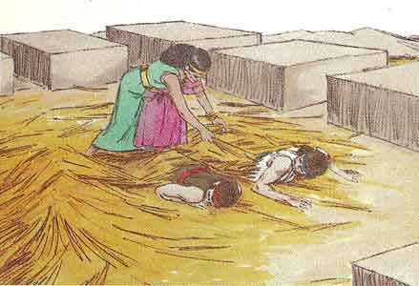kindness, that you also will show kindness to my father’s house, and give me a true token, 13and spare my father, my mother, my brothers, my sisters, and all that they have, and deliver our lives from death.”*

**Question 4**

Fill in the blanks for the follow verse, and write down the verse number in the box below it.

For the your God, He is in heaven above, and on

beneath. (Joshua Chapter 2, Verse )

**Question 5**

List the 2 events, accoridng to verse 10, that allowed Rahab, and the people of Jericho, know that the God of the Israelites was a powerful God, and made them lose courage in themselves.

1.

2.

**Question 6**

True or False

The one request that Rahab had of the spies was to save her family if Israel were to destroy Jericho? True/ False

* Thursday 3rd September: Read **Joshua Chapter 2: 14-16** and answer the questions:

**A plan to save the two men**

*14So the men answered her, “Our lives for yours, if none of you tell this business of ours. And it shall be, when the Lord has given us the land, that we will deal kindly and truly with you.”*

*15Then she let them down by a rope through the window, for her house was on the city wall; she dwelt on the wall. 16And she said to them, “Get to the mountain, lest the pursuers meet you. Hide there three days, until the pursuers have returned. Afterward you may go your way.”*

*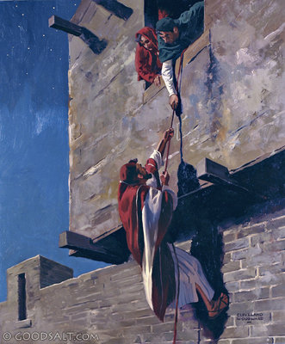***Question 7**

Yes/ No

Did the spies agree to help Rahab? Yes/ No

Did Rahab live in the middle of the city? Yes/ No

The men had to hide in the mountains for 3 days? Yes/No

The men walked out of the city doors? Yes/ No

* Friday 4th September: Read **Joshua Chapter 2: 17-21** and answer the questions:

*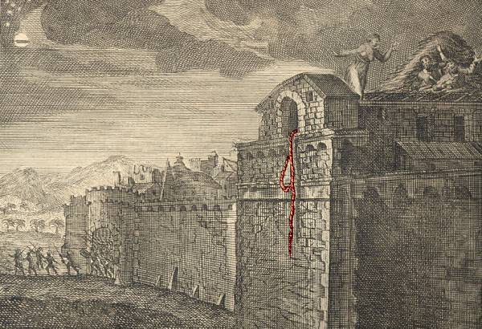***The Scarlet Cord**

*17So the men said to her: “We will be blameless of this oath of yours which you have made us swear, 18unless, when we come into the land, you bind this line of scarlet cord in the window through which you let us down, and unless you bring your father, your mother, your brothers, and all your father’s household to your own home. 19So it shall be that whoever goes outside the doors of your house into the street, his blood shall be on his own head, and we will be guiltless. And whoever is with you in the house, his blood shall be on our head if a hand is laid on him. 20And if you tell this business of ours, then we will be free from your oath which you made us swear.”*

*21Then she said, “According to your words, so be it.” And she sent them away, and they departed. And she bound the scarlet cord in the window.*

**Question 8**

Highlight the people that were to be safe in the house of Rahab when the Israelites returned.

Rahab, The King, her father, her servants, her brothers, her mother, her friends, at least 2 soldiers

**Question 9**

Why did Rahab have to tie the scarlet (red) cord in her window until the Israelites came back?

* Saturday 5th September: Read **Joshua Chapter 2: 22-24** and answer the questions:

**The two men return to Joshua safely**

*22They departed and went to the mountain, and stayed there three days until the pursuers returned. The pursuers sought them all along the way, but did not find them. 23So the two men returned, descended from the mountain, and crossed over; and they came to Joshua the son of Nun, and told him all that had befallen them*

*.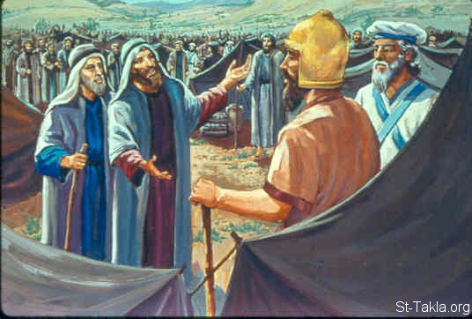*

*24And they said to Joshua, “Truly the Lord has delivered all the land into our hands, for indeed all the inhabitants of the country are fainthearted because of us.”*

**Question 10**

Match the word with its definition

Inhabitants, Fainthearted, Pursuers, Befallen, Delivered

|  |  |
| --- | --- |
|  | Lacking courage- feeling nervous |
|  | To have something bad happen to someone |
|  | People who live in a particular place |
|  | To bring and hand over |
|  | People that follow or chase something |

***What to do when you finish your Bible Study.***

1. ***Either send it by email to your class email address or print and hand it to your servants next Sunday.***
2. ***If you want to send your Bible Study by email, please select your class email address below:***

[stthomas6b1@gmail.com](mailto:stthomas6b1@gmail.com) Uncle George

[stpeter6b2@gmail.com](mailto:stpeter6b2@gmail.com) Uncle Mina

[stphilip6g@gmail.com](mailto:stphilip6g@gmail.com) Aunty Jacky

***Click on the following link to see how many points you have.***

**Year 6B1 (St Thomas)**  
[https://docs.google.com/spreadsheets/d/1B3hbaPWXLPr-bqV8YIabw159aKTkQlJ3I1pKK7mRhEI/edit?usp=sharing](https://webmail.meriden.nsw.edu.au/owa/redir.aspx?C=b6b7aaaa4ff64c008d6db035dc9d08cb&URL=https%3a%2f%2fdocs.google.com%2fspreadsheets%2fd%2f1B3hbaPWXLPr-bqV8YIabw159aKTkQlJ3I1pKK7mRhEI%2fedit%3fusp%3dsharing)

**Year 6B2 (St Peter)**

[https://docs.google.com/spreadsheets/d/1-3aY66NbtvgQdVxKQsLKIN32-mekY1UfV-fU-a6A3aE/edit?usp=sharing](https://webmail.meriden.nsw.edu.au/owa/redir.aspx?C=b6b7aaaa4ff64c008d6db035dc9d08cb&URL=https%3a%2f%2fdocs.google.com%2fspreadsheets%2fd%2f1-3aY66NbtvgQdVxKQsLKIN32-mekY1UfV-fU-a6A3aE%2fedit%3fusp%3dsharing)

**Year 6G (StPhilip)**

[https://docs.google.com/spreadsheets/d/1KKS7TLUdMux972uO8yehkyA-gpRY7so_qA22MaRSM-I/edit?usp=sharing](https://webmail.meriden.nsw.edu.au/owa/redir.aspx?C=b6b7aaaa4ff64c008d6db035dc9d08cb&URL=https%3a%2f%2fdocs.google.com%2fspreadsheets%2fd%2f1KKS7TLUdMux972uO8yehkyA-gpRY7so_qA22MaRSM-I%2fedit%3fusp%3dsharing)