C:\Documents and Settings\suzy\Local Settings\Temporary Internet Files\Content.IE5\3JXW24R5\MC900383922[1].wmfSunday 23rd August, 2015

Name:

Class:

Finish Date: Saturday 29th August, 2015

Completed Bible Study = 15 points

Email Homework by the due date = 5 points

**Year 6 Bible Study Joshua Chapter 1**

**For the questions below Highlight, underline or change the font colour to choose the correct answer.**

* Monday 24th August: Read **Joshua Chapter 1: 1-4** and answer the questions:

### God’s Commission to Joshua

*After the death of Moses the servant of the Lord, it came to pass that the Lord spoke to Joshua the son of Nun, Moses’ assistant, saying: 2“Moses My servant is dead. Now therefore, arise, go over this Jordan, you and all this people, to the land which I am giving to them—the children of Israel. 3Every place that the sole of your foot will tread upon I have given you, as I said to Moses. 4From the wilderness and this Lebanon as far as the great river, the River Euphrates, all the land of the Hittites, and to the Great Sea toward the going down of the sun, shall be your territory.*

**Where is the Promised Land?**

This map reveals the 7 nations mentioned in the Bible that existed in the land of Canaan before God gave the land to the Israelites. The ***Canaanites*** dwelt in the plains, the ***Amorites*** lived in the hills, some of the other nations were the ***Perizzites***, the ***Hivites***, the ***Hittites***, the ***Jebusites***, the ***Moabites***, the ***Edomites***, the ***Philistines***, and the ***Girgashites***. These nations were descendants of ***Canaan, the fourth son of Ham*** who was cursed by Noah. Some of them were ***Giants***.

**Question 1**

Looking at the map on the right, identify which two tribes the Camp of the Israelites was between.

a) Edomites and Hitites

b) Moabites and Amorites

c) Moabites and Canaanites

d) Philistines and Girgashites

**Question 2**

What words were used to describe Moses in Verse 1 after he had died? What does this tell us about the life of Moses?

**Question 3**

What was the role of Joshua before he became the leader of the Israelites?

a) A normal person

b) Leader of the army

c) The assistant of Moses

d) A priest

**Question 4**

Looking at the map again, what river did the Camp of the Israelites have to cross? And what was the promise that God gave them after they crossed this river?

* Tuesday 25th August: Read **Joshua Chapter 1: 5-7** and answer the questions:

*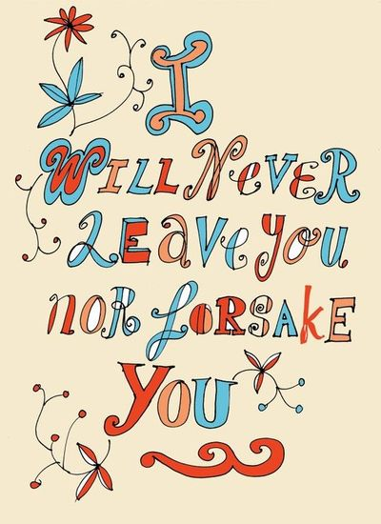***God tells Joshua He will never leave him**

*5No man shall be able to stand before you all the days of your life; as I was with Moses, so I will be with you. I will not leave you nor forsake you. 6Be strong and of good courage, for to this people you shall divide as an inheritance the land which I swore to their fathers to give them. 7Only be strong and very courageous, that you may observe to do according to all the law which Moses My servant commanded you; do not turn from it to the right hand or to the left, that you may prosper wherever you go.*

**Question 5**

Is God’s promise in verse 5, exclusively to Joshua? Yes/ No

What does this promise mean to you?

**Question 6**

Match each word to its definition- Strong, Courageous, Forsake, Prosper.

Highlight each word where it appears in the passage above.

|  |  |
| --- | --- |
|  | not discouraged by danger or pain; brave. |
|  | able to withstand force, pressure, or wear. |
|  | to make sucessful |
|  | abandon or leave |

* Wednesday 26th August: Read **Joshua Chapter 1: 8-9** and answer the questions:

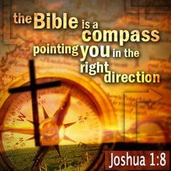

**God encourages Joshua**

*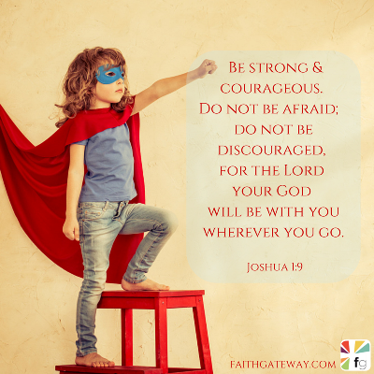8This Book of the Law shall not depart from your mouth, but you shall meditate in it day and night, that you may observe to do according to all that is written in it. For then you will make your way prosperous, and then you will have good success.*

*9Have I not commanded you? Be strong and of good courage; do not be afraid, nor be dismayed, for the Lord your God is with you wherever you go.”*

**Question 7**

To mediate means to think deeply about something. Verse 8 asks us to mediate on the “Book of the Law,” that is to say the word of God- we have the Bible!

List 3 ways we can mediate on the Bible.

**1)**

**2)**

**3)**

What promise do we receive if we meditate on the word of God? Please copy it EXACTLY from the passage above.

**Question 8**

Watch the following clip from YouTube.

<https://www.youtube.com/watch?v=t34ajxa7TCI>

According to this hymn, when should we trust in God? (List them in the order that you hear them)

**1)** When t

**2)** When I feel

**3)** When life’s

**4)** When all is

**5)** When I feel

**6)** When I know

**7)** When I’m

**8)** When I

**Question 9**

Why do we feel this strength, courage and trust through all these times? Complete from verse 9

The LORD your God is

* Thursday 27th August: Read **Joshua Chapter 1: 10-11** and answer the questions:

**Question 9**

With the help of a parent, or older brother or sister, open up a Bible at home, and write out the two verses for today’s reading. (Joshua 1: 10-11)

(HINT: The Book of Joshua is in the Old Testament, and we are reading Chapter ONE- the very first passage in Joshua)

10Then Joshua commanded

* Friday 28th August: Read **Joshua Chapter 1: 12-15** and answer the questions:

**The Lord reminds Joshua what He has said to Moses**

*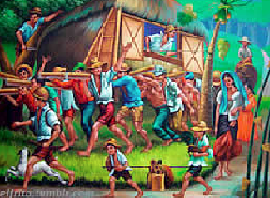12And to the Reubenites, the Gadites, and half the tribe of Manasseh Joshua spoke, saying, 13“Remember the word which Moses the servant of the Lord commanded you, saying, ‘The Lord your God is giving you rest and is giving you this land.’ 14Your wives, your little ones, and your livestock shall remain in the land which Moses gave you on this side of the Jordan. But you shall pass before your brethren armed, all your mighty men of valor, and help them, 15until the Lord has given your brethren rest, as He gave you, and they also have taken possession of the land which the Lord your God is giving them. Then you shall return to the land of your possession and enjoy it, which Moses the Lord’s servant gave you on this side of the Jordan toward the sunrise.”*

**Question 10**

Before the Rubenites, Gadites and half the tribe of Manasseh were able to rest on the side of the Jordan (their land and home) that they were already on, what did they have to do to the rest of the Israel?

a) Sing for them

b) Rest with them

c) Help them move

d) Make fun of them for having to cross the river

**Question 11**

List some ways that we can help others (in our own home) before we rest

**1)**

**2)**

**3)**

* Saturday 29th August: Read **Joshua Chapter 1: 16-18** and answer the questions:

*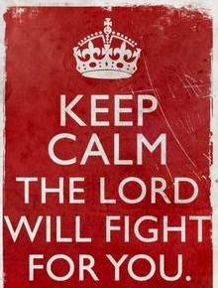***The Israelites support Joshua**

*16So they answered Joshua, saying, “All that you command us we will do, and wherever you send us we will go. 17Just as we heeded Moses in all things, so we will heed you. Only the Lord your God be with you, as He was with Moses. 18Whoever rebels against your command and does not heed your words, in all that you command him, shall be put to death. Only be strong and of good courage.”*

**Question 12**

The main message of the chapter is repeated here once again, and this time it’s by the people of Israel, rather than from God.

There are TWO parts to this message! What are they?

1) The Lord your God is

2) Be strong and

***What to do when you finish your Bible Study.***

1. ***Either send it by email to your class email address or print and hand it to your servants next Sunday.***
2. ***If you want to send your Bible Study by email, please select your class email address below:***

[stthomas6b1@gmail.com](mailto:stthomas6b1@gmail.com) Uncle George

[stpeter6b2@gmail.com](mailto:stpeter6b2@gmail.com) Uncle Mina

[stphilip6g@gmail.com](mailto:stphilip6g@gmail.com) Aunty Jacky

***Click on the following link to see how many points you have.***

**Year 6B1 (St Thomas)**  
[https://docs.google.com/spreadsheets/d/1B3hbaPWXLPr-bqV8YIabw159aKTkQlJ3I1pKK7mRhEI/edit?usp=sharing](https://webmail.meriden.nsw.edu.au/owa/redir.aspx?C=b6b7aaaa4ff64c008d6db035dc9d08cb&URL=https%3a%2f%2fdocs.google.com%2fspreadsheets%2fd%2f1B3hbaPWXLPr-bqV8YIabw159aKTkQlJ3I1pKK7mRhEI%2fedit%3fusp%3dsharing)

**Year 6B2 (St Peter)**

[https://docs.google.com/spreadsheets/d/1-3aY66NbtvgQdVxKQsLKIN32-mekY1UfV-fU-a6A3aE/edit?usp=sharing](https://webmail.meriden.nsw.edu.au/owa/redir.aspx?C=b6b7aaaa4ff64c008d6db035dc9d08cb&URL=https%3a%2f%2fdocs.google.com%2fspreadsheets%2fd%2f1-3aY66NbtvgQdVxKQsLKIN32-mekY1UfV-fU-a6A3aE%2fedit%3fusp%3dsharing)

**Year 6G (StPhilip)**

[https://docs.google.com/spreadsheets/d/1KKS7TLUdMux972uO8yehkyA-gpRY7so_qA22MaRSM-I/edit?usp=sharing](https://webmail.meriden.nsw.edu.au/owa/redir.aspx?C=b6b7aaaa4ff64c008d6db035dc9d08cb&URL=https%3a%2f%2fdocs.google.com%2fspreadsheets%2fd%2f1KKS7TLUdMux972uO8yehkyA-gpRY7so_qA22MaRSM-I%2fedit%3fusp%3dsharing)